II. Requirement Specifications

1. Authentication

1.1 UC-01: User Login

a. Functional Description

ID and Name: | UC-01 Login
Created By: | QuanLVA | Date Created: | 1/6/26
Primary Actor: | System User (Administrator, Doctor, Patient) | Secondary Actors: | Authentication Service,  Database
Description: | A user accesses the AI-Assisted Diabetes Monitoring System by entering a registered phone number and password. The system authenticates the user's credentials and grants access to the corresponding dashboard based on the user's role.
Trigger: | A user selects the [Đăng nhập] button after entering their phone number and password.
Preconditions: | PRE-1. The user has a registered account in the system.  PRE-2. The user's account is active.  PRE-3. The Login page is available.
Postconditions: | Successful Login  POST-1. The user is authenticated successfully.  POST-2. A login session is created.  POST-3. The user is redirected to the dashboard corresponding to their role.  Failed Login  POST-4. The system displays an error message and no session is created.
Normal Flow: | 1.0 Login  - The user accesses the Login page.  - The system displays the "Số điện thoại", "Mật khẩu" fields and the "Đăng nhập" button.  - The user enters the registered phone number.  - The user enters the password.  - User clicks the "Đăng nhập" button.  - The system encrypts the entered password using the BCrypt hashing algorithm.  - The system validates the phone number and password. (See 1.0.E1)  - The system verifies that the account status is active. (See 1.0.E2)  - The system determines the user's role.  - The system creates a login session.  - The system redirects the user to the corresponding dashboard based on the user's role.
Alternative Flows:
Exceptions: | 1.0.E1 Invalid Phone Number or Password  - The system cannot authenticate the entered phone number and password.  - The system displays the message:  "Tên tài khoản hoặc mật khẩu không chính xác."  - The user remains on the Login page.  - The user may re-enter the login information.  1.0.E2 Account Locked  - The system successfully authenticates the phone number and password.  - The system detects that the account status is locked  - The system denies access.  - The system displays the message:  "Tài khoản của bạn đã bị khóa. Vui lòng liên hệ với quản trị viên."  - The user remains on the Login page.
Priority: | High
Frequency of Use: | All users are required to log in before accessing any system functions. The login function is expected to be used multiple times each day, with peak usage occurring during working hours.
Business Rules:
Other Information: | - The password input field will hide all entered characters.  - Users can click the eye icon to show or hide the password.  - The login page will provide a "Quên mật khẩu?" link to recover the password.  - The login page will provide a "Đăng ký ngay" link if the patient does not have an account (the "Đăng ký ngay" link is for patients only).  - Users can cancel the login process at any time before clicking the "Login" button.
Assumptions: | - Each user account is uniquely identified by a registered phone number.  - Each user is assigned exactly one role in the system.  - Only accounts with Active status are allowed to log in.  - The authentication service and database are available during the login process.  - A corresponding dashboard has been configured for each user role.

b. Business Rules

ID | Business Rule | Business Rule Description
BR1 | Password Encoding | User passwords must be encoded using the BCrypt hashing algorithm before being stored and authenticated.
BR2 | Invalid Login | A user cannot be authenticated if the entered phone number or password is incorrect. The system shall display the message "Tên tài khoản hoặc mật khẩu không chính xác."
BR3 | Account Status Validation | A user cannot log in if the account status is Locked. The system shall display the message "Tài khoản của bạn đã bị khóa. Vui lòng liên hệ với quản trị viên."
BR4 | Role-based Access Control | After successful authentication, the system shall redirect the user to the dashboard corresponding to the user's role.

1.2 UC-02: User Registration

a. Functional Description

ID and Name: | UC‑02 Register
Created By: | QuanLVA | Date Created: | 1/6/26
Primary Actor: | Patient | Secondary Actors: | Authentication Service, OTP Service, Database
Description: | A patient registers a new account in the AI‑Assisted Diabetes Monitoring System by providing personal information and verifying their phone number via OTP. The system creates a new user account and corresponding patient profile. (Note: Doctor accounts are created only by the Administrator, not through this registration flow.)
Trigger: | The patient clicks the Đăng kí ngay link on the Login page.
Preconditions: | PRE‑1. The patient does not have an existing account.  PRE‑2. The patient is not logged in.  PRE‑3. The Registration page is available.
Postconditions: | Successful Registration  POST‑1. A new user account is created with Patient role.  POST‑2. A new patient profile is created and linked to the user account.  POST‑3. A new patient routine is created.  POST‑4. The system redirects to the Login page with a success message: "Đăng ký tài khoản thành công! Vui lòng đăng nhập."  Failed Registration  POST‑5. The system displays an appropriate error message and the patient remains on the relevant page.
Normal Flow: | 2.0 Register  1. The patient accesses the Registration page via the Đăng ký ngay link.  2. The system displays the registration form with the following fields:  - Họ và tên (bắt buộc)  - Số điện thoại (bắt buộc)  - Email (không bắt buộc)  - Mật khẩu (bắt buộc) – must meet complexity requirements  - Xác nhận mật khẩu (bắt buộc)  - Ngày sinh, Giới tính, Nhóm máu  - Chiều cao, Cân nặng  - Địa chỉ, Tiền sử bệnh án, Dị ứng  3. The patient enters information in all required fields. (See BR6)  4. The system displays password requirements: "Mật khẩu mạnh" with guidelines:  - Chứa ít nhất 8 ký tự  - Bao gồm chữ hoa và chữ thường  - Chứa ít nhất một chữ số  - Chứa ký tự đặc biệt (!@#$)  5. If the patient enters an email, the system validates the format. (See exception 2.0.E7)  6. The patient checks the "Tôi đồng ý..." checkbox.  7. The patient clicks the Đăng kí button.  8. The system validates all input data. (See exceptions 2.0.E1, 2.0.E2, 2.0.E3, 2.0.E4, 2.0.E5, 2.0.E6, 2.0.E7, 2.0.E8)  9. The system checks if the phone number already exists. (See exception 2.0.E9)  10. The system checks if the email already exists (if provided). (See exception 2.0.E10)  11. The system stores the registration data temporarily in the session.  12. The system generates a 6‑digit OTP with a 5‑minute expiry time.  13. The system "sends" the OTP (displayed in the console).  14. The system redirects the patient to the OTP Verification page.  15. The patient enters the OTP and clicks Xác nhận.  16. The system verifies the entered OTP. (See exceptions 2.0.E11, 2.0.E12, 2.0.E13)  17. The system creates a new User with role PAT.  18. The system creates a new Patient profile linked to the user (including email if provided).  19. The system creates a new PatientRoutine linked to the patient.  20. The system clears the registration session.  21. The system redirects to the Login page with success message: "Đăng ký tài khoản thành công! Vui lòng đăng nhập."
Alternative Flows: | Resend OTP (triggered from step 14 of Normal Flow)  1. The patient clicks the Gửi lại mã button.  2. The system checks if 60 seconds have passed since the last OTP was sent. (See exception 2.0.E13)  3. The system generates a new 6‑digit OTP with a new 5‑minute expiry time.  4. The system "sends" the new OTP (displayed in the console).  5. The system displays: "Mã OTP mới đã được gửi."  6. Use case returns to step 14 of the Normal Flow.
Exceptions: | 2.0.E1 Invalid Form Input – Missing Required Fields  1. The patient clicks Đăng kí without completing all required fields.  2. The system displays: "Vui lòng nhập đầy đủ các thông tin bắt buộc."  3. The patient remains on the Registration page.  2.0.E2 Invalid Form Input – Invalid Phone Number Format  1. The patient enters non‑numeric characters in the "Số điện thoại" field.  2. The system prevents the input of non‑numeric characters.  3. The patient remains on the Registration page.  2.0.E3 Invalid Form Input – Invalid Password  1. The patient enters a password that does not meet complexity requirements.  2. The system displays: "Mật khẩu phải có ít nhất 8 ký tự, bao gồm chữ hoa, chữ thường, số và ký tự đặc biệt."  3. The patient remains on the Registration page.  2.0.E4 Invalid Form Input – Password Confirmation Mismatch  1. The patient enters a new password and a different confirm password.  2. The system displays: "Mật khẩu xác nhận không khớp."  3. The patient remains on the Registration page.  2.0.E5 Invalid Form Input – Invalid Date of Birth  1. The patient selects a date of birth in the future or more than 120 years ago.  2. The system prevents the selection.  3. The patient remains on the Registration page.  2.0.E6 Invalid Form Input – Invalid Height  1. The patient enters a height value ≤ 1 cm or ≥ 300 cm.  2. The system displays a validation message.  3. The patient remains on the Registration page.  2.0.E7 Invalid Form Input – Invalid Weight  1. The patient enters a weight value ≤ 1 kg or ≥ 1000 kg.  2. The system displays a validation message.  3. The patient remains on the Registration page.  2.0.E8 Invalid Form Input – Invalid Email Format  1. The patient enters an email with an invalid format (e.g., missing @ or domain).  2. The system displays: "Email không hợp lệ. Vui lòng nhập đúng định dạng."  3. The patient remains on the Registration page.  2.0.E9 Phone Number Already Exists  1. The system finds an existing account with the entered phone number.  2. The system displays: "Số điện thoại đã tồn tại trên hệ thống."  3. The patient remains on the Registration page.  2.0.E10 Email Already Exists  1. The system finds an existing account with the entered email (if provided).  2. The system displays: "Email đã được sử dụng bởi tài khoản khác."  3. The patient remains on the Registration page.  2.0.E11 OTP Session Expired  1. The session for registration data is invalid or expired.  2. The system displays: "Phiên đăng ký đã hết hạn. Vui lòng đăng ký lại."  3. The patient is redirected to the Registration page.  2.0.E12 OTP Expired  1. The patient enters an OTP after 5 minutes have passed.  2. The system displays: "Mã OTP đã hết hạn. Vui lòng yêu cầu mã mới."  3. The patient remains on the OTP Verification page.  2.0.E13 Incorrect OTP  1. The patient enters an incorrect OTP.  2. The system displays: "Mã OTP không chính xác"  3. The patient remains on the OTP Verification page.  2.0.E14 Resend OTP Cooldown  1. The patient clicks Gửi lại mã before 60 seconds have passed.  2. The patient remains on the OTP Verification page.
Priority: | High
Frequency of Use: | Expected to be used by new patients. Frequency is moderate and depends on the number of new patients registering.
Business Rules:
Other Information: | - The Đăng ký ngay link is only displayed to patients.  - The OTP is a random 6‑digit number, valid for 5 minutes.  - The patient must wait 60 seconds before requesting a new OTP.  - The OTP is printed to the console for simulation purposes.  - The registration form includes a checkbox "Tôi đồng ý..." that must be checked.  - Email is optional – if provided, it must be valid and unique.  - Password requirements: 8+ characters, at least one uppercase, one lowercase, one digit, and one special character.  - The Xác nhận mật khẩu field must match the Mật khẩu field exactly.
Assumptions: | - The system supports patient registration only.  - The OTP service is available for generating OTPs.  - The patient has a valid phone number to receive the OTP.  - The patient can access the OTP within 5 minutes.

b. Business Rules

ID | Business Rule | Business Rule Description
BR1 | Registration Form Validation | The following fields are mandatory and must be validated:  - Họ và tên: Not empty.  - Số điện thoại: Numeric only.  - Mật khẩu: Minimum 8 characters, must contain at least one uppercase letter (A-Z), one lowercase letter (a-z), one digit (0-9), and one special character (!@#$%^&* etc.).  - Xác nhận mật khẩu: Must match the Mật khẩu field exactly.  - Ngày sinh: Cannot be future date; max 120 years ago.  - Chiều cao: 1 < value < 300 cm.  - Cân nặng: 1 < value < 1000 kg.  - Tôi đồng ý...: Must be checked.  - Email: Optional – if provided, must follow valid email format (e.g., user@domain.com).
BR2 | Phone Number Uniqueness | The phone number must be unique in the system. If a phone number already exists, the registration is rejected.
BR3 | Email Uniqueness | The email (if provided) must be unique in the system. If an email already exists, the registration is rejected.
BR4 | OTP Generation and Expiry | An OTP is generated for each registration attempt. It is valid for 5 minutes.
BR5 | OTP Resend Cooldown | A patient must wait 60 seconds before requesting a new OTP.
BR6 | Registration Data Persistence During OTP Verification | Registration data is stored in the session during OTP verification to maintain state.
BR7 | Role Assignment | All registrations through this flow are assigned the Patient role only.
BR8 | Doctor Account Creation | Doctor accounts are created exclusively by an Administrator and are not part of this use case

1.3 UC-03: Forgot Password

a. Functional Description

ID and Name: | UC‑03 Forgot Password
Created By: | QuanLVA | Date Created: | 1/6/26
Primary Actor: | System User (Patient, Doctor, Admin) | Secondary Actors: | Authentication Service, OTP Service, Database
Description: | A registered user (Patient or Doctor) resets their password by verifying their registered phone number via OTP and setting a new password.
Trigger: | The user clicks the Quên mật khẩu? link on the Login page.
Preconditions: | PRE‑1. The user has a registered account in the system.  PRE‑2. The user knows the registered phone number associated with the account.  PRE‑3. The user is not logged in.
Postconditions: | Successful Reset  POST‑1. The user's password is updated in the system.  POST‑2. The OTP session and verification status are cleared.  POST‑3. The system invalidates the current session.  POST‑4. The system redirects to the Login page with a success message: "Đặt lại mật khẩu thành công! Vui lòng đăng nhập."  Failed Reset  POST‑5. The system displays an appropriate error message and the user remains on the relevant page.
Normal Flow: | 3.0 Forgot Password  1. The user accesses the Login page.  2. The user clicks the Quên mật khẩu? link.  3. The system displays the "Nhập số điện thoại" page.  4. The user enters the registered phone number.  5. The user clicks the Gửi mã OTP button.  6. The system validates the phone number. (See exception 3.0.E1)  7. The system generates a 6‑digit OTP and stores it with a 5‑minute expiry time.  8. The system "sends" the OTP (displayed in the console).  9. The system redirects the user to the OTP Verification page.  10. The system displays: "Mã OTP có hiệu lực trong 5 phút" and a countdown timer.  11. The user enters the 6‑digit OTP and clicks Xác nhận.  12. The system verifies the entered OTP. (See exceptions 3.0.E2, 3.0.E3, 3.0.E4)  13. The system marks the OTP as verified and redirects to the Reset Password page.  14. The user enters a new password and confirm password, then click Cập nhật mật khẩu.  15. The system validates the new password meets security requirements.  16. The system checks if the new password and confirm password match. (See exception 3.0.E5)  17. The system updates the user's password.  18. The system invalidates the current session.  19. The system redirects to the Login page with success message: "Đặt lại mật khẩu thành công! Vui lòng đăng nhập."
Alternative Flows: | 3.1 Resend OTP (triggered during OTP Verification)  1. The user clicks the Gửi lại mã button.  2. The system checks if 60 seconds have passed since the last OTP was sent. (See exception 3.0.E6)  3. The system generates a new 6‑digit OTP with a new 5‑minute expiry time.  4. The system "sends" the new OTP (displayed in the console).  5. The system resets the countdown timer to 60 seconds.  6. The system displays: "Mã OTP mới đã được gửi."  7. Use case returns to step 11 of the Normal Flow
Exceptions: | 3.0.E1 Phone Number Not Found  1. The user enters a phone number that does not exist in the system.  2. The system displays: "Số điện thoại không tồn tại trên hệ thống."  3. The user remains on the "Nhập số điện thoại" page.  3.0.E2 OTP Session Invalid  1. The session has expired or been tampered with.  2. The system displays: "Phiên xác thực không hợp lệ"  3. The user remains on the OTP Verification page.  3.0.E3 OTP Expired  1. The user enters an OTP after 5 minutes have passed.  2. The system displays: "Mã OTP đã hết hạn."  3. The user remains on the OTP Verification page.  3.0.E4 Incorrect OTP  1. The user enters an incorrect OTP.  2. The system displays: "Mã OTP không chính xác."  3. The user remains on the OTP Verification page.  3.0.E5 Password Confirmation Mismatch  1. The user enters a new password and a different confirm password.  2. The system displays: "Mật khẩu xác nhận không khớp."  3. The user remains on the Reset Password page.  3.0.E6 Resend OTP Cooldown  1. The user clicks Gửi lại mã before 60 seconds have passed.  2. The user remains on the OTP Verification page.
Priority: | High
Frequency of Use: | Expected to be used moderately when users forget their passwords.
Business Rules:
Other Information: | - The Quên mật khẩu? link is available to all user types (Patients, Doctors).  - The OTP is a random 6‑digit number, valid for 5 minutes.  - The user must wait 60 seconds before requesting a new OTP.  - The OTP is printed to the console for simulation purposes.  - The session is invalidated after a successful password reset.  - The Reset Password page displays password requirements: 8+ characters, uppercase, lowercase, number, and special character.
Assumptions: | - The user has a valid phone number registered in the system.  - The OTP can be accessed within 5 minutes.  - The system encodes the new password before saving (BCrypt).

b. Business Rules

ID | Business Rule | Business Rule Description
BR1 | Registered Phone Number Required | The phone number must exist in the system. If not found, the password reset is rejected.
BR2 | OTP Generation and Expiry | A 6‑digit OTP is generated for each reset attempt. It is valid for 5 minutes.
BR3 | OTP Verification Required | The user must successfully verify the OTP before being allowed to set a new password.
BR4 | Password Confirmation Match | The new password and confirm password must match exactly.
BR5 | Password Security Encoding | The new password must be encoded (BCrypt) before being stored.
BR6 | Session Invalidation After Reset | The session is invalidated after a successful password reset for security.
BR7 | Password Complexity Requirements | The new password must have:  - At least 8 characters  - At least one uppercase letter (A-Z)  - At least one lowercase letter (a-z)  - At least one digit (0-9)  - At least one special character (!@#$%^&* etc.)
BR8 | OTP Resend Cooldown | The user must wait 60 seconds before requesting a new OTP.

2. User Management

2.1 UC-04: Manage Doctor Accounts

a. Functional Description
ID and Name: | UC-04 Manage Doctor Accounts
Created By: | SonPC | Date Created: | 01/06/26
Primary Actor: | Admin | Secondary Actors: | N/A
Description: | Allows the Administrator to create new doctor accounts and update doctor profile information, including specialty, clinic room assignment, and personal information.
Trigger: | Admin selects the “Quản lý người dùng” module and chooses to create or edit a doctor account.
Preconditions: | PRE-1. Admin has successfully authenticated.  PRE-2. Admin has the Administrator role.  PRE-3. Room and Role data already exist in the system.
Postconditions: | POST-1. A new doctor account is successfully created, or an existing doctor profile is updated.  POST-2. Doctor information is stored in the Account and Profile tables.  POST-3. The doctor list is refreshed.
Normal Flow: | 4.0 Create Doctor Account  - Admin opens the User Management page.  - The system displays the list of user accounts.  - Admin clicks “Tạo mới”.  - The system displays the Doctor Information form.  - Admin enters doctor information including Full Name, Phone Number, Password, Specialty, Room Assignment, Address, Gender and Date of Birth.  - Admin clicks “Lưu”.  - The system validates all required information.  - The system creates records in Account and Profile.  - The system displays a success notification.
Alternative Flows: | 4.1 Edit Doctor Information  - Admin selects an existing doctor.  - The system displays doctor information.  - Admin updates editable information.  - Admin clicks “Lưu”.  - The system validates the updated information.  - The system updates the doctor's profile.  - The system displays a success notification.
Exceptions: | 4.0.E1 Duplicate Phone Number  - The system detects the phone number already exists.  - The system displays an error message.  - Admin enters another phone number.  4.0.E2 Missing Required Information  - The system detects required fields are empty.  - The system highlights invalid fields.  - Admin completes the required information.
Priority: | High
Frequency of Use: | Low
Business Rules: | BR-01, BR-02, BR-03
Other Information: | - Only doctor accounts can be created by Admin.  - Patient accounts must be registered through the public registration process.  3. Passwords are stored in encrypted format.
Assumptions: | - Clinic rooms have been configured.  - The Doctor role already exists.

b. Business Rules

ID | Business Rule | Business Rule Description
BR-01 | Doctor Account Creation | Only Administrators can create doctor accounts.
BR-02 | Phone Number Uniqueness | Every doctor account must use a unique phone number as the login credential.
BR-03 | Room Assignment | Every doctor must be assigned to one active clinic room before the account can be created.
BR-04 | Password Encryption | Doctor passwords must be encrypted before being stored in the database.

2.2 UC-05: View User Information

a. Functional Description
ID and Name: | UC-05 View User Information
Created By: | SonPC | Date Created: | 01/06/26
Primary Actor: | Admin | Secondary Actors: | N/A
Description: | Allows the Administrator to search, filter and view doctor and patient account information.
Trigger: | Administrator opens the User Management page.
Preconditions: | PRE-1. Administrator has logged into the system.  PRE-2. User accounts exist.
Postconditions: | POST-1. Requested user information is displayed.
Normal Flow: | 5.0 View User Information  - Administrator opens User Management.  - The system displays all users.  - Administrator filters users by role or enters search keywords.  - The system displays matching users.  - Administrator selects a user.  - The system displays detailed information.
Alternative Flows: | N/A
Exceptions: | 5.0.E1 No Matching Records  - The system cannot find any matching user.  - The system displays "Không tìm thấy người dùng.”
Priority: | High
Frequency of Use: | High
Business Rules: | BR-01, BR-02, BR-03
Other Information: | Search supports partial matching by full name and phone number.
Assumptions: | User information already exists.

b. Business Rules

ID | Business Rule | Business Rule Description
BR-01 | Search Users | Administrators may search users by full name, phone number or role.
BR-02 | User Information Access | Administrators can view account and profile information of all users.
BR-03 | Medical Privacy | Administrators cannot view or modify clinical examination records, prescriptions or laboratory results.

2.3 UC-06: Lock/Unlock User Accounts

a. Functional Description
ID and Name: | UC-06 Lock/Unlock User Accounts
Created By: | SonPC | Date Created: | 01/06/26
Primary Actor: | Admin | Secondary Actors: | N/A
Description: | Allows the Administrator to activate or deactivate user accounts.
Trigger: | Administrator clicks Lock or Unlock.
Preconditions: | PRE-1. Administrator has logged into the system.  PRE-2. Target account exists.
Postconditions: | POST-1. Account status is updated.  POST-2. Locked users cannot log into the system.
Normal Flow: | 6.0 Lock/Unlock User Accounts  - Administrator selects a user.  - Administrator clicks Lock or Unlock.  - The system displays a confirmation dialog.  - The administrator confirms the action.  - System updates account status.  - The system displays a success notification.
Alternative Flows: | 6.1 Cancel Operation  - Administrator cancels the confirmation dialog.  - The system closes the dialog.
Exceptions: | 6.0.E1 Account Does Not Exist  - The system cannot locate the account.  - The system displays an error message.
Priority: | High
Frequency of Use: | Medium
Business Rules: | BR-01, BR-02, BR-03
Other Information: | The administrator cannot lock his own account.
Assumptions: | Only Administrators have permission to change account status.

b. Business Rules

ID | Business Rule | Business Rule Description
BR-01 | Account Lock | Only Administrators may lock or unlock user accounts.
BR-02 | Login Restriction | Locked accounts are denied access to the system until unlocked.
BR-03 | Confirmation | The system must request confirmation before changing an account status.

2.4 UC-07: Manage Doctor Profile

a. Functional Description
ID and Name: | UC-07 Manage Doctor Profile
Created By: | SonPC | Date Created: | 01/06/26
Primary Actor: | Doctor | Secondary Actors: | N/A
Description: | Allows a doctor to view and update his/her own personal profile information, including full name, address, date of birth, gender, specialty, image and assigned consultation room.
Trigger: | The doctor selects "Chỉnh sửa hồ sơ" from the navigation menu.
Preconditions: | PRE-1. Doctor has successfully logged into the system.  PRE-2. A doctor's account exists.
Postconditions: | POST-1. Doctor profile information is updated successfully.  POST-2. Updated information is stored in the Profile table.
Normal Flow: | 7.0 Update Doctor Profile  - Doctor opens the Profile page.  - The system displays the current profile information.  - Doctor edits editable information.  - The doctor clicks “Lưu thay đổi” button.  - The system validates the entered information.  - The system updates the doctor's profile.  - The system displays a success notification.
Alternative Flows: | 7.1 Cancel Profile Update  - Doctor clicks “Hủy”.  - The system discards all unsaved changes.  - System returns to the queue page.
Exceptions: | 7.0.E1 Missing Required Information  - The system detects one or more required fields are empty.  - The system highlights invalid fields.  - The doctor updates the required information.
Priority: | Medium
Frequency of Use: | Medium
Business Rules: | BR-01, BR-02, BR-03, BR-04
Other Information: | - The doctor cannot modify the account role.  - The doctor cannot modify the account status.  - The doctor cannot modify the login phone number.
Assumptions: | Doctor profiles already exist in the system.

b. Business Rules

ID | Business Rule | Business Rule Description
BR-01 | Personal Information Update | Doctors may update only their own profile information.
BR-02 | Immutable Account Information | Login phone number, account role, and account status cannot be modified by doctors.
BR-03 | Mandatory Information | Full names are mandatory profile fields and cannot be empty.
BR-04 | Room Assignment Restriction | The assigned consultation room should be changed by an Administrator.

2.5 UC-08: Reset Password in Doctor Profile

a. Functional Description
ID and Name: | UC-08 Reset Password in Doctor Profile
Created By: | SonPC | Date Created: | 01/06/26
Primary Actor: | Doctor | Secondary Actors: | N/A
Description: | Allows a doctor to change the account password after providing the current password and confirming the new password.
Trigger: | Doctor selects "Đổi mật khẩu" from the profile page.
Preconditions: | PRE-1. Doctor has successfully logged into the system.  PRE-2. A doctor's account exists.
Postconditions: | POST-1. Password is successfully updated.  POST-2. The new password is securely encrypted before being stored.
Normal Flow: | 8.0 Change Password  - Doctor click “Đổi mật khẩu“ button in profile page.  - The system displays the password change form.  - The doctor enters the current password.  - The doctor enters a new password.  - The doctor confirms the new password.  - Doctor clicks “Cập nhật mật khẩu”.  - The system validates the current password.  - The system validates the new password according to the password policy.  - The system encrypts the new password.  - The system updates the password.  - The system displays a success notification.
Alternative Flows: | 8.1 Cancel Password Change  - Doctors want to stop change and click “Ẩn”.  - The system closes the password form without saving any changes.
Exceptions: | 8.0.E1 Incorrect Current Password  - The system determines that the current password is incorrect.  - The system displays an error message.  - Doctor re-enters the current password.  8.0.E2 Password Confirmation Does Not Match  - The system detects that the confirmation password does not match the new password.  - The system displays an error message.  - The doctor enters the confirmation password again.
Priority: | High
Frequency of Use: | Low
Business Rules: | BR-01, BR-02, BR-03, BR-04, BR-05
Other Information: | - Passwords are never displayed in plain text.  - The system should require re-authentication if the session has expired.
Assumptions: | Password encryption service is available and functioning correctly.

b. Business Rules

ID | Business Rule | Business Rule Description
BR-01 | Current Password Verification | Doctors must provide the correct current password before changing it.
BR-02 | Password Confirmation | The new password and confirmation password must be identical.
BR-03 | Password Encryption | All passwords must be encrypted before being stored in the database.
BR-04 | Password History | The system should prevent doctors from reusing their most recently used password if password history is enabled.

2.6 UC-09: Manage Patient Profile

a. Functional Description

ID and Name: | UC-09 Manage Patient Profile
Created By: | LuanHM | Date Created: | 01/06/26
Primary Actor: | Patient | Secondary Actors: | N/A
Description: | Allows the patient to view and update their own personal profile information, including full name, date of birth, gender, blood group, height, weight, address, medical history, and allergy notes.
Trigger: | The patient selects "Chỉnh sửa hồ sơ" (Edit Profile) from the navigation menu.
Preconditions: | PRE-1. Patient has successfully logged into the system.  PRE-2. The patient's account status is Active.
Postconditions: | POST-1. Patient profile information is updated successfully.  POST-2. Updated information is stored in the Patient table.
Normal Flow: | 9.0 Update Patient Profile  1. Patient opens the Profile page.  2. The system displays the current profile information retrieved from the database.  3. Patient edits editable information (Full Name, Date of Birth, Gender, Blood Group, Height, Weight, Address, Medical History, Allergy Notes).  4. The patient clicks the “Lưu thay đổi” (Save Changes) button.  5. The system validates the entered information against the defined constraints (See BR-03).  6. The system updates the patient's profile in the database.  7. The system displays a success notification.
Alternative Flows: | 9.1 Cancel Profile Update  1. Patient clicks “Hủy” (Cancel) while editing information.  2. The system discards all unsaved changes.  3. The system returns to the original profile view page.
Exceptions: | 9.0.E1 Missing Required Information  1. The system detects one or more required fields (Full Name) are empty upon submission.  2. The system highlights the invalid fields.  3. The patient updates the required information to retry.  9.0.E2 Invalid Range Data  1. The system detects that the entered height, weight, or date of birth exceeds logical limits (Height < 50 cm or > 250 cm; Weight < 1 kg or > 300 kg; Date of birth in the future).  2. The system displays an appropriate validation error message.  3. The patient corrects the data to meet the rules.  9.0.E3 Invalid Supervisor Details  1. The system detects that the supervisor name exceeds 90 characters or contains invalid characters, or supervisor phone contains non-numeric characters or has length outside 10-15 digits.  2. The system displays a validation error message.  3. The patient corrects the supervisor information.  9.0.E4 Invalid Address Length  1. The system detects that the address exceeds 200 characters.  2. The system displays a validation error message.  3. The patient corrects the address.  9.0.E5 Invalid Email Format  1. The system detects that the email format is invalid or exceeds 100 characters.  2. The system displays a validation error message.  3. The patient corrects the email.
Priority: | Medium
Frequency of Use: | Medium
Business Rules: | BR-01, BR-02, BR-03, BR-04
Other Information: | - The patient cannot modify the account role.  - The patient cannot modify the account status.  - The patient cannot modify the login phone number (must contact Admin for verification).
Assumptions: | Patient profiles already exist in the system from the public registration phase.

b. Business Rules

ID | Business Rule | Business Rule Description
BR-01 | Personal Information Update | Patients may view and update only their own profile information.
BR-02 | Immutable Account Information | Login phone number, account role, and account status cannot be modified by patients.
BR-03 | Mandatory Information & Range Limits | Full names and phone numbers are mandatory profile fields and cannot be empty. Height must be between 1 and 300 cm, and Weight must be between 1 and 1000 kg. Date of birth cannot be a future date.
BR-04 | Data Synchronicity | Core health metrics (height, weight) saved in the profile will serve as the baseline context for the AI Assistant to monitor and analyze diabetes risks.

2.7 UC-10: Change Password in Patient Profile

a. Functional Description

ID and Name: | UC-10 Change Password in Patient Profile
Created By: | LuanHM | Date Created: | 01/06/26
Primary Actor: | Patient | Secondary Actors: | N/A
Description: | Allows a patient to change the account password after providing the current password and confirming the new password.
Trigger: | Patient selects "Đổi mật khẩu" from the profile page..
Preconditions: | PRE-1. Patient has successfully logged into the system.  PRE-2. A patient's account exists.
Postconditions: | POST-1. Password is successfully updated.  POST-2. The new password is securely encrypted before being stored.
Normal Flow: | 10.0 Change Password  1. Patient clicks “Đổi mật khẩu“ button in profile page.  2. The system displays the password change form.  3. The patient enters the current password.  4. The patient enters a new password.  5. The patient confirms the new password.  6. Patient clicks “Cập nhật mật khẩu”.  7. The system validates the current password.  8. The system validates the new password according to the password policy.  9. The system encrypts the new password.  10. The system updates the password.  11. The system displays a success notification.
Alternative Flows: | 10.1 Cancel Password Change  1. Patients want to stop change and click “Ẩn”.  2. The system closes the password form without saving any changes.
Exceptions: | 10.0.E1 Incorrect Current Password  1. The system determines that the current password is incorrect.  2. The system displays an error message.  3. Patient re-enters the current password.  10.0.E2 Password Confirmation Does Not Match  1. The system detects that the confirmation password does not match the new password.  2. The system displays an error message.  3. The patient enters the confirmation password again.  10.0.E3 Invalid Password Complexity  1. The system detects that the new password does not meet the security policy (must contain at least 8 characters, including uppercase, lowercase, digits, and special characters !@#$).  2. The system displays a complexity error message.  3. The patient enters a stronger password.  10.0.E4 New Password Same As Current  1. The system detects that the new password is identical to the current password.  2. The system displays an error message.  3. The patient enters a different new password.
Priority: | High
Frequency of Use: | Low
Business Rules: | BR-01, BR-02, BR-03, BR-04, BR-05
Other Information: | - Passwords are never displayed in plain text.  - The system should require re-authentication if the session has expired.
Assumptions: | Password encryption service is available and functioning correctly.

b. Business Rules

ID | Business Rule | Business Rule Description
BR-01 | Current Password Verification | Patients must provide the correct current password before changing it.
BR-02 | Password Confirmation | The new password and confirmation password must be identical.
BR-03 | Password Encryption | All passwords must be encrypted before being stored in the database.
BR-04 | Password History | The system should prevent patients from reusing their most recently used password if password history is enabled.
BR-05 | Password Complexity Policy | The new password must contain at least 8 characters, including at least one uppercase letter (A-Z), one lowercase letter (a-z), one digit (0-9), and one special character (!@#$%^&*).

3. System Configuration & Master Data Management

3.1 UC-11: Manage Medication Catalog

a. Functional Description
ID and Name: | UC-11: Manage Medication Catalog
Created By: | AnhNT | Date Created: | 01/06/2026
Primary Actor: | Admin | Secondary Actors: | None
Description: | Admin manages the master catalog of medications (name, dosage form, concentration/strength, administration route, and usage instructions) that doctors use when prescribing treatment (UC-DOC-06) and that the AI Assistant references when answering patients' medication-related questions (UC-PAT-07).
Trigger: | Admin selects "Quản lý thuốc" from the Admin sidebar.
Preconditions: | PRE-1. Admin has successfully logged into the system.
Postconditions: | POST-1. A new medication record is created, or an existing one is updated, and persisted in the Medication table.  POST-2. The medication's Status reflects the requested state (Active or Clocked).  POST-3. Only medications with Status = Active are selectable by doctors when prescribing (UC-DOC-06).
Normal Flow: | 1. Admin opens the Medicine Management screen. (see 3.1.E1)  2. System displays summary statistics (Total, Active, Clocked, distinct routes) and a paginated list of medications sorted by name.  3. Admin optionally filters by Status, Dosage Form or Administration Route, or searches by keyword. (see 3.1.A1)  4. Admin clicks "Add Medicine".  5. System displays the Add Medicine form.  6. Admin enters Medicine Name, Dosage Form and Administration Route (required), Concentration and Usage Instruction (optional), then clicks "Save Medicine". (see 3.1.E2)  7. System validates that the medication name does not already exist, generates a new Medication ID in the format "MED-NN", sets Status = Active, and saves the record.  8. System redirects to the Medicine Management list with a success notification.
Alternative Flows: | 3.1.A1 Edit an existing medication  1. Admin clicks the "Edit" icon on a medication row.  2. System displays the Edit Medicine form pre-filled with the current values.  3. Admin updates one or more fields and clicks "Save Medicine". (see 3.1.E2)  4. System validates the (possibly changed) name for uniqueness, updates the record, and returns to step 8 of the Normal Flow.  3.1.A2 Clock / Restore a medication  1. Admin clicks the lock/unlock icon on a medication row.  2. System asks Admin to confirm the action in a confirmation modal.  3. Admin confirms.  4. System sets the medication's Status to "Clocked" (if it was Active) or "Active" (if it was Clocked) and returns to step 8 of the Normal Flow.
Exceptions: | 3.1.E1 No medications in the catalog  1. System displays the empty-state message "No medications found" instead of table rows.  3.1.E2 Duplicate medication name  1. System detects that the entered Medicine Name already exists (case-insensitive).  2. System rejects the request and redisplays the form with the error "Medicine <name> already exists!".
Priority: | High
Frequency of Use: | Performed by Admin whenever a medication needs to be added, updated, or retired; typically a few times per week, but the resulting catalog is read heavily by doctors during every prescription.
Business Rules: | BR-MED-1, BR-MED-2, BR-MED-3, BR-MED-4, BR-MED-5
Other Information: | 1. The system enforces exactly three Dosage Form values (Tablet, Capsule, Injection) and four Administration Route values (Oral, Subcutaneous, Intravenous, Intramuscular) through fixed dropdown options.  2. Medication ID is system-generated and read-only; Admin cannot set or edit it manually.
Assumptions: | The medication catalog is shared across all doctors and patients in the clinic; there is no per-doctor or per-department medication list.

b. Business Rules
ID | Business Rule | Business Rule Description
BR-MED-1 | Unique Medication Name | The system must reject creating or updating a medication whose name matches (case-insensitive) an existing medication name in the catalog.
BR-MED-2 | Auto-generated Medication ID | Each new medication is assigned a system-generated ID in the format "MED-NN", where NN is the next sequential number after the highest existing numeric suffix.
BR-MED-3 | Soft Delete Only | Removing a medication from active use ("Clock") only changes its Status to "Clocked"; the record is never physically deleted, so historical prescriptions that reference it remain valid.
BR-MED-4 | Default Status on Creation | Every newly created medication is initialized with Status = "Active".
BR-MED-5 | Restricted Value Sets | Dosage Form must be one of {tablet, capsule, injection}; Administration Route must be one of {Oral, Subcutaneous, Intravenous, Intramuscular}.

3.2 UC-12: Manage Symptoms Catalog

a. Functional Description

ID and Name: | UC-12: Manage Symptoms Catalog
Created By: | QuanLVA | Date Created: | 01/06/2026
Primary Actor: | Admin | Secondary Actors: | Database
Description: | The Administrator manages the catalog of diabetes clinical symptoms in the system, including: viewing statistics, searching, filtering by status, adding new symptoms, editing symptom names, locking, or restoring existing symptoms.
Trigger: | The Administrator clicks the Danh mục triệu chứng menu on the sidebar.
Preconditions: | PRE-1. The Administrator has logged into the Admin account successfully.  PRE-2. The account has valid access permissions.  PRE-3. The symptom catalog page is ready to load data.
Postconditions: | Successful Management  POST-1. The new symptom is stored in the database and an ID in the format SYMxxxx is automatically generated upon successful addition.  POST-2. The symptom name is updated in the database upon successful edit.  POST-3. The active status of the symptom is updated in the database (Hoạt động <-> Tạm khóa) upon successful lock or restore.  POST-4. The UI updates statistics in real time and displays a successful toast message in Vietnamese.  Failed Management  POST-5. The system displays a detailed error message in a Vietnamese toast, remains on the current UI, and does not save any changes to the Database.
Normal Flow: | 12.0 Manage Symptom Catalog  - The Administrator clicks the Danh mục triệu chứng menu on the sidebar.  - The system loads data from the database and displays the symptom catalog page including:  - Statistical cards: Tổng triệu chứng, Hoạt động, Đang khóa.  - Search tool and status filter dropdown.  - Nút Thêm Triệu chứng button.  - A table listing symptoms: Symptom Name (with ID), Status, and Action column (containing Chỉnh sửa, Khóa / Khôi phục buttons).  - Pagination controls.  - The Administrator performs one of the following management actions:  - Search & Filter: See Alternative Flow 12.1.A.  - Add symptom: See Alternative Flow 12.1.B.  - Edit symptom: See Alternative Flow 12.1.C.  - Lock symptom: See Alternative Flow 12.1.D.  - Restore symptom: See Alternative Flow 12.1.E.
Alternative Flows: | 12.1.A: Search and Filter Symptoms  - At the status filter dropdown, the Administrator selects one of the values: Tất cả trạng thái, Hoạt động, or Tạm khóa.  - At the search bar, the Administrator enters a keyword (symptom ID or name) to search.  - When the Administrator types a keyword or selects a status, the system sends a filter request to the backend and displays the matching symptom list.  - If the Administrator clears the search bar, the system automatically reloads the entire list.  Alternative Flow 12.1.B: Add New Symptom  - The Administrator clicks the Thêm Triệu chứng button.  - The system displays the Thêm Triệu chứng Mới modal with the input field: Symptom name (required).  - The Administrator enters the symptom name (e.g., "Mệt mỏi", "Mờ mắt", etc.) and clicks Lưu Triệu chứng.  - The system validates the input data (See Exception 12.0.E1).  - The system automatically generates a unique ID for the new symptom in the format SYM + 4 random digits (ensuring no duplicate IDs exist in the database).  - The system stores the new symptom in the Database with the default status of Hoạt động.  - The system closes the modal, reloads the symptom list, updates statistical cards, and displays the success toast: "Triệu chứng "[Tên triệu chứng]" đã được thêm thành công!".  Alternative Flow 12.1.C: Edit Symptom  - The Administrator clicks the Chỉnh sửa button (pencil icon) for the corresponding symptom in the list.  - The system requests the symptom details via the API /admin/symptoms/api/{id} (See Exception 12.0.E2).  - The system opens the Chỉnh sửa Triệu chứng modal and pre-fills the input field with the current symptom name.  - The Administrator edits the symptom name and clicks Lưu Thay đổi.  - The system validates the new symptom name (See Exception 12.0.E3).  - The system updates the new symptom name in the Database.  - The system closes the modal, reloads the list, and displays the success toast: "Cập nhật triệu chứng thành công!".  Alternative Flow 12.1.D: Lock Symptom (Soft Delete)  - The Administrator clicks the Khóa button (orange locked lock icon) on the row of an active symptom.  - The system displays a confirmation modal with the title Khóa triệu chứng, asking: "Bạn có chắc chắn muốn khóa triệu chứng "[Tên triệu chứng]"?" and the subtitle: "Triệu chứng này sẽ bị tạm ẩn khỏi danh sách hoạt động.".  - The Administrator clicks the Xác nhận button.  - The system updates the symptom status to false (Tạm khóa) in the Database (See Exception 12.0.E4).  - The system closes the confirmation modal, reloads the list, updates statistical cards, and displays the success toast: "Triệu chứng "[Tên triệu chứng]" đã bị khóa!".  Alternative Flow 12.1.E: Restore Symptom  - The Administrator clicks the Khôi phục button (green unlocked lock icon) on the row of a locked symptom.  - The system displays a confirmation modal with the title Khôi phục triệu chứng, asking: "Bạn có chắc chắn muốn khôi phục triệu chứng "[Tên triệu chứng]"?" and the subtitle: "Triệu chứng này sẽ hoạt động trở lại bình thường.".  - The Administrator clicks the Xác nhận button.  - The system updates the symptom status to true (Hoạt động) in the Database (See Exception 12.0.E4).  - The system closes the confirmation modal, reloads the list, updates statistical cards, and displays the success toast: "Triệu chứng "[Tên triệu chứng]" đã được khôi phục thành công!".
Exceptions: | 12.0.E1: Symptom name already exists when adding  - The system detects that the entered symptom name already exists in the database (case-insensitive).  - The system halts the saving process, redirects to the page, and displays the error message: "Tên triệu chứng đã tồn tại: [Tên triệu chứng]".  - The new symptom is not created, and the Administrator must click the Hủy button or close the modal and try again.  12.0.E2: Error loading symptom data for editing  - The system fails to load the symptom details via the API (due to connection error or non-existent ID).  - The system displays a toast error message: "Lỗi khi tải dữ liệu triệu chứng".  - The edit modal does not open, and the Administrator remains on the list page.  12.0.E3: Duplicate symptom name when editing  - The system detects that the edited symptom name matches another symptom name that already exists in the system.  - The system halts the saving process, redirects to the page, and displays the error message: "Tên triệu chứng đã tồn tại: [Tên triệu chứng]".  12.0.E4: Symptom not found during Lock/Restore  - The target symptom has been modified or deleted by another concurrent task.  - The system does not find the symptom ID in the database, halts the action, and displays the error message: "Không tìm thấy triệu chứng!".  12.0.E5: Symptom name contains special characters when adding or editing  - The system detects that the input symptom name contains special characters (characters not matching letters, numbers, spaces, commas, periods, or parentheses).  - The system halts the saving/updating process, redirects to the page, and displays the error message: "Tên triệu chứng không được chứa ký tự đặc biệt!".
Priority: | High (This is a core data catalog for doctors to select clinical symptoms for patients).
Frequency of Use: | Low (Only used during initial setup or when updating clinical guidelines).
Business Rules: | BR1, BR2, BR3, BR4
Other Information: | - The symptom list displays both the Symptom ID and Symptom Name for easy comparison.  - The search function supports both accented and unaccented Vietnamese search, as well as fuzzy search, via the utility class SearchUtil.  - Locking a symptom is a soft delete; the symptom data is not physically removed from the Database to preserve historical data integrity for clinical examination records previously linked to that symptom.  - Once locked, the symptom will not be displayed on the doctor's exam UI for selection during new examinations.  - The admin UI automatically submits search filters when the Administrator clears the search input.
Assumptions: | - The logged-in user is assigned the Admin role, and the session is still valid.  - The UI data is synchronized with the actual state in the Database at the time of the operation.  - The Database service is operational to handle all updates and query requests.

b. Business Rules

ID | Business Rule | Business Rule Description
BR1 | Symptom name uniqueness | The symptom name (symptomName) is mandatory, cannot be empty, and must be unique across the system (case-insensitive). For example, if "Mệt mỏi" already exists, one cannot add "mệt mỏi" or "MỆT MỎI".Additionally, it must not contain special characters (only Unicode letters, numbers, spaces, and the characters (, ), ,, ., - are allowed).
BR2 | Symptom ID generation rule | The symptom ID (symptomId) must be automatically generated in the format SYM followed by 4 digits (e.g., SYM1234). During generation, the system must verify the uniqueness of the ID in the Database before saving.
BR3 | State transitions | A newly created symptom defaults to Hoạt động (status = true). When locked, the status changes to false (Tạm khóa). When restored, it reverts to true (Hoạt động).
BR4 | Symptom list pagination | The symptom list displays a maximum of 7 rows per page. When exceeding 7 rows, the system automatically paginates at the bottom of the data table.

3.3 UC-13: Manage Laboratory Test Catalog

a. Functional Description

ID and Name: | UC-13: Manage Laboratory Test Catalog
Created By: | QuanDH | Date Created: | 01/06/2026
Primary Actor: | Admin | Secondary Actors: | None
Description: | Admin manages the master catalog of laboratory tests (including test name, category/type, unit of measurement, reference ranges, and base cost) that doctors use when ordering lab investigations (UC-DOC-xx) and lab technicians reference when filling in patient test results (UC-TECH-xx).
Trigger: | Admin selects "Quản lý danh mục xét nghiệm" from the Admin sidebar.
Preconditions: | PRE-1. Admin has successfully logged into the system.
Postconditions: | POST-1. A new laboratory test record is created, or an existing one is updated, and safely persisted in the Laboratory Test table.  POST-2. The laboratory test's Status correctly reflects the requested state (Active or Blocked).  POST-3. Only laboratory tests with Status = Active are visible and selectable by doctors during the clinical ordering process.
Normal Flow: | 1. Admin opens the Laboratory Test Management screen.  2. System displays summary statistics (Total Tests, Active, Blocked, grouped by Laboratory Categories) and a paginated list of tests sorted alphabetically by name.  3. Admin optionally filters the list by Status, Test Category, or searches using keywords (Name or Code).  4. Admin clicks the "Add Laboratory Test" button.  5. System displays the Add Laboratory Test form.  6. Admin inputs the required details: Test Name, Category, Unit of Measurement, Normal Reference Ranges (Min/Max value or text description), and Cost.  7. Admin clicks "Save".  8. System validates the incoming data against system constraints.  9. System stores the data, closes the form, and displays a success notification on the refreshed list.
Alternative Flows: | 3.3.A1 Edit an existing laboratory test  1. Admin clicks the "Edit" icon on a laboratory test row.  2. System displays the Edit Laboratory Test form pre-filled with the current values.  3. Admin updates one or more fields and clicks "Save". (see 3.3.E2)  4. System validates the (possibly changed) name and code for uniqueness, updates the record, and returns to step 2 of the Normal Flow.  3.3.A2 Block / Restore a laboratory test  1. Admin clicks the block/unlock icon on a laboratory test row.  2. System asks Admin to confirm the action in a confirmation modal.  3. Admin confirms.  4. System sets the test's Status to "Blocked" (if it was Active) or "Active" (if it was Blocked) and returns to step 2 of the Normal Flow.
Exceptions: | 3.3.E1 No laboratory tests in the catalog  1. System displays the empty-state message "No laboratory tests found" instead of table rows.  3.3.E2 Duplicate laboratory test name or code  1. System detects that the entered Laboratory Test Name or Test Code already exists (case-insensitive).  2. System rejects the request and redisplays the form with the error "Laboratory test <name/code> already exists!".
Priority: | High
Frequency of Use: | Performed by Admin whenever a laboratory test needs to be added, updated, or blocked; typically a few times per month, but the resulting catalog is read heavily by doctors during every medical order/prescription creation.
Business Rules: | BR-UC13-01, BR-UC13-02, BR-UC13-03, BR-UC13-04
Other Information: | 1. The system enforces fixed Laboratory Categories (e.g., Hematology, Biochemistry, Immunology, Microbiology) through a hardcoded dropdown list.  2. Laboratory Test ID is system-generated and read-only; Admin cannot set or edit it manually.
Assumptions: | The laboratory test catalog is shared across all doctors, lab technicians, and departments in the clinic; there is no per-doctor or per-department test catalog list.

b. Business Rules

ID | Business Rule | Business Rule Description
BR-UC13-01 | Unique Test Code and Name | Each laboratory test within the system must possess a unique Name and unique Identification Code. Duplicate entries within the same category are strictly prohibited.
BR-UC13-02 | Status Restrictions | - Active: Fully operational; available for selection in doctor orders.  - Blocked: Temporarily or permanently disabled. It cannot be chosen for new medical orders but must remain preserved in historical medical records.
BR-UC13-03 | Price Modification Integrity | Any modifications or adjustments made to the base cost of a laboratory test will only apply to future medical orders and will not retroactively affect already paid or ongoing orders.
BR-UC13-04 | Form Validation Bounds | All numerical thresholds for reference ranges (Minimum/Maximum limits) and costs must be positive values greater than zero. Data validation will fail if formatting constraints are breached.

3.4 UC-14: Configure Clinic Rooms

a. Functional Description

ID and Name: | UC-14: Configure Clinic Room
Created By: | QuanDH | Date Created: | 01/06/2026
Primary Actor: | Admin | Secondary Actors: | None
Description: | Admin manages the master catalog of laboratory tests (including test name, category/type, unit of measurement, reference ranges, and base cost) that doctors use when ordering lab investigations (UC-DOC-xx) and lab technicians reference when filling in patient test results (UC-TECH-xx).
Trigger: | Admin selects "Cấu hình hệ thống" (System Configuration) and clicks on the "Clinic Rooms" tab from the Admin dashboard.
Preconditions: | PRE-1. Admin has successfully logged into the system.
Postconditions: | POST-1. A new clinic room record is created, or an existing one is updated, and safely persisted in the Room table.  POST-2. Only clinic rooms configured in the system can be assigned to doctors and selected for laboratory test catalogs.
Normal Flow: | 1. Admin opens the System Configuration screen and selects the Clinic Rooms tab.  2. System displays a list of all existing clinic rooms sorted alphabetically by name.  3. Admin optionally searches for clinic rooms using keywords (Name or Description).  4. Admin inputs the required details: Room Name and Description in the creation form.  5. Admin clicks "Save".  6. System validates the incoming data against system constraints (non-empty and unique room name).  7. System stores the data, clears the input fields, and displays a success notification with the updated list.
Alternative Flows: | 3.4.A1 Edit an existing clinic room  1. Admin clicks the "Edit" icon on a clinic room row.  2. System displays the Edit Clinic Room form pre-filled with the current values.  3. Admin updates one or more fields (Room Name, Description) and clicks "Save". (see 3.4.E1, 3.4.E2)  4. System validates the changes, updates the record, and returns to step 2 of the Normal Flow.  3.4.A2 Delete a clinic room  1. Admin clicks the "Delete" icon on a clinic room row.  2. System asks to confirm the action in a confirmation modal.  3. Admin confirms the deletion.  4. System validates database references (checking if the room is assigned to doctors or lab tests). (see 3.4.E3)  5. System deletes the record, refreshes the table, and displays a success notification.
Exceptions: | 3.4.E1 No clinic rooms in the catalog  1. System displays the empty-state message "No clinic rooms found" instead of table rows.  3.4.E2 Duplicate clinic room name  1. System detects that the entered Room Name already exists (case-insensitive).  2. System rejects the request and redisplays the form with the error "Tên đã tồn tại." (Name already exists).  3.4.E3 Room deletion constraint failed  1. System detects that the clinic room is assigned to a doctor or is referenced by a laboratory test catalog.  2. System prevents deletion and silently redirects or displays an error.
Priority: | High
Frequency of Use: | Performed by Admin whenever clinic rooms are set up, renamed, or deleted; typically rare (e.g., a few times per year or when room layouts change), but the resulting room list is heavily referenced by doctors' profiles and laboratory test setups.
Business Rules: | BR-UC14-01, BR-UC14-02, BR-UC14-03, BR-UC14-04
Other Information: | 1. Room ID is system-generated and read-only; Admin cannot set or edit it manually.
Assumptions: | The list of clinic rooms is shared across all users and departments; there is no duplicate room configurations for different branches unless explicitly specified.

b. Business Rules

ID | Business Rule | Business Rule Description
BR-UC14-01 | Unique room name | The clinic room name must be unique (case-insensitive). The system will not allow creating or updating to an existing room name.
BR-UC14-02 | Required fields | The room name field is mandatory and cannot be empty or contain only whitespace. The maximum character length is 100 characters.
BR-UC14-03 | Description length | The description field is optional and has a maximum character limit of 255 characters.
BR-UC14-04 | Room deletion constraint | A clinic room cannot be deleted if it is currently assigned to a doctor or referenced by any laboratory test catalog in the system.

3.5 UC-15: Configure Medication Timings

a. Functional Description

ID and Name: | UC-15: Configure Medication Timings
Created By: | QuanDH | Date Created: | 01/06/2026
Primary Actor: | Admin | Secondary Actors: | None
Description: | Admin manages the master catalog of medication timings (including timing name) that doctors select when prescribing medications to patients (UC-DOC-xx) to ensure patients receive precise medical reminders.
Trigger: | Admin selects "Cấu hình hệ thống" (System Configuration) and clicks on the "Medication Timings" tab from the Admin dashboard.
Preconditions: | PRE-1. Admin has successfully logged into the system.
Postconditions: | POST-1. A new medication timing record is created, or an existing one is updated, and safely persisted in the Medication Timing table.  POST-2. The medication timings are immediately available as selections in the doctor's prescribing workflow.
Normal Flow: | 1. Admin opens the System Configuration screen.  2. System displays a list of all existing medication timings sorted alphabetically.  3. Admin optionally searches for medication timings using keywords.  4. Admin inputs the required details: Medication Timing Name in the creation form.  5. Admin clicks "Save".  6. System validates the incoming data against system constraints.  7. System stores the data, clears the input fields, and displays a success notification with the updated list.
Alternative Flows: | 3.5.A1 Edit an existing medication timing  1. Admin clicks the "Edit" icon on a medication timing row.  2. System displays the Edit Medication Timing form pre-filled with the current values.  3. Admin updates the Timing Name and clicks "Save". (see 3.5.E2)  4. System validates the changes, updates the record, and returns to step 2 of the Normal Flow.  3.5.A2 Delete a medication timing  1. Admin clicks the "Delete" icon on a medication timing row.  2. System asks to confirm the action in a confirmation modal.  3. Admin confirms the deletion.  4. System validates database references (checking if the timing is linked to any active prescription or reminder). (see 3.5.E3)  5. System deletes the record, refreshes the table, and displays a success notification.
Exceptions: | 3.5.E1 No medication timings in the catalog  1. System displays the empty-state message "No medication timings found" instead of table rows.  3.5.E2 Duplicate medication timing name  1. System detects that the entered Medication Timing Name already exists (case-insensitive).  2. System rejects the request and redisplays the form with the error "Tên đã tồn tại." (Name already exists).  3.5.E3 Timing deletion constraint failed  1. System detects that the medication timing is currently used in active patient prescriptions or active medication reminders.  2. System prevents deletion and silently redirects or displays an error.
Priority: | High
Frequency of Use: | Performed by Admin when setting up or modifying medication timings; typically rare (e.g., a few times per year when new clinical timing standards are introduced), but the timings catalog is read heavily by doctors when creating every prescription.
Business Rules: | BR-UC15-01, BR-UC15-02, BR-UC15-03
Other Information: | 1. Medication Timing ID is system-generated and read-only; Admin cannot set or edit it manually.
Assumptions: | Medication timings are shared across all patient prescriptions and remain constant regardless of specific doctor preferences.

b. Business Rules

ID | Business Rule | Business Rule Description
BR-UC15-01 | Unique timing name | The medication timing name (e.g., "After breakfast", "Before bedtime") must be unique (case-insensitive).
BR-UC15-02 | Required fields | The timing name is mandatory and cannot be left blank or contain only whitespace. The maximum character length is 100 characters.
BR-UC15-03 | Timing deletion constraint | A medication timing cannot be deleted if it is currently being used in any patient's active prescription or active medication reminder schedule.

4. Patient Registration & Examination Workflow

4.1 UC-16: Request Medical Examination

a. Functional Description

ID and Name: | UC-16: Request Medical Examination
Created By: | LuanHM | Date Created: | 01/06/2026
Primary Actor: | Patient | Secondary Actors: | N/A
Description: | Patient requests an online medical examination by entering details about their current symptoms, medical history, and selecting a preferred doctor, room, or consultation schedule. The request is submitted to the system and is initially set to 'Requested' status, waiting for the attending doctor to review.
Trigger: | The patient selects 'Request Examination' from the Patient Dashboard or sidebar navigation menu.
Preconditions: | PRE-1. Patient has successfully logged into the system. PRE-2. Patient profile exists with valid personal details.
Postconditions: | POST-1. A new Clinical Examination record is created in the database with status 'Requested'. POST-2. The patient's requested symptoms and medical history notes are saved.
Normal Flow: | 16.0 Request Medical Examination  1. Patient clicks the "Yêu cầu khám bệnh mới" button on the Patient Progress page.  2. System displays a modal with a single text area field for "Lý do khám / Triệu chứng hiện tại".  3. Patient enters details about their current symptoms or reason for the examination.  4. Patient clicks the "Gửi yêu cầu" button.  5. System validates that the health details text area is not empty. (See 16.0.E1)  6. System checks if the patient already has an active examination. (See 16.0.E2)  7. System retrieves the first active doctor with role "DOC" in the system and automatically assigns them to the request.  8. System creates a new Clinical Examination record with PatientID, assigned DoctorID, Status = 'Requested', MedicalHistory = <entered text>, and ExamDate = current date/time.  9. System redirects the patient to the Patient Progress page displaying a success notification.
Alternative Flows: | N/A
Exceptions: | 16.0.E1 Missing Medical History  1. Patient submits request with empty text area.  2. System displays validation error "Vui lòng nhập lý do khám hoặc triệu chứng của bạn."  3. Patient remains on the page.  16.0.E2 Active Examination Exists  1. Patient already has an examination in "Requested", "Pending", or "InProgress" status.  2. System displays error message "Bạn đã có một yêu cầu khám đang chờ duyệt hoặc một ca khám đang diễn ra."  3. Patient is prevented from submitting the request.
Priority: | High
Frequency of Use: | Medium
Business Rules: | BR-06, BR-07
Other Information: | The request is pending until the doctor reviews it from their queue.
Assumptions: | The list of doctors displays only active doctors with valid room configuration.

b. Business Rules

ID | Business Rule | Business Rule Description
BR-06 | Doctor Selection | Patients can only request examinations from doctors who have Active status and are assigned to a clinic room.
BR-07 | Pending Request Limit | A patient cannot submit a new examination request if they already have an active request in 'Requested' status for the same doctor.

4.2 UC-17: View Today's Clinic Queue

a. Functional Description
ID and Name: | UC-17 View Today’s Clinic Queue
Created By: | SonPC | Date Created: | 01/06/26
Primary Actor: | Doctor | Secondary Actors: | N/A
Description: | Allows the doctor to view the list of patients who have been assigned for consultation on the current day. The doctor can monitor the consultation queue, identify each patient's examination status, and access the patient's clinical examination for consultation.
Trigger: | The doctor selects "Hàng đợi" from the navigation menu after logging into the system.
Preconditions: | PRE-1. Doctor has successfully logged into the system.  PRE-2. A doctor's account exists.  PRE-3. At least one patient has been assigned to the doctor for the current day.
Postconditions: | POST-1. The consultation queue is displayed.  POST-2. Doctors may proceed to start, resume, view a clinical examination for a selected patient with specific status.
Normal Flow: | 17.0 View Today's Clinic Queue  - Doctor opens the “Hàng đợi” page.  - The system retrieves all clinical examinations assigned to the logged-in doctor for the current date.  - The system displays the consultation queue, including Patient Name, Gender/Age, Appointment Time, Examination Status, and Consultation Action.  - The doctor reviews the queue.  - The doctor selects the action of a patient.  - The system opens the patient's Clinical Examination page.
Alternative Flows: | 17.1 Filter Queue by Status  - Doctor selects an examination status (“Đang chờ”, “Đang khám”, “Hoàn thành”, “Đã hủy”).  - The system filters the consultation queue according to the selected status.  17.2 Search Patient  - The doctor enters the patient's name.  - The system displays matching patients in the consultation queue.
Exceptions: | 17.0.E1 No Patients Assigned  - The system cannot find any consultation assigned to the doctor for today.  - The clinic queue is empty.
Priority: | High
Frequency of Use: | Very High (Used whenever a doctor starts a working session.)
Business Rules: | BR-01, BR-02, BR-03, BR-04
Other Information: | - The queue is sorted by appointment time in ascending order.  - Doctors can only access patients assigned to themselves.  - Completed examinations are displayed as read-only modal, edit can be before the end of the day.
Assumptions: | Clinical Examination records are automatically created when an appointment is confirmed.

b. Business Rules

ID | Business Rule | Business Rule Description
BR-01 | Doctor Queue Restriction | Doctors may view only patients assigned to themselves.
BR-02 | Queue Ordering | Patients are displayed in ascending order based on appointment time.
BR-03 | Examination Access | A doctor can open only the clinical examination assigned to that doctor.
BR-04 | Queue Status | Each consultation must display one of the following statuses: “Đang chờ”, “Đang khám”, “Hoàn thành”, “Đã hủy”.

4.3 UC-18: View Medical Examination Progress

a. Functional Description
ID and Name: | UC-18 View Medical Examination Progress
Created By: | LuanHM | Date Created: | 01/06/26
Primary Actor: | Patient | Secondary Actors: | N/A
Description: | Allows the patient to track their current status in the clinic's workflow (e.g., waiting for clinical exam, undergoing exam, waiting for lab tests, or exam completed) for their scheduled visit on the current day.
Trigger: | The patient navigates to the "My Examination Status" or dashboard section on their mobile/web app.
Preconditions: | PRE-1. The patient has successfully logged into the system.  PRE-2. The patient has an ongoing or scheduled clinical examination for today.
Postconditions: | POST-1. The live status and progress of the patient's examination workflow are displayed on the screen.
Normal Flow: | 18.0 View Progress  1. Patient navigates to the Patient Progress page (/patient/progress).  2. The system checks the database for the patient's clinical examinations that are either requested/pending or scheduled for today.  3. The system renders a timeline card for each checkup showing: clinical exam ID, date/time, doctor name, next appointment, and status badge ("Chờ duyệt", "Đang chờ", "Đang khám", "Đã hủy", "Hoàn thành").  4. The system displays the checkup's related sections: symptoms/medical history, diagnosis notes, treatment plans (goals, diet, exercise, glucose monitoring), lab orders & results (with abnormal flags highlighted), and prescription details.
Alternative Flows: | N/A
Exceptions: | 18.0.E1 No Active Examination Today  1. The system cannot find an active clinical record matching the current date.  2. The system displays: "You have no check-ups scheduled or active for today."
Priority: | High
Frequency of Use: | High (Checked multiple times by the patient while inside the clinic).
Business Rules: | BR-01, BR-02
Other Information: | - The real-time update can be simulated using continuous polling or a refresh trigger.
Assumptions: | The ClinicalExamination status field is modified instantly when a doctor or laboratory technologist executes actions.

b. Business Rules

ID | Business Rule | Business Rule Description
BR-01 | Privacy Boundaries | A patient can strictly only view the workflow progress of their own assigned clinical identity.
BR-02 | Standard Status Workflow | The workflow progress status must precisely align with one of the predefined master codes: "Đang chờ" (Waiting), "Đang khám" (Undergoing Exam), "Chờ xét nghiệm" (Waiting for Lab), or "Hoàn thành" (Completed).

`4.4 UC-19: Accept/Rejected Medical Examination Requests

a. Functional Description

ID and Name: | UC-19 Accept/Rejected Medical Examination Requests
Created By: | LuanHM | Date Created: | 01/06/26
Primary Actor: | Doctor | Secondary Actors: | N/A
Description: | Allows the doctor to review patient incoming online medical examination requests, schedule appointment dates and times for accepted requests, or reject requests with a mandatory cancellation reason.
Trigger: | The doctor clicks on 'Duyệt yêu cầu khám' (Review Requests) or navigates to the Request Management page.
Preconditions: | PRE-1. Doctor has successfully logged into the system.  PRE-2. At least one examination request exists in 'Requested' status.
Postconditions: | POST-1. Approved request status is set to 'Pending' and scheduled time is saved.  POST-2. Rejected request status is set to 'Cancelled' and cancellation reason is saved.
Normal Flow: | 19.0 Review & Accept Request  1. The doctor accesses the Request Management page.  2. The system displays a list of all request-related examinations.  3. The doctor searches for a patient or filters by status.  4. The doctor reviews a request's clinical history description.  5. The doctor clicks the "Duyệt" (Approve) button.  6. The system opens a modal to select the appointment date and time.  7. The doctor selects a time and clicks "Confirm".  8. The system updates the examination status to "Pending" and sets the scheduled date/time.
Alternative Flows: | 19.1 Review & Reject Request  1. The doctor clicks the "Từ chối" (Reject) button on a request.  2. The system opens a modal prompting for the cancellation reason.  3. The doctor enters the reason and clicks "Confirm".  4. The system updates the examination status to "Cancelled" and saves the cancellation reason.
Exceptions: | 19.1.E1 Cancellation Reason is Empty  1. The doctor attempts to submit the rejection form without providing a cancellation reason.  2. The system displays the validation message "Vui lòng nhập lý do từ chối".  3. The doctor enters the reason and submits again.
Priority: | High
Frequency of Use: | High
Business Rules: | BR-01, BR-02
Other Information: | N/A
Assumptions: | N/A

b. Business Rules

ID | Business Rule | Business Rule Description
BR-01 | Mandatory Rejection Reason | The doctor must specify a cancellation reason when rejecting an examination request.
BR-02 | Queue Enrollment upon Approval | Once approved, the request is added to the clinic queue with status 'Pending' and becomes available in the doctor's today queue if the scheduled date matches the current date.

5. Clinical Examination & Treatment Management

5.1 UC-20:View Reason, Select & Comment on Patient Symptoms

a. Functional Description
ID and Name: | UC-21 Select & Comment on Patient Symptoms
Created By: | SonPC | Date Created: | 01/06/26
Primary Actor: | Doctor | Secondary Actors: | N/A
Description: | Allows the doctor to review the patient's initial reason for visit, select one or more symptoms from the symptom catalog, and record additional clinical notes for each selected symptom.
Trigger: | The doctor opens “Bắt đầu” action button in queue.
Preconditions: | PRE-1. Clinical Examination exists.  PRE-2. Symptom Catalog contains active symptoms.
Postconditions: | POST-1. Selected symptoms are stored.  POST-2. Symptom notes are saved.  POST-3. Examination status is set to InProgress.
Normal Flow: | 20.0 Record Symptoms  - The system displays the patient's reason for visit (read-only) and the symptom catalog.  - The doctor selects one or more symptoms.  - The doctor optionally enters notes for each selected symptom.  - The doctor submits the form (clicks a tab or "Next").  - The system deletes the examination's previously saved symptom selections and saves the current selections and notes.
Alternative Flows: | N/A
Exceptions: | 20.0.E1 No Symptoms Selected  - Doctor saves without selecting symptoms.  - The system allows saving because symptoms are optional.
Priority: | High
Frequency of Use: | Very High
Business Rules: | BR-01, BR-02, BR-03
Other Information: | Multiple symptoms may be selected.
Assumptions: | Symptoms are maintained by the Administrator.

b. Business Rules

ID | Business Rule | Business Rule Description
BR-01 | Multiple Symptoms | Multiple symptoms may be selected for one examination.
BR-02 | Active Symptoms Only | Only active symptoms are available for selection.
BR-03 | Symptom Notes | Notes are optional for each symptom.

5.2 UC-21: Order Laboratory Tests, Review Results & Record Diagnosis

a. Functional Description
ID and Name: | UC-21 Order Laboratory Tests, Review Results & Record Diagnosis
Created By: | SonPC | Date Created: | 01/06/26
Primary Actor: | Doctor | Secondary Actors: | N/A
Description: | Allows the doctor to order one or more laboratory tests for a patient during a clinical examination. The system create a laboratory results simulator, evaluates the results against predefined reference thresholds, displays status indicators, and enables the doctor to record the final diagnosis based on the patient's symptoms and laboratory findings.
Trigger: | The doctor opens Tab 2 ("Xét nghiệm & Chẩn đoán") of the clinical examination workspace.
Preconditions: | PRE-1. Doctor has successfully logged into the system.  PRE-2. A Clinical Examination record already exists.  PRE-3. Laboratory Test Catalog contains at least one active laboratory test.
Postconditions: | POST-1. Laboratory Results are stored in the system.  POST-2. Laboratory results are displayed for review.  POST-3. Abnormal laboratory indicators are highlighted based on configured reference thresholds.  POST-4. The final diagnosis is recorded in the Clinical Examination.
Normal Flow: | 21.0 Order Laboratory Tests, Review Results & Record Diagnosis  - Doctor opens the “Chỉ định nhanh toàn bộ xét nghiệm” section.  - The system determines the patient's type.  - The system generates a simulated result for every active laboratory test, compared against the reference threshold matching the patient's type.  - The system stores the laboratory order and results, and displays them with a status flag.  - The doctor reviews the laboratory results together with the patient's symptoms and reason.  - The doctor enters the final diagnosis and submits the tab.
Alternative Flows: | 21.1 View Existing Laboratory Results  - Doctor opens an existing completed laboratory order.  - The system displays previously recorded laboratory results.  - The doctor reviews the results and updates the diagnosis if necessary.
Exceptions: | 21.0.E1 Diagnosis Is Empty  - The doctor attempts to save the examination without entering a diagnosis.  - The system displays the message "Ghi chú chẩn đoán lâm sàng không được để trống và không được chứa mỗi space"  - The doctor enters the diagnosis and saves again.
Priority: | High
Frequency of Use: | High
Business Rules: | BR-01, BR-02, BR-03
Other Information: | - Multiple laboratory tests may be ordered within a single Laboratory Order.  - Laboratory results simulators are automatically retrieved from the system.  - Laboratory results are displayed in read-only mode.  - The diagnosis should be determined after reviewing both laboratory results and clinical symptoms.
Assumptions: | Reference thresholds have been configured for every laboratory test; if a threshold is missing for a test, the system stores that result as "N/A" with a Normal flag instead of a real value.

b. Business Rules

ID | Business Rule | Business Rule Description
BR-01 | Active Laboratory Tests | Doctors may order only laboratory tests whose status is Active.
BR-02 | Reference Threshold Evaluation | Every laboratory result must be compared with the configured reference threshold corresponding to the patient's type.
BR-03 | Diagnosis Requirement | The doctor must review laboratory results before recording the final diagnosis, and a diagnosis is required before proceeding to the treatment plan.

5.3 UC-22: Create Treatment Plan

a. Functional Description
ID and Name: | UC-22 Create Treatment Plan
Created By: | SonPC | Date Created: | 01/06/26
Primary Actor: | Doctor | Secondary Actors: | N/A
Description: | Allows the doctor to create an individualized treatment plan for a patient after completing the clinical diagnosis. The treatment plan includes treatment goals, dietary recommendations, exercise recommendations, and blood glucose monitoring instructions.
Trigger: | The doctor opens Tab 3 ("Phác đồ điều trị") of the clinical examination workspace.
Preconditions: | PRE-1. Doctor has successfully logged into the system.  PRE-2. A Clinical Examination record already exists.  PRE-3. The final diagnosis has already been recorded.  PRE-4. The Clinical Examination has not been cancelled.
Postconditions: | POST-1. Treatment Plan information is stored in the TreatmentPlan table.  POST-2. The treatment plan is associated with the corresponding Clinical Examination.  POST-3. The doctor may continue to create the patient's prescription.
Normal Flow: | 22.0 Create Treatment Plan  - The doctor surfed the Treatment Plan section.  - The system displays the Treatment Plan form.  - The doctor enters a treatment goal, if required.  - The doctor enters dietary recommendations, if required.  - The doctor enters exercise recommendations, if required.  - The doctor enters blood glucose monitoring instructions, if required.  - The doctor submits the tab.  - The system saves the entered fields as-is.
Alternative Flows: | 22.1 Update Treatment Plan  - The doctor edits one or more treatment plan fields.  - Doctor saves the updated information.  - The system updates the Treatment Plan.
Exceptions: | N/A
Priority: | High
Frequency of Use: | High
Business Rules: | BR-01
Other Information: | - All treatment plan fields are optional, individually and collectively  - The tab can be submitted with all four fields left blank.
Assumptions: | - The doctor determines the treatment plan based on the patient's diagnosis, symptoms, reason, and laboratory results.  - A Treatment Plan belongs to exactly one Clinical Examination.

b. Business Rules

ID | Business Rule | Business Rule Description
BR-01 | One Treatment Plan per Examination | Each Clinical Examination may have only one Treatment Plan; saving again updates the same record instead of creating a new one.

5.4 UC-23: Prescribe Medications

a. Functional Description
ID and Name: | UC-23 Prescribe Medications
Created By: | SonPC | Date Created: | 01/06/26
Primary Actor: | Doctor | Secondary Actors: | N/A
Description: | Allows the doctor to build a prescription for a patient during a clinical examination. The doctor selects a medication from the catalog, specifies dosage instructions, treatment duration, medication schedule, and additional usage instructions. Medication lines are held temporarily and are stored, together with the prescription, only when the examination is completed.
Trigger: | The doctor opens Tab 4 ("Kê đơn thuốc") of the clinical examination workspace.
Preconditions: | PRE-1. Doctor has successfully logged into the system.  PRE-2. A Clinical Examination record already exists.  PRE-3. A Treatment Plan has been created.  PRE-4. The Medication Catalog contains at least one active medication.
Postconditions: | POST-1. A Prescription is created.  POST-2. One or more Prescription Details are stored.  POST-3. Medication schedules are stored.  POST-4. The prescription is linked to the corresponding Clinical Examination.
Normal Flow: | 23.0 Create Prescription  - The doctor opens the Prescription tab.  - The system displays the medication catalog and the current prescription list.  - The doctor selects medication.  - The doctor enters the treatment duration in days.  - The doctor selects the treatment start date.  - The doctor enters the dosage for each administration.  - The doctor selects one or more medication timings.  - The doctor enters additional medication instructions if necessary.  - The doctor clicks "Thêm vào đơn thuốc".  - The system calculates the expected end date and total quantity, and adds the medication line to the prescription list.  - The doctor repeats Steps 3–10 if additional medications are required.  - The doctor reviews the complete prescription list.  - The doctor clicks "Hoàn thành ca khám".  - The system creates the Prescription, Prescription Detail, and Prescription Timing records, and marks the examination as Completed.
Alternative Flows: | 23.1 Add Multiple Medications  - The doctor selects another medication and completes its details.  - The system adds it to the current prescription list.  - Return to Step 12 of the Normal Flow.  23.2 Remove Medication Before Saving  - The doctor removes medication from the prescription.  - The system removes the medication from the temporary prescription list.  - The doctor continues editing the prescription.
Exceptions: | 23.0.E1 Invalid Dosage  - The doctor enters an invalid dosage.  - The system displays a validation message.  - The doctor corrects the dosage.  23.0.E2 No Medication Timing Selected  - Doctor attempts to save without selecting any medication timing.  - System displays the message: “Vui lòng chọn ít nhất một thời điểm sử dụng”.  - The doctor selects one or more medication timings.
Priority: | High
Frequency of Use: | Very High
Business Rules: | BR-01, BR-02, BR-03, BR-04, BR-05
Other Information: | - A prescription may contain multiple medications.  - Each medication may have one or more medication timings.  - Medication instructions are displayed to the patient after the prescription is completed.  - Expected End Date and Total Quantity are automatically calculated based on Start Date, Duration Days, Dosage, and Timing count.
Assumptions: | - Medication information has been configured by the administrator.  - Medication Timing options have been configured before prescribing medications.  - Total Quantity may be calculated automatically according to the dosage, treatment duration, and medication timing.

b. Business Rules

ID | Business Rule | Business Rule Description
BR-01 | Active Medication Only | Doctors may prescribe only medications whose status is Active.
BR-02 | Multiple Medications | A prescription may contain one or more medications.
BR-03 | Medication Timing Requirement | Every prescribed medication must have at least one medication timing.
BR-04 | Automatic End Date Calculation | The system automatically calculates the expected End Date based on the Start Date and Duration Days.
BR-05 | Clinical Examination Association | Every prescription must belong to exactly one Clinical Examination.

5.5 UC-24: Edit Completed Clinical Examination

a. Functional Description
ID and Name: | UC-24 Edit Completed Clinical Examination
Created By: | SonPC | Date Created: | 01/06/26
Primary Actor: | Doctor | Secondary Actors: | N/A
Description: | Allows the doctor to modify information in a completed clinical examination within 24 hours after the examination has been marked as Completed. The doctor may update the diagnosis, treatment plan, laboratory review, or prescription if corrections are required or missed.
Trigger: | The doctor selects a completed clinical examination from the medical history and clicks the "Sửa" button.
Preconditions: | PRE-1. Doctor has successfully logged into the system.  PRE-2. A Clinical Examination record already exists.  PRE-3. The Clinical Examination status is Completed.  PRE-4. The logged-in doctor is the owner of the Clinical Examination.  PRE-5. The examination was completed within the last 24 hours.
Postconditions: | POST-1. The examination was completed within the last 24 hours.  POST-2. The latest examination information is displayed.
Normal Flow: | 24.0 Edit Completed Clinical Examination  - The doctor clicks "Sửa" on a completed examination from today's Queue.  - The system verifies the doctor is the owner of the examination and that it took place today.  - The system reopens the 4-tab examination workspace in Edit Mode, pre-filled with the existing data.  - The doctor updates one or more of: Reason/Symptoms, Laboratory results & Diagnosis, Treatment plan, Prescription.  - The doctor reviews the updated information.  - The doctor clicks "Hoàn tất chỉnh sửa" on the Prescription tab.  - The system re-validates the entered information.  - The system updates the Clinical Examination and related records, keeping the status as Completed.  - The system displays the message "Cập nhật ca khám thành công!"
Alternative Flows: | N/A
Exceptions: | 24.0.E1 Editing Time Expired  - The system detects that more than 24 hours have passed since the examination was completed.  - The system displays the message “Chỉ được phép chỉnh sửa ca khám được thực hiện trong ngày hôm nay!”  - The system disables all editing functions.  24.0.E2 Unauthorized Doctor  - The logged-in doctor is not the owner of the examination.  - The system denies access.  - The system displays an authorization error message.
Priority: | Medium
Frequency of Use: | Low
Business Rules: | BR-01, BR-02, BR-03, BR-04, BR-05
Other Information: | - Only the assigned doctor may edit a completed clinical examination.  - All modifications are applied to the existing examination record.  - Medication quantities are automatically recalculated if prescription information changes.
Assumptions: | The 24-hour editing period is calculated from the examination completion time.

b. Business Rules

ID | Business Rule | Business Rule Description
BR-01 | 24-Hour Editing Limit | A completed clinical examination may only be edited within 24 hours after its completion time.
BR-02 | Owner Permission | Only the doctor who performed the clinical examination is allowed to edit it.
BR-03 | Automatic Quantity Recalculation | If prescription information is modified, the system automatically recalculates the medication quantity.
BR-04 | Automatic End Date Calculation | The system automatically calculates the expected End Date based on the Start Date and Duration Days.
BR-05 | Examination Integrity | The Clinical Examination remains associated with the same patient and cannot be reassigned to another patient or doctor during editing.

6. Medical Records & Treatment History

6.1 UC-25: View Patient Medical History

a. Functional Description
ID and Name: | UC-25 View Patient Medical History
Created By: | SonPC | Date Created: | 01/06/26
Primary Actor: | Doctor | Secondary Actors: | N/A
Description: | Allows doctors to review a patient's complete clinical examination history before, during, or after a consultation. Doctors can search examination records by date range and open any examination to view detailed medical information, including symptoms, laboratory results, diagnosis, treatment plan, and prescribed medications.
Trigger: | The doctor selects "Lịch sử" from a patient's queue or clicks the "Lịch sử bệnh án" button while performing a clinical examination.
Preconditions: | PRE-1. Doctor has successfully logged into the system.  PRE-2. The patient exists in the system.  PRE-3. The doctor has permission to access the patient's medical records.
Postconditions: | POST-1. The patient's medical history is displayed.  POST-2. Selected examination details are displayed in read-only mode.
Normal Flow: | 25.0 View Patient Medical History  - The doctor selects a patient.  - The doctor clicks the "Lịch sử" action button.  - The system retrieves all clinical examinations belonging to the selected patient.  - The system displays the examination history list ordered by examination date (newest first).  - Doctor optionally enters Date From and Date To.  - Doctor clicks "Lọc".  - The system filters examination records within the selected period.  - The doctor selects one examination record.  - The doctor clicks "Xem chi tiết".  - The system opens the examination detail page.  - System displays:  - Reason for examination  - Symptoms  - Laboratory test orders  - Laboratory results  - Diagnosis  - Treatment plan  - Prescription information  - The doctor reviews the information.  - The doctor returns to the history list.
Alternative Flows: | 25.1 View history during clinical examination  - While recording a clinical examination, the doctor clicks the "Lịch sử bệnh án" button.  - The system opens the patient's medical history page.  - The doctor reviews previous examinations.  - Doctor returns to the current examination page without losing entered information.  25.2 View complete history without searching  - Doctor leaves Date From and Date To empty.  - The system displays all examination records.
Exceptions: | 25.0.E1 No examination history found  - The system displays ”Không tìm thấy lịch sử khám bệnh.”  - The doctor may return to the queue page.  25.0.E2 No examination matches selected period  - The system displays "Không tìm thấy lịch sử khám bệnh."  - Doctors may modify the search criteria.
Priority: | High
Frequency of Use: | Very High (Used before almost every patient consultation.)
Business Rules: | BR-01, BR-02, BR-03, BR-04, BR-05, BR-06, BR-07
Other Information: | - Examination records are displayed in descending examination date order by default.  - The examination detail page is read-only.  - Searching supports Date From and Date To filters.  - The history page can be accessed from both the patient queue and the clinical examination screen.
Assumptions: | Assume all completed and in-progress examinations are stored in the ClinicalExamination table and linked to the patient.

b. Business Rules

ID | Business Rule | Business Rule Description
BR-01 | Authorized Access | Only authenticated doctors are allowed to access patient medical histories.
BR-02 | Patient Ownership | Doctors may only view examination records belonging to the selected patient.
BR-03 | Read-only Records | Medical history records cannot be modified from the Medical History screen.
BR-04 | Date Range Filtering | The system shall allow filtering examination history using Date From and Date To.
BR-05 | Chronological Ordering | Examination history shall be sorted by examination date in descending order by default.
BR-06 | Complete Examination Details | Each examination detail shall include medical history, symptoms, laboratory tests, laboratory results, diagnosis, treatment plan, and prescriptions.
BR-07 | Multiple Entry Points | The Medical History page shall be accessible both from the patient profile and from the clinical examination screen.

6.2 UC-26: View & Search Medical Records History

a. Functional Description

ID and Name: | UC-26 View & Search Medical Records History
Created By: | LuanHM | Date Created: | 01/06/26
Primary Actor: | Patient | Secondary Actors: | N/A
Description: | Allows patients to view their complete historical clinical examination records and search or filter past medical records using a specific date range.
Trigger: | The patient selects "Lịch sử bệnh án" (Medical Records History) from the main application menu.
Preconditions: | PRE-1. Patient is fully authenticated in the system.
Postconditions: | POST-1. A chronological grid list of the patient's past check-ups is securely rendered.
Normal Flow: | 26.0 View and Search Records  1. Patient navigates to the Medical Records page.  2. The system retrieves all past ClinicalExamination instances associated with the patient's ID.  3. The system renders the historical list sorted with the newest check-up at the top.  4. The patient enters a custom date range into "Date From" and "Date To" fields and hits "Tìm kiếm" (Search).  5. The system filters the records matching the requested temporal window.  6. The patient clicks on an entry to review details like clinical diagnoses and risk trends.
Alternative Flows: | N/A
Exceptions: | 26.0.E1 No Records Found  1. The patient has no historical entries or no entries within the selected date range.  2. The system outputs a text layout: "No medical records found."  26.0.E2 Invalid Date Range  1. The patient enters a start date that is after the end date.  2. The system displays the error message: "Ngày bắt đầu (Từ ngày) không thể lớn hơn Ngày kết thúc (Đến ngày)."  3. The search is not processed.
Priority: | High
Frequency of Use: | Medium
Business Rules: | BR-01, BR-02, BR-03
Other Information: | - All data shown to the patient actor is strictly read-only; no modification capabilities are provided.
Assumptions: | Database indexing on the PatientID and ExamDate columns is available for fast retrieval.

b. Business Rules

ID | Business Rule | Business Rule Description
BR-01 | Strict Data Ownership | Patients are blocked from injecting alternative query parameters to request histories that do not belong to their specific authenticated UserID.
BR-02 | Historical Presentation | The medical record overview panel must display the clinical field elements clearly: Examination Date, Final Diagnosis, and Doctor Name.
BR-03 | Read-Only Masking | No input controls or editing mechanisms can be active inside the historical UI view layer for patients.

6.3 UC-27: View Prescription Details

a. Functional Description

ID and Name: | UC-27 View Prescription Details
Created By: | LuanHM | Date Created: | 01/06/26
Primary Actor: | Patient | Secondary Actors: | N/A
Description: | Allows the patient to select a specific clinical session or notification item and review the complete details of the E-prescription issued by the doctor, including active medications, dosage, specific timings, and duration.
Trigger: | The patient clicks on "Xem Đơn Thuốc" (View Prescription) inside an examination summary or reminder notification.
Preconditions: | PRE-1. The patient is logged in.  PRE-2. A valid prescription record exists and is mapped to the clinical event.
Postconditions: | POST-1. Complete active pharmaceutical items and instructions are accurately displayed to the patient.
Normal Flow: | 27.0 View Prescription  1. Patient triggers the view request for a prescription.  2. The system fetches the corresponding data from the Prescription and PrescriptionDetail entities.  3. The system maps the specific foreign key relations to retrieve human-readable text configurations from the Medication catalog table.  4. The system prints out a structured summary window displaying: Doctor Name, Creation Date, Medication Name, Form, Concentration, Dosage, explicit Timings, and total Duration.
Alternative Flows: | N/A
Exceptions: | 27.0.E1 Prescription Not Issued  1. The selected examination session does not contain an active prescription record (e.g., patient only required lab tests).  2. The system shows an explicit label: "No prescription was issued for this examination session."
Priority: | High
Frequency of Use: | High (Checked daily by patients to manage medication routines).
Business Rules: | BR-01, BR-02
Other Information: | - The prescription view includes a direct integration link to generate automated daily routine reminders inside the client system app.
Assumptions: | Every prescription entry is bound cleanly to exactly one master exam ID inside the clinical data tier.

b. Business Rules

ID | Business Rule | Business Rule Description
BR-01 | Prescriber Integrity | The patient view screen must explicitly lock and reflect the original details finalized by the doctor; details are unalterable by the patient.
BR-02 | Unified Metadata Mapping | All medication schedules must automatically match the exact timing specifications configured during the clinical appointment (e.g., Morning, Noon, Afternoon, Night).

7. Patient Routine & Medical Reminder Management

7.1 UC-28: Configure Daily Routines

a. Functional Description

ID and Name: | UC-28 Configure Daily Routines
Created By: | LuanHM | Date Created: | 01/06/26
Primary Actor: | Patient | Secondary Actors: | N/A
Description: | Allows patients to customize and save their personal baseline timings for daily life events (e.g., standard breakfast time, lunch time, dinner time, and bedtime) to ensure the AI Assistant triggers medication notifications at logical hours.
Trigger: | The patient opens the "Cài đặt nhắc nhở" (Reminder & Routine Settings) menu layout.
Preconditions: | PRE-1. The patient has successfully authenticated into the application.
Postconditions: | POST-1. The customized routine schedule limits are updated in the user profile/routine storage tables.
Normal Flow: | 28.0 Configure Routines  1. Patient enters the Routine Configuration page.  2. The system presents the time picker controls initialized with the system defaults (e.g., Breakfast: 07:00 AM, Lunch: 12:00 PM, Dinner: 07:00 PM).  3. Patient modifies the hours and minutes options to match their real lifestyle habits.  4. Patient clicks “Lưu thiết lập” (Save Configuration).  5. The system checks constraints to make sure time variables are chronological and do not overlap.  6. The system persists the active time metadata adjustments to database state config and flashes a success text.
Alternative Flows: | N/A
Exceptions: | 28.0.E1 Patient Profile Not Found  1. Patient has not created a patient profile yet.  2. The system redirects the patient to the profile edit page with error message: "Vui lòng tạo hồ sơ của bạn trước."
Priority: | Medium
Frequency of Use: | Low (Configured once upon first login or during major lifestyle changes).
Business Rules: | BR-01, BR-02
Other Information: | - These baseline user-defined hours act as parameters for the background AI cron processing logic that computes notification firing schedules.
Assumptions: | Time zone configuration defaults consistently to local time bounds.

b. Business Rules

ID | Business Rule | Business Rule Description
BR-01 | Temporal Integrity | All routine setup values must capture active 24-hour timestamp patterns and maintain sequential logic (Breakfast < Lunch < Dinner < Sleep).
BR-02 | Notification Adaptation Engine | If a patient modifies their routine, the background notification orchestrator must instantly adapt and re-map all future un-triggered daily notification alarms.

7.2 UC-29: Receive and View Reminders and Notifications

a. Functional Description

ID and Name: | UC-29: Receive and View Reminders and Notifications
Created By: | QuanLVA | Date Created: | 01/06/26
Primary Actor: | Patient | Secondary Actors: | Database, Email Service
Description: | Patients receive medication reminders and appointment checkup notifications generated automatically by the system based on their active prescriptions and daily routines. Patients can view detailed notifications, mark all as read, search/filter history, enable desktop browser notifications, and have their future reminders automatically rescheduled when their daily routines change.
Trigger: | Active Trigger: The patient clicks the Thông báo (Notifications) or Nhắc nhở dùng thuốc (Medication Reminders) menu on the sidebar.  Passive Trigger: The scheduler triggers a due medication reminder/checkup appointment alert, or the patient updates their daily routine.
Preconditions: | PRE-1. The patient has logged in successfully.  PRE-2. The patient has a valid diagnosis record (ClinicalExamination) and prescription created by a doctor to generate reminders.
Postconditions: | Successful Management  POST-1. The system displays the list of medication reminders scheduled for today correctly.  POST-2. The read status of notifications changes to true (isRead = true) when viewed in detail or after clicking the Đánh dấu tất cả là đã đọc button.  POST-3. Desktop browser push notifications are successfully displayed to the patient's device upon arrival.  POST-4. Automatic reminder emails are successfully dispatched to the patient's registered email address.  POST-5. Future reminders are successfully updated to new times when the patient's daily routine is updated.  Failed Management  POST-6. The system shows an error message, fails to update notification states or schedules, and the database remains unchanged.
Normal Flow: | 29.0 Receive and View Reminders and Notifications  - The patient accesses the Nhắc nhở dùng thuốc page from the sidebar menu.  - The system loads active reminders from the database and displays the daily reminders dashboard including:  - Summary statistics cards: Nhắc nhở dùng thuốc hôm nay, Uống ngay, Sắp diễn ra, and Thông báo AI.  - Guide box explaining how medication reminders work.  - Nút Bật thông báo trình duyệt button.  - List of scheduled medication cards (Medication Reminders) for today sorted in chronological order.  - The patient can perform one of the following actions:  - Enable browser push notifications: See Alternative Flow 30.1.A.  - View notification history: See Alternative Flow 30.1.B.  - View notification details: See Alternative Flow 30.1.C.  - Receive automatic system email alerts: See Alternative Flow 30.1.D.  - Trigger automatic reminder rescheduling on routine change: See Alternative Flow 30.1.E.  - The system updates the view or reminder schedule accordingly.
Alternative Flows: | 29.1.A: Enable Browser Push Notifications  - The patient clicks the Bật thông báo trình duyệt button.  - The frontend JavaScript requests browser notification permissions from the patient.  - If the patient grants permission, the system displays the confirmation alert: "Thông báo dùng thuốc trên trình duyệt đã được bật." (See Exception 30.0.E1).  - The system schedules local client-side timers based on the data attributes (data-reminder-time) of the medication cards.  - Once a reminder time is reached, the browser triggers a system push notification: "Nhắc nhở lịch sử dụng thuốc" displaying the medication name and scheduled timing, and highlights the corresponding card with a "Uống ngay" badge.  Alternative Flow 29.1.B: View Notification History  - The patient clicks the Xem lịch sử thông báo button.  - The system redirects the patient to the notification history page (/patient/notifications/history) showing all past notifications grouped by date: Hôm nay, Hôm qua, and Cũ hơn.  - The patient can click the Tất cả or Chưa đọc tabs to filter notifications.  - The patient can click Đánh dấu tất cả là đã đọc. The system sends a POST request to /patient/notifications/mark-all-read, marks all reminders as read in the database, hides the button, and updates the unread counters to 0 (See Exception 30.0.E2).  Alternative Flow 29.1.C: View Notification Details  - The patient clicks a notification card from the history list.  - The system redirects to the notification details page (/patient/notifications/{id}) and updates the read status (isRead = true) in the Database.  - The system checks the type of the notification:  - If it is an Appointment Reminder: The system displays the banner Thông báo lịch tái khám định kỳ, doctor in charge (Bác sĩ phụ trách), day of week and date (Thời gian), checkup location (Vị trí thăm khám), and preparation instructions (e.g., fasting for 8 hours).  - If it is a Medication Reminder: The system displays the banner Chi tiết nhắc nhở dùng thuốc, medication name (Tên thuốc), dosage (Liều lượng), timing (Thời điểm dùng thuốc), instructions (Hướng dẫn sử dụng), and doctor notes (Ghi chú từ Bác sĩ điều trị).  - If the medication reminder is linked to a clinical examination, the system displays the Xem đơn thuốc button. The patient can click it to view the detailed prescription.  Alternative Flow 30.1.D: Send Automatic Email Reminder (Background Task)  - Every 60 seconds, the system background task scanner triggers scanDueReminders().  - The scanner queries the database for unsent and due reminders (isSent = false and scheduledTime <= now).  - For each due reminder, the system retrieves the patient's registered email address (See Exception 30.0.E3).  - The system sends an email containing the reminder's title and message via the EmailService.  - The system updates the status of the reminder in the database to isSent = true.  Alternative Flow 29.1.E: Reschedule Future Reminders on Routine Change (System Triggered)  - The patient updates their daily routine settings (such as breakfast, lunch, dinner, or bedtime hours) in the patient routine profile section.  - Upon saving the updated routine (PatientRoutine), the system triggers the MedicationRescheduleService.  - The service fetches all future medication reminders for the patient where the scheduled time is greater than or equal to the current time (scheduledTime >= now).  - For each future reminder, the system recalculates the appropriate reminder time using the new routine settings and updates the scheduledTime in the Database.  - The system successfully completes the recalculation, keeping all historical sent reminders unchanged.
Exceptions: | 29.0.E1: Browser notification permission denied  The patient declines the permission dialog, or the browser does not support the Notification API.  The system alerts: "Quyền thông báo không được cấp phép." or "Trình duyệt này không hỗ trợ thông báo trên màn hình máy tính.".  The client-side scheduler falls back to standard alert dialogues while the page is actively open.  29.0.E2: Failed to update read status  The API call to mark notifications as read fails due to a network error or session expiration.  The system alerts: "Không tìm thấy thông tin bệnh nhân".  The unread notifications remain unchanged.  29.0.E3: Patient has no configured email  The background task finds that the patient's email field is empty or null.  The system prints a console warning and redirects the email to a default fallback address (lequan13112005@gmail.com).  The system marks the reminder as isSent = true to prevent infinite retries.
Priority: | High (Crucial for treatment compliance and keeping patients on schedule).
Frequency of Use: | High (Patients check reminders daily; the backend task runs every minute).
Business Rules: | BR-01, BR-02, BR-03, BR-04, BR-05
Other Information: | - The medication reminders page shows today's schedule. The history page allows reviewing past messages.  - Medical appointment details are parsed dynamically using clinical exam parameters such as nextAppointment.  - Soft lock (lockStatus = true) is applied to future medication reminders of a patient whenever a new prescription is generated to prevent conflicts.  - Reminder texts are generated using a localized HTML/text template managed by the backend service.  - Changes in the patient's lifestyle or daily hours propagate automatically to update future reminder triggers.
Assumptions: | - The patient has a device connected to the internet to receive emails and access the patient portal.  - The patient uses a modern browser supporting desktop notifications to receive push alerts.  - The registered email address of the patient is correct.

b. Business Rules

ID | Business Rule | Business Rule Description
BR-01 | Reminder schedule offset | Medication reminders are scheduled to be sent and displayed 30 minutes prior to the designated medication intake segment.
BR-02 | Daily routine calculation | The exact timing of the reminder is calculated based on the patient's routine settings (e.g. breakfast time, lunch time) stored in PatientRoutine combined with the prescription timing configuration.
BR-03 | Daily routine calculation | Upon generation of new reminders for a new diagnosis/exam, all future unsent medication reminders under the old prescription are locked (lockStatus = true) and hidden.
BR-04 | Unique email dispatch | Each reminder records isSent as true once dispatched to prevent duplicated emails for the same reminder instance.
BR-05 | Real-time routine sync | Any modification in PatientRoutine must immediately trigger a recalculation and update the scheduledTime of all unsent reminders whose scheduledTime is in the future.

7.3 UC-30: View Upcoming Follow-up Appointment

a. Functional Description

ID and Name: | UC-30 View Upcoming Follow-up Appointment
Created By: | LuanHM | Date Created: | 01/06/26
Primary Actor: | Patient | Secondary Actors: | N/A
Description: | Allows patients to check the dashboard section to view the specific calendar date, scheduled slot, and clinic room assigned by their physician for their upcoming follow-up diabetes consultation checkup.
Trigger: | The patient views the main home section panel dashboard of the application portal.
Preconditions: | PRE-1. Patient is fully authenticated into the system portal app.  PRE-1. A doctor has committed a specific appointment date inside the NextAppointment attribute column of a completed clinic session.
Postconditions: | POST-1. The appointment parameters are displayed clearly to the patient.
Normal Flow: | 30.0 View Appointment Info  1. Patient logs into the dashboard.  2. The system retrieves the latest clinical examination record for the patient.  3. The system displays the "Lịch hẹn tiếp theo" (date and time of the next appointment) and the doctor's name on the dashboard.
Alternative Flows: | N/A
Exceptions: | 30.0.E1 No Scheduled Follow-Up  1. The primary care doctor did not set a mandatory subsequent appointment during the last checkup visit.  2. The system dashboard renders a clean status placeholder: "No upcoming follow-up appointments scheduled."
Priority: | Medium
Frequency of Use: | Low to Moderate (Typically reviewed a few times per month).
Business Rules: | BR-01, BR-02
Other Information: | N/A
Assumptions: | Follow-up appointment scheduling values are strictly managed by medical personnel during clinical check-up workflows.

b. Business Rules

ID | Business Rule | Business Rule Description
BR-01 | Date Domain Check | Only upcoming appointment entries that are strictly chronologically ahead of or equal to the current system calendar day can be highlighted on the primary dashboard interface.
BR-02 | Automatic Cancellation Sync | If an internal administrative system action flags the status of the master checkup event as "Đã hủy" (Cancelled), the corresponding follow-up dashboard container must be immediately un-rendered.

7.4 UC-31: View Patient Medication Schedule

a. Functional Description

ID and Name: | UC-31 View Patient Medication Schedule
Created By: | QuanLVA | Date Created: | 01/06/2026
Primary Actor: | Doctor | Secondary Actors: | Database
Description: | Doctors view a list of patients who have active medication reminders or scheduled appointments today. Doctors can search for patients and click to view the detailed schedule of reminders for a specific patient, allowing them to track the notification sent status (Đã gửi / Chờ gửi) and patient read status (Đã đọc / Chưa đọc).
Trigger: | The Doctor clicks the Nhắc nhở bệnh nhân menu on the header.
Preconditions: | PRE-1. The Doctor has logged in successfully.  PRE-2. The account has valid Doctor access permissions (DOC role).
Postconditions: | Successful View  POST-1. The system displays the list of patients having reminders today, containing full name, age, gender, and their latest examination date.  POST-2. The system displays the detailed list of reminders for the selected patient for today, categorized by time, containing titles, messages, sent status, and read status.  Failed View  POST-3. The system shows an error message, fails to load the reminder schedules, and the Doctor remains on the login page or list view.
Normal Flow: | 31.0 View Patient Reminders  - The Doctor clicks the Nhắc nhở bệnh nhân menu on the header.  - The system loads data from the database and redirects the Doctor to the patients list page (/doctor/reminders) including:  - Header with search bar Tìm theo tên hoặc mã....  - Bảng danh sách bệnh nhân table with columns: Họ và tên, Tuổi / Giới tính, Thời gian khám gần nhất, and Thao tác containing the Xem chi tiết button.  - Pagination controls (displays maximum 10 patients per page).  - The Doctor can perform one of the following actions:  - Search patients: See Alternative Flow 32.1.A.  - View patient's reminder details: See Alternative Flow 32.1.B.  - Navigate through the patient list pages: See Alternative Flow 32.1.C.  - The system updates the view accordingly.
Alternative Flows: | 31.1.A: Search Patients  - In the search box, the Doctor enters a search query (patient name or ID) and submits the form.  - The system filters the patients' list and updates the display (case-insensitive search).  - If no patient matches the query, the system displays the empty state: Không có bệnh nhân nào along with the message "Hôm nay không có bệnh nhân nào có lịch nhắc nhở.".  31.1.B: View Patient's Reminder Details  - The Doctor clicks the Xem chi tiết button on the row of the target patient.  - The system redirects the Doctor to the patient's reminder details page (/doctor/reminders/{patientId}).  - The system loads the patient info banner (displaying full name, age, gender, phone number) and the daily reminder schedule cards list sorted by scheduled hour:  - For each card, the system displays the scheduled hour (Hôm nay at hour), title, description text, sent status badge (Đã gửi or Chờ gửi), and patient read status badge (Đã đọc or Chưa đọc).  - The Doctor clicks the back button (left arrow button next to Chi tiết nhắc nhở hôm nay) to return to the patients list.  31.1.C: Navigate Through the Patient List Pages  - The Doctor clicks a page number or the navigation arrows (chevron-left / chevron-right) at the footer of the patient list.  - The system fetches the corresponding segment of patient records (10 elements offset) and updates the table.
Exceptions: | 31.0.E1: Session expired  The system detects that the Doctor's session is expired or invalid.  The system blocks access and redirects the Doctor to the login page /login.  31.0.E2: Patient has no reminders scheduled today  The Doctor accesses the details page of a patient who has no reminder records for the current date.  The system displays the empty state: Không có nhắc nhở nào along with the message "Bệnh nhân này không có nhắc nhở nào trong ngày hôm nay.".
Priority: | Medium (Important for doctors to monitor patient adherence and ensure reminders are sent successfully).
Frequency of Use: | Moderate (Checked periodically by doctors during shifts or checkups).
Business Rules: | BR-01, BR-02, BR-03
Other Information: | - The list displays patients' age calculated dynamically based on their date of birth (dob).  - If a patient has never had an exam, the column Thời gian khám gần nhất displays Chưa có lịch sử khám.  - Reminders only show entries scheduled for today (between 00:00:00 and 23:59:59 of the current date).
Assumptions: | - The Database and application services are running normally.  - The Doctor has an active network connection to query patient records.

b. Business Rules

ID | Business Rule | Business Rule Description
BR-01 | Doctor visibility scope | The Doctor can only view patients who have at least one reminder record scheduled for the current date.
BR-02 | Latest exam sorting | The column Thời gian khám gần nhất displays the maximum exam date found among all clinical examinations associated with the patient.
BR-03 | Pagination limit | The patient list table shows a maximum of 10 rows per page. Pagination is hidden if there is only 1 page.

8. AI Assistant & System Monitoring

8.1 UC-32: Chat with AI Assistant

a. Functional Description

ID and Name: | UC-32: Chat with AI Assistant
Created By: | AnhNT | Date Created: | 01/06/2026
Primary Actor: | Patient | Secondary Actors: | AI Assistant (fine-tuned Llama 3.2 model served by Ollama), AI Hybrid RAG Intent Processing
Description: | Patient converses in natural Vietnamese with the AI health assistant about diabetes care. Depending on the intent of each question, the assistant either answers using its general medical knowledge or first retrieves the patient's own medical data (profile, clinical examination, treatment plan, lab results, prescriptions) through a Retrieval-Augmented Generation (RAG) tool before composing a personalized answer.
Trigger: | Patient opens the "Hỗ Trợ AI" screen and submits a question in the message box.
Preconditions: | PRE-1. Patient has successfully logged into the system.  PRE-2. The AI system has been enabled by Admin (isAiEnabled = true). (see 8.1.E1)  PRE-3. The Ollama server and the configured diabetes model are reachable at the configured URL.
Postconditions: | POST-1. The patient's question and the AI's answer are persisted as two AI_Message records under an AI_Conversation.  POST-2. If personal data was retrieved, one row is written to ai_patient_access_log for each RAG data type accessed.  POST-3. If this is the first exchange in the conversation, the conversation's Topic is auto-generated from the question.
Normal Flow: | 1. Patient opens the Chat screen; system loads (or creates, if none exists) the patient's conversation and its message history. (see 8.1.A2)  2. Patient types a question (max 2000 characters) and clicks "Gửi".  3. System retrieves up to the last 20 messages of the conversation as context and saves the patient's message.  4. System classifies the question: it first checks a keyword fallback list, then (if inconclusive) asks the AI model to decide whether the question needs the patient's personal medical data. (see 8.1.A1)  5. If the question needs personal data, system calls the matching AI Tool method (get_general_record / get_clinical_examination / get_treatment_plan / get_lab_results / get_prescriptions) for the current patient and logs the access.  6. System builds a consultation prompt combining the conversation history, any retrieved medical data, and the question, then calls the Ollama model with the medical-assistant system prompt.  7. System saves the AI's answer as a new message and displays it in the chat window, formatted in Markdown.  8. If it was the first message pair, system regenerates the conversation topic from the first five words of the question.
Alternative Flows: | 32.1.A1 Keyword fallback classification  1. If the question contains a recognized personal-data keyword (e.g. "đơn thuốc", "kết quả xét nghiệm", "hồ sơ của tôi"), system skips the AI-based classification and directly maps the keyword to the matching RAG action. Continue at step 5 of the Normal Flow.  32.1.A2 Start a new conversation  1. Patient clicks "Bắt đầu cuộc trò chuyện mới".  2. System creates a new AI_Conversation for the patient and clears the message panel. Continue at step 2 of the Normal Flow.  32.1.A3 View or delete conversation history  1. Patient selects a previous conversation from the history list; system loads its messages.  2. Patient deletes a conversation; system removes all of its messages and the conversation record.
Exceptions: | 32.1.E1 AI system disabled by Admin  1. System immediately returns a fixed maintenance notice ("Hệ thống Trợ lý AI hiện đang được tạm tắt...") without contacting Ollama, and the use case ends.  32.1.E2 AI service unavailable or empty response  1. The call to the Ollama API fails or returns an empty response.  2. System saves and displays a Vietnamese apology message asking the patient to try again later.
Priority: | High
Frequency of Use: | The core, most frequently used patient-facing feature; expected to be used multiple times per session by most patients.
Business Rules: | BR-CHAT-1, BR-CHAT-2, BR-CHAT-3, BR-CHAT-4, BR-CHAT-5, BR-CHAT-6
Other Information: | 1. Every AI answer must end with the disclaimer "Thông tin này mang tính tham khảo, không thay thế tư vấn của bác sĩ."  2. The assistant must never print raw JSON, patient IDs, or tool-call syntax directly to the patient.
Assumptions: | The Ollama server runs the fine-tuned "diabetes" GGUF model (based on Llama 3.2 3B, QLoRA fine-tuned) reachable on the same network as the Spring Boot application.

b. Business Rules

ID | Business Rule | Business Rule Description
BR-CHAT-1 | AI Availability Gate | While the AI system is disabled by Admin, every chat request must receive a fixed maintenance notice instead of contacting the AI model.
BR-CHAT-2 | Two-Stage Processing | Every question passes through a Stage-1 intent classification (keyword fallback, then LLM router) before a Stage-2 model call generates the final answer.
BR-CHAT-3 | Personal Data Isolation | RAG tool calls only ever query data belonging to the currently authenticated patient's own patientId; no cross-patient access is possible from the chat feature.
BR-CHAT-4 | Conversation Ownership | A conversationId supplied in a request must belong to the requesting patient, otherwise the request is rejected.
BR-CHAT-5 | History Window | Only the most recent 20 messages of a conversation are sent as context to the AI model.
BR-CHAT-6 | Auto Topic Naming | The conversation topic is automatically derived from the first five words of the patient's first question and is not manually editable.

8.2 UC-33: AI Hybrid RAG Intent Processing

a. Functional Description

ID and Name: | UC-33: AI Hybrid RAG Intent Processing
Created By: | QuanLVA | Date Created: | 01/06/26
Primary Actor: | Patient | Secondary Actors: | Database, Ollama API, Admin (Auditor/Monitor)
Description: | The system processes patient chat queries to the AI Assistant. It classifies query intents (personal medical data vs. general medical knowledge). If personal data is requested, it executes RAG (Retrieval-Augmented Generation) by querying the SQL database, automatically logs this access via AOP auditing, and feeds the context to the local Ollama LLM to generate a personalized response. Otherwise, it answers general questions directly.
Trigger: | The patient sends a question to the AI Assistant on the AI Chat interface.
Preconditions: | PRE-1. The patient has logged in successfully and opened an active chat session.  PRE-2. The AI Assistant feature is enabled in the system configuration (aiMonitoringService.isAiEnabled() = true).  PRE-3. The Ollama API service is running and accessible.
Postconditions: | Successful Processing  POST-1. The user's query is successfully classified as either NONE (general) or mapped to a valid data access action (e.g., get_prescriptions).  POST-2. If classified as personal, the correct medical data is retrieved from SQL, and a patient access log (AiPatientAccessLog) is saved in the Database via AOP.  POST-3. Ollama generates a personalized response in Vietnamese using Markdown formatting.  POST-4. The user message and the generated AI message are saved in the Database under the active conversation.  Failed Processing  POST-5. If the AI system is disabled, a warning message is shown, and no query is processed.  POST-6. If a database query or Ollama connection fails, a Vietnamese fallback error message is shown to the patient.
Normal Flow: | 33.0 AI Hybrid RAG Intent Processing  - The patient enters a question (e.g., "Kết quả xét nghiệm HbA1c của tôi thế nào?") and sends it to the AI Assistant.  - The system saves the user message (AIMessage with sender as "Patient") into the Database.  - The system runs Stage 1 (Chặng 1): Intent Classification & Routing:  - The system checks if the question matches any keyword fallback (e.g., "xét nghiệm" matches get_lab_results) to skip LLM classification (See Business Rule BR1).  - If no keyword match, the system sends the question and classification instructions (systemPromptTool) to the Ollama API.  - Ollama returns a JSON string representing the RAG action (e.g., {"action": "get_lab_results", "patient_id": "PAT001"}) or NONE for general queries.  - The system extracts and parses the JSON action.  - The system runs RAG Tool Data Retrieval:  - Since a valid action is detected (e.g., get_lab_results), the system executes fetchDataFromRepository() to load the patient's actual medical logs from the Database:  - get_general_record: Height, weight, blood group, medical history, allergies.  - get_clinical_examination: Symptoms, diagnosis note, next checkup, prescriptions.  - get_treatment_plan: Goals, diet, exercise, and glucose monitoring plan.  - get_lab_results: Laboratory test results and reference ranges.  - get_prescriptions: Active medications, dosages, and timings.  - AOP Logging: The aspect class AiToolAspect intercepts the data fetch method, creates a log entry (AiPatientAccessLog), and saves it to the Database (See Business Rule BR3).  - The system runs Stage 2 (Chặng 2): Answer Generation:  - The system combines the localized system prompt (STAGE_2_SYSTEM_PROMPT), recent conversation history (up to 3 messages), the retrieved SQL data context, and the current question.  - The system sends this combined prompt to the Ollama API.  - Ollama generates a personalized response in Vietnamese using Markdown headers, lists, and bold text.  - The system saves the AI response (AIMessage with sender as "AI") into the Database.  - The system displays the AI response on the patient's chat screen.
Alternative Flows: | 33.1.A: AI System Disabled by Admin  - The patient sends a question to the AI Assistant.  - The system checks aiMonitoringService.isAiEnabled() and detects it is false.  - The system blocks the request and immediately returns the fallback message: "⚠️ Hệ thống Trợ lý AI hiện đang được tạm tắt để bảo trì hoặc giám sát. Vui lòng quay lại sau, hoặc liên hệ quản trị viên để biết thêm chi tiết.".  33.1.B: General Medical or Greeting Query  - The patient sends a greeting (e.g., "Xin chào bác sĩ") or a general query (e.g., "Bệnh tiểu đường Type 2 là gì?").  - In Stage 1, the classifier determines the intent is NONE.  - The system skips RAG database retrieval (no patient data is queried or logged).  - The system proceeds directly to Stage 2, generating a general educational response based on the LLM's trained knowledge.
Exceptions: | - 33.0.E1: SQL Database query error  - The database query fails during data retrieval (e.g., entity connection error).  - The system catches the exception and sets the RAG context to "Không thể truy xuất dữ liệu bệnh án do lỗi: [Error Message]".  - The system passes this context to Stage 2 so the AI can politely inform the patient that their data is temporarily inaccessible, preventing a system crash.  - 33.0.E2: Ollama API service failure  - The connection to the Ollama API endpoint (/api/generate) fails or times out.  - The system logs the error and returns the fallback message: "Xin lỗi, hiện tại hệ thống AI đang gặp sự cố khi xử lý câu hỏi của bạn. Vui lòng thử lại sau.".
Priority: | High (Fundamental logic of the AI Assistant; provides personalized clinical support).
Frequency of Use: | High (Triggered on every chat message sent by patients).
Business Rules: | BR-01, BR-02, BR-03
Other Information: | - The patient access log records the data type accessed (e.g. get_prescriptions) and the access timestamp. Admins can monitor these logs under the Giám sát dashboard (Nhật ký truy xuất dữ liệu bệnh nhân (RAG Access Logs)).  - The system prompt forces the AI to output responses in Vietnamese using friendly, encouraging medical tones, and to restrict itself to the retrieved SQL context.  - Ollama options (e.g. temperature, num_predict) are configured dynamically per stage: Stage 1 (Router) uses a low temperature (0.1) and small output limit (128 tokens) for speed and deterministic output; Stage 2 (Generator) uses a temperature of 0.2 and 1024 token limit for comprehensive, detailed answers.
Assumptions: | - The Ollama API service is running locally or at the URL configured in the properties file.  - The patient profile exists in the database.

b. Business Rules

ID | Business Rule | Business Rule Description
BR-01 | Keyword fallback classification | The system must first match the query against predefined keywords (e.g., "đơn thuốc", "xét nghiệm", "tiền sử") to bypass LLM classification. If a keyword matches, it returns the pre-mapped JSON tool immediately to save server resources and latency.
BR-02 | Conversation history window | The final generation prompt must append a maximum of 3 messages from the recent conversation history to maintain context without overloading the token limit.
BR-03 | Audit log isolation | The AOP aspect logging of RAG access must execute in a new propagation transaction (REQUIRES_NEW) to ensure that access logs are recorded successfully even if the main chat transaction rollback occurs due to generation errors.
BR-04 | Medical diagnosis boundary | The AI Assistant is prohibited from diagnosing new illnesses or prescribing medicines, and must always conclude with the disclaimer: "Thông tin này mang tính tham khảo, không thay thế tư vấn của bác sĩ.".

8.3 UC-34: View Diabetes Risk Assessment

a. Functional Description

ID and Name: | UC-34 View Diabetes Risk Assessment
Created By: | LuanHM | Date Created: | 01/06/26
Primary Actor: | Patient | Secondary Actors: | N/A
Description: | Allows the patient to view a dedicated medical dashboard showing diabetes risk indicator metrics, vital sign trends, and AI-driven automated evaluation logs calculated from their personal metrics and lab findings.
Trigger: | The patient switches to the "Đánh giá nguy cơ" (Risk Assessment Insights) view segment.
Preconditions: | PRE-1. Patient is logged into the application interface.  PRE-1. Current clinical vital signs or laboratory test metrics are logged in the database.
Postconditions: | POST-1. Graphical analytical summaries and risk flag categories are rendered on the screen.
Normal Flow: | 34.0 View Risk Assessment  1. Patient triggers the Risk Insights section button.  2. The backend application service initiates a query scanning the latest rows inside the LabResult and vital signs data logs.  3. The system maps the patient's data parameters directly against the predefined administrative alert rules and safety thresholds.  4. The application builds a visual summary interface displaying specific metrics (e.g., Fasting Blood Glucose, HbA1c) alongside colored threat badges (e.g., Normal, Prediabetes, High Risk).  5. The screen presents an automated descriptive evaluation text generated by the AI Assistant.
Alternative Flows: | N/A
Exceptions: | 34.0.E1 Insufficient Biomarker Data  1. The patient profile contains zero completed laboratory entries or active vital data logs.  2. The user interface outputs an empty data message block: "Insufficient tracking telemetry available. Please complete your scheduled clinic laboratory work."
Priority: | High
Frequency of Use: | Moderate (Typically checked after new clinical laboratory processing tasks).
Business Rules: | BR-01, BR-02, BR-03
Other Information: | - Every diagnostic risk data sheet explicitly renders a fixed legal medical disclaimer footer noting that the text represents an automated helper evaluation and is not a substitute for standard clinical consultation.
Assumptions: | The baseline medical rule thresholds are managed and validated by clinic administrators.

b. Business Rules

ID | Business Rule | Business Rule Description
BR-01 | Precision Threshold Matching | All high-risk alert flags and color codes must strictly evaluate metrics against the active reference thresholds configured by the Admin role.
BR-02 | Automated Legal Disclaimer | The risk insight screen must explicitly append the text: "Thông tin này mang tính tham khảo, không thay thế tư vấn của bác sĩ." on all patient-facing panels.
BR-03 | Data Seclusion Protection | Patient profiles can only query risk indices computed from their specific account profile token context to guarantee clinical privacy.

8.4 UC-35: Monitor AI System Performance

a. Functional Description
ID and Name: | UC-35: Monitor AI System Performance
Created By: | AnhNT | Date Created: | 01/06/2026
Primary Actor: | Admin | Secondary Actors: | None
Description: | Admin monitors the operational status of the AI Assistant subsystem — the active model name, average response latency, number of distinct patients served today, and a global on/off switch — and reviews a searchable audit log of every time the assistant accessed a patient's personal medical data through the RAG tool.
Trigger: | Admin selects "Giám sát hệ thống AI" from the Admin sidebar.
Preconditions: | PRE-1. Admin has successfully logged into the system.  PRE-2. Admin's role has been granted access to AI Assistant & System Monitoring.
Postconditions: | POST-1. If Admin changed the AI on/off switch, the new state is applied immediately to all subsequent chat requests.  POST-2. The Patient Access Log table reflects the filter criteria and pagination requested by Admin.
Normal Flow: | 1. Admin opens the AI System Monitoring screen.  2. System displays overview statistics: average latency, active model name, number of distinct patients served since 00:00 today, and current AI status ("Đang hoạt động" / "Tạm tắt") with a toggle switch.  3. System displays a paginated table of Patient Access Log entries (most recent first), showing Access ID, Patient ID, Data Type, originating question (if available), and access timestamp.  4. Admin optionally filters the log by Patient ID, Data Type, and/or a from–to date range and clicks "Lọc". (see 8.4.A2)  5. System reloads the table with the filtered, paginated results.
Alternative Flows: | 35.4.A1 Toggle the AI system on/off  1. Admin switches the "Trạng thái AI" toggle.  2. System displays a confirmation modal describing the effect of the action.  3. Admin confirms.  4. System updates the in-memory AI-enabled flag and immediately reflects the new status on the dashboard; subsequent chat requests (UC-PAT-07) are enabled or blocked accordingly.  35.4.A2 Reset filters  1. Admin clicks "Đặt lại".  2. System clears all filter fields and reloads the first page of the unfiltered log.
Exceptions: | 35.4.E1 No matching log entries  1. System displays the empty-state message "Không tìm thấy dữ liệu truy xuất nào" instead of table rows.
Priority: | Medium
Frequency of Use: | Reviewed periodically by Admin (e.g., daily) for operational oversight and compliance auditing of AI access to patient data.
Business Rules: | BR-MON-1, BR-MON-2, BR-MON-3, BR-MON-4
Other Information: | 1. The AI-enabled flag is currently held in memory only (AtomicBoolean) and resets to enabled whenever the application restarts.  2. Average latency is a placeholder metric reserved for a future release; it is not yet computed from real request timings.
Assumptions: | Every access to a patient's personal medical data by the AI Assistant always goes through the shared AiTool component, so the AOP-based logging captures every such access.

b. Business Rules
ID | Business Rule | Business Rule Description
BR-MON-1 | Access Log Immutability | Entries in the Patient Access Log are created automatically by the system (via AOP) and cannot be created, edited, or deleted from the Admin UI.
BR-MON-2 | Kill-Switch Scope | While Admin has disabled the AI system, every chat request from every patient must immediately receive a fixed maintenance message instead of an AI-generated answer.
BR-MON-3 | Distinct Daily Users Metric | "Người dùng hôm nay" counts only distinct, known patient IDs (excluding "UNKNOWN") with at least one access-log entry since 00:00 of the current day.
BR-MON-4 | Default Log Pagination | The Patient Access Log defaults to 7 rows per page, sorted by Accessed At in descending order (most recent first).

8.5 UC-36: System Log Monitoring

a. Functional Description

b. Business Rules

9. Rating

9.1 UC-37: Rating for doctor

a. Functional Description

ID and Name: | UC-37: Rating for doctor
Created By: | LuanHM | Date Created: | 04/07/2026
Primary Actor: | Patient | Secondary Actors: | None
Description: | Allows patients to rate and comment on their completed clinical examinations.
Trigger: | Patient clicks "Đánh giá" next to a completed clinical examination in the Medical Records History list.
Preconditions: | PRE-1. Patient has logged into the system.  PRE-2. Clinical examination status is "Completed".  PRE-3. Clinical examination has not been rated yet.
Postconditions: | POST-1. A new DoctorRating record is created.  POST-2. The doctor's average rating and total ratings count are updated dynamically.
Normal Flow: | 1. Patient opens the Medical Records History screen.  2. System displays a list of completed examinations.  3. Patient identifies a completed examination and clicks the "Đánh giá" button.  4. System displays the Rating form (modal).  5. Patient selects a rating from 1 to 5 stars, writes a feedback comment (optional), and clicks "Gửi đánh giá".  6. System validates the input, saves the rating, and updates the doctor's average rating.  7. System displays a success notification ("Cảm ơn bạn đã gửi đánh giá cho bác sĩ!") and redirects to the Medical Records History list.
Alternative Flows: | None
Exceptions: | 37.0.E1: Clinical examination is not completed  1. Patient attempts to access rating form for an incomplete exam.  2. System redirects to history and shows error message "Bạn chỉ có thể đánh giá lượt khám đã hoàn thành."  37.0.E2: Clinical examination is already rated  1. Patient attempts to rate an already rated exam.  2. System redirects to history and shows error message "Lượt khám này đã được đánh giá trước đó."  37.0.E3: Invalid rating value  1. Patient bypasses client validation and sends a value outside the 1-5 range.  2. System displays error "Chỉ số đánh giá phải nằm trong khoảng từ 1 đến 5 sao."
Priority: | Medium
Frequency of Use: | Once per clinical examination.
Business Rules: | BR-RATE-1, BR-RATE-2, BR-RATE-3
Other Information: | None
Assumptions: | The rating is directly associated with a clinical examination ID, ensuring one rating per exam.

b. Business Rules

ID | Business Rule | Business Rule Description
BR-RATE-1 | One Rating Per Exam | A patient cannot rate the same clinical examination more than once.
BR-RATE-2 | Valid Rating Range | The rating value must be an integer between 1 (lowest) and 5 (highest) stars.
BR-RATE-3 | Optional Comments | Feedback comments are optional; patients can submit a rating with only the star value.

9.2 UC-38: View Rating

a. Functional Description

ID and Name: | UC-38: View Rating
Created By: | LuanHM | Date Created: | 04/07/2026
Primary Actor: | Admin | Secondary Actors: | None
Description: | Allows System Administrators to view rating statistics, star distribution percentages, and detailed chronological feedback comments for all doctors.
Trigger: | System Administrator selects "Đánh giá Bác sĩ" from the admin sidebar.
Preconditions: | PRE-1. User is logged into the system as a System Administrator.
Postconditions: | None
Normal Flow: | 1. System Administrator selects "Đánh giá Bác sĩ" from the admin sidebar.  2. System queries the database for overall rating statistics, star distribution percentages, and the feedback log.  3. System displays the overall average score, total ratings count, star percentages, and the chronological feedback feed.  4. System Administrator can filter ratings by selecting a specific doctor from a dropdown list or by star count (1 to 5 stars).  5. System Administrator can paginate through the list.
Alternative Flows: | None
Exceptions: | 38.0.E1: No ratings yet  1. System displays average score as "0.0", total ratings count as "0", and shows the message "Chưa có bất kỳ đánh giá hay góp ý nào từ người bệnh."
Priority: | Medium
Frequency of Use: | Regularly by System Administrators to monitor patient feedback and doctor performance.
Business Rules: | BR-RATE-5
Other Information: | None
Assumptions: | Only completed clinical examinations can have ratings.

b. Business Rules

ID | Business Rule | Business Rule Description
BR-RATE-4 | Restriction on Doctor Access | Doctors are not permitted to view rating statistics or patient feedback comments.
BR-RATE-5 | Admin-Wide Ratings | System Administrators can view ratings and average scores for all doctors in the system.

III. Design Specifications

1. Authentication

1.1 Login Screen
This screen is the primary authentication gateway of the Diabetes Healthcare Monitoring System. It allows system users, including System Administrators (Role AD), Doctors (Role DOC), and Patients (Role PAT), to log into the system using their registered phone number and password.
The system validates the input phone number and password on the frontend (FE) via login.js and on the backend (BE) via AuthenticationController.java. Upon successful authentication, the system grants security authorities via Spring Security Context, stores user information in the Session, and automatically redirects the user to the dashboard corresponding to their Role ID:
- Patient (PAT): Redirects to /patient/dashboard
- Doctor (DOC): Redirects to /doctor/dashboard
- Admin (AD): Redirects to /admin/dashboard
Related Use Cases:
- UC-01 System Login (Đăng nhập)
- UC-04 Account Registration (Đăng ký) - Forward link from login screen
- UC-05 Forgot Password (Quên mật khẩu) - Forward link from login screen

UI Design
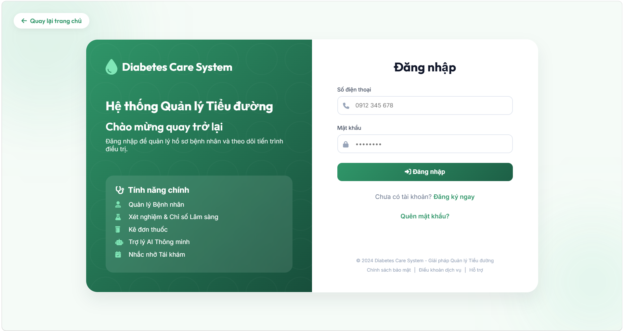
UI Elements Table
Field Name | Field Type | Description
Input Fields
Số điện thoại | Text Input (tel) | The phone number used for user login. Required.
Mật khẩu | Password Input | The password of the account. Required.
Form Actions
Đăng nhập | Button | Performs basic client-side validation and submits the login form (POST request to /login).
Links / Navigation
Quay lại trang chủ | Link | Redirects back to the system homepage (/).
Đăng ký ngay | Link | Redirects users to the Account Registration screen (/register).
Quên mật khẩu? | Link | Redirects users to the Forgot Password screen (/forgot-password).
Chính sách bảo mật | Link | Links to the system's privacy policy page.
Điều khoản dịch vụ | Link | Links to the system's terms of service page.
Hỗ trợ | Link | Links to technical support.
Feedback Messages
errorMsg | Alert / Text | Displays error message from client-side (if inputs are empty) or returned from the server (incorrect phone number/password, account status is Clocked (locked), or role not recognized).
successMsg | Alert / Text | Displays success message when redirected after a successful Password Reset (resetSuccess=true) or Registration (registerSuccess=true).

Database Access
Table | CRUD | Description
Account | R | Reads detailed account credentials (PasswordHash, Status, and RoleID) matching the phone number for authentication and lock status verification.
Role | R | Reads role details of the user to assign authorities (SimpleGrantedAuthority) and determine the target dashboard URL.
Patient | R | Reads patient profile details when the logged-in user is PAT to store the Patient entity in the Session for subsequent requests.
Profile | R | Reads doctor profile details when the logged-in user is DOC to store the Profile entity in the Session for subsequent requests.
QL Commands
1/ Authenticate account details via Phone Number (Authentication)
Queries account details from the Account table (mapped to User entity) based on the phone number provided by the user. The password verification is handled in Java using BCryptPasswordEncoder.matches(password, user.getPasswordHash()).
sql
SELECT UserID, PhoneNumber, PasswordHash, Status, RoleID
FROM Account
WHERE PhoneNumber = ?;
2/ Retrieve Patient profile information (if RoleID = 'PAT')
When the authenticated account has the patient role, the system queries the Patient table by User ID to retrieve personal profile details and store them in the session.
sql
SELECT UserID, Address, Bloodgroup, Dob, Email, FullName, Gender, Height, PhoneNumber, Weight, PermanentMedicalHistory, AllergyNotes
FROM Patient
WHERE UserID = ?;
3/ Retrieve Doctor profile information (if RoleID = 'DOC')
When the authenticated account has the doctor role, the system queries the Profile table by User ID to retrieve doctor profile details and store them in the session.
sql
SELECT UserID, Address, Dob, Email, FullName, Gender, PhoneNumber, Specialty
FROM Profile
WHERE UserID = ?;

1.2 Patient Registration Screen

a. Patient Registration Screen
This screen is the main registration interface for new Patients in the system. It allows patients to input their personal contact information, set a secure password, and fill in clinical demographics (date of birth, gender, blood group, height, weight) as well as medical background notes (allergies and underlying medical history).
The screen enforces thorough frontend validation in register.js before submitting. Upon hitting submit, the data is verified by the backend (checking phone number uniqueness and password complexity) and saved in the HTTP session. The system then issues a random 6-digit OTP code to the patient's phone number via SMS to verify their identity on the subsequent verification page.
Related Use Cases:
- UC-04 Account Registration (Đăng ký)

UI Design
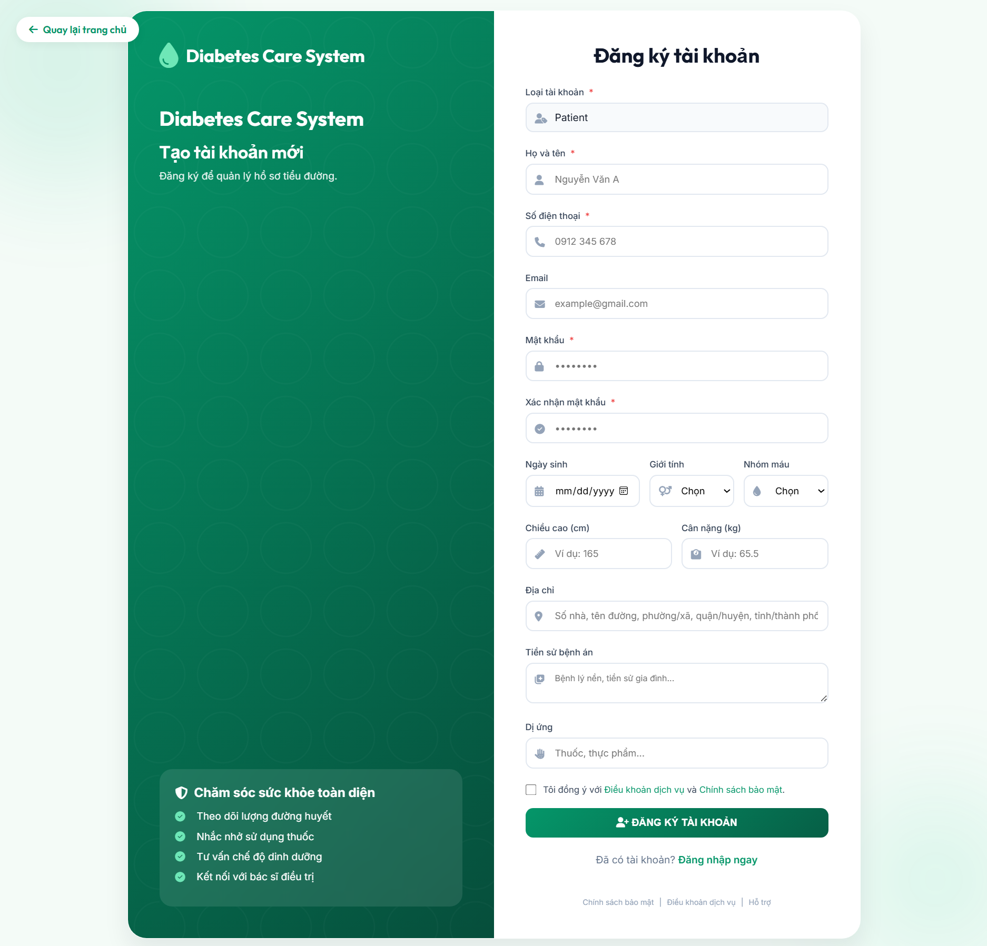

UI Elements Table
Field Name | Field Type | Description
Input Fields - Account Information
Loại tài khoản | Hidden Input | Hidden field holding the target registration Role ID (PAT for Patient). Hidden from direct modification but shows a text label "Patient" to the user. Required.
Họ và tên | Text Input | Full name of the patient. Required.
Số điện thoại | Text Input (tel) | The patient's phone number. Clamped to digits only. Must be between 10 and 11 digits long. Used as the login username. Required.
Email | Text Input (email) | Contact email address. Maximum length is 100 characters. Checked against standard email pattern. Optional.
Mật khẩu | Password Input | The user's chosen password. Triggers a real-time validator card. Must be at least 8 characters long, contain uppercase and lowercase letters, at least one digit, and one special character (!@#$). Required.
Xác nhận mật khẩu | Password Input | Verification field to ensure the password is typed correctly. Must match the "Mật khẩu" field. Required.
Input Fields - Patient Profile & Clinical Demographics
Ngày sinh | Date Picker | Date of birth. Automatically limited to prevent future dates (maximum = today) or unrealistically ancient dates (minimum = today minus 120 years). Optional.
Giới tính | Dropdown Select | Gender options: Nam (Male - 0) or Nữ (Female - 1). Optional.
Nhóm máu | Dropdown Select | Selection dropdown containing options: A+, A-, B+, B-, AB+, AB-, O+, O-. Optional.
Chiều cao (cm) | Text Input (number) | Patient's height in centimeters. Restrained to a valid range of (1 to 299 cm) to prevent errors. Optional.
Cân nặng (kg) | Text Input (number) | Patient's weight in kilograms (supports decimals, e.g., 65.5). Restrained to a valid range of (1 to 999 kg). Optional.
Địa chỉ | Text Input | Home address description. Max 200 characters. Optional.
Tiền sử bệnh án | Textarea | Notes about clinical background, chronic diseases, or family health inheritance. Optional.
Dị ứng | Text Input | Notes about known allergies (drugs, foods, chemicals, etc.). Optional.
Form Actions
Chấp nhận điều khoản | Checkbox | User consent check to accept Terms of Service and Privacy Policy. Must be checked. Required.
ĐĂNG KÝ TÀI KHOẢN | Button | Trigger button that checks client validation and submits the registration form (POST to /register).
Links / Navigation
Quay lại trang chủ | Link | Redirects back to the system homepage (/).
Đăng nhập ngay | Link | Redirects the user to the Login page (/login).
Feedback Messages
errorMsg | Alert / Text | Displays errors when inputs are blank or invalid (e.g. invalid phone format, weak password, mismatched confirm password, invalid height/weight, email format error) or server errors (phone already registered, role does not exist).
Database Access
Table | CRUD | Description
Account | R | Checks if the phone number already exists in the system to prevent multiple accounts using the same phone number.
Role | R | Verifies the target role exists in the database.
SQL Commands
1/ Check Phone Number Uniqueness (Step-1 validation)
Retrieves the total count of accounts matching the entered phone number.
sql
SELECT COUNT(*)
FROM Account
WHERE PhoneNumber = ?;

b. OTP Verification Screen
This screen acts as the middle verification step for Patient registration. Once step-1 registration succeeds, a temporary map regData is cached in the session, and a random 6-digit OTP is sent to the patient's phone number. The patient must input the 6-digit OTP code before their credentials and profile details are written to the database.
The screen coordinates individual input character slots with automatic cursor movements. It includes a 60-second countdown before enabling the "Gửi lại OTP" action. Upon clicking resend, a secure AJAX request generates a new OTP code, updates the session expiration timestamp to 5 minutes, and resets the countdown timer. Confirming the OTP submits a POST request to /register/verify-otp. If successful, the records are created, session tokens are cleared, and the user is redirected to the login screen with a success flag.
Related Use Cases:
- UC-04 Account Registration (Đăng ký - OTP Verification phase)

UI Design
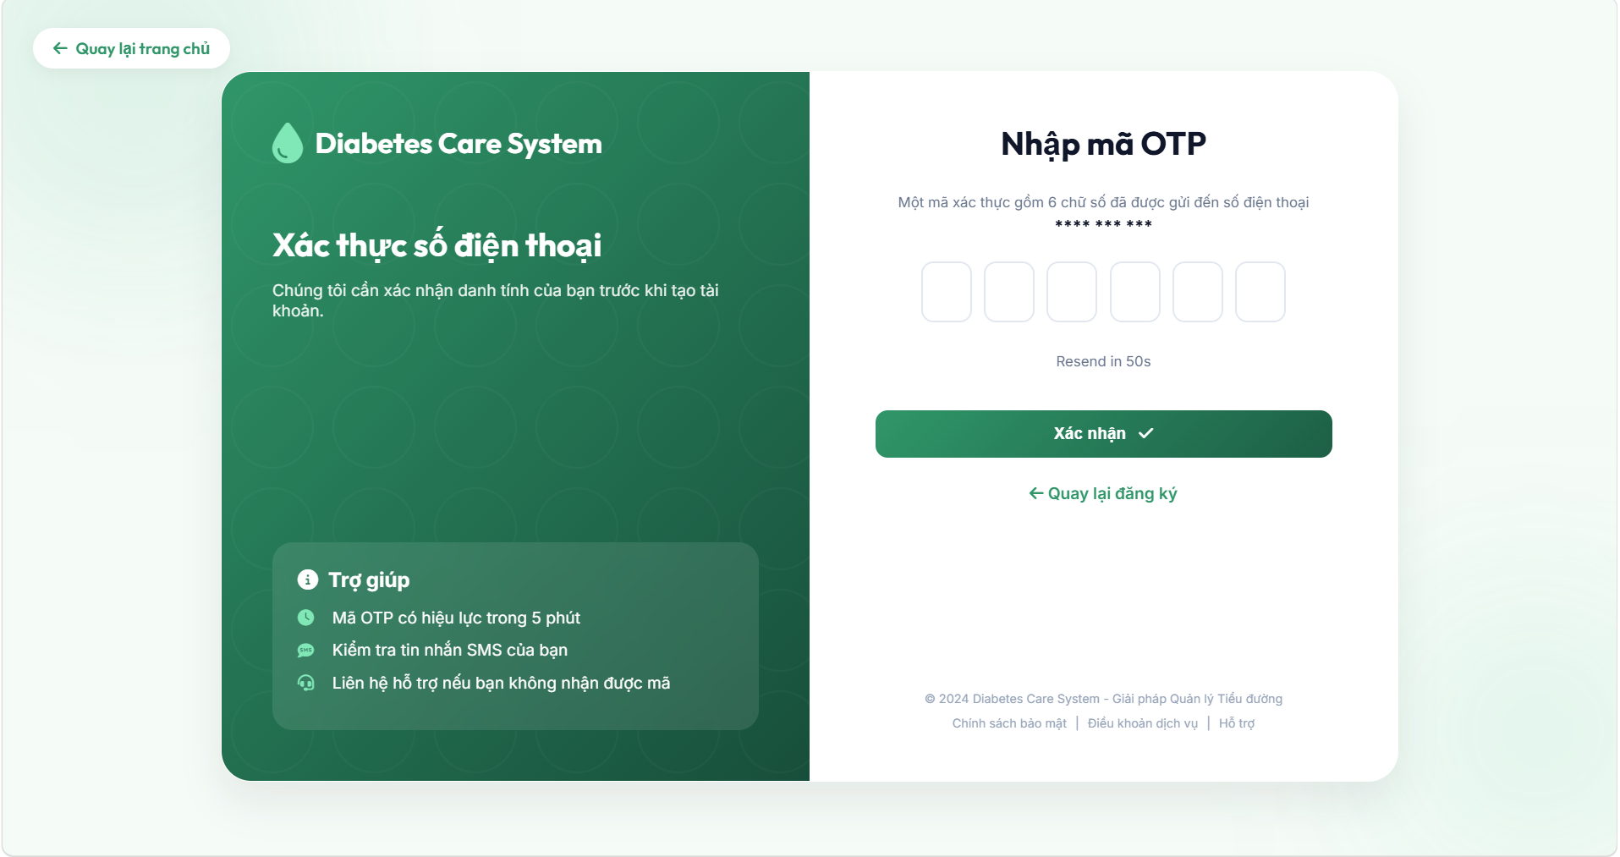

UI Elements Table
Field Name | Field Type | Description
Input Fields
Mã OTP (6 boxes) | 6 Text Inputs | Six separated text boxes, each accepting a single number (pattern [0-9]). Automated JavaScript switches focus to the next field on input, and returns focus to the previous box on Backspace press. Required.
otpValue | Hidden Input | Stores the joined 6-digit string compiled from the 6 individual boxes upon submission. Sent as parameter otp.
Form Actions
Xác nhận | Button | Submits the OTP code for server-side verification (POST request to /register/verify-otp).
Gửi lại OTP | Button / Link | Sends an AJAX POST request to /register/resend-otp to generate and re-send a new 6-digit OTP code. Disabled and hidden while countdown timer is active.
Links / Navigation
Quay lại đăng ký | Link | Redirects back to the main registration form (/register).
Feedback Messages
countdown | Text | Displays a countdown timer (Resend in Xs) showing remaining time before enabling the "Gửi lại OTP" button. Counts down from 60 seconds.
errorMsg | Alert / Text | Displays errors when OTP validation fails (expired OTP session, incorrect OTP code, or incomplete entry of 6 digits).
successMsg | Alert / Text | Shows temporary confirmation when a new OTP has been re-issued and sent to the phone number.

Database Access
Table | CRUD | Description
Account | C, R | Reads database to double-check phone number existence (avoiding race conditions) and creates a new account record with hashed password.
Role | R | Checks validity of the registration Role ID.
Patient | C | Inserts profile data (personal details, address, date of birth, blood group, height, weight, medical records) linked to the new account.
PatientRoutine | C | Instantiates default morning, afternoon, and evening routine tracking profiles for the registered Patient.

SQL Commands
1/ Validate phone number uniqueness again (race condition checks)
sql
SELECT COUNT(*)
FROM Account
WHERE PhoneNumber = ?;
2/ Retrieve role details matching Role ID
sql
SELECT RoleID, RoleName
FROM Role
WHERE RoleID = 'PAT';
3/ Create User Account
Inserts a new record in the Account table with the generated Patient ID (prefixed with P), phone number, BCrypt encrypted password hash, role, and active status.
sql
INSERT INTO Account (UserID, PhoneNumber, PasswordHash, Status, RoleID)
VALUES (?, ?, ?, 'Active', 'PAT');
4/ Create Patient Profile Details
Inserts personal profile demographics and clinical measurements linked to the user account in the Patient table.
sql
INSERT INTO Patient (UserID, FullName, PhoneNumber, Address, Dob, Gender, Height, Weight, Bloodgroup, PermanentMedicalHistory, AllergyNotes, Email)
VALUES (?, ?, ?, ?, ?, ?, ?, ?, ?, ?, ?, ?);
5/ Initialize Default Routine Trackers
Initializes a blank routine checklist table record linked to the patient ID.
sql
INSERT INTO PatientRoutine (UserID)
VALUES (?);

1.3 Forgot Password Screen

a. Request Password Reset Screen
This screen initiates the password recovery workflow. Users input their registered phone number. The backend (in ResetPasswordController.java) checks if the phone number is active in the system.
If registered, the system generates a random 6-digit OTP code, sets reset session keys (resetPhoneNumber, resetOtp, otpExpiredAt (valid for 5 minutes), otpVerified = false), dispatches the OTP via SMS using SmsService, and redirects the user to the OTP verification page. Client-side input cleaning in forgot_phone.js forces input sanitization (numbers only, length 10-11).
Related Use Cases:
- UC-05 Forgot Password (Quên mật khẩu)

UI Design
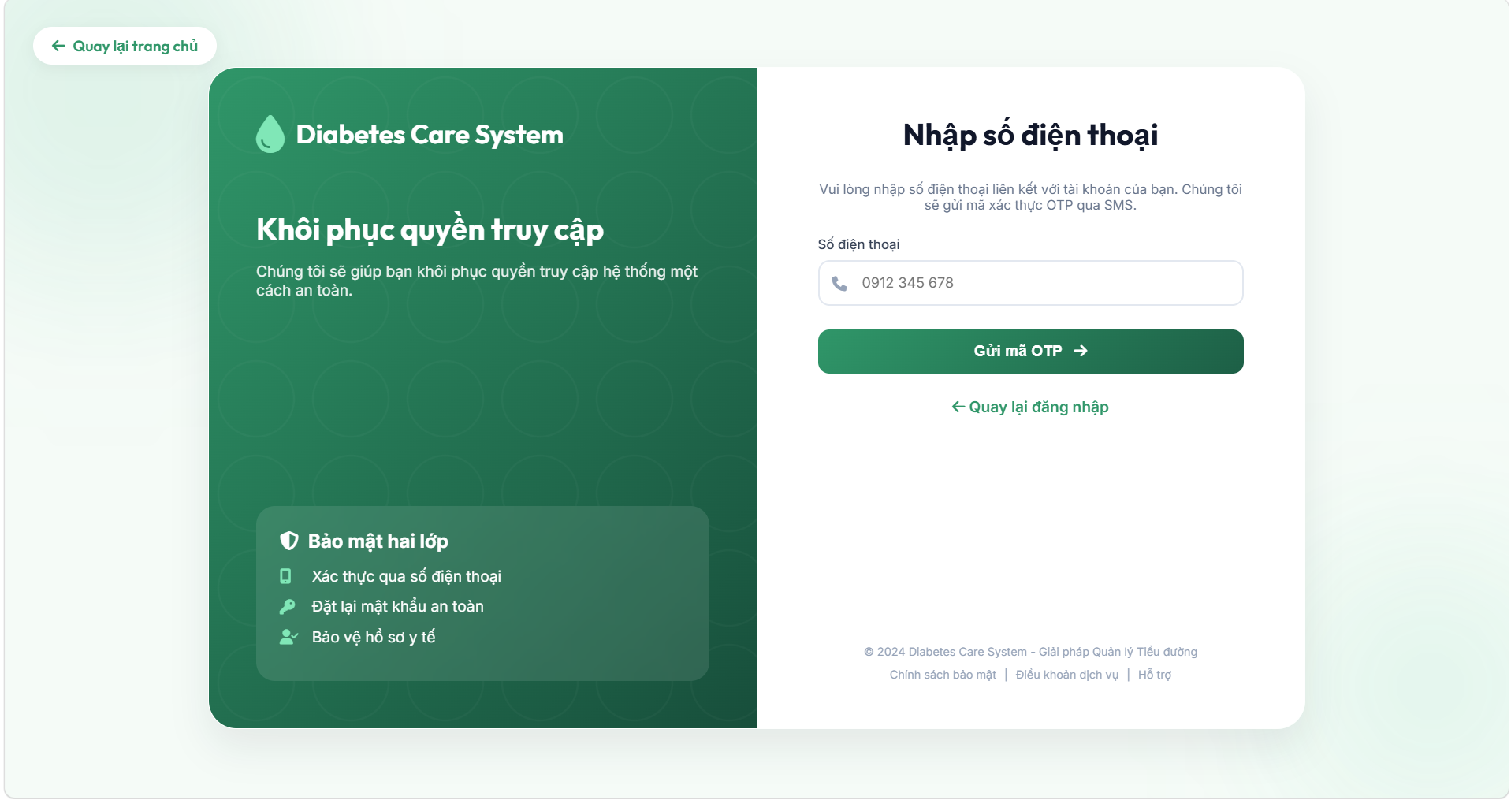
UI Elements Table
Field Name | Field Type | Description
Input Fields
Số điện thoại | Text Input (tel) | The registered phone number associated with the account. Checked to be between 10 and 11 digits. Required.
Form Actions
Gửi mã OTP | Button | Submits the form to trigger the OTP code generation and transmission (POST request to /forgot-password/send-otp).
Links / Navigation
Quay lại trang chủ | Link | Redirects back to the system homepage (/).
Quay lại đăng nhập | Link | Redirects back to the Login screen (/login).
Feedback Messages
errorMsg | Alert / Text | Displays error messages (e.g. invalid phone number format under client side, or "Số điện thoại không tồn tại trên hệ thống" from the server).

Database Access
Table | CRUD | Description
Account | R | Reads the table to find if a user matching the phone number exists.
SQL Commands
1/ Find user matching the Phone Number
sql
SELECT UserID, PhoneNumber, PasswordHash, Status, RoleID
FROM Account
WHERE PhoneNumber = ?;

b. Password Reset OTP Verification Screen
This screen prompts the user to enter the 6-digit verification code. The user interface (in forgot-otp.html and forgot_otp.js) separates the digits into six numeric boxes, allowing automated autofocus jump patterns and multi-digit clipboard paste support.
A 59-second countdown prevents premature OTP requests. Submitting the code sends a POST request to /forgot-password/verify-otp. The server checks the matching code and its 5-minute expiration timestamp. On success, the session key otpVerified is set to true, and the user is redirected to the password reset page.
Related Use Cases:
- UC-05 Forgot Password (Quên mật khẩu - OTP Verification phase)

UI Design
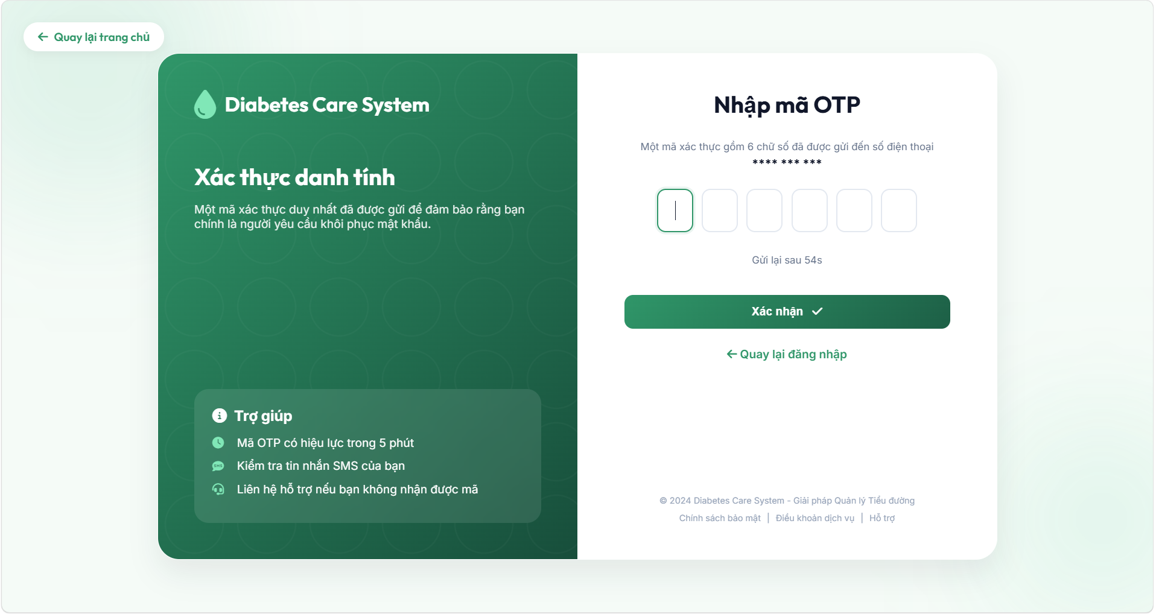

UI Elements Table
Field Name | Field Type | Description
Input Fields
Mã OTP (6 boxes) | 6 Text Inputs | Six individual inputs. Digit inputs trigger focus movements forward, while backspace triggers backward movements. Clipboard paste intercepts are configured to fill all six slots from a copied string. Required.
otpValue | Hidden Input | Stores the aggregated 6-digit OTP string. Sent as form parameter otp.
Form Actions
Xác nhận | Button | Submits the form to verify the OTP code (POST request to /forgot-password/verify-otp).
Gửi lại OTP | Button / Link | Resets the countdown timer (visually handles the resend countdown. Hidden and disabled during countdown).
Links / Navigation
Quay lại đăng nhập | Link | Redirects back to the Login screen (/login).
Feedback Messages
countdown | Text | Displays remaining time before enabling the OTP resend action (Gửi lại sau Xs). Counts down from 59s.
errorMsg | Alert / Text | Displays verification error messages (e.g. incorrect OTP code, expired code, or empty input notifications).

c. Set New Password Screen
This is the final phase of the password recovery flow. Access is protected by validating the session flag otpVerified = true. If invalid, the user is redirected to the start.
The screen accepts the new password and a confirmation copy. The frontend validation in reset_pass.js evaluates security details in real-time, requiring a password length >= 8, uppercase, lowercase, numbers, and symbols. Toggles are provided to reveal password values. Submitting the form posts to /forgot-password/reset, which encrypts the password with BCrypt, updates the database, invalidates the reset session, and redirects to /login?resetSuccess=true.
Related Use Cases:
- UC-05 Forgot Password (Quên mật khẩu - Password resetting phase)

UI Design
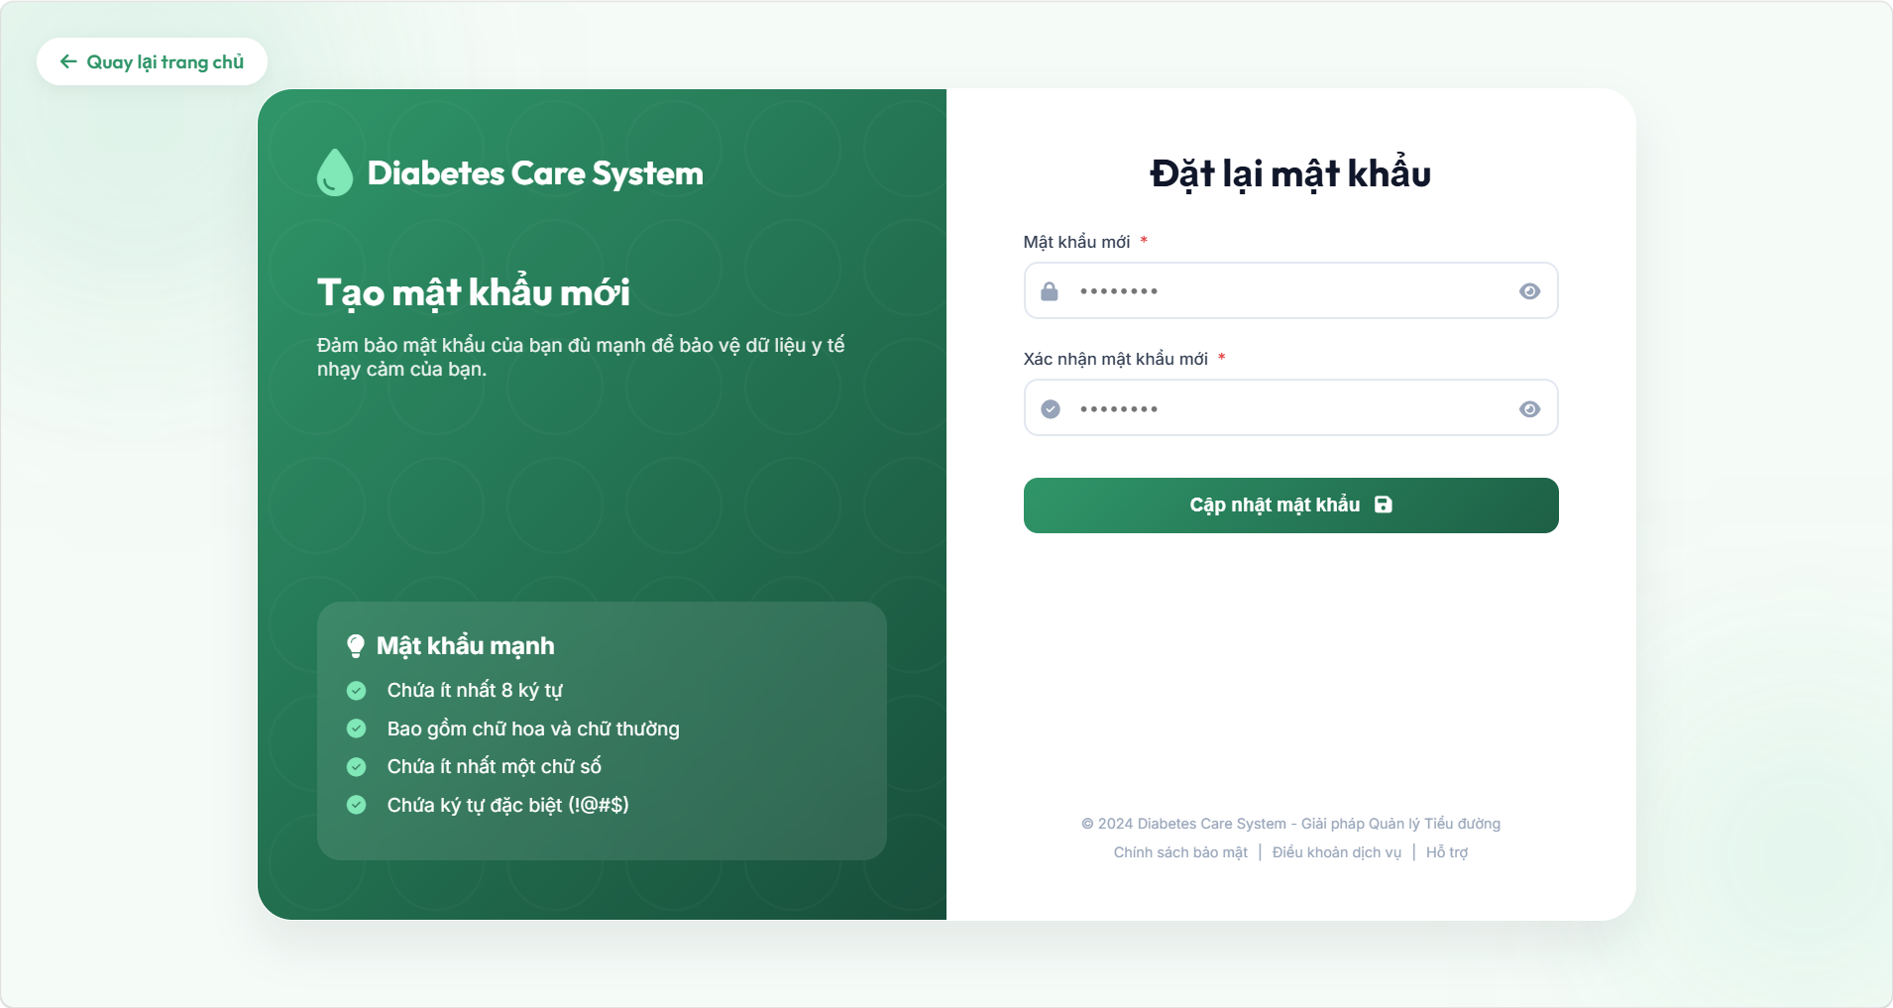

UI Elements Table
Field Name | Field Type | Description
Input Fields
Mật khẩu mới | Password Input | Input field for the new password. Triggers strength checks (length >= 8, upper/lowercase, numbers, special symbols !@#$). Built-in visibility switch toggle (eye icon). Required.
Xác nhận mật khẩu mới | Password Input | Input to recheck password accuracy. Must match the value in "Mật khẩu mới". Built-in visibility switch toggle (eye icon). Required.
Form Actions
Cập nhật mật khẩu | Button | Submits the form to encrypt the password and update the database (POST request to /forgot-password/reset).
Links / Navigation
Quay lại trang chủ | Link | Redirects to the homepage (/).
Feedback Messages
errorMsg | Alert / Text | Displays password constraint violations (e.g. length, character requirements), mismatched password confirmation, or missing session indicators.

Database Access
Table | CRUD | Description
Account | U, R | Reads database to find the user by their phone number (saved in the session), and updates the password hash values in the column.

SQL Commands
1/ Find user matching the Phone Number
sql
SELECT UserID, PhoneNumber, PasswordHash, Status, RoleID
FROM Account
WHERE PhoneNumber = ?;
2/ Update Account Password Hash
Updates the user account password with the BCrypt-encrypted hash value.
sql
UPDATE Account
SET PasswordHash = ?
WHERE UserID = ?;

2. Administration

2.1 Admin Dashboard Screen
This screen acts as the main operations monitor for System Administrators (Role AD). It exposes a graphical overview of key metrics such as total patients, doctors, AI conversations, and reminders. The dashboard features a system activity chart (built dynamically with Chart.js using backend calculations in DashboardServiceImpl.java) plotting AI conversations and reminders sent over the last 7 days. Quick insight cards provide real-time information on high-risk patients and abnormal alerts.

UI Design
(The dashboard is structured into a clean green-themed panel. It hosts a top layout header for screen context and profile information, a grid of summary metric cards, a system activity area/line chart alongside quick metrics, and a refresh data control button)
[NOTE: INSERT ADMIN DASHBOARD SCREEN UI DESIGN IMAGE HERE]
UI Elements Table
Field Name | Field Type | Description
Header Navigation
Tổng quan | Text (Header title) | Section title rendered dynamically in the layout header.
Thông báo (Bell) | Button | System notifications indicator.
Trợ giúp (Question Circle) | Button | Technical help link.
Quản trị viên | Profile Indicator | Displays avatar icon and active profile text for the Administrator account.
Statistics Summary Cards
Tổng số bệnh nhân | Statistic Card | Displays total patient counts (dynamic value from backend stats.totalPatients).
Tổng số bác sĩ | Statistic Card | Displays total doctor counts (dynamic value from backend stats.totalDoctors).
Cuộc trò chuyện với AI | Statistic Card | Displays total count of conversational threads with the AI chatbot (dynamic value from backend stats.totalConversations).
Tổng số nhắc nhở | Statistic Card | Displays total scheduled reminder counts (dynamic value from backend stats.totalReminders).
Charts and Information Panel
Hoạt động hệ thống (7 ngày qua) | Chart (Canvas) | Visualized line and area chart mapping daily counts of AI conversations (aiData) and sent reminders (reminderData) over the past 7 days.
Bệnh nhân nguy cơ cao | Text Info block | Counts patients requiring immediate clinical attention (dynamic value stats.highRiskPatients).
Cảnh báo bất thường | Text Info block | Counts abnormal glucose alerts logged today (dynamic value stats.abnormalGlucoseAlerts).
Trạng thái hệ thống | Text Info block | Constant indicator reflecting general status: "Hoạt động" (Active).
Form Actions
Làm mới dữ liệu | Button | Triggers page reload to pull the latest dashboard counters.

Database Access
Table | CRUD | Description
Patient | R | Reads the list of all registered patients to count total patient volume.
Profile | R | Reads the list of all doctor profiles (accounts matching Role ID 'DOC') to count total doctor accounts.
AI_Conversation | R | Counts all AI conversation rows and filters conversations created in the last 7 days.
Reminder | R | Counts all medication/examination reminder records and filters reminders scheduled in the last 7 days.

SQL Commands
1/ Count total patients
sql
SELECT COUNT(*)
FROM Patient;
2/ Count total doctors
sql
SELECT COUNT(*)
FROM Profile p
INNER JOIN Account a ON p.UserID = a.UserID
WHERE a.RoleID = 'DOC';
3/ Count total AI conversations
sql
SELECT COUNT(*)
FROM AI_Conversation;
4/ Count total reminders
sql
SELECT COUNT(*)
FROM Reminder;
5/ Retrieve AI conversations created in the last 7 days
sql
SELECT *
FROM AI_Conversation
WHERE CreatedAt BETWEEN ? AND ?;
6/ Retrieve reminders scheduled in the last 7 days
sql
SELECT *
FROM Reminder
WHERE ScheduledTime BETWEEN ? AND ?;

2.2 User Management Screen

a. User Management Screen
This is the main screen of the User Management module. It allows the System Administrator to view all user accounts (Doctors and Patients) within the Diabetes Healthcare Monitoring System. The administrator can filter users by their roles, search for specific users by name or phone number, and toggle the account status (Lock/Unlock) to restrict unauthorized access. Patient accounts can only be viewed and locked/unlocked, but cannot be manually created or edited by the administrator.

Related Use Cases:
- UC-02 View User Information
- UC-03 Lock/Unlock User Accounts
- UI Design

UI Design
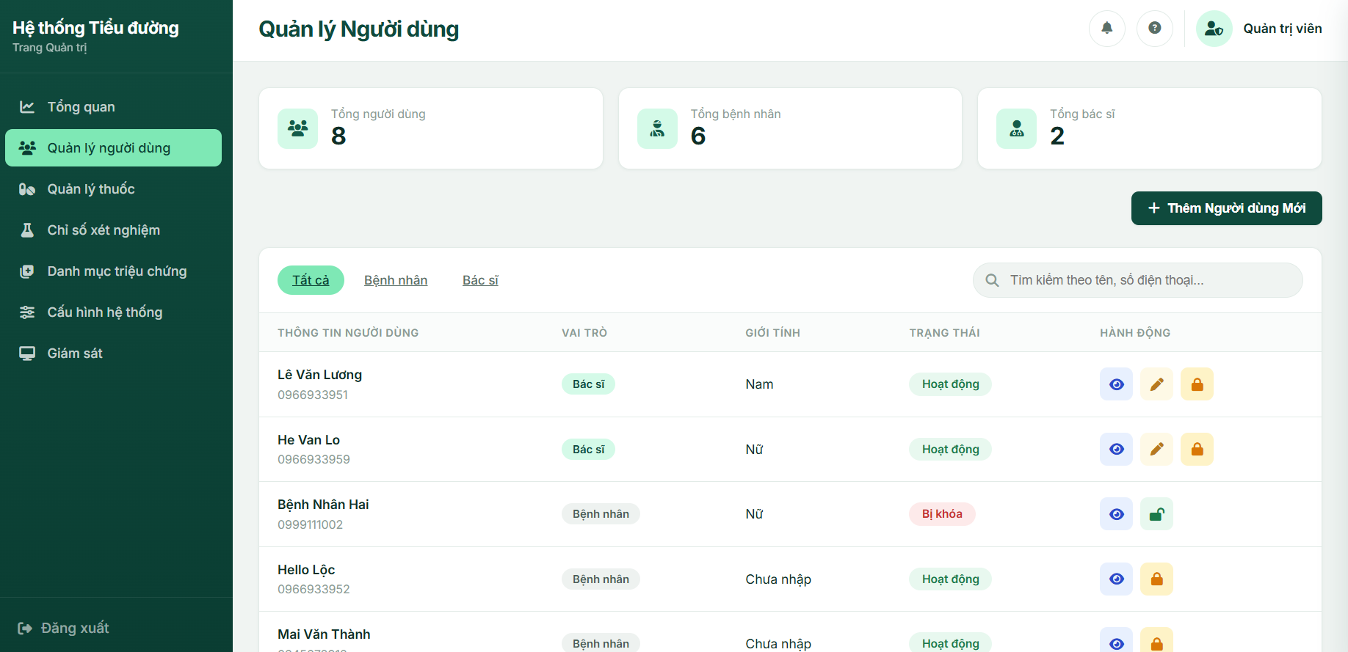

Field Name | Field Type | Description
Search & Filter Fields
Total Users | Statistic Card | Displays the total number of registered users (Doctors + Patients).
Total Doctors | Statistic Card | Displays the total number of doctor accounts.
Total Patients | Statistic Card | Displays the total number of patient accounts.
Role Filter | Combo Box (Single-Choice) | Filter by All / Doctor / Patient. Default: All. Reloads the list on change.
Search keyword | Textbox, String | Search by Full Name or Phone Number. Default: blank.
Add New User | Button | Opens the Add Doctor modal.
Data Table
Full Name | Text | Displays the full name of the user.
Phone Number | Text | Displays the account's registered phone number.
Role | Badge | Doctor / Patient, color-coded.
Gender | Badge | Male/Female
Status | Badge | Active (green) / Locked (red).
Data Actions
Edit | Icon | Opens the Edit Doctor modal pre-filled with the current data (Only visible/applicable for Doctor accounts).
Lock / Unlock | Icon | Toggles Status between Active and Locked after a confirmation modal; icon and tooltip switch between lock/unlock depending on the current status.

Database Access
Table | CRUD | Description
Account | R, U | Read account details. Update account status (Lock/Unlock).
Profile | R | Read doctor profile info for the data table.
Patient | R | Read patient specific profile information for the data table.
SQL Commands
1/ Retrieve paginated and filtered user list
SELECT a.UserID, a.Phone, a.Status, a.RoleID, p.FullName, pat.Gender AS PatientGender
FROM Account a
LEFT JOIN Profile p ON a.UserID = p.UserID
LEFT JOIN Patient pat ON a.UserID = pat.UserID
WHERE (a.RoleID = ? OR ? = 'all')
AND (a.Phone LIKE '%' + ? + '%' OR p.FullName LIKE '%' + ? + '%')
ORDER BY a.UserID
OFFSET ? ROWS FETCH NEXT ? ROWS ONLY;
2/ Toggle Lock/Unlock Account Status
sql
UPDATE Account
SET Status = CASE WHEN Status = 'Active' THEN 'Locked' ELSE 'Active' END
WHERE UserID = ?;

b. Add Doctor Screen (Modal)
This modal screen is triggered when the Administrator clicks the "Add Doctor" button. It allows the admin to register a new Doctor account into the system. The system strictly validates the uniqueness of the phone number and enforces a minimum password length of 6 characters.

Related Use Cases
- UC-01 Manage Doctor Accounts (Create)

UI Design
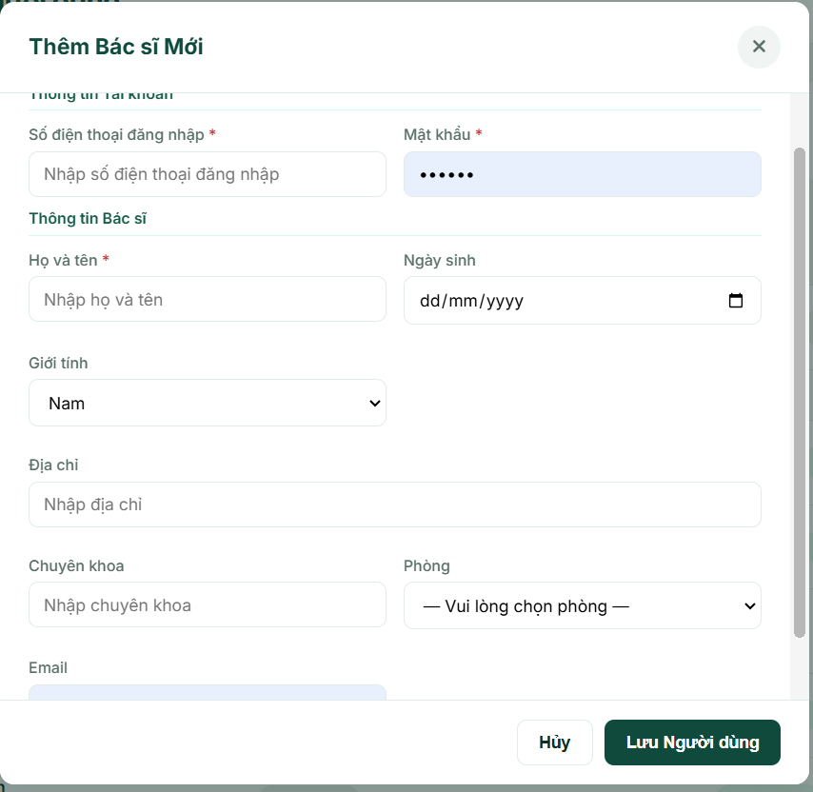
Field Name | Field Type | Description
Input Fields
Phone Number | Text Input | The phone number used for the doctor's login. Must be unique.
Password | Password Input | Required for new accounts (Minimum 6 characters).
Full Name | Text Input | The full name of the doctor.
Email | Text Input | The contact email address of the doctor.
Date of Birth | Date Picker | The date of birth of the doctor.
Gender | Radio Button | The gender of the doctor (Male/Female).
Address | Text Input | The residential or contact address of the doctor.
Specialty | Text Input | The medical specialty of the doctor.
Assigned Room | Dropdown | Assigns the doctor to a specific clinic room.
Form Actions
Cancel | Button | Cancel the add doctor screen modal.
Save | Button | Submits the form to create the doctor account.

Database Access
Table | CRUD | Description
Account | C, R | Check if the phone number exists. Create a new doctor account.
Profile | C | Create the doctor's profile details.
Room | R | Retrieve the list of active clinic rooms for the dropdown.
SQL Commands
1/ Check phone number uniqueness (Validation)
sql
SELECT COUNT(*)
FROM Account
WHERE Phone = ?;
2/ Create a new Doctor Account
sql
INSERT INTO Account (UserID, Phone, Password, RoleID, Status)
VALUES (?, ?, ?, 'DOC', 'Active');
INSERT INTO Profile (UserID, FullName, Address, DOB, Gender, Specialty, RoomID, Email)
VALUES (?, ?, ?, ?, ?, ?, ?, ?);

c. Edit Doctor Screen (Modal)
This modal screen is triggered when the Administrator clicks the "Edit" button on a specific Doctor record. It pre-fills the form with the doctor's existing information and allows the admin to update their contact details, personal info, or assigned room. For security reasons, passwords cannot be updated here.

Related Use Cases
- UC-01 Manage Doctor Accounts (Update)

UI Design
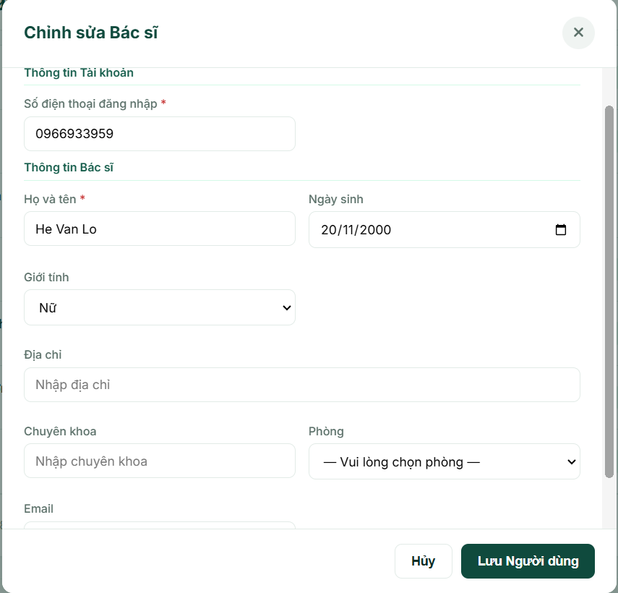
Field Name | Field Type | Description
Input Fields
Phone Number | Text Input | The phone number used for the doctor's login. Must be unique.
Password | Password Input | (Hidden) Passwords cannot be updated on this screen.
Full Name | Text Input | The full name of the doctor.
Email | Text Input | The contact email address of the doctor.
Date of Birth | Date Picker | The date of birth of the doctor.
Gender | Radio Button | The gender of the doctor (Male/Female).
Address | Text Input | The residential or contact address of the doctor.
Specialty | Text Input | The medical specialty of the doctor.
Assigned Room | Dropdown | Assigns the doctor to a specific clinic room.
Form Actions
Cancel | Button | Cancel the edit form modal.
Save Changes | Button | Submits the form to update the doctor's profile.

Database Access
Table | CRUD | Description
Account | U, R | Check if the new phone number belongs to another user. Update the account's phone number.
Profile | U | Update the doctor's profile details.
Room | R | Retrieve the list of active clinic rooms for the dropdown.
SQL Commands
1/ Check phone number uniqueness (Validation excluding current user)
sql
SELECT COUNT(*)
FROM Account
WHERE Phone = ? AND UserID != ?;
2/ Update an existing Doctor Account
sql
UPDATE Account
SET Phone = ?
WHERE UserID = ?;
UPDATE Profile
SET FullName = ?, Address = ?, DOB = ?, Gender = ?, Specialty = ?, RoomID = ?, Email = ?
WHERE UserID = ?;

d. View User Information Screen (Modal)
This modal screen is triggered when the Administrator clicks the "View" icon on any user record in the data table. It opens a read-only modal displaying the complete profile of the selected user. The system intelligently adapts the displayed fields based on the user's role:

For Doctors: Displays professional information such as Specialty and Assigned Room.
For Patients: Displays critical medical demographics such as Height, Weight, Blood Group, Permanent Medical History, Allergy Notes, and Emergency Supervisor contacts.

Related Use Cases
- UC-02 View User Information

UI Design
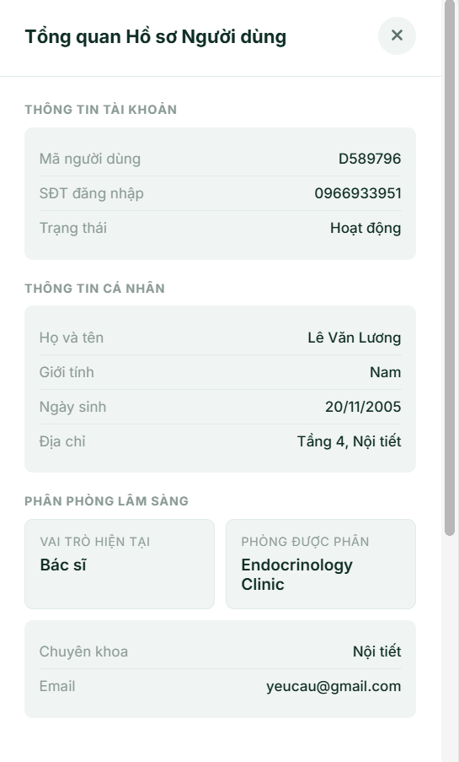
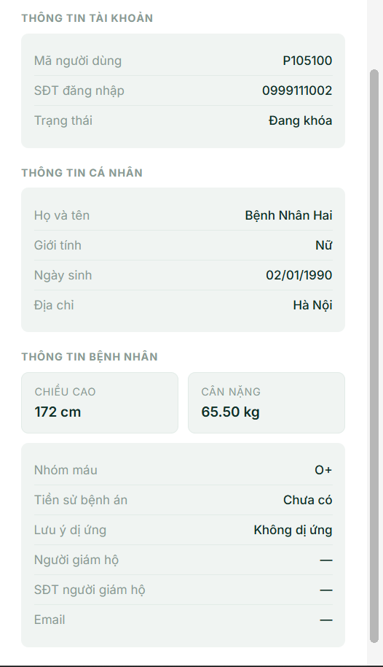
Field Name | Field Type | Description
Common Profile Fields (Both Roles)
UserID | Text (Read-only) | The User ID of the user.
Full Name | Text (Read-only) | The full name of the user.
Phone Number | Text (Read-only) | The registered account phone number.
Email | Text (Read-only) | The contact email address.
Date of Birth | Text (Read-only) | The date of birth.
Gender | Text (Read-only) | Male / Female.
Address | Text (Read-only) | The residential or contact address.
Role & Status | Badge | The role and current account status.
Doctor-Specific Fields (Hidden for Patients)
Specialty | Text (Read-only) | The medical specialty of the doctor.
Assigned Room | Text (Read-only) | The clinic room assigned to the doctor.
Patient-Specific Fields (Hidden for Doctors)
Physical Metrics | Text (Read-only) | Height (cm) and Weight (kg).
Blood Group | Text (Read-only) | The patient's blood type (e.g., O+, A-).
Medical History | Text (Read-only) | Permanent medical history or chronic diseases.
Allergies | Text (Read-only) | Known drug or food allergies.
Supervisor Name | Text (Read-only) | Name of the guardian or emergency contact.
Supervisor Phone | Text (Read-only) | Phone number of the guardian.
Form Actions
Close | Button | Closes the modal and returns to the user list.

Database Access
Table | CRUD | Description
Account | R | Read basic account status and phone number.
Profile | R | Read general profile details (Name, DOB, Gender, Email, Address, Specialty, Room).
Patient | R | Read patient-specific clinical and supervisor details.
SQL Commands
1/ Retrieve comprehensive user details based on ID:
sql
SELECT
a.Phone, a.Status, a.RoleID,
p.FullName, p.Address, p.DOB, p.Gender, p.Email, p.Specialty,
r.RoomName,
pat.Height, pat.Weight, pat.BloodGroup, pat.PermanentMedicalHistory,
pat.AllergyNotes, pat.SupervisorName, pat.SupervisorPhone
FROM Account a
LEFT JOIN Profile p ON a.UserID = p.UserID
LEFT JOIN Room r ON p.RoomID = r.RoomID
LEFT JOIN Patient pat ON a.UserID = pat.UserID
WHERE a.UserID = ?;

2.3 System Log Screen

2.4 View Rating
This screen allows System Administrators to view overall rating statistics, star distribution percentages, and detailed chronological patient feedback and comments for all doctors. System Administrators can filter ratings by doctor or by star count (1 to 5 stars), and paginate through the feedback log. Related use case:
· UC-39: View Rating

UI Design

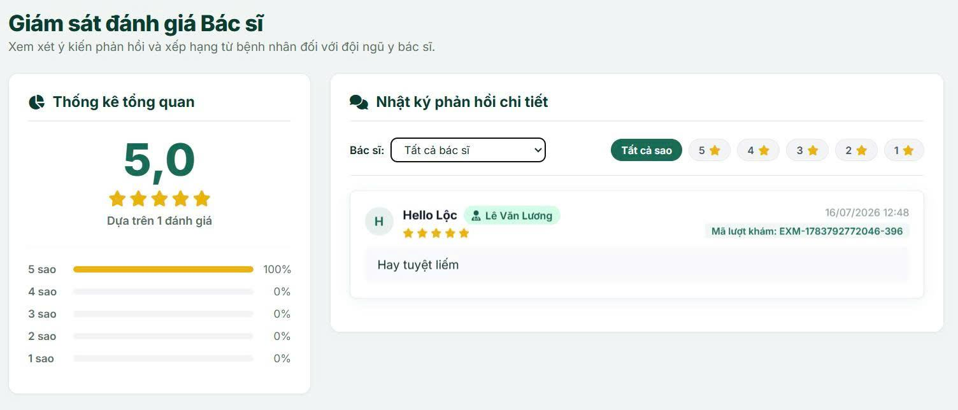

Field Name | Field Type | Description
Search & Filter Fields

Bác sĩ | Dropdown Select | Allows Admin to filter ratings by selecting a specific doctor or selecting 'Tất cả bác sĩ' (All Doctors). Triggers reload on change.
Lọc theo sao | Filter Tags (Links) | Filters ratings by selecting All stars, or 5 stars down to 1 star.
Statistics Summary

Điểm trung bình | Statistic Card | Displays the overall average rating score formatted to 1 decimal place (e.g., 4.5) alongside the star ratings representation.
Số lượng đánh giá | Statistic Card | Displays the total count of ratings matching the selected doctor filter.
Phân bố tỷ lệ sao | Percentage Bars (5) | Progress bars showing the percentage distribution of ratings from 5-star to 1-star (star5Pct down to star1Pct).
Feedback Feed Columns

Ảnh đại diện bệnh nhân | Avatar Icon | Displays patient's avatar (or first letter of the name) in a circular badge.
Thông tin bệnh nhân | Text | Displays the patient's full name (or 'Bệnh nhân ẩn danh').
Tên bác sĩ | Badge | Displays the doctor's full name alongside a doctor icon.
Số sao đánh giá | Stars Row | Displays the rating score represented by filled (yellow) and empty stars.
Ngày giờ | Text | Displays the creation timestamp of the rating formatted as 'dd/MM/yyyy HH:mm'.
Mã lượt khám | Badge | Displays the corresponding clinical examination ID.
Nội dung bình luận | Text Block | Displays the detailed text feedback from the patient, defaulting to 'Không có bình luận chi tiết.' if blank.
Pagination

Trước / Sau | Pagination Item (Link/Button) | Navigates to the previous or next page of reviews.
Số trang | Pagination Item (Link list) | Direct page navigation links.

Database Access

Table | CRUD | Description
DoctorRating | R | Reads rating records to calculate statistics (average, total count, star percentages) and retrieves paginated, filtered review logs.
Profile | R | Reads profile details of patients (to display name) and doctors (to populate the doctor selection filter dropdown and display doctor name).
Account | R | Reads account roles to filter profiles that belong to the Doctor role (RoleID = 'DOC').

SQL Commands
1/ Retrieve all doctors for the filter dropdown list
SELECT p.UserID, p.FullName, p.Specialty
FROM Profile p
JOIN Account a ON p.UserID = a.UserID
WHERE a.RoleID = 'DOC'
ORDER BY p.FullName ASC;
2/ Retrieve filtered and paginated list of doctor ratings (sorted by newest first)
SELECT r.RatingID, r.ClinicalExamID, r.PatientID, r.DoctorID, r.RatingValue, r.Comment, r.CreatedAt,
pat.FullName AS PatientName, doc.FullName AS DoctorName
FROM DoctorRating r
LEFT JOIN Profile pat ON r.PatientID = pat.UserID
LEFT JOIN Profile doc ON r.DoctorID = doc.UserID
WHERE (@doctorId IS NULL OR r.DoctorID = @doctorId)
AND (@star IS NULL OR r.RatingValue = @star)
ORDER BY r.CreatedAt DESC
OFFSET @offset ROWS FETCH NEXT @rows ROWS ONLY;
3/ Retrieve count of filtered ratings (for pagination)
SELECT COUNT(*)
FROM DoctorRating
WHERE (@doctorId IS NULL OR DoctorID = @doctorId)
AND (@star IS NULL OR RatingValue = @star);
4/ Compute ratings statistics (average rating score and total count)
SELECT AVG(CAST(RatingValue AS FLOAT)) AS AverageRating, COUNT(*) AS TotalRatings
FROM DoctorRating
WHERE (@doctorId IS NULL OR DoctorID = @doctorId);
5/ Compute star distribution counts
SELECT RatingValue, COUNT(*) AS StarCount
FROM DoctorRating
WHERE (@doctorId IS NULL OR DoctorID = @doctorId)
GROUP BY RatingValue;

3. Master Data Management

3.1 Medication Catalog Management Screen

a. Medicine List
This screen allows Admin to view, filter, search, and manage the master list of medications used throughout the system. Related use case:
· UC-AD-04: Manage Medication Catalog

UI Design
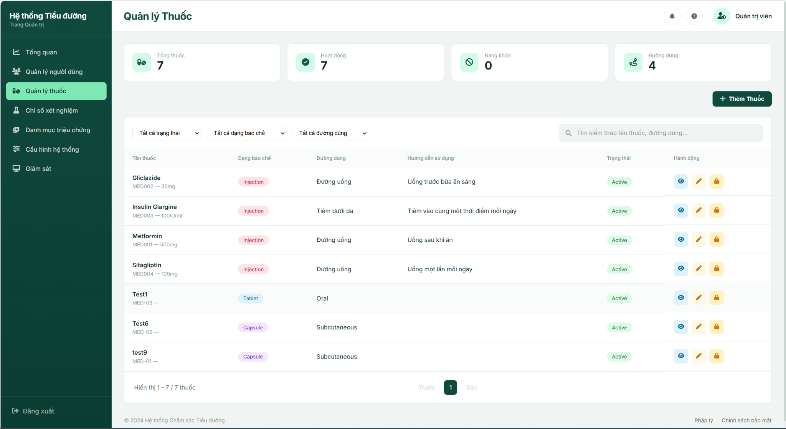
Field Name | Field Type | Description
Search & Filter Fields
Status | Combo Box (Single-Choice) | Filter by All Status / Active / Clocked. Default: All Status. Reloads the list on change.
Dosage Form | Combo Box (Single-Choice) | Filter by All Forms / Tablet / Capsule / Injection. Default: All Forms.
Administration Route | Combo Box (Single-Choice) | Filter by All Routes / Oral / Subcutaneous / Intravenous / Intramuscular. Default: All Routes.
Search keyword | Text Box, String | Search by medicine name or administration route. Default: blank.
Add Medicine | Button | Opens the Add Medicine modal.
Data Table
Medicine Name | Text | Medication name, together with Medication ID and Concentration shown beneath it.
Dosage Form | Badge | Tablet / Capsule / Injection, color-coded.
Route | Text | Administration route, or "—" if not set.
Usage Instruction | Text | Truncated to 80 characters; full text shown as a tooltip on hover.
Status | Badge | Active (green) / Clocked (grey).
Data Actions
View | Icon | Opens the medication detail in read-only mode.
Edit | Icon | Opens the Edit Medicine modal pre-filled with the current data.
Clock / Restore | Icon | Toggles Status between Active and Clocked after a confirmation modal; icon and tooltip switch between lock/unlock depending on the current status.

Database Access
Table | CRUD | Description
Medication | R | Query the filtered, sorted, paginated list of medications and compute catalog statistics (total, active, clocked, oral/injectable counts, distinct routes).
SQL Commands:
1/ Query the filtered, paginated list of medications
SELECT MedicationID, MedicationName, Form, Concentration, AdministrationRoute, UsageInstruction, Status
FROM Medication
WHERE (@status IS NULL OR Status = @status) AND (@form IS NULL OR Form = @form)
AND (@route IS NULL OR AdministrationRoute = @route)
AND (MedicationName LIKE '%' + @keyword + '%' OR AdministrationRoute LIKE '%' + @keyword + '%')
ORDER BY MedicationName ASC

2/ Compute catalog statistics
SELECT COUNT(*) FROM Medication;
SELECT COUNT(*) FROM Medication WHERE Status = 'Active';
SELECT COUNT(*) FROM Medication WHERE Status = 'Clocked';
SELECT DISTINCT AdministrationRoute FROM Medication WHERE AdministrationRoute IS NOT NULL AND AdministrationRoute <> '';

b. Add / Edit Medicine
This modal lets Admin create a new medication or update an existing one. Related use case:
· UC-AD-04: Manage Medication Catalog

UI Design
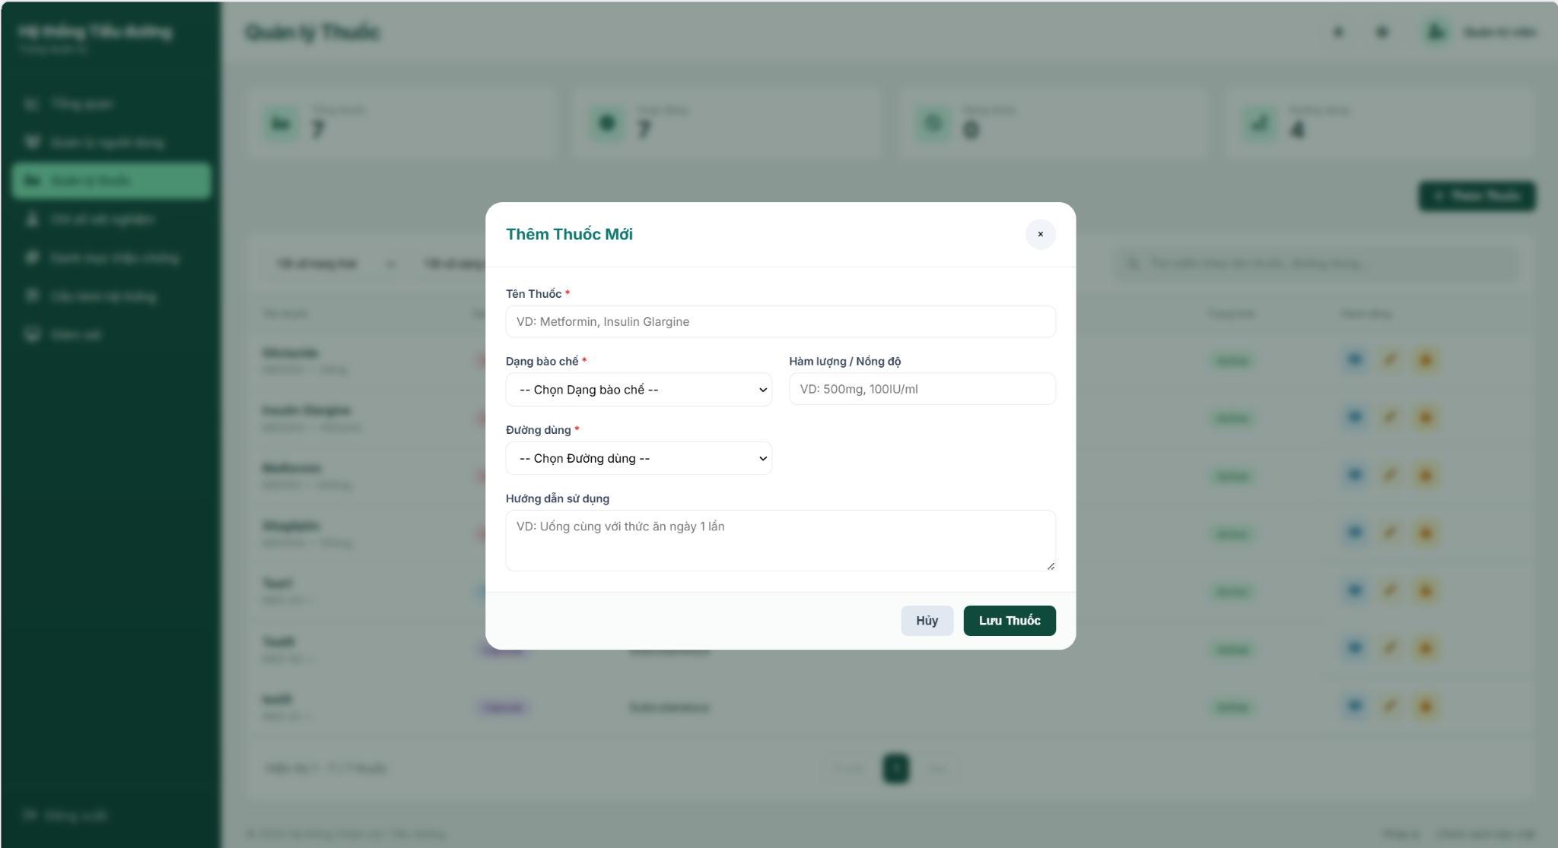

Field Name | Field Type | Description
Medicine Name* | Text Box | Name of the medication, e.g. "Metformin". Must be unique (case-insensitive).
Dosage Form* | Combo Box (Single-Choice) | Tablet / Capsule / Injection.
Concentration / Strength | Text Box | Optional strength label, e.g. "500mg", "100IU/ml".
Administration Route* | Combo Box (Single-Choice) | Oral / Subcutaneous / Intravenous / Intramuscular.
Usage Instruction | Text Area | Free-text dosing/usage guidance, e.g. "Take with meals once daily".
Save Medicine | Button | Validates and submits the form (POST /admin/medicines/add or /admin/medicines/edit/{id}).
Cancel | Button | Closes the modal without saving any change.

Database Access
Table | CRUD | Description
Medication | C, U | Insert a new medication row (Add) or update an existing one (Edit), after checking name uniqueness.
SQL Commands:
1/ Check medicine name uniqueness
SELECT COUNT(*) FROM Medication WHERE LOWER(MedicationName) = LOWER(@medicationName) [AND MedicationID <> @excludedId]

2/ Insert a new medication
INSERT INTO Medication (MedicationID, MedicationName, Form, Concentration, AdministrationRoute, UsageInstruction, Status)
VALUES (@newId, @medicationName, @form, @concentration, @administrationRoute, @usageInstruction, 'Active')

3/ Update an existing medication
UPDATE Medication SET MedicationName = @medicationName, Form = @form, Concentration = @concentration,
AdministrationRoute = @administrationRoute, UsageInstruction = @usageInstruction
WHERE MedicationID = @id

4/ Update status only (Clock / Restore)
UPDATE Medication SET Status = @status WHERE MedicationID = @id

3.2 Symptoms Catalog Management Screen

a. Symptoms Catalog Management Screen
This screen is the main interface of the Symptoms Catalog Management module. It allows System Administrators to view all symptom profiles in the database. The administrator can filter symptoms by their status (All, Active, Clocked), search for specific symptoms by name or ID, and perform actions (edit, toggle status between active/locked, or permanently delete a symptom).
Related Use Cases:
- UC-12 Manage Symptoms Catalog

UI Design
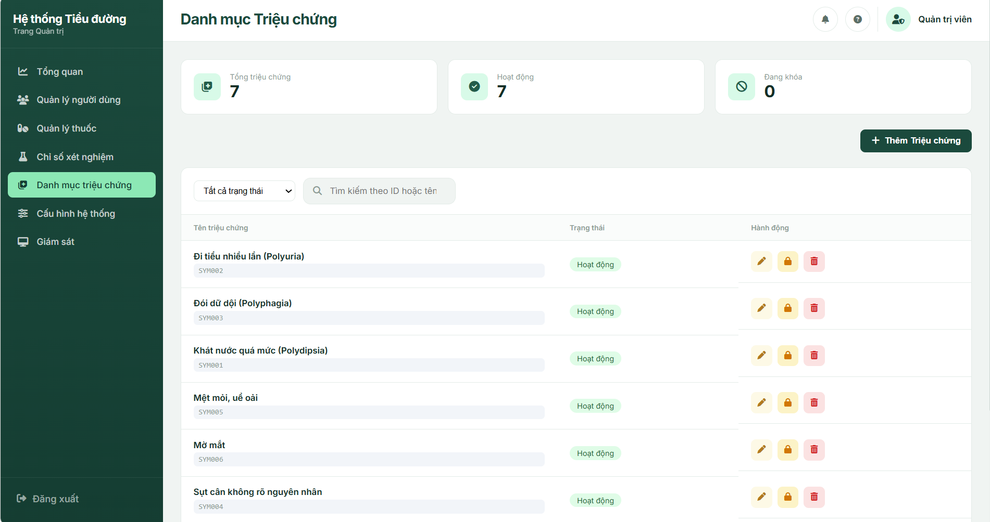
UI Elements Table
Field Name | Field Type | Description
Search & Filter Fields
Lọc trạng thái | Dropdown Select | Filters symptoms by All, Active (Hoạt động), or Locked (Tạm khóa). Default: All. Triggers reload on change.
Tìm kiếm | Text Input | Search input for symptom ID or name. Submits on Enter or search icon click. Clears to reset.
Statistics Summary
Tổng triệu chứng | Statistic Card | Displays the total number of symptom profiles in the system (dynamic value totalSymptoms).
Hoạt động | Statistic Card | Displays total number of active symptoms (dynamic value activeSymptoms).
Đang khóa | Statistic Card | Displays total number of locked symptoms (dynamic value clockedSymptoms).
Data Table Columns
Tên triệu chứng | Text | Displays both the name and ID of the symptom.
Trạng thái | Badge | Status badge indicating: "Hoạt động" (Green badge) / "Tạm khóa" (Red badge).
Action Elements
Thêm Triệu chứng | Button | Opens the Add Symptom Modal popup.
Chỉnh sửa | Button (Icon) | Opens the Edit Symptom Modal prefilled with the current record's info.
Khóa / Khôi phục | Button (Icon) | Triggers the action confirmation dialog to toggle active or clocked status.
Xóa triệu chứng | Button (Icon) | Triggers the warning confirmation modal to permanently delete the symptom.
Pagination
Trước / Sau | Link / Button | Navigates to the previous or next page.
Số trang | Link list | Dynamic page number navigation links.

Database Access
Table | CRUD | Description
Symptoms_Catalog | R | Reads the list of symptoms, applying search keyword, status filter, and pagination options.
SQL Commands
1/ Retrieve paginated and filtered symptoms
sql
SELECT SymptomID, SymptomName, Status
FROM Symptoms_Catalog
WHERE (:keyword IS NULL OR LOWER(SymptomID) LIKE LOWER(CONCAT('%', :keyword, '%')) OR LOWER(SymptomName) LIKE LOWER(CONCAT('%', :keyword, '%')))
AND (:status IS NULL OR Status = :status)
ORDER BY SymptomName ASC;
2/ Read summary statistics totals
sql
SELECT COUNT(*) FROM Symptoms_Catalog;
SELECT COUNT(*) FROM Symptoms_Catalog WHERE Status = 1;
SELECT COUNT(*) FROM Symptoms_Catalog WHERE Status = 0;

b. Add Symptom Screen (Modal)
This popup form modal is triggered when clicking the "Thêm Triệu chứng" button. It allows the admin to register a new symptom catalog into the system. The system strictly validates the uniqueness and format of the symptom name.
Related Use Cases:
- UC-12 Manage Symptoms Catalog (Create)

UI Design
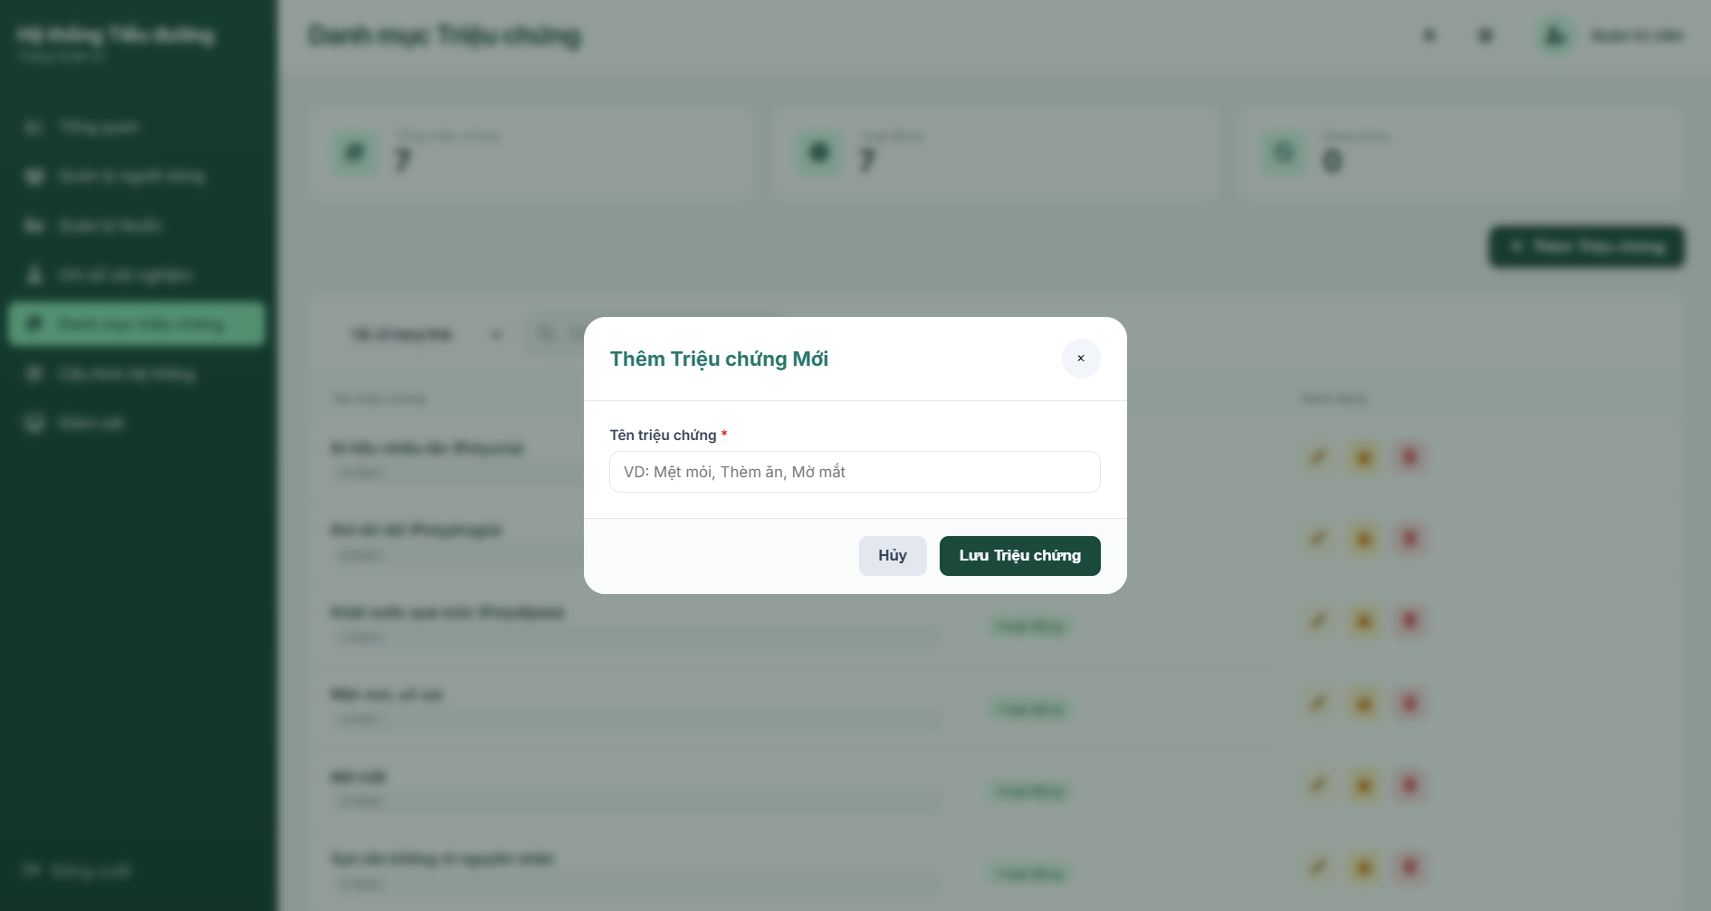

UI Elements Table
Field Name | Field Type | Description
Input Fields
Tên triệu chứng | Text Input | Enter name of new symptom. Allows only letters, numbers, spaces, and basic symbols ((),.-). Required.
Form Actions
Hủy | Button | Closes the modal and resets the input field.
Lưu Triệu chứng | Button | Submits the form to insert the new symptom record (POST request to /admin/symptoms/add).
Feedback Messages
nameError | Text (Error hint) | Displays validation error messages if name format fails.

Database Access
Table | CRUD | Description
Symptoms_Catalog | C, R | Reads table to ensure name uniqueness. Generates random symptom ID (pattern: SYM + 4 digits) and inserts record.
SQL Commands
1/ Validate symptom name uniqueness (case-insensitive)
sql
SELECT COUNT(*)
FROM Symptoms_Catalog
WHERE LOWER(SymptomName) = LOWER(?);
2/ Check generated random ID uniqueness
sql
SELECT COUNT(*)
FROM Symptoms_Catalog
WHERE SymptomID = ?;
3/ Insert new symptom record
sql
INSERT INTO Symptoms_Catalog (SymptomID, SymptomName, Status)
VALUES (?, ?, 1);

c. Edit Symptom Screen (Modal)
This modal popup is triggered when clicking the "Chỉnh sửa" icon button for a symptom. It loads the current details via a REST API GET request, pre-fills the form with the symptom name, and allows the admin to update it. Uniqueness and formatting checks are applied on submit.
Related Use Cases:
- UC-12 Manage Symptoms Catalog (Update)

UI Design
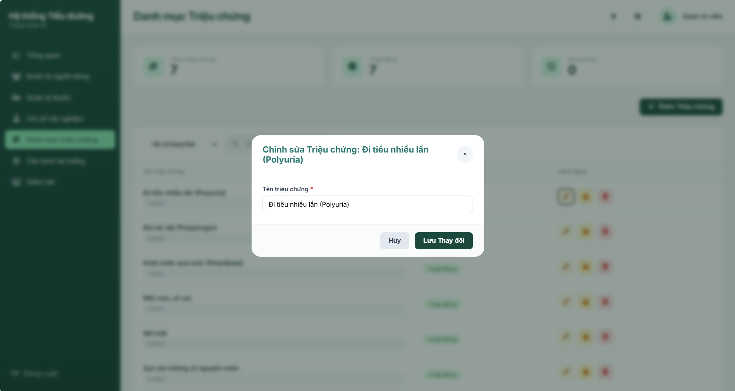
UI Elements Table
Field Name | Field Type | Description
Input Fields
Tên triệu chứng | Text Input | Pre-filled name text of the symptom. Allows updates. Required.
Form Actions
Hủy | Button | Closes the edit modal overlay.
Lưu Thay đổi | Button | Submits the updated symptom details (POST request to /admin/symptoms/edit/{id).

Database Access
Table | CRUD | Description
Symptoms_Catalog | U, R | Reads details by ID, checks name uniqueness if changed, and updates name values.

SQL Commands
1/ Retrieve Symptom details by ID
sql
SELECT SymptomID, SymptomName, Status
FROM Symptoms_Catalog
WHERE SymptomID = ?;
2/ Verify name uniqueness (excluding current symptom record)
sql
SELECT COUNT(*)
FROM Symptoms_Catalog
WHERE LOWER(SymptomName) = LOWER(?) AND SymptomID <> ?;
3/ Update Symptom name
sql
UPDATE Symptoms_Catalog
SET SymptomName = ?
WHERE SymptomID = ?;

d. Confirm Action Popup (Modal)
A unified warning confirmation modal overlay reused dynamically by JavaScript to verify critical actions: locking a symptom (inactive status), restoring a symptom (active status), or permanently deleting a symptom. The modal dynamically adapts its title, icon class, colors, and button styling using gradients to match the specific action.
Related Use Cases:
- UC-12 Manage Symptoms Catalog (Lock / Restore / Delete)

UI Design
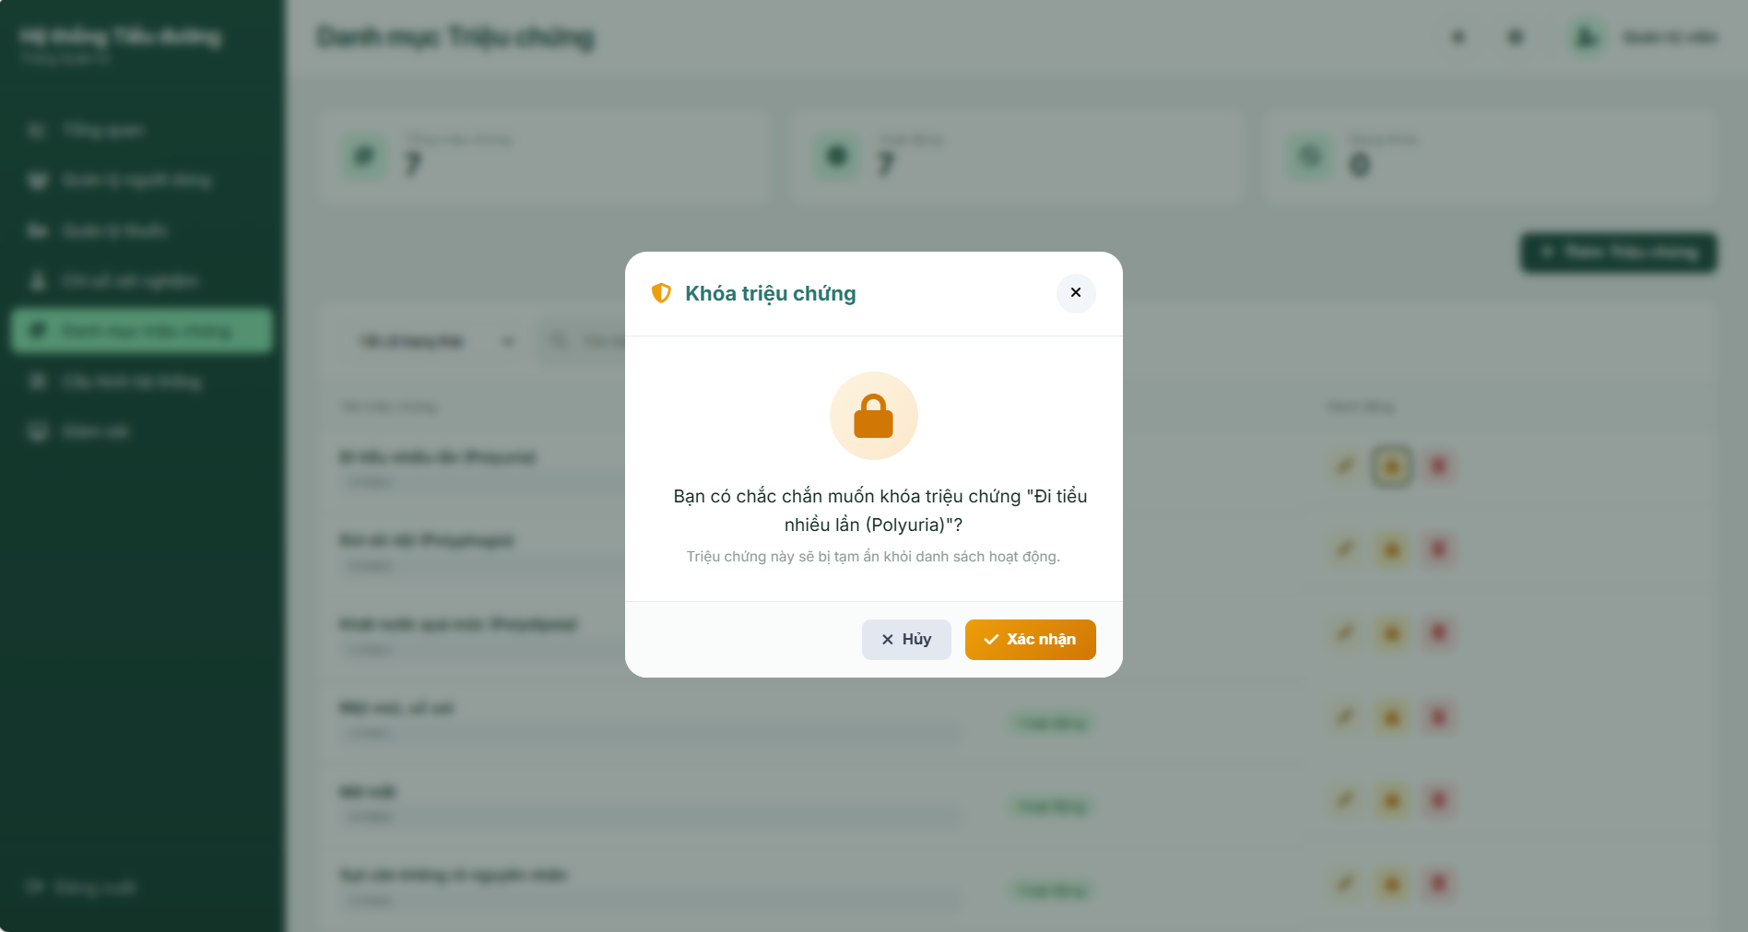
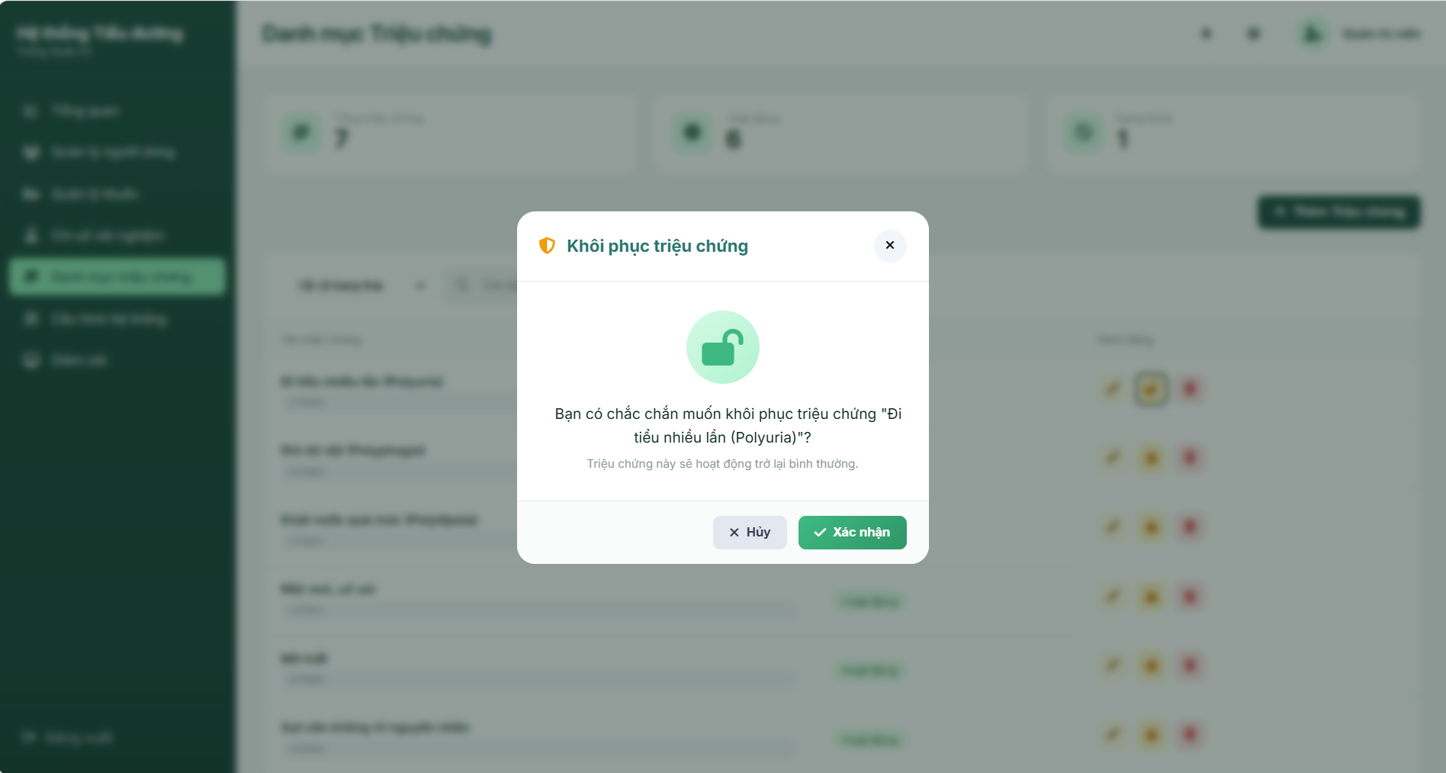
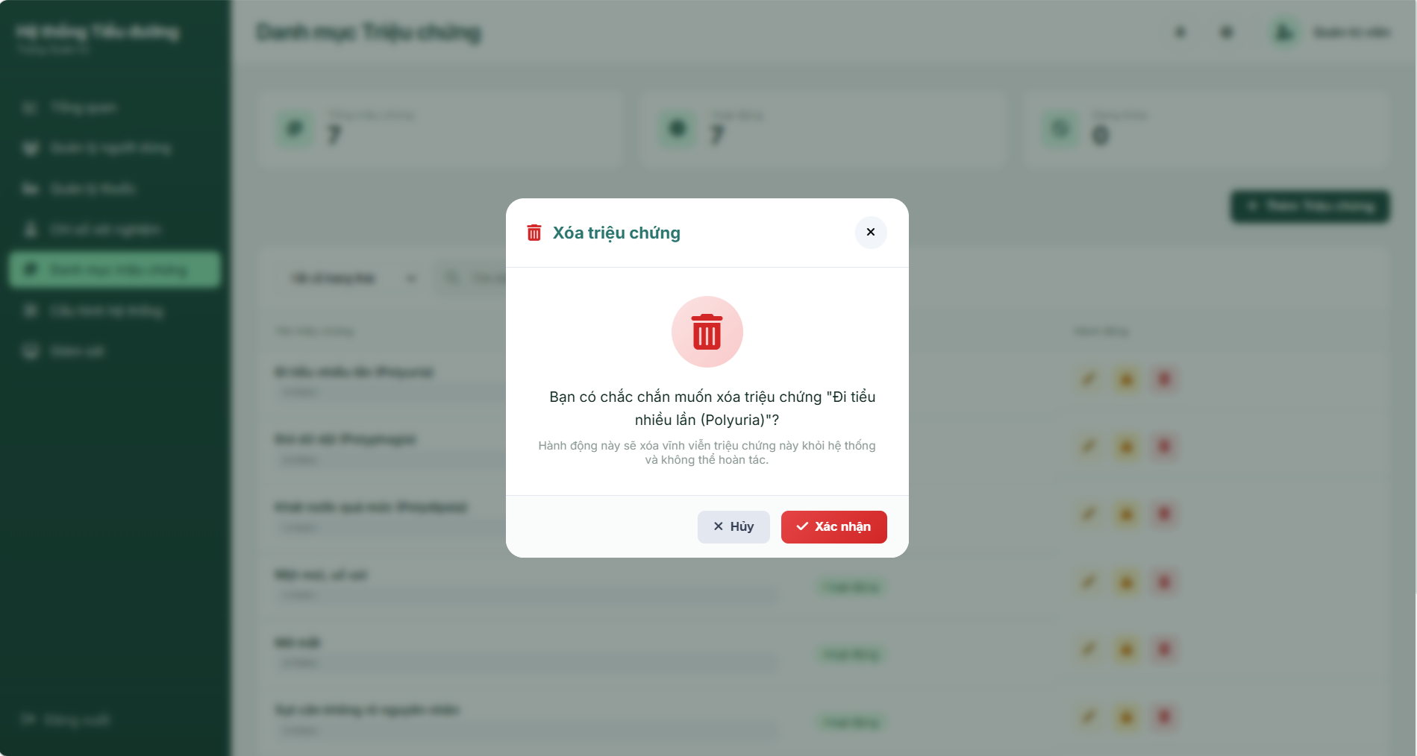
UI Elements Table
Field Name | Field Type | Description
Form Actions
Hủy | Button | Cancels the operation and closes the confirmation modal overlay.
Xác nhận | Button | Submits the form action dynamically (POST request to Lock, Restore, or Delete endpoints). Disables button and changes text to "Đang xử lý..." to prevent double submits.
Feedback Messages
confirmModalTitle | Text | Dynamic dialog header text (e.g. "Khóa triệu chứng" / "Khôi phục triệu chứng" / "Xóa triệu chứng").
confirmMessage | Text | Core descriptive question including target symptom name.
confirmSubMessage | Text | Additional descriptive warning detailing result consequences (e.g. "Hành động này sẽ xóa vĩnh viễn...").

Database Access
Table | CRUD | Description
Symptoms_Catalog | U, D | Updates symptom Status to 0 (Lock) or 1 (Restore), or Deletes (Delete) the matching symptom record.
SQL Commands
1/ Lock Symptom (Soft delete)
sql
UPDATE Symptoms_Catalog
SET Status = 0
WHERE SymptomID = ?;
2/ Restore Symptom
sql
UPDATE Symptoms_Catalog
SET Status = 1
WHERE SymptomID = ?;
3/ Delete Symptom (Hard delete)
sql
DELETE FROM Symptoms_Catalog
WHERE SymptomID = ?;

3.3 Laboratory Test Catalog Management Screen

a. Laboratory Test Catalog Management Screen
This screen is the primary interface for managing the Laboratory Test Catalog within the Diabetes Healthcare Monitoring System. It allows System Administrators (Role AD) to view, search, create, update, delete, and toggle the status (active/inactive) of various laboratory tests.

The system performs frontend input validation via `lab-tests.js` (enforcing character limits, preventing XSS-prone characters, and checking threshold limits) and backend validation via `LabTestCatalogController.java`. Upon submission, tests are persisted in the database, and the user is redirected to the main management screen with appropriate success or error alerts.
Related Usecases:
UC-13: Manage Laboratory Test Catalog
UI Design:
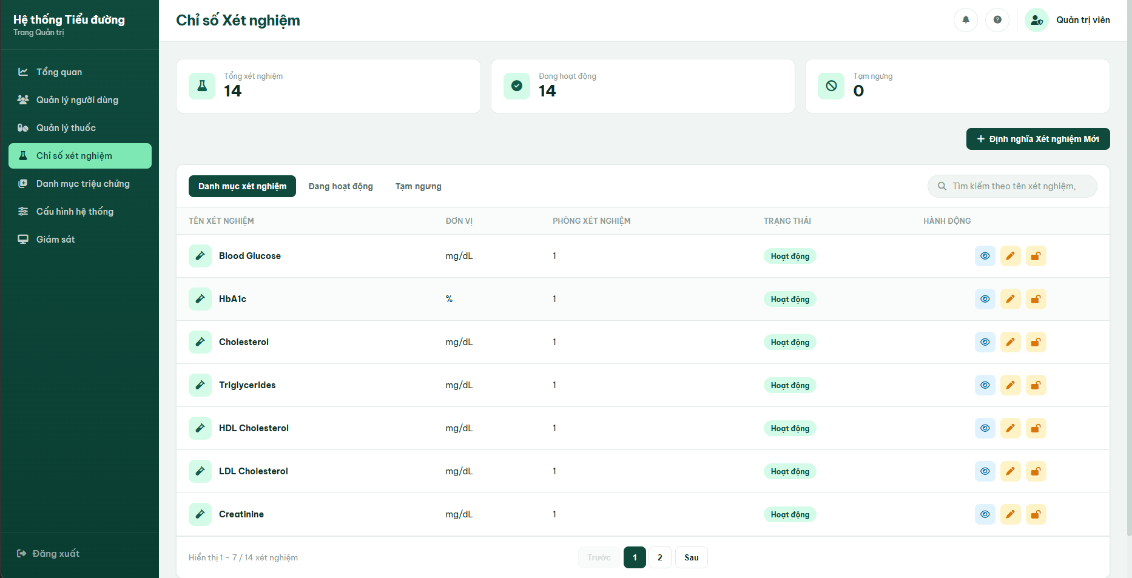

Field Name | Field Type | Description
Search & Filter Fields
Status Filter (Tabs) | Tab Group | Filters the laboratory test list using tabs: Lab Test Catalog (All), Active (Đang hoạt động), or Inactive (Tạm ngưng). Default: All.
Search | Text Input | Search input for laboratory test name, unit, or room ID. Reloads the list upon pressing Enter or clicking the search icon.
Statistics Summary
Total Tests | Statistic Card | Displays the total number of laboratory tests in the system (dynamic value statTotal).
Active | Statistic Card | Displays the total number of active tests (dynamic value statActive).
Inactive | Statistic Card | Displays the total number of inactive/suspended tests (dynamic value statInactive).
Data Table Columns
Test Name | Text | Displays the full name of the laboratory test along with a vial icon.
Unit | Text | Displays the unit of measurement (e.g., mg/dL, %).
Clinic Room | Text | Displays the assigned clinic room name or ID performing the test.
Status | Badge | Status badge indicating: "Hoạt động" (Green badge) / "Tạm ngưng" (Red badge).
Action Elements
Define New Test | Button | Opens the Define Lab Test Modal popup to register a new laboratory test.
View Details | Button (Icon) | Opens the View Detail Modal displaying all test parameters and Min-Max ranges.
Edit | Button (Icon) | Opens the Edit Lab Test Modal prefilled with the selected record's current details.
Lock / Unlock | Button (Icon) | Triggers the action confirmation dialog to toggle active or inactive status (locks/unlocks the laboratory test).
Pagination
Previous / Next | Button | Navigates to the previous or next page of the list (Page Size = 7).
Page Numbers | Button list | Dynamically generated page number buttons for quick navigation.
Database Access:

Table | CRUD | Description
Lab_Test_Catalog | R | Reads the list of laboratory tests, applying keyword, status filter, and statistics counting.

SQL Commands:

- Retrieve paginated and filtered laboratory tests
SELECT LabTestID, TestName, Unit, MinValue, MaxValue, Description, RoomID, Status
FROM Lab_Test_Catalog
WHERE (? IS NULL OR Status = ?)
AND (TestName LIKE ? OR Unit LIKE ?);

- Read summary statistics totals
SELECT COUNT(*) FROM Lab_Test_Catalog;
SELECT COUNT(*) FROM Lab_Test_Catalog WHERE Status = 1;
SELECT COUNT(*) FROM Lab_Test_Catalog WHERE Status = 0;

b. Define Lab Test Screen ( Modal)
This popup form modal is triggered when clicking the "Định nghĩa Xét nghiệm Mới" button. It allows the admin to register a new laboratory test into the system. The system strictly validates the input format, threshold ranges, and the uniqueness of the laboratory test name both client-side (FE) and server-side (BE).
Related Use Cases:
UC-13 : Manage Laboratory Test Catalog
UI Design:
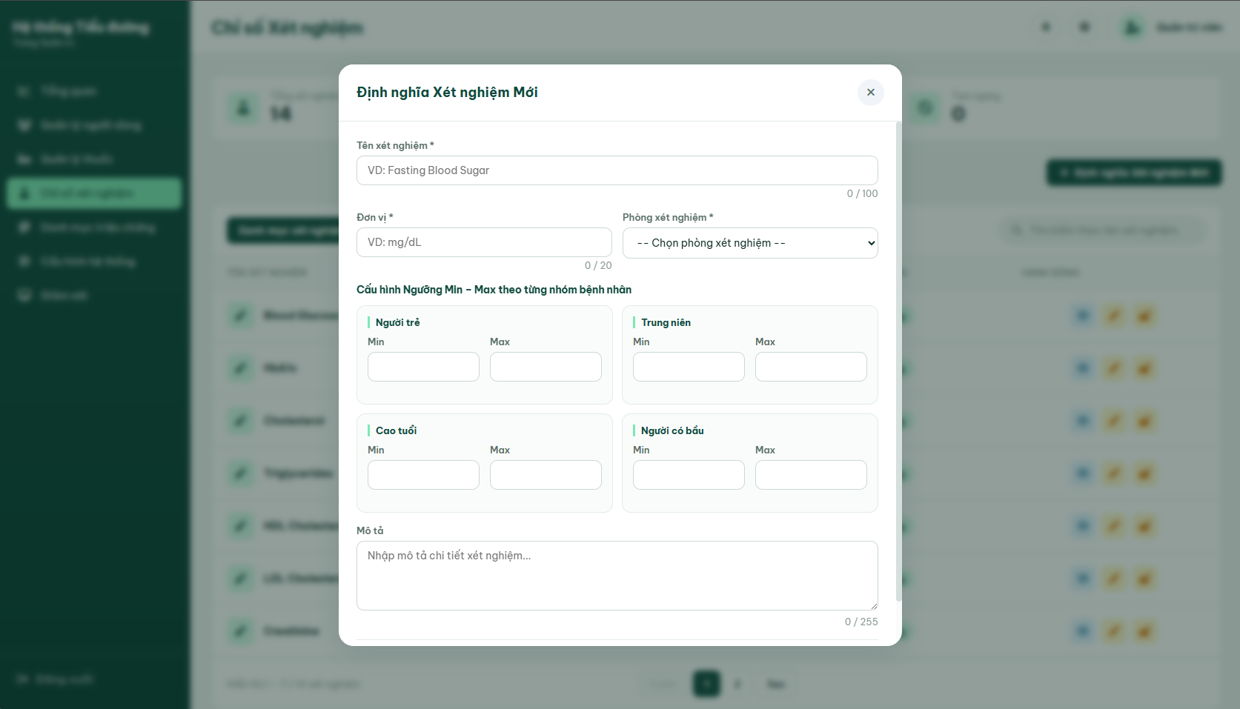

Field Name | Field Type | Description
Input Fields
Test Name | Text Input | Enter the name of the new laboratory test. Required. Max 100 characters. Must not contain dangerous special characters (`< > ; ' " \ ``).
Unit | Text Input | Enter the unit of measurement (e.g., mg/dL, %). Required. Max 20 characters. Must not contain dangerous special characters.
Clinic Room | Select Dropdown | Choose the performing clinic room from the list of available rooms in the Room table. Required.
Min - Max Threshold (Young) | Number Inputs | Enter Min and Max threshold values for young patients. Required. Value must be ≥ 0 and Min ≤ Max.
Min - Max Threshold (Middle-aged) | Number Inputs | Enter Min and Max threshold values for middle-aged patients. Required. Value must be ≥0 and Min ≤ Max.
Min - Max Threshold (Elderly) | Number Inputs | Enter Min and Max threshold values for elderly patients. Required. Value must be ≥0 and Min ≤ Max.
Min - Max Threshold (Pregnant) | Number Inputs | Enter Min and Max threshold values for pregnant patients. Required. Value must be ≥0 and Min  ≤ Max.
Description | Text Area | Enter a detailed description of the laboratory test. Optional. Max 255 characters. Must not contain dangerous special characters
Form Actions
Cancel | Button | Closes the modal and resets all form input fields.
Save Laboratory Test | Button | Performs validation checks and submits the form data (POST request to /admin/lab-tests/create).
Feedback Messages
errorCreateTestName | Text (Error hint) | Displays formatting error validation warning if name contains dangerous characters.
errorCreateUnit | Text (Error hint) | Displays formatting error validation warning if unit is invalid.
errorCreateDesc | Text (Error hint) | Displays formatting error validation warning if description contains dangerous characters.
errorMessage | Text (Error hint) | Displays errors returned from server: "Tên xét nghiệm đã tồn tại." (duplicate), "Vui lòng nhập đầy đủ dữ liệu." (empty), or "Vui lòng chọn phòng xét nghiệm." (room).
Database Access:

Table | CRUD | Description
Lab_Test_Catalog | C,R | Reads the list of laboratory tests, applying keyword, status filter, and statistics counting.
Room | R | Read Room details to populate the clinic room select option dropdown.

SQL Commands:
- Verify uniqueness of Laboratory Test Name (case-insentive)
SELECT COUNT(*)
FROM Lab_Test_Catalog
WHERE LOWER(TestName) = LOWER(?);
- Insert new laboratory test record
INSERT INTO Lab_Test_Catalog (LabTestID, TestName, Unit, MinValue, MaxValue, Description, RoomID, Status)
VALUES (?, ?, ?, ?, ?, ?, ?, 1);

c. Edit Lab Test Screen (Modal)
This modal popup is triggered when clicking the "Chỉnh sửa" icon button for a laboratory test. It loads the test's details via a GET request, pre-fills the form fields, and allows the admin to update them. Uniqueness, format, and non-empty validation are performed upon submission.
Related Usecases:
UC-13: Manage Laboratory Test Catalog
UI Design:
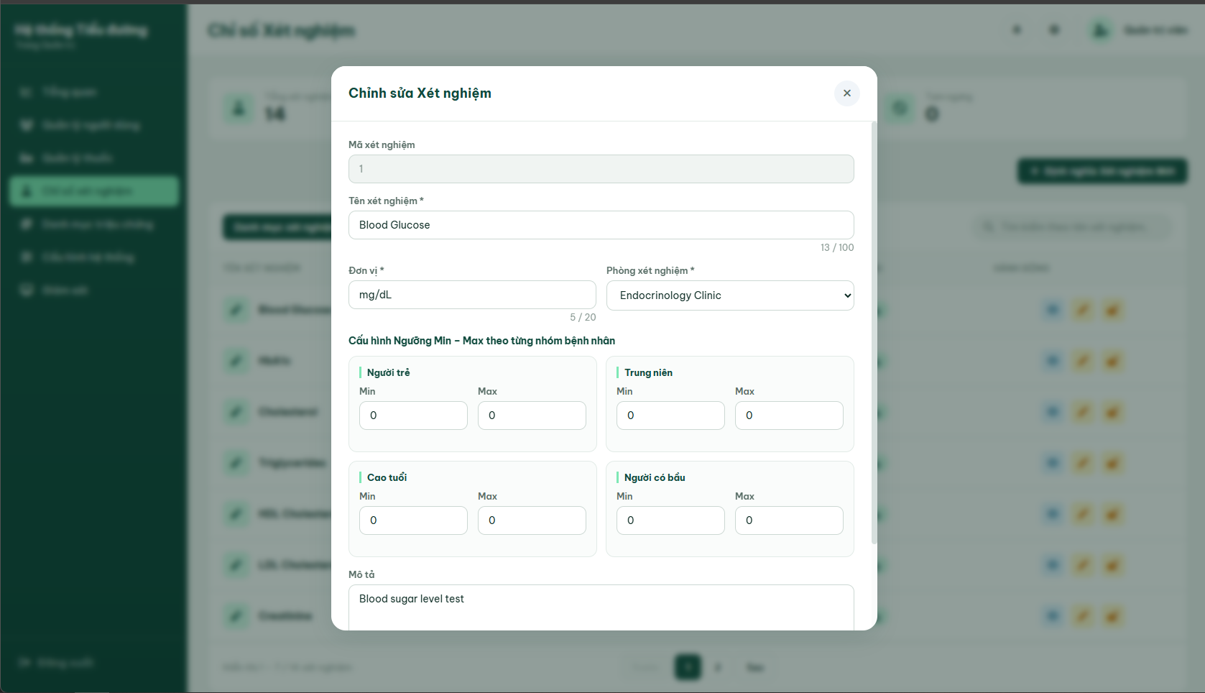

Field Name | Field Type | Description
Input Fields
Laboratory Test ID | Text Input (Disabled) | Displays the immutable laboratory test ID (LabTestID) currently being edited.
Test Name | Text Input | Edit the laboratory test name. Required. Max 100 characters. Must not contain dangerous special characters.
Unit | Text Input | Edit the unit of measurement. Required. Max 20 characters. Must not contain dangerous special characters.
Clinic Room | Select Dropdown | Edit the assigned clinic room for the test. Required.
Min - Max Thresholds | Number Inputs | Edit the threshold values for the 4 patient groups. Required. Value must be ≥0 and Min ≤ Max.
Description | Text Area | Edit the test description details. Optional. Max 255 characters.
Form Actions
Cancel | Button | Closes the modal and resets all form input fields.
Update Laboratory Test | Button | Submits the updated details to the server (POST request to /admin/lab-tests/update/{id}).
Feedback Messages
errorEditTestName | Text (Error hint) | Formatting validation error hint on the edit screen.
errorEditUnit | Text (Error hint) | Formatting validation error hint on the edit screen.
errorEditDesc | Text (Error hint) | Formatting validation error hint on the edit screen.
errorMessage | Alert (Server) | Server error warning alert if the updated test name conflicts with an existing test.
Database Access:

Table | CRUD | Description
Lab_Test_Catalog | U,R | Reads details by ID, checks name uniqueness excluding current ID, and updates the record.

SQL Commands:
- Retrieve Laboratory Test details by ID
SELECT LabTestID, TestName, Unit, MinValue, MaxValue, Description, RoomID, Status
FROM Lab_Test_Catalog
WHERE LabTestID = ?;
- Verify name uniqueness( Excluding current laboratory test record)
SELECT COUNT(*)
FROM Lab_Test_Catalog
WHERE LOWER(TestName) = LOWER(?) AND LabTestID <> ?;
- Update Laboratory Test details
UPDATE Lab_Test_Catalog
SET TestName = ?, Unit = ?, MinValue = ?, MaxValue = ?, Description = ?, RoomID = ?
WHERE LabTestID = ?;

d. Confirm Action Popup (Modal)

A dynamic warning confirmation modal overlay dynamically managed by JavaScript to verify critical actions: locking a test (suspending/deactivating to inactive status) or unlocking/restoring a test (activating to active status). The modal dynamically adapts its title, details, and warning message based on the specific action.
Relative Use Cases:
UC-13: Manage Laboratory Test Catalog
UI Design:
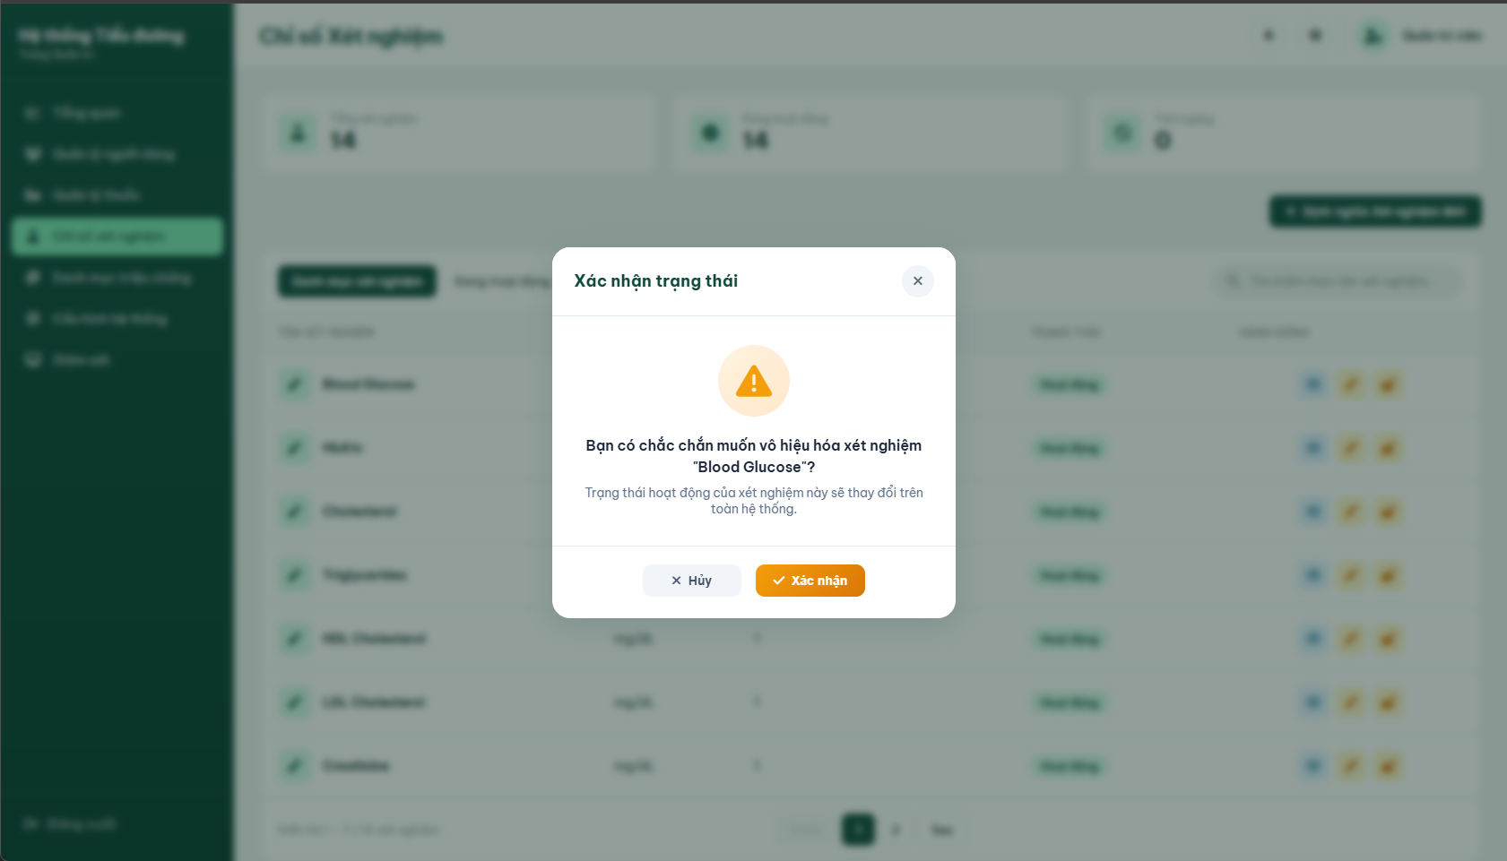

Field Name | Field Type | Description
Form Actions
Cancel | Button | Cancels the operation and closes the confirmation modal overlay.
Confirm | Button | Submits the lock/unlock action (POST request to Toggle Status endpoint). Disables the button and displays "Đang xử lý..." to prevent double submissions.
Feedback Messages
confirmTitle | Text | Dynamic dialog header text (e.g., "Xác nhận trạng thái").
confirmMessage | Text | Core descriptive question containing the target test name (e.g., Bạn có chắc chắn muốn vô hiệu hóa xét nghiệm "HbA1c"?).
confirmSubMessage | confirmSubMessage | Additional descriptive warning detailing the action consequences (e.g., Trạng thái hoạt động của xét nghiệm này sẽ thay đổi trên toàn hệ thống.).
Database Access:

Table | CRUD | Description
Lab_Test_Catalog | U | Updates the test Status to 0 (Suspend/Lock) or 1 (Restore/Unlock).

SQL Commands:
- Lock Laboratory Tests(Soft Delete/ Deactivate)
UPDATE Lab_Test_Catalog
SET Status = 0
WHERE LabTestID = ?;
- Unlock/ Activate Laboratory Test
UPDATE Lab_Test_Catalog
SET Status = 1
WHERE LabTestID = ?;

3.4 Room Configuration Screen

a. Room Configuration Screen
This screen (accessible under the "Phòng khám" tab of the Configuration module) allows System Administrators to view all clinic rooms registered in the database. The administrator can search for specific rooms, navigate through pages, and trigger modal actions to add, edit, or permanently delete room entries.
Related Use Cases:
UC-14: Configure Clinic Room
UI Design:
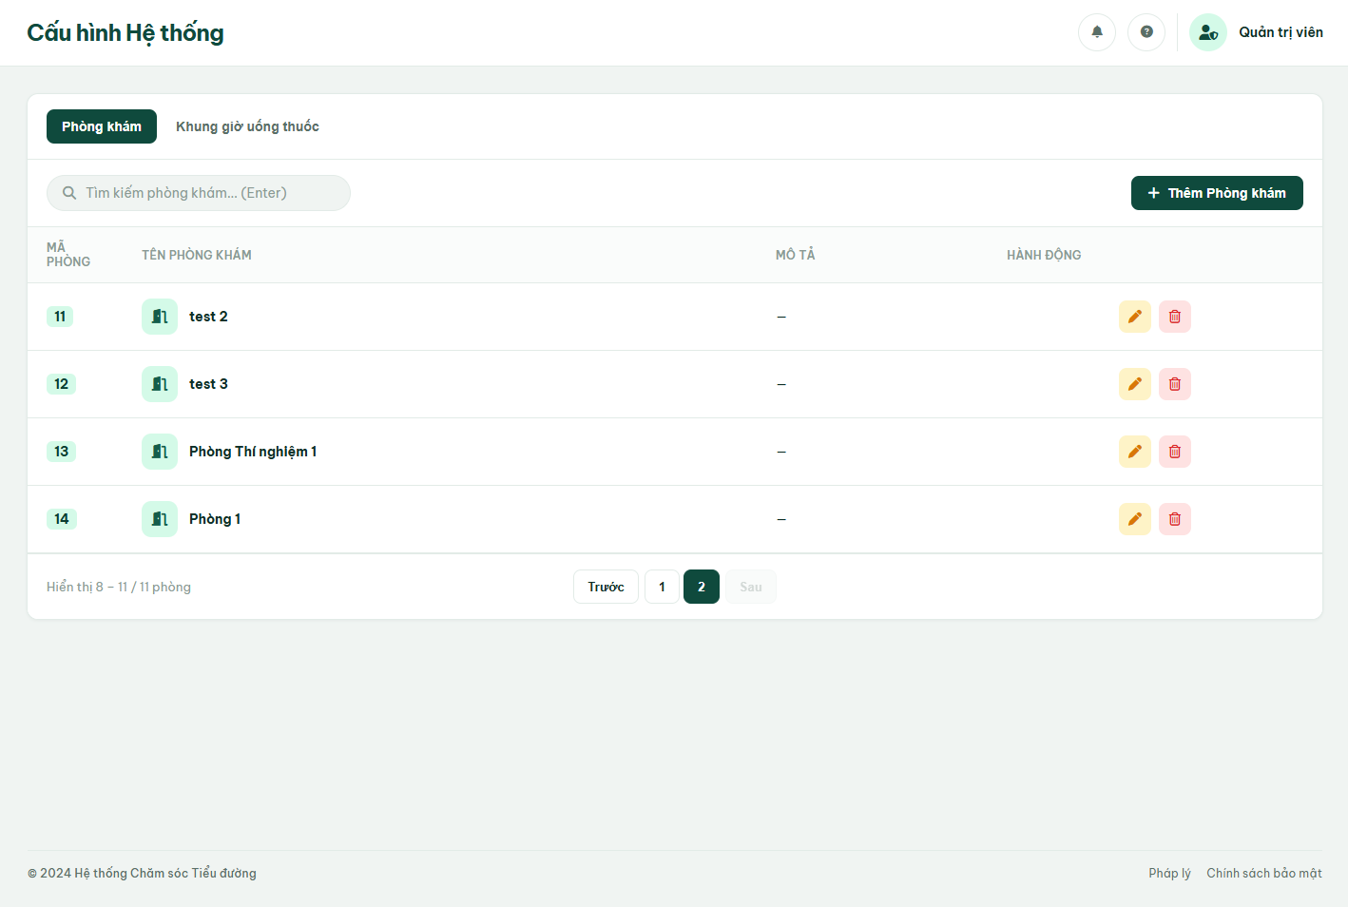

Field Name | Field Type | Description
Search & Filter Fields
Search | Search Input | Search input for clinic room names. Submits and reloads the room list on Enter or search icon click.
Data Table Columns
Room ID | Text | Displays the database ID of the clinic room.
Clinic Room Name | Text | Displays the name of the clinic room with a door icon.
Description | Text | Displays brief description or location of the room.
Action Elements
Add Clinic Room | Button | Opens the Add Room Modal popup.
Edit | Button (Icon) | Opens the Edit Room Modal prefilled with the current room's details.
Delete | Button (Icon) | Triggers the warning confirmation modal to permanently delete the clinic room.
Pagination
Previous / Next | Button | Navigates to the previous or next page (Page Size = 7).
Page Numbers | Button list | Dynamic page numbers for quick table navigation.
Database Access:

Table | CRUD | Description
Room | R | Reads the list of rooms, applying the search keyword and pagination options.

SQL Commands
- Retrieve paginated and filtered rooms
SELECT RoomID, RoomName, Description
FROM Room
WHERE (? IS NULL OR RoomName LIKE ? OR Description LIKE ?);
- Retrieve all room profiles
SELECT RoomID, RoomName, Description
FROM Room;

b. Add Room Screen
This popup modal is triggered by clicking the "Add Clinic Room" button. It allows the admin to register a new clinic room. The system validates formatting rules and empty fields on submit.
Related Use Cases:
UC-14: Configure Clinic Room
UI Design:
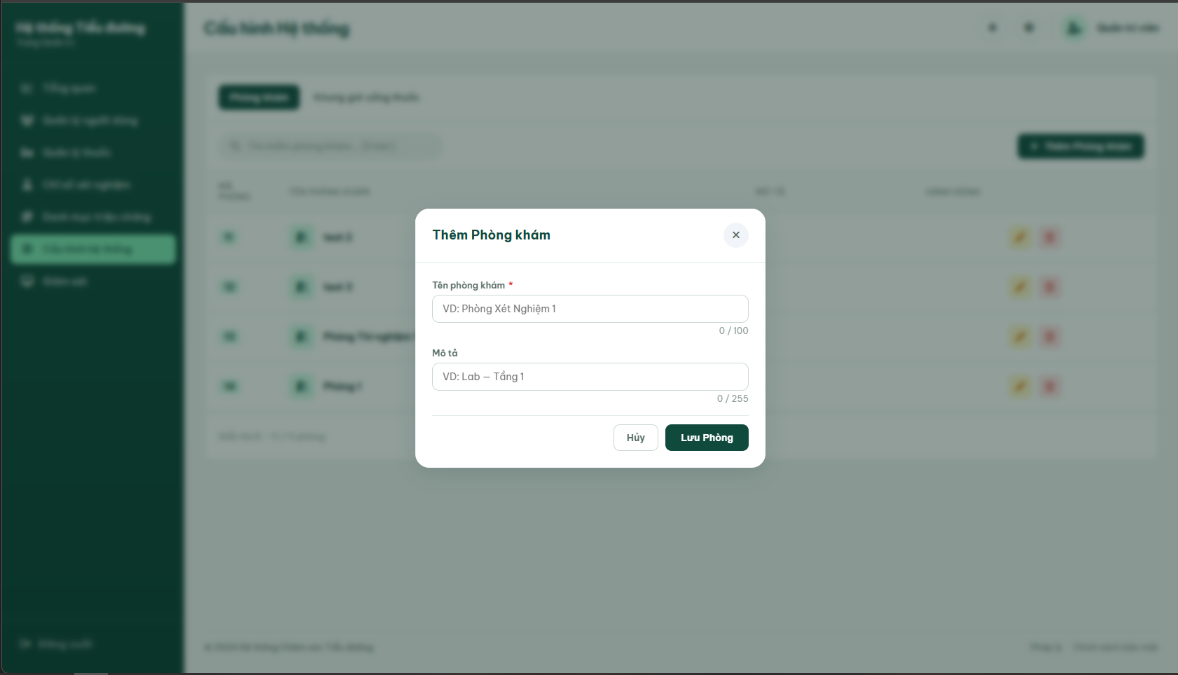

Field Name | Field Type | Description
Input Fields
Clinic Room Name | Text Input | Enter the room name. Required. Max 100 characters. Must not contain dangerous special characters (`< > ; ' " \ ``).
Description | Text Input | Enter room location or details. Optional. Max 255 characters.
Form Actions
Cancel | Button | Closes the modal and resets inputs.
Save Room | Button | Validates inputs and submits form (POST to /admin/configure/room/create).
Feedback Messages
errorAddRoomName | Text (Error hint) | Displays formatting warning if name contains dangerous characters.
errorAddRoomDesc | Text (Error hint) | Displays formatting warning if description contains dangerous characters.
Database Access:

Table | CRUD | Description
Room | C | Inserts a new clinic room record

SQL Commands:
- Insert new clinic room
INSERT INTO Room (RoomName, Description)
VALUES (?, ?);

c. Edit Room Screen
This modal popup is triggered by clicking the “Edit” icon button on a room now. It loads details via JS datasets, pre-fills inputs and allows the admin to update room specifications

Related Use Cases:
UC-14: Configure Clinic Room
UI Design
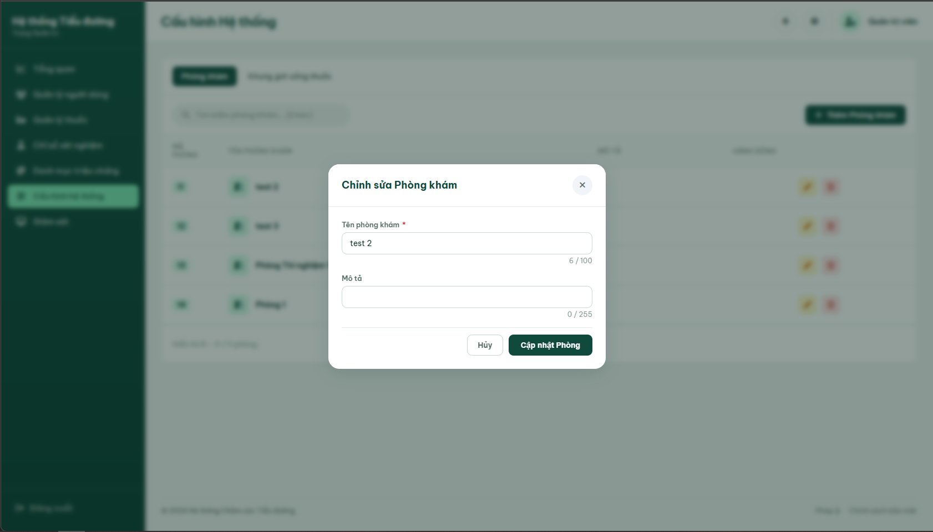

Field Name | Field Type | Description
Input Fields
Clinic Room Name | Text Input | Edit room name. Required. Max 100 characters. No special characters allowed.
Description | Text Input | Edit room description. Optional. Max 255 characters.
Form Actions
Cancel | Button | Closes the edit modal overlay.
Save Room | Button | Submits updated room details (POST to /admin/configure/room/update/{id}).
Feedback Messages
errorEditRoomName | Text (Error hint) | Validation formatting warning on edit name field.
errorEditRoomDesc | Text (Error hint) | Validation formatting warning on edit description field.
Database Access:

Table | CRUD | Description
Room | U,R | Reads details by ID and updates RoomName and Description.

SQL Commands:
- Retrieve room by ID
SELECT RoomID, RoomName, Description
FROM Room
WHERE RoomID = ?;
- Update room info
UPDATE Room
SET RoomName = ?, Description = ?
WHERE RoomID = ?;

d. Confirm Action Popup
A Dynamic confirmation dialog prompted when deleted a room.
Related Use Cases:
UC-14: Configure Clinic Room
UI Design
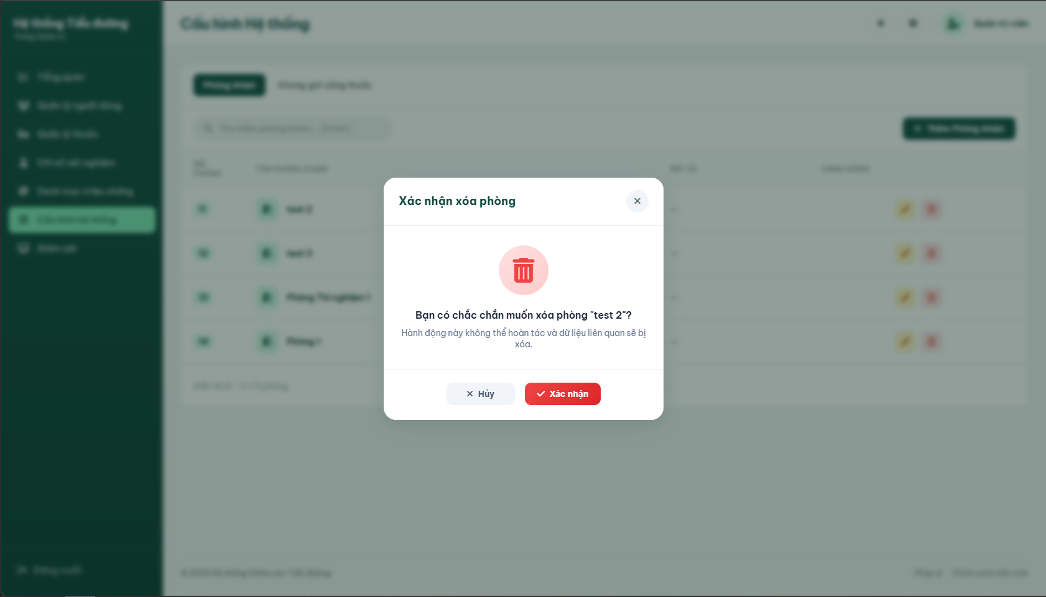

Field Name | Field Type | Description
Form Actions
Cancel | Button | Cancels deletion and closes modal.
Confirm | Button | Confirms deletion and submits form (POST to /admin/configure/room/delete/{id}).
Database Access:

Table | CRUD | Description
Room | D | Deletes the room record from the database.

SQL Commands
- Delete clinic room
DELETE FROM Room
WHERE RoomID = ?;

3.5 Medication Timing Configuration Screen

a. Medication Timing Configuration Screen
This screen (accessible under the "Medication Timing" tab of the Configuration module) allows System Administrators to view all medication timing slots. The administrator can search timings, navigate pages, and trigger actions to add, edit, or permanently delete timing profiles.
Related Use Cases:
UC-15: Configure Medication Timings
UI Design:
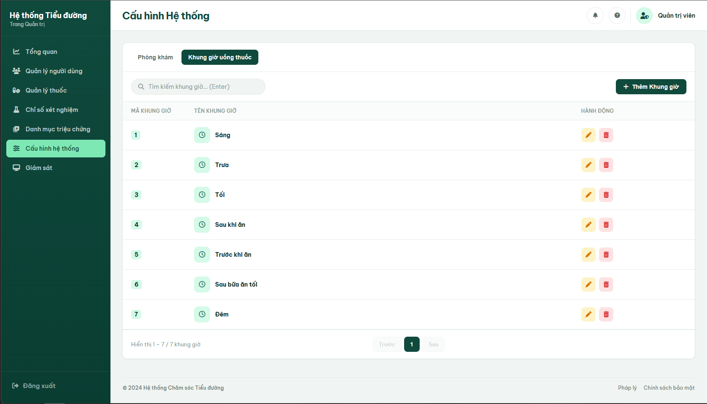

Field Name | Field Type | Description
Search & Filter Fields
Search | Search Input | Search input for medication timing names. Submits and filters list on Enter keypress or search icon click.
Data Table Columns
Timing Name | Text | Displays the name of the timing (e.g., Morning, Noon, Evening) with a clock icon.
Action Elements
Add Timing | Button | Opens the Add Timing Modal popup.
Edit | Button (Icon) | Opens the Edit Room Modal prefilled with the current room's details.
Delete | Button (Icon) | Triggers the warning confirmation modal to permanently delete the clinic room.
Pagination
Previous / Next | Button | Navigates to the previous or next page (Page Size = 7).
Page Numbers | Button list | Dynamic page numbers for quick table navigation.
Database Access:

Table | CRUD | Description
MediacationTiming | R | Reads the list of timings, applying search keyword filter.

SQL Commands
- Retrieve paginated and filtered timings
SELECT TimingID, TimingName
FROM MedicationTiming
WHERE (? IS NULL OR TimingName LIKE ?);
- Retrieve all timing profiles
SELECT TimingID, TimingName
FROM MedicationTiming;

b. Add Timing Screen
This popup modal is triggered by clicking the "Add Timing" button. It allows the admin to register a new medication timing slot. The system checks for name uniqueness and formats.
Related Use Cases:
UC-15: Configure Medication Timings
UI Design:
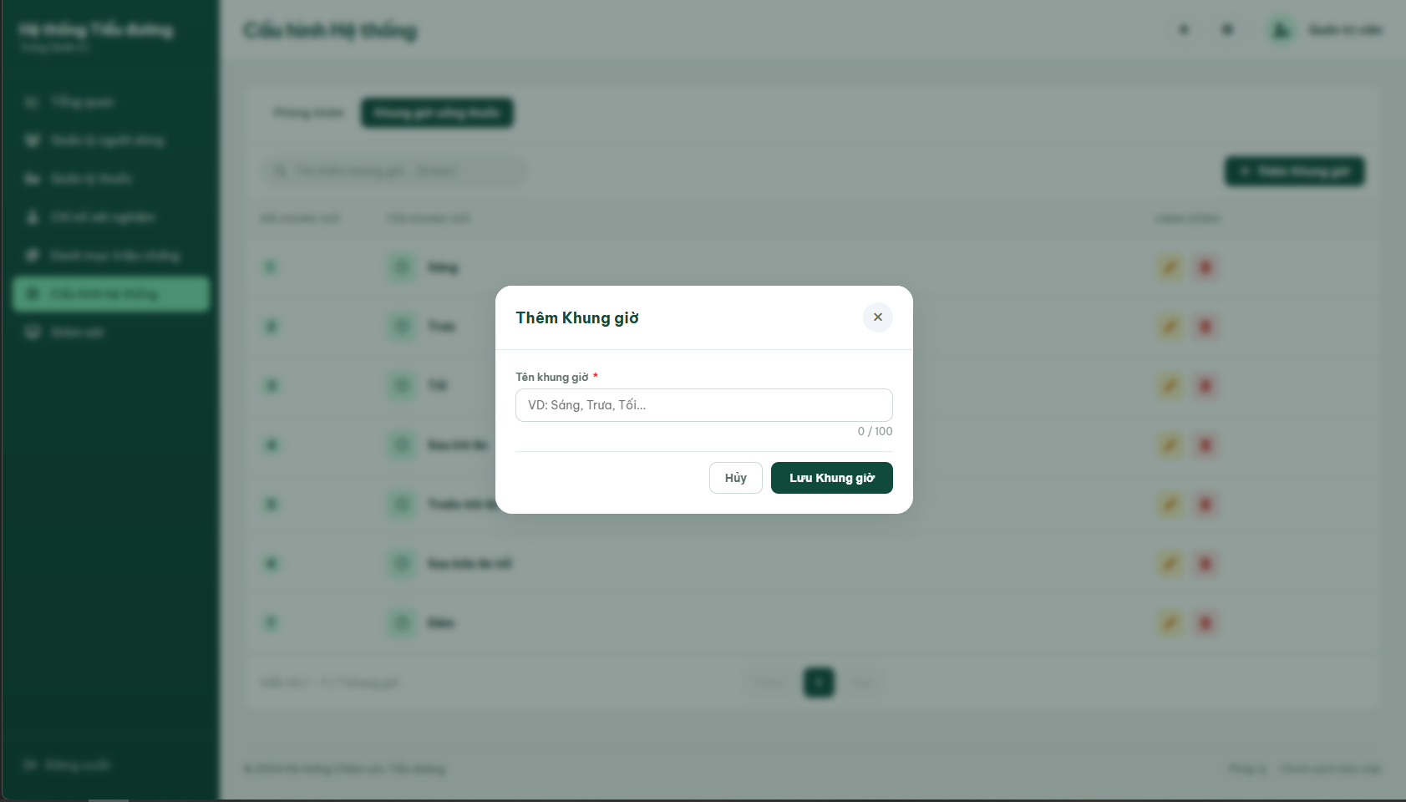

Field Name | Field Type | Description
Input Fields
Timing Name | Text Input | Enter the timing name. Required. Max 100 characters. No special characters allowed (`< > ; ' " \ ``).
Form Actions
Cancel | Button | Closes the modal and resets inputs.
Save Timing | Button | Validates inputs and submits form (POST to /admin/configure/timing/create).
Feedback Messages
errorAddTimingName | Text (Error hint) | Formatting validation error warning.
errorMessage | Text (Error hint) | Displays server error if name already exists ("Tên đã tồn tại.").
Database Access:

Table | CRUD | Description
MediacationTiming | C,R | Reads table to check uniqueness, then inserts new medication timing slot.

SQL Commands
- Verify uniqueness of Medication Timing Name
SELECT COUNT(*)
FROM MedicationTiming
WHERE LOWER(TimingName) = LOWER(?);
- Insert new medication timing slot
INSERT INTO MedicationTiming (TimingName)
VALUES (?);

c. Edit Timing Screen
This modal popup is triggered by clicking the “Edit” icon button on a timing row
Related Use Cases:
UC-15: Configure Medication Timings
UI Design:
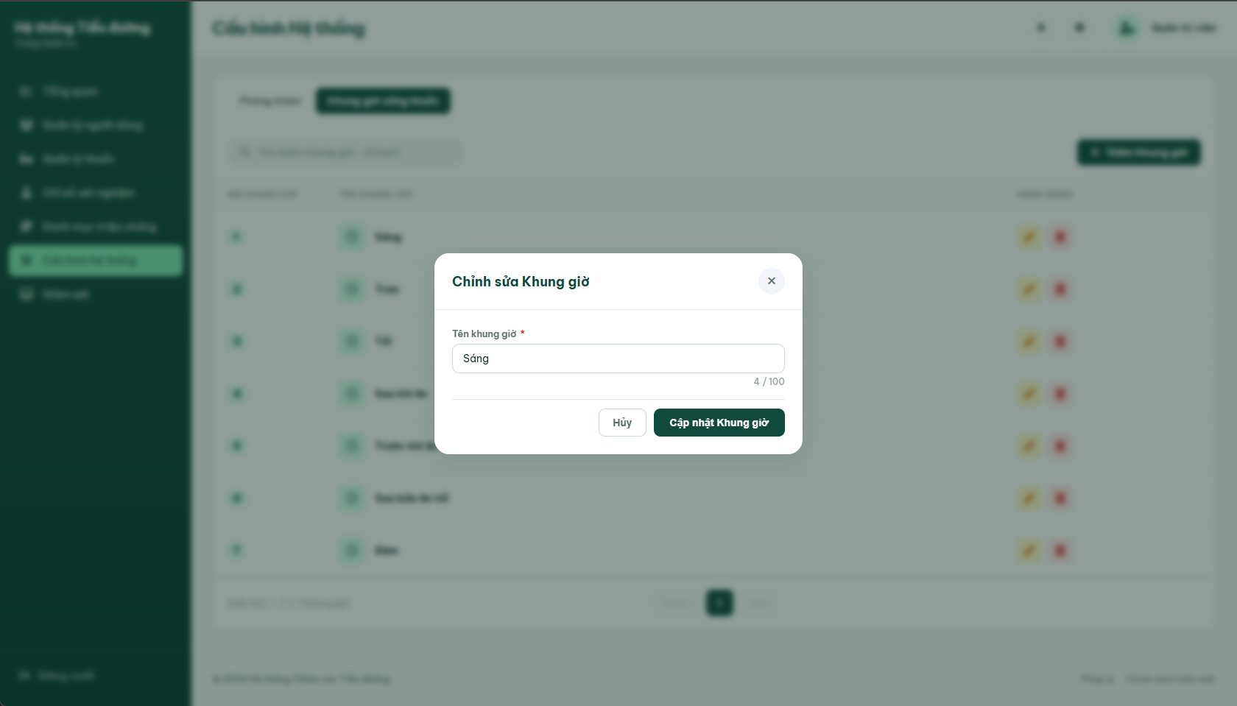

Field Name | Field Type | Description
Input Fields
Timing Name | Text Input | Edit the timing name. Required. Max 100 characters. No special characters.
Form Actions
Cancel | Button | Closes the edit modal overlay.
Update Timing | Button | Submits updated timing name (POST to /admin/configure/timing/update/{id}).
Feedback Messages
errorEditTimingName | Text (Error hint) | Formatting validation warning on the edit timing name field.
errorMessage | Alert (Server) | Server error warning if timing name conflicts with another entry.
Database Access:

Table | CRUD | Description
MediacationTiming | U,R | Reads by ID, checks uniqueness excluding current record, and updates the name.

SQL Commands:
- Retrieve timing by ID
SELECT TimingID, TimingName
FROM MedicationTiming
WHERE TimingID = ?;
- Verify timing name uniqueness (excluding current timing ID)
SELECT COUNT(*)
FROM MedicationTiming
WHERE LOWER(TimingName) = LOWER(?) AND TimingID <> ?;
- Update timing name
UPDATE MedicationTiming
SET TimingName = ?
WHERE TimingID = ?;

d. Confirm Action popup
A dynamic confirmation dialog prompted when deleting a timing slot
Related Use Cases:
UC-15: Configure Medication Timings
UI Design:
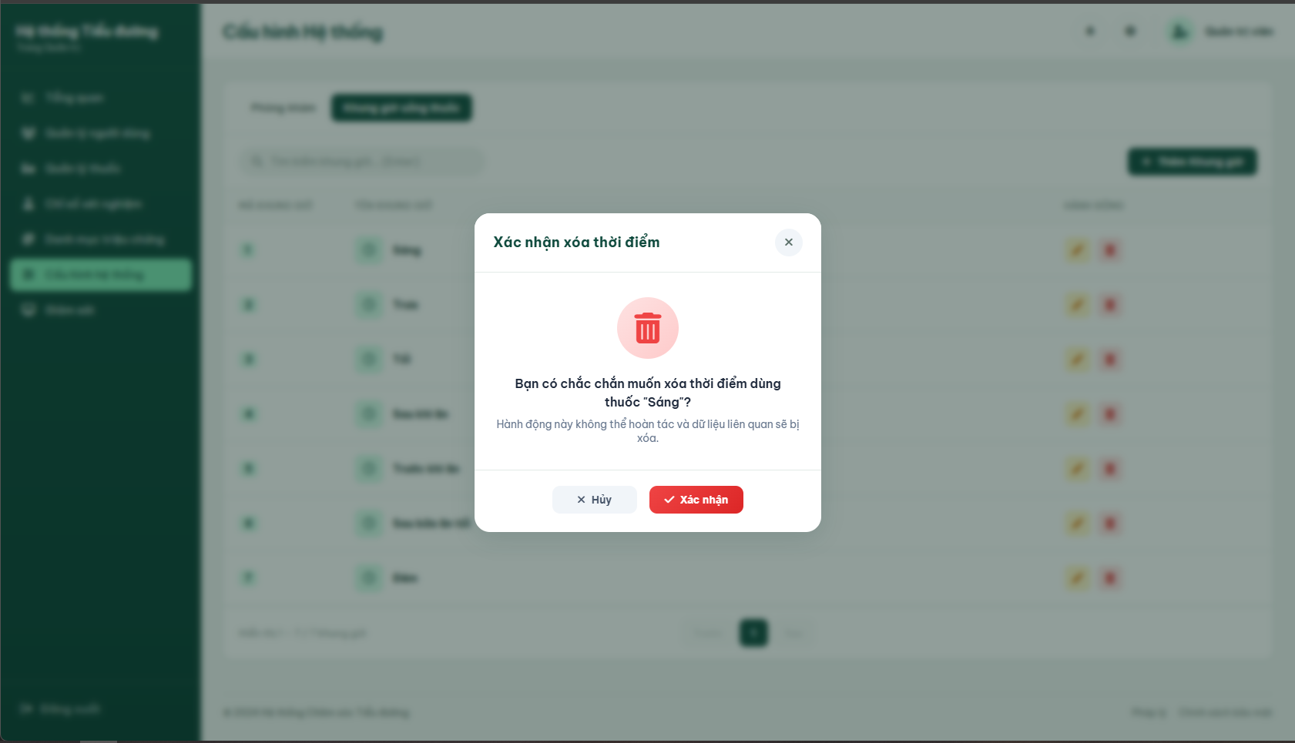

Field Name | Field Type | Description
Form Actions
Cancel | Button | Cancels deletion and closes modal.
Confirm | Button | Confirms deletion and submits form (POST to /admin/configure/timing/delete/{id}).
Database Access:

Table | CRUD | Description
MediacationTiming | D | Deletes the timing record from the database.

SQL Commands
- Delete medication timing
DELETE FROM MedicationTiming
WHERE TimingID = ?;

3.6 AI Model Monitoring Screen

a. AI System Overview
This section gives Admin a real-time snapshot of the AI Assistant's operational health and a single switch to enable/disable the assistant system-wide. Related use case:
· UC-AD-09: Monitor AI System Performance

UI Design
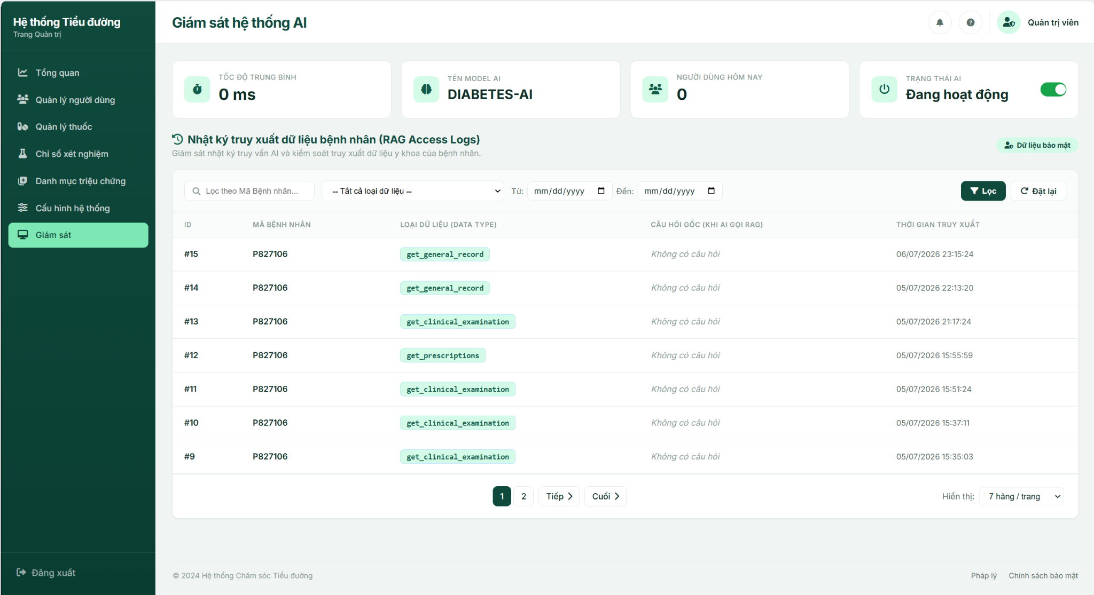

Field Name | Field Type | Description
Tốc độ trung bình | Stat Card | Average AI response latency, shown in ms or s.
Tên model AI | Stat Card | Name of the currently active Ollama model.
Người dùng hôm nay | Stat Card | Number of distinct patients whose data was accessed by the AI today.
Trạng thái AI | Stat Card + Toggle | "Đang hoạt động" / "Tạm tắt"; toggling opens a confirmation modal before calling POST /admin/monitoring/api/toggle-ai.

Database Access
Table | CRUD | Description
ai_patient_access_log | R | Compute the count of distinct patients accessed today, used for the "Người dùng hôm nay" statistic.
SQL Commands:
1/ Count distinct patients served today
SELECT COUNT(DISTINCT patientId) FROM ai_patient_access_log
WHERE accessedAt >= @startOfToday AND patientId <> 'UNKNOWN'
Note: Average latency and the AI-enabled flag are currently served from application memory, not persisted to the database (see Other Information in UC-AD-09).

b. Patient Access Log
This section lets Admin search and review every RAG data access the AI Assistant has made on behalf of patients. Related use case:
· UC-AD-09: Monitor AI System Performance

UI Design

Field Name | Field Type | Description
Search Fields
Mã Bệnh nhân | Text Box | Filter by Patient ID (partial match). Default: blank.
Loại dữ liệu (Data Type) | Combo Box (Single-Choice) | Filter by get_general_record / get_clinical_examination / get_treatment_plan / get_lab_results / get_prescriptions. Default: all types.
Từ / Đến | Date Picker (x2) | Filter by access date range.
Lọc | Button | Applies the current filters and reloads the table.
Đặt lại | Hyperlink | Clears all filters and reloads the first page.
Data Table
ID | Integer | Access-log entry identifier.
Mã Bệnh nhân | Text | Patient ID whose data was accessed.
Loại dữ liệu | Tag | The RAG action name that was executed.
Câu hỏi gốc | Text | The patient's original question, if captured; otherwise "Không có câu hỏi".
Thời gian truy xuất | DateTime | Timestamp of the access, formatted dd/MM/yyyy HH:mm:ss.

Database Access
Table | CRUD | Description
ai_patient_access_log | R | Query the filtered, paginated, and sorted (most recent first) list of RAG data-access log entries for display.
SQL Commands:
1/ Query filtered patient access log entries
SELECT id, patientId, dataType, accessedAt FROM ai_patient_access_log
WHERE (@patientId IS NULL OR patientId LIKE '%' + @patientId + '%')
AND (@dataType IS NULL OR dataType = @dataType)
AND (@fromDate IS NULL OR accessedAt >= @fromDate)
AND (@toDate IS NULL OR accessedAt <= @toDate)
ORDER BY accessedAt DESC

4. Clinic Management & Doctor Portal

4.1 Doctor Dashboard Screen
This is the primary landing page (home hub) for doctors after logging into the system. It provides a real-time overview of their daily schedule, pending actions, and patient adherence alerts. The dashboard aggregates metrics such as pending online consultation requests, today's onsite queue status, and unread treatment reminders. It serves as a central hub where doctors can quickly navigate to view request lists, patient request lists, and details of medication alerts.

Related Use Cases
UC-17 View Today's Clinic Queue
UC-25 View Patient Medical History
Review, Accept/Reject Examination Request
View Medication Reminders

UI Design
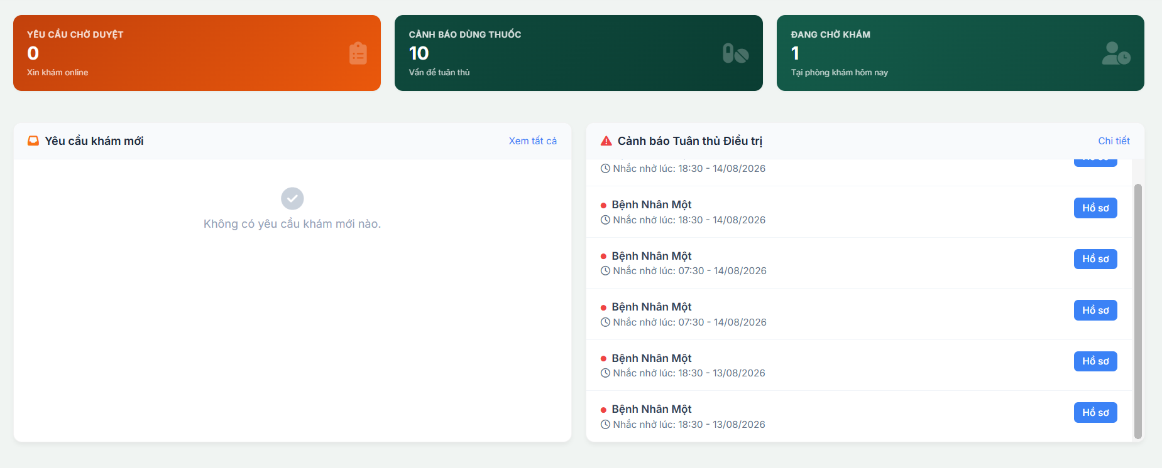
Field Name / UI Control | Field Type | Description
Pending Requests Card | Metric Card | Displays the total count of examination requests with status “Requested” assigned to the doctor.
Medication Warning Card | Metric Card | Displays the total count of unread medication adherence reminders for the doctor's patients.
Today's Queue Card | Metric Card | Displays the total count of scheduled examinations for today with status “Pending” and “In Progress”.
New Exam Requests Panel | List Widget | Lists up to 5 newest pending examination requests containing Patient Name, Request Date, and reason.
"Xem tất cả" Requests Link | Link Button | Redirects the doctor to the detailed Examination Request Management page.
Medication Compliance Panel | List Widget | Lists up to 6 of the most recent generated compliance reminders showing patient name, and scheduled time.
"Chi tiết" Reminders Link | Link Button | Redirects the doctor to the detailed AI reminders page.
"Hồ sơ" Button | Action Button | Placed next to each patient reminder; redirects the doctor to that patient's full medical history page.

Database Access
Table | CRUD | Description
Profile | R | Reads the logged-in doctor's personal information (e.g., Full Name, …) to display in the header.
Clinical_Examination | R | Read: Retrieves counts of today's queue and list of recent pending requests.
Reminder | R | Reads reminders generated for the doctor's patients to show in the compliance panel.
Patient | R | Reads the patient's full name and profile details linked to examinations and reminders.

SQL Commands
1/ Retrieve Doctor Profile Info
sql
SELECT UserID, FullName, Address, Dob, Gender, Specialty, RoomID, Email
FROM [Profile]
WHERE UserID = ?;
2/ Retrieve Count of Today's Clinic Queue (Pending & InProgress)
sql
SELECT COUNT(*)
FROM [ClinicalExamination]
WHERE DoctorID = ?
AND (Status = 'Pending' OR Status = 'InProgress')
AND CAST(ExamDate AS DATE) = CAST(GETDATE() AS DATE);
3/ Retrieve Newest 5 Pending Examination Requests
sql
SELECT TOP 5 e.ClinicalExamID, e.ExamDate, e.MedicalHistory, p.FullName
FROM [ClinicalExamination] e
JOIN [Patient] p ON e.PatientID = p.UserID
WHERE e.DoctorID = ?
AND e.Status = 'Requested'
ORDER BY e.ExamDate DESC;
4/ Retrieve Top 10 Recent Patient Reminders
sql
SELECT TOP 10 r.ReminderID, r.ScheduledTime, r.Title, r.IsRead, p.FullName, p.UserID
FROM [Reminder] r
JOIN [ClinicalExamination] e ON r.ClinicalExamID = e.ClinicalExamID
JOIN [Patient] p ON r.PatientID = p.UserID
WHERE e.DoctorID = ?
ORDER BY r.ScheduledTime DESC;
5/ Quick Approve Examination Request
sql
UPDATE [ClinicalExamination]
SET Status = 'Pending', ExamDate = GETDATE()
WHERE ClinicalExamID = ?;
6/ Quick Reject Examination Request
sql
UPDATE [ClinicalExamination]
SET Status = 'Cancelled', CancelReason = N'Bác sĩ từ chối'
WHERE ClinicalExamID = ?;

4.2 Medical Examination Request Management Screen
This screen allows the Doctor to manage incoming online medical examination requests submitted by patients. The doctor can view all pending requests, review patient clinical details (submitted symptoms and medical history), and take action to either accept the request (setting status to 'Pending' to add it to the clinic queue) or reject the request (setting status to 'Cancelled' with a specified reason).

UI Design
Field Name / UI Control | Field Type | Description
Request Search & Filter Bar | Form | Contains status filter (All, Pending, Approved/Pending, Cancelled) and patient name keyword search input.
Requests Data Table | Data Grid | Displays all examination requests, showing Request ID, Patient Name, Requested Date, Medical History Description, Status, and Action buttons.
Approve Button | Button | Accepts the request; opens a dialog to confirm the appointment date and time, updating status to 'Pending'.
Reject Button | Button | Rejects the request; opens a confirmation dialog with a mandatory text area for the doctor to provide the cancellation reason, updating status to 'Cancelled'.
Detail Icon | Action Button | Opens a modal or slide-over panel displaying the full request details including the patient's age, gender, contact number, and detailed history description.

Database Access
Table | CRUD | Description
ClinicalExamination | R, U | Reads requested examinations and updates Status, ExamDate, and CancelReason upon approval or rejection.
Patient | R | Retrieve details about the patient who requested the examination (Name, Gender, DOB, Phone).

SQL Commands
1/ Retrieve All Examination Requests for the Doctor (Filtered & Paginated)
sql
SELECT ce.ClinicalExamID, ce.ExamDate, ce.MedicalHistory, ce.Status, ce.CancelReason,
p.UserID AS PatientID, p.FullName, p.Dob, p.Gender
FROM [ClinicalExamination] ce
JOIN [Patient] p ON ce.PatientID = p.UserID
WHERE ce.DoctorID = ?
AND (? = 'all' OR ce.Status = ?)
AND (? = '' OR p.FullName LIKE '%' + ? + '%')
ORDER BY ce.ExamDate DESC
OFFSET ? ROWS FETCH NEXT ? ROWS ONLY;
2/ Approve Examination Request
sql
UPDATE [ClinicalExamination]
SET Status = 'Pending', ExamDate = ?
WHERE ClinicalExamID = ?;
3/ Reject Examination Request
sql
UPDATE [ClinicalExamination]
SET Status = 'Cancelled', CancelReason = ?
WHERE ClinicalExamID = ?;
4/ Count Total Requests (for Pagination)
sql
SELECT COUNT(*)
FROM [ClinicalExamination] ce
JOIN [Patient] p ON ce.PatientID = p.UserID
WHERE ce.DoctorID = ?
AND (? = 'all' OR ce.Status = ?)
AND (? = '' OR p.FullName LIKE '%' + ? + '%');

4.3 Today's Clinic Queue Screen
This screen allows the Doctor to manage their daily clinic appointments queue. The doctor can view all scheduled patient examinations for today, filter the queue by statuses (Pending/Đang chờ, InProgress/Đang khám, Completed/Hoàn thành, Cancelled/Đã hủy), and search for specific patients by name. From this screen, the doctor can start/resume a patient examination or view their past medical history. If there is already an active exam (status "InProgress"), the system will automatically restrict the doctor from starting another exam and redirect them to the ongoing examination sheet.

Related Use Cases
UC-17 View Today's Clinic Queue
Review, Accept/Reject Examination Request
UC-25 View Patient Medical History

UI Design
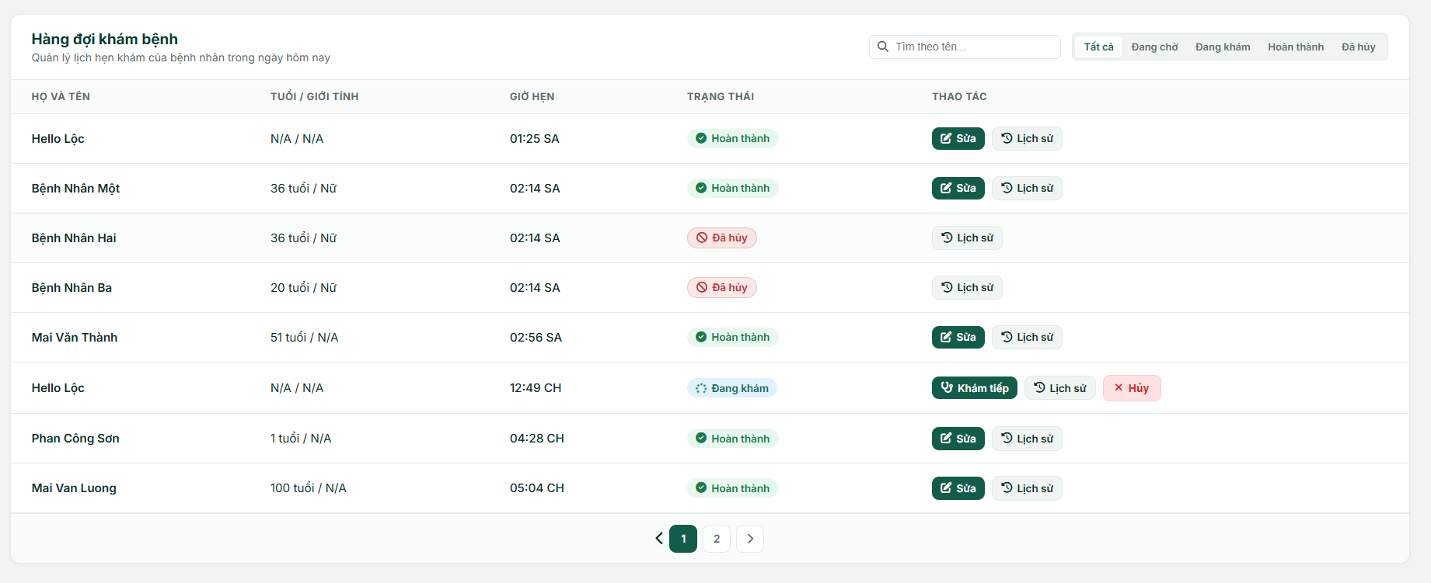

Field Name / UI Control | Field Type | Description
Search Input | Text Input | Filters the list by searching the patient's Full Name.
Status Filter Pills | Navigation Link | Quick filters to display appointments by status (“Tất cả”, “Đang chờ”, “Đang khám”, “Hoàn thành”, “Đã hủy”).
Patient Column | Text (Column) | Displays the Patient's Full Name.
Age / Gender Column | Text (Column) | Displays calculated age from patient's Dob and gender text mapped from the Gender bit.
Appointment Time | Text (Column) | Displays the examination time from ExamDate.
Status Badge | Badge (Column) | Displays status: Pending (Đang chờ), InProgress (Đang khám), Completed (Hoàn thành), Cancelled (Đã hủy).
"Bắt đầu" / "Khám tiếp" | Action Button | Triggers the clinical examination workspace for a patient with “Pending”or “In Progress” status.
"Sửa" Button | Action Button | Allows the doctor to update details of a Completed examination.
"Lịch sử" Button | Action Button | Opens the patient's comprehensive medical history page.
“Hủy” Button | Action Button | Open the modal for doctor to enter cancel reason of clinical examination.
Pagination Bar | Navigation Control | Renders previous/next page buttons and page numbers when total records exceed the page limit (8 items/page).

Database Access
Table | CRUD | Description
Profile | R | Read the logged-in doctor's department and personal details.
Patient | R | Reads the patient's full name, date of birth, and gender.
ClinicalExamination | R, U | Read: Queries list of today's examinations for the doctor, filters by status/search, checks for any existing In Progress exam.  Update: Updates status to start/resume exam.

SQL Commands
1/ Check for Active (InProgress) Examination for the Doctor
sql
SELECT TOP 1 ClinicalExamID, PatientID, DoctorID, Status
FROM [ClinicalExamination]
WHERE DoctorID = ?
AND Status = 'InProgress';
2/ Retrieve Count of Today's Filtered Clinic Queue (for Pagination)
sql
SELECT COUNT(*)
FROM [ClinicalExamination] e
JOIN [Patient] p ON e.PatientID = p.UserID
WHERE e.DoctorID = ?
AND CAST(e.ExamDate AS DATE) = CAST(GETDATE() AS DATE)
AND e.Status != 'Requested'
AND (? = 'all' OR e.Status = ?)
AND (? = '' OR p.FullName LIKE '%' + ? + '%' OR p.UserID LIKE '%' + ? + '%');
3/ Retrieve Paginated & Filtered Today's Clinic Queue
sql
SELECT e.ClinicalExamID, e.ExamDate, e.MedicalHistory, e.Status,
p.UserID AS PatientID, p.FullName, p.Dob, p.Gender
FROM [ClinicalExamination] e
JOIN [Patient] p ON e.PatientID = p.UserID
WHERE e.DoctorID = ?
AND CAST(e.ExamDate AS DATE) = CAST(GETDATE() AS DATE)
AND e.Status != 'Requested'
AND (? = 'all' OR e.Status = ?)
AND (? = '' OR p.FullName LIKE '%' + ? + '%' OR p.UserID LIKE '%' + ? + '%')
ORDER BY e.ExamDate ASC
OFFSET ? ROWS FETCH NEXT ? ROWS ONLY;

4.4 Clinical Examination Screen

a. Patient General Information Component
This component displayed persistently across the entire clinical examination workflow. It shows the patient's administrative profiles, physiological metrics, medical alerts, and daily routine schedules. It calculates the patient's age dynamically based on their date of birth and computes the BMI index with active classification warnings (Underweight, Normal, Overweight, Obese).

UI Design
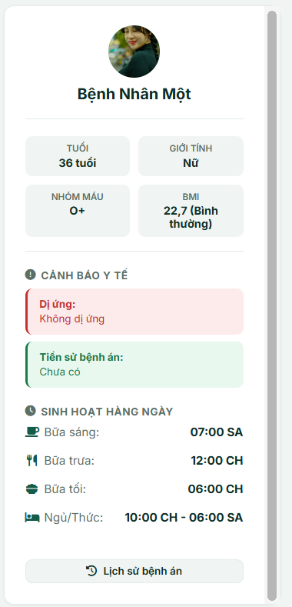
Field Name / UI Control | Field Type | Description
Patient Card Header | Container | Houses the patient's avatar image and full name title.
Patient Avatar | Image | Patient's profile picture. If ImageUrl is null/empty, displays a default hospital user icon
Patient Full Name | Label (h2) | Displays the patient's full name (FullName).
Patient ID | Label (Hidden) | Hidden label containing the patient's ID (UserID).
Age | Label | Calculates age dynamically using formula: Current Year - Year of Birth (e.g. 24 tuổi). Displays N/A if empty.
Gender | Label | Maps the binary gender representation (e.g. 1 to Nữ, 0 to Nam). Displays N/A if empty.
Blood Group | Label | Displays a patient's blood type (Bloodgroup from DB, e.g., O+).
BMI | Label | Displays value rounded to 1 decimal place followed by bracketed status:  - (Thiếu cân) if BMI < 18.5.  - (Bình thường) if 18.5 < BMI < 25.0.  - (Thừa cân) if 25.0 BMI < 30.0.  - (Béo phì) if BMI > 30.0.
Allergy Warning | Box Panel | Displays Allergy Notes. Default fallback: Không có dị ứng thuốc nào được ghi nhận.
Medical History Warning | Box Panel | Alerts box Displays PermanentMedicalHistory. Default fallback: Không có tiền sử bệnh án được ghi nhận.
Breakfast Routine | Label | Displays daily breakfast time formatted as hh:mm AM/PM.
Lunch Routine | Label | Displays daily lunch time formatted as hh:mm AM/PM.
Dinner Routine | Label | Displays daily dinner time formatted as hh:mm AM/PM.
Sleep / Wake Routine | Label | Displays daily sleeping time (SleepTime) and wake up time (WakeUpTime) formatted as SleepTime / WakeUpTime.
View Medical History | Button | Triggers javascript function to redirect doctor to patient's clinical examination history page.

Database Access
Table | CRUD | Description
Patient | R | Reads patient's full name, dob, gender, bloodgroup, height, weight, allergyNotes, permanentMedicalHistory, and imageUrl.
PatientRoutine | R | Read the patient's breakfastTime, lunchTime, dinnerTime, sleepTime, and wakeUpTime.

SQL Commands
1/ Fetch Patient Vitals and Profile Details
sql
SELECT UserID, FullName, Dob, Gender, Bloodgroup, AllergyNotes, PermanentMedicalHistory, ImageUrl
FROM [Patient]
WHERE UserID = ?;
2/ Fetch Patient Daily Routine Schedule
sql
SELECT UserID, BreakfastTime, LunchTime, DinnerTime, WakeUpTime, SleepTime
FROM [PatientRoutine]
WHERE UserID = ?;

b. Clinical Symptoms & Reason Screen
This screen is Step 1 ("Triệu chứng & Lý do khám") of the 4-step clinical examination wizard. By the time the doctor reaches this screen, the examination has already started (from the Queue screen), so the doctor reviews the patient's initial reason for visit (read-only), selects matching clinical symptoms from the master catalog, and inputs remarks for each checked symptom before moving to the next tab.
Related Use Cases
- UC-19 Record Medical History
- UC-20 Select & Comment on Patient Symptoms

UI Design
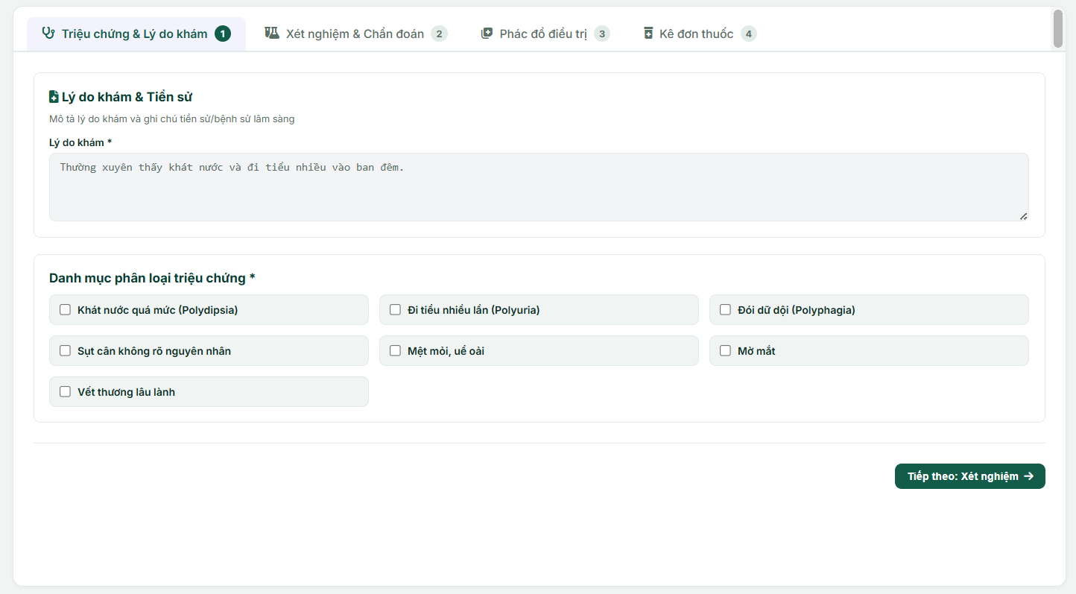
Field Name / UI Control | Field Type | Description
Exam Step Tab Bar (4 tabs) | Navigation / Action Button | Switches between the 4 exam steps. Clicking a tab submits and saves the current tab's form before navigating, so data on Tab 1 is persisted even if the doctor jumps ahead.
Return queue Link | Navigation Link | Returns to the doctor Queue. Only visible when the exam is opened in Edit Mode.
Reason for Visit | Text Area | Displays the patient's initial reason for visit (readonly).
Symptoms Selection Grid | Container | Displays the master list of symptoms from the catalog as selectable cards.
Symptom Checkbox | Checkbox | Selects/deselects a symptom.
Symptom Comment Input | Text Input | Allows the doctor to enter specific details for a selected symptom.
Next Step Button | Action Button | Validates and saves Tab 1 data and switches to the next step.

Database Access
Table | CRUD | Description
ClinicalExamination | R, U | Read: Loads the reason for visit, next appointment date, and status.  Update: Saves changes to status, next appointment.
SymptomsCatalog | R | Read the list of symptoms from the master catalog.
ExamSymptom | C, R, D | Read: Loads saved symptoms and notes for edit mode.  Delete: Clears old symptom records before saving updates.  Create: Inserts newly selected symptoms and comments.

SQL Commands
1/ Fetch Patient Gender and Examination Status

sql
SELECT p.Gender, e.ClinicalExamID, e.MedicalHistory, e.NextAppointment, e.Status
FROM [Patient] p
JOIN [ClinicalExamination] e ON e.PatientID = p.UserID
WHERE e.ClinicalExamID = ?;
2/ Retrieve All Symptoms from Catalog

sql
SELECT SymptomID, SymptomName, Description
FROM [SymptomsCatalog];
3/ Retrieve Existing Symptoms and Comments for Draft/Edit Mode

sql
SELECT SymptomID, Note
FROM [ExamSymptom]
WHERE ClinicalExamID = ?;
4/ Delete Old Symptom Selections

sql
DELETE FROM [ExamSymptom]
WHERE ClinicalExamID = ?;
5/ Insert Symptom Selection with Comments

sql
INSERT INTO [ExamSymptom] (ClinicalExamID, SymptomID, Note)
VALUES (?, ?, ?);

c. Laboratory Orders, Results & Diagnosis Screen
This screen allows the doctor to order clinical laboratory tests for the patient. The doctor can assign all matching tests from the catalog with a single click, view simulated test results (value, flag, and reference ranges), monitor flagged warning indicators (LOW, CAO, BÌNH THƯỜNG), and input the final clinical diagnosis and remarks based on the patient's examination outcomes.

Layout Requirement: Embedded with the persistent a. Patient General Information Component layout at the top.
Related Use Cases
UC-21 Order Laboratory Tests, Review Results & Record Diagnosis

UI Design
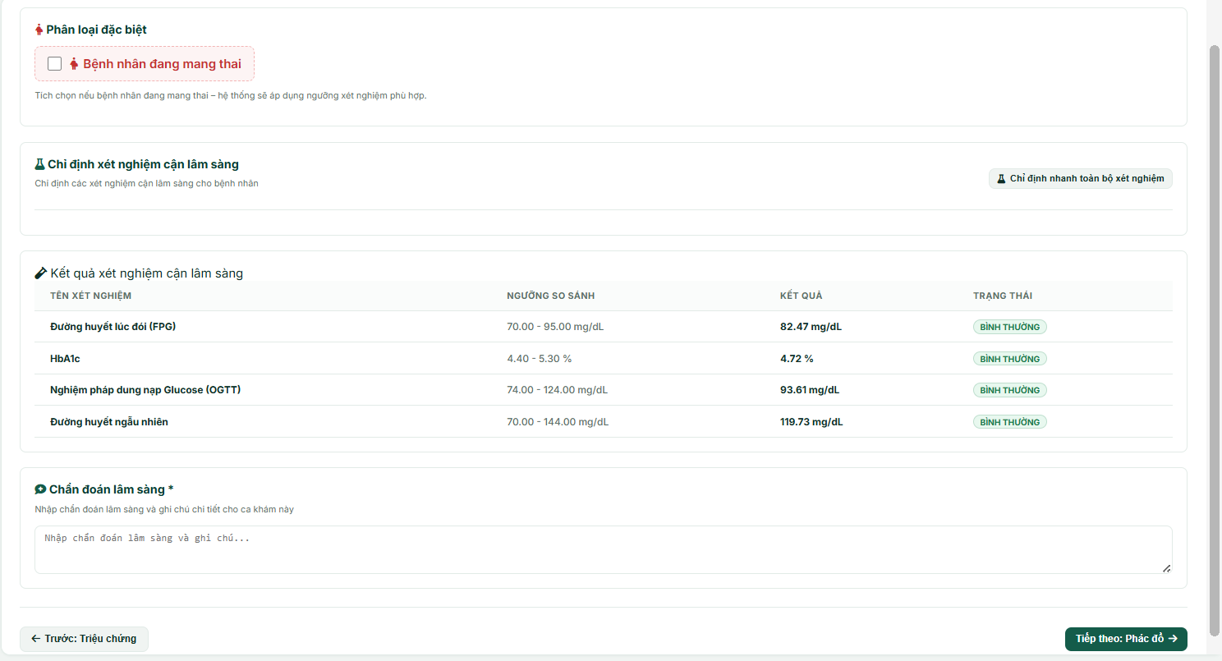
Field Name / UI Control | Field Type | Description
Pregnancy Toggle | Checkbox | Marks the patient as pregnant for female patients; applies the pregnancy-specific reference thresholds when tests are ordered.
"Chỉ định nhanh toàn bộ xét nghiệm" | Action Button | Assigns all active lab tests from the catalog and generates simulated results.
Lab Results Grid / Table | Table Container | Renders columns: Test Name, Reference Range, Value, and Status Flag badge.
Status Flag Badge | Badge (Column) | Renders flag labels: "BÌNH THƯỜNG" (Normal), "THẤP" (Low), "CAO" (High).
Clinical Diagnosis Input | Text Area | Allows the doctor to input the final clinical diagnosis and detailed check-up remarks (DiagnosisNote).
Tab navigation buttons ("Trước: Triệu chứng" / "Tiếp theo: Phác đồ") | Action Button | Saves the current tab data and moves to Tab 1 or Tab 3.

Database Access
Table | CRUD | Description
Lab_Test_Catalog | R | Read the list of active laboratory tests in the system.
PatientType | R | Resolves the matching patient type (by age range, or Pregnant) used to select thresholds.
IndicatorThreshold | R | Reads minimum/maximum thresholds for each lab test based on the matched patient type.
LabOrder | C, R, D | Read: Retrieves the existing order. Delete: Clears the old order. Create: Creates a new lab order for the exam.
LabResult | C, R, D | Read: Retrieves saved test results. Delete: Clears old results. Create: Saves simulated lab test values.
ClinicalExamination | R, U | Read: Queries existing clinical diagnosis note. Update: Updates the clinical diagnosis note for the examination.

SQL Commands
1/ Retrieve Active Lab Test Catalog
sql
SELECT LabTestID, TestName, Unit
FROM [Lab_Test_Catalog]
WHERE Status = 1;
2/ Resolve Patient Type
sql
SELECT PatientTypeID, TypeName, MinAge, MaxAge
FROM [PatientType];
3/ Retrieve Threshold for Test & Patient Type
sql
SELECT ThresholdID, MinValue, MaxValue
FROM [IndicatorThreshold]
WHERE LabTestID = ? AND PatientTypeID = ?;
4/ Clear Old Lab Results for Exam
sql
DELETE FROM [LabResult]
WHERE LabOrderID IN (SELECT LabOrderID FROM [LabOrder] WHERE ClinicalExamID = ?);
5/ Clear Old Lab Order for Exam
sql
DELETE FROM [LabOrder]
WHERE ClinicalExamID = ?;
6/ Create New Lab Order
sql
INSERT INTO [LabOrder] (LabOrderID, ClinicalExamID, Status)
VALUES (?, ?, 'Completed');
7/ Insert Lab Result
sql
INSERT INTO [LabResult] (LabResultID, LabOrderID, LabTestID, ResultValue, ReferenceRange, Flag, Status)
VALUES (?, ?, ?, ?, ?, ?, 'Completed');
8/ Save Clinical Diagnosis Note
sql
UPDATE [ClinicalExamination]
SET DiagnosisNote = ?
WHERE ClinicalExamID = ?;

d. Treatment Plan Screen
This screen is Step 3 ("Phác đồ điều trị") of the 4-step clinical examination. The doctor schedules the next appointment and establishes a diabetes treatment and management plan for the patient: treatment goals, nutritional dietary advice, physical exercise routines, and blood glucose self-monitoring frequency.
Layout Requirement: Embedded with the persistent a. Patient General Information Component layout at the top.
Related Use Cases
- UC-22 Create Treatment Plan

UI Design
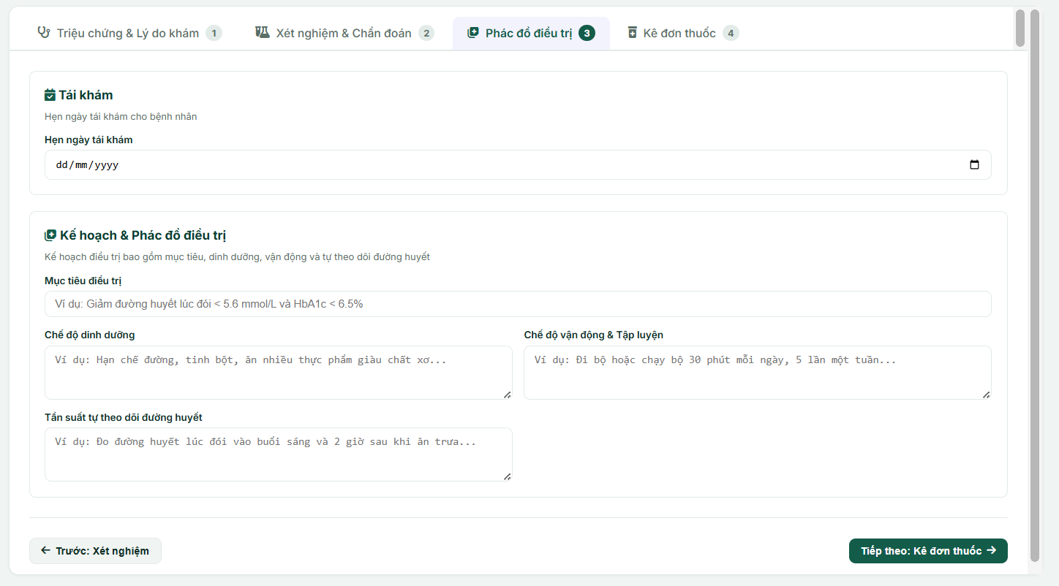
Field Name / UI Control | Field Type | Description
Next Appointment Date | Date Input | Allows the doctor to select a follow-up date for the patient.
Treatment Goal | Text Input | Sets specific therapeutic targets.
Diet Plan | Text Area | Prescribes nutritional guidelines and dietary restrictions for the patient.
Exercise Plan | Text Area | Defines regular physical activities, duration, and exercise frequency.
Glucose Monitoring Frequency | Text Area | Instructs the patient on when and how often to measure blood glucose levels at home.
Tab navigation buttons ("Trước: Xét nghiệm" / "Tiếp theo: Kê đơn thuốc") | Action Button | Saves the current tab data and moves to Tab 2 or Tab 4.

Database Access
Table | CRUD | Description
ClinicalExamination | R, U | Read: Loads the drafted next appointment date. Update: Saves the next appointment date and exam status.
TreatmentPlan | C, R, U | Read: Loads the drafted treatment goals and plans for the clinical exam. Create: Inserts a new treatment plan record for the patient's exam. Update: Modifies the existing treatment goals, diet, exercise, and monitoring plans.

SQL Commands
1/ Retrieve Next Appointment Date for the Exam
sql
SELECT NextAppointment, Status
FROM [ClinicalExamination]
WHERE ClinicalExamID = ?;
2/ Retrieve Existing Treatment Plan for the Exam
sql
SELECT TreatmentGoal, DietPlan, ExercisePlan, GlucoseMonitoringPlan
FROM [TreatmentPlan]
WHERE ClinicalExamID = ?;
3/ Update Next Appointment Date
sql
UPDATE [ClinicalExamination]
SET NextAppointment = ?, Status = 'InProgress'
WHERE ClinicalExamID = ?;
4/ Create New Treatment Plan
sql
INSERT INTO [TreatmentPlan] (ClinicalExamID, TreatmentGoal, DietPlan, ExercisePlan, GlucoseMonitoringPlan, CreatedAt)
VALUES (?, ?, ?, ?, ?, GETDATE());
5/ Update Existing Treatment Plan
sql
UPDATE [TreatmentPlan]
SET TreatmentGoal = ?, DietPlan = ?, ExercisePlan = ?, GlucoseMonitoringPlan = ?
WHERE ClinicalExamID = ?;

e. Prescription Management Screen
This screen is Step 4 ("Kê đơn thuốc") of the 4-step clinical examination. The doctor views all added medications inside a card list, edits or deletes existing entries, and uses an inline add/edit panel to select a medication from the catalog, configure dosage, and select multi-point timing schedules. Added lines are held in the session and only persisted, together with the rest of the exam, when the doctor completes the examination.

Layout Requirement: Embedded with the persistent a. Patient General Information Component layout at the top.
Related Use Cases
UC-23 Prescribe Medications

UI Design
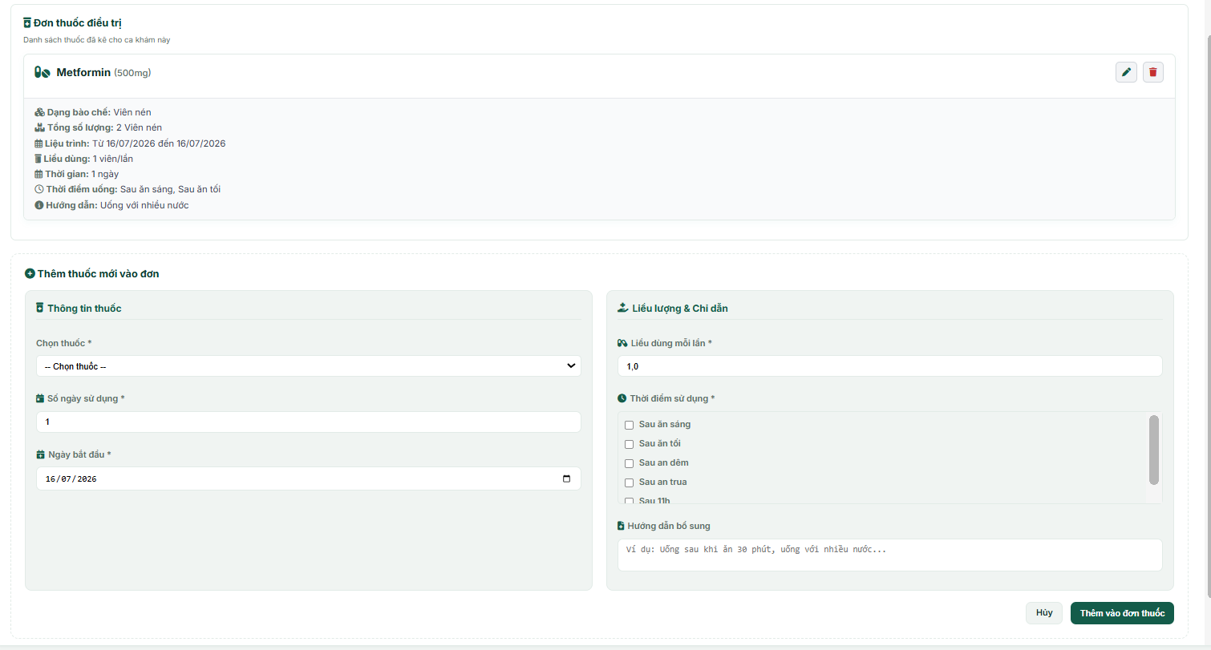
Field Name / UI Control | Field Type | Description
Prescription Items List | Container | Displays added medication details.
"Edit" Icon Button | Action Button | Reloads the screen with the inline form pre-filled for the selected prescription line.
"Delete" Icon Button | Action Button | Prompts a confirmation dialog to delete the medication from the prescription.
Choose Medication | Dropdown Select | Selects a medication from the catalog.
Duration Days | Number Input | Number of days the medication should be taken.
Start Date | Date Input | The date the patient starts taking the medication.
Dosage Per Intake | Number Input | Dosage to take per administration.
Intake Timings | Multi-Select | Checkboxes to select intake timings.
Additional Instructions | Text Area | Additional advice for the medication.
"Thêm vào đơn thuốc" / "Cập nhật thuốc" Button | Action Button | Adds the medication to, or updates it in, the prescription list held for this exam.
"Hoàn thành ca khám" / "Hoàn tất chỉnh sửa" Button | Action Button | Saves all prescription lines to the database and marks the examination as Completed.

Database Access
Table | CRUD | Description
Medication | R | Reads the medication catalog for the selection, and looks up the chosen medication when a line is added.
MedicationTiming | R | Reads the list of standard daily timing frequencies for the checkboxes.
Prescription | C, R, D | Read: Loads the saved prescription for the examination. Delete: Clears the previous prescription. Create: Generates a new prescription header. Written once, when the examination is completed.
PrescriptionDetail | C, R, D | Read: Loads saved detail lines. Create: Inserts dosage, duration, and quantity lines. Delete: Clears old details before re-saving. Written once, when the examination is completed.
PrescriptionTiming | C, R, D | Create: Links timing selections to a detail line. Delete: Clears old timing links. Written once, when the examination is completed.
SQL Commands
1/ Fetch Medication Catalog (for the dropdown)
sql
SELECT MedicationID, MedicationName, Concentration, Form
FROM [Medication];
2/ Fetch Medication Timings Catalog
sql
SELECT TimingID, TimingName
FROM [MedicationTiming];
3/ Retrieve Saved Prescription for the Exam
sql
SELECT pd.PrescriptionDetailID, pd.MedicationID, pd.Dosage, pd.DurationDays, pd.TotalQuantity,
pd.StartDate, pd.EndDate, pd.MedicationPlan
FROM [PrescriptionDetail] pd
JOIN [Prescription] p ON pd.PrescriptionID = p.PrescriptionID
WHERE p.ClinicalExamID = ?;
4/ Clear Old Prescription Details
sql
DELETE FROM [PrescriptionDetail]
WHERE PrescriptionID = (SELECT PrescriptionID FROM [Prescription] WHERE ClinicalExamID = ?);
5/ Clear Old Prescription Header
sql
DELETE FROM [Prescription]
WHERE ClinicalExamID = ?;
6/ Create Prescription Header
sql
INSERT INTO [Prescription] (PrescriptionID, ClinicalExamID, CreatedAt)
VALUES (?, ?, GETDATE());
7/ Insert Prescription Detail Line
sql
INSERT INTO [PrescriptionDetail] (PrescriptionDetailID, PrescriptionID, MedicationID, Dosage, DurationDays, TotalQuantity, StartDate, EndDate, MedicationPlan)
VALUES (?, ?, ?, ?, ?, ?, ?, ?, ?);
8/ Insert Prescription Timing Link
sql
INSERT INTO [PrescriptionTiming] (PrescriptionDetailID, TimingID)
VALUES (?, ?);

4.5 Patient Medical History Screen
This screen displays the patient's comprehensive medical history as a chronological timeline of past examinations. The doctor can filter these records by date range, view summaries of reasons for visit, diagnoses or cancellation notes, and paginate through records at a limit of 5 items per page.

Related Use Cases
UC-25 View Patient Medical History

UI Design
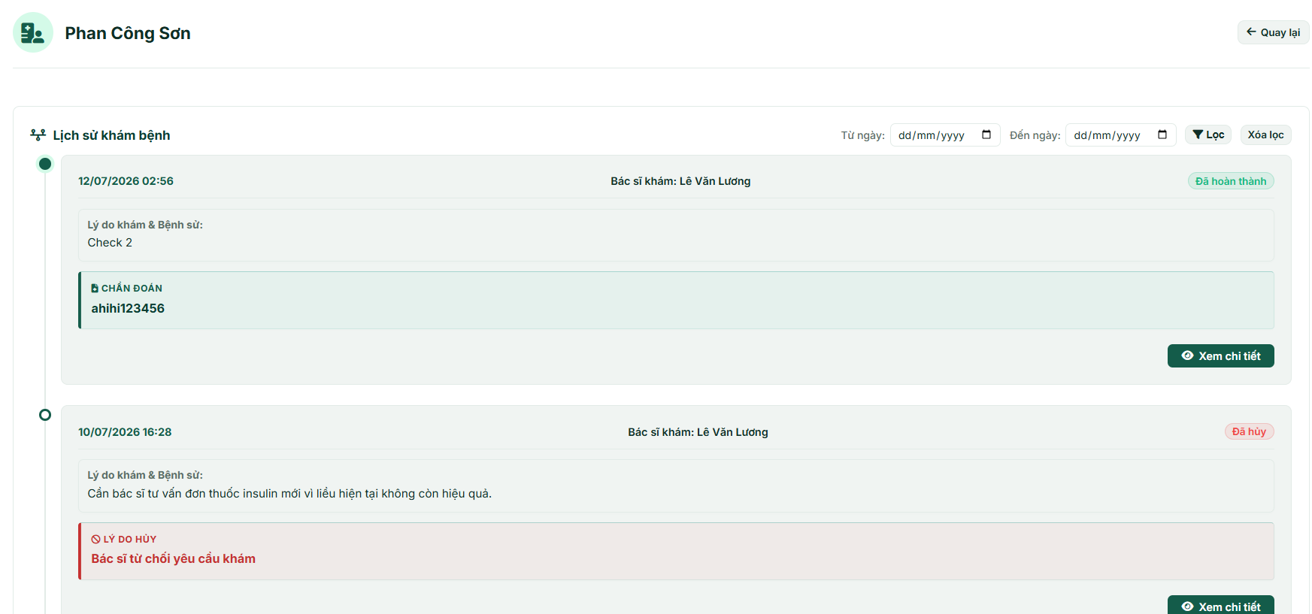
Field Name / UI Control | Field Type | Description
Back Button | Navigation Link | Return to the active examination queue.
Start Date Filter | Date Input | Filters clinical examinations starting from the selected date.
End Date Filter | Date Input | Filters clinical examinations up to the selected date.
"Lọc" (Filter) Button | Action Button | Submits the date parameters to filter the history timeline.
"Xóa lọc" Link | Navigation Link | Resets the start/end date filters and loads the entire timeline history.
Timeline Trail | Container | Displays the clinical examination cards vertically in chronological order.
Timeline Item Card | Card Container | Shows the exam date/time, doctor name, and status badge ("Đã hoàn thành" / "Đã hủy").
Reason & History Card | Card Block | Displays the patient's initial reason for visit and medical history notes.
Diagnosis Card | Card Block | Displays the final diagnostic remarks (only visible for Completed exams).
Cancellation Card | Card Block | Displays the cancellation reason (only visible for Cancelled exams).
"Xem chi tiết" Button | Navigation Link | Navigates the doctor to the detailed view of the selected clinical examination.
Pagination Bar | Navigation Control | Renders page buttons and page numbers when total records exceed 5 items/page.

Database Access
Table | CRUD | Description
Patient | R | Reads the patient's full name, ID, and avatar image.
ClinicalExamination | R | Queries today's and past examinations (Completed/Cancelled), handles filters and pagination.
Profile | R | Read the full name of the doctor who conducted each historical examination.

SQL Commands
1/ Fetch Patient Profile

sql
SELECT UserID, FullName, ImageUrl
FROM [Patient]
WHERE UserID = ?;
2/ Fetch Count of Filtered Clinical Examinations (for Pagination)

sql
SELECT COUNT(*)
FROM [ClinicalExamination]
WHERE PatientID = ?
AND Status IN ('Completed', 'Cancelled')
AND (? = '' OR ExamDate >= ?)
AND (? = '' OR ExamDate <= ?);
3/ Fetch Paginated and Filtered Clinical Examinations

sql
SELECT e.ClinicalExamID, e.ExamDate, e.MedicalHistory, e.DiagnosisNote, e.CancelReason, e.Status,
dp.FullName AS DoctorName
FROM [ClinicalExamination] e
JOIN [User] d ON e.DoctorID = d.UserID
LEFT JOIN [Profile] dp ON d.UserID = dp.UserID
WHERE e.PatientID = ?
AND e.Status IN ('Completed', 'Cancelled')
AND (? = '' OR e.ExamDate >= ?)
AND (? = '' OR e.ExamDate <= ?)
ORDER BY e.ExamDate DESC
OFFSET ? ROWS FETCH NEXT ? ROWS ONLY;

4.6 Clinical Examination Detail Screen
This screen allows the doctor to view the absolute details of a specific past clinical examination. It renders static panels showing chosen symptoms with doctor notes, full treatment goal plans (diet, exercise, glucose monitoring), ordered laboratory test results with flags (LOW/CAO/BÌNH THƯỜNG), and the complete prescribed medication details.

Related Use Cases
UC-25 View Patient Medical History

UI Design
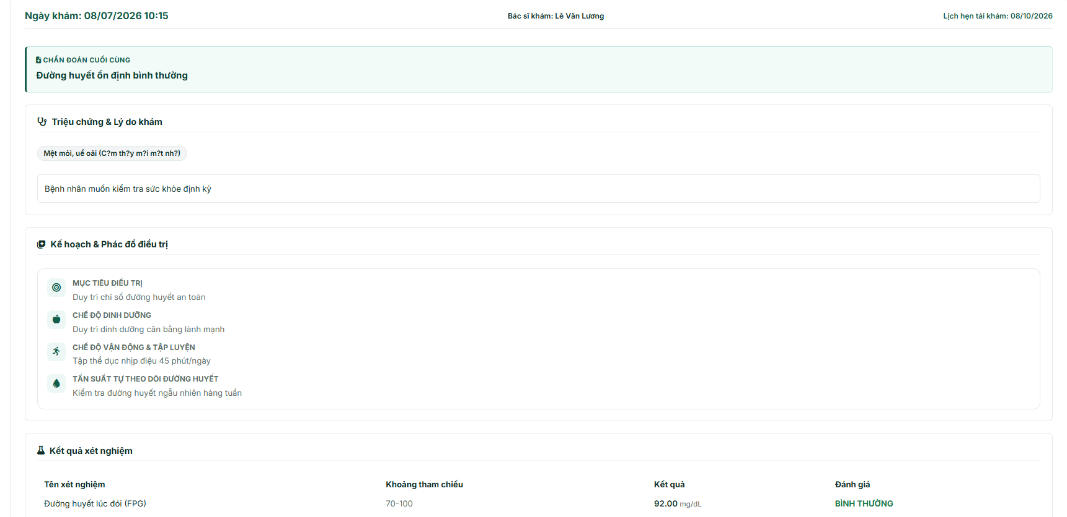
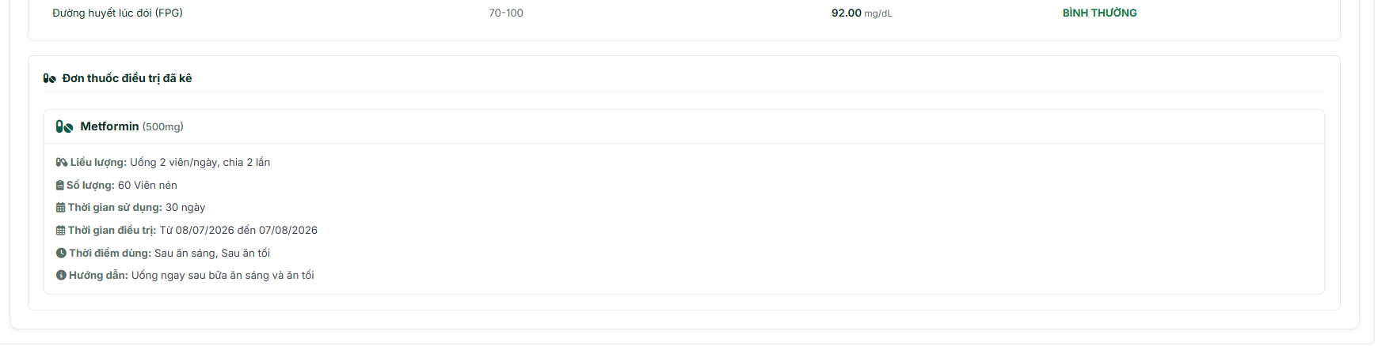
Field Name / UI Control | Field Type | Description
Back Button | Navigation Link | Returns to the patient's medical history timeline screen.
Examination Header Meta | Grid Panel | Displays treat date, and treating doctor's name.
Diagnosis Card | Card Block | Displays the final diagnostic remarks (only visible for Completed exams).
Cancellation Card | Card Block | Displays the cancellation reason (only visible for Cancelled exams).
Symptoms List | Card Panel | Lists selected symptoms as badges alongside their custom remarks.
Treatment Plan List | Card Panel | Displays goals, nutrition/diet tips, exercise routines, and glucose check plans.
Lab Results Table | Table Container | Lists test name, reference range, value, and status flag (normal/low/high).
Prescription Cards List | Container | Lists all prescribed drugs, dosages, quantities, treatment duration, end/start date, times, and medication plan.

Database Access
Table | CRUD | Description
Patient | R | Reads the patient's full name, ID, and avatar image.
ClinicalExamination | R | Read the core record (date, medical history, diagnosis note, next appointment, status).
TreatmentPlan | R | Read the goals, diet plans, exercise plans, and monitoring schedule.
ExamSymptom | R | Read symptoms and custom notes associated with the exam.
LabResult | R | Read the laboratory test details, result values, and flag statuses.
PrescriptionDetail | R | Reads medication dosages, quantities, duration, and instructions.
PrescriptionTiming | R | Reads intake timings linked to the prescription details.

SQL Commands
1/ Fetch Clinical Examination Core Record

sql
SELECT e.ClinicalExamID, e.ExamDate, e.MedicalHistory, e.DiagnosisNote, e.CancelReason, e.NextAppointment, e.Status,
dp.FullName AS DoctorName
FROM [ClinicalExamination] e
JOIN [User] d ON e.DoctorID = d.UserID
LEFT JOIN [Profile] dp ON d.UserID = dp.UserID
WHERE e.ClinicalExamID = ?;
2/ Fetch Patient Profile

sql
SELECT UserID, FullName, ImageUrl
FROM [Patient]
WHERE UserID = ?;
3/ Fetch Treatment Plan Details

sql
SELECT TreatmentGoal, DietPlan, ExercisePlan, GlucoseMonitoringPlan
FROM [TreatmentPlan]
WHERE ClinicalExamID = ?;
4/ Fetch Selected Symptoms and Remarks

sql
SELECT s.SymptomName, es.Note
FROM [ExamSymptom] es
JOIN [SymptomsCatalog] s ON es.SymptomID = s.SymptomID
WHERE es.ClinicalExamID = ?;
5/ Fetch Laboratory Test Results

sql
SELECT lt.TestName, lr.ReferenceRange, lr.ResultValue, lt.Unit, lr.Flag
FROM [LabResult] lr
JOIN [LabOrder] lo ON lr.LabOrderID = lo.LabOrderID
JOIN [LabTest] lt ON lr.LabTestID = lt.LabTestID
WHERE lo.ClinicalExamID = ?;
6/ Fetch Prescribed Medications

sql
SELECT pd.PrescriptionDetailID, m.MedicationName, m.Concentration, m.Form, pd.Dosage, pd.TotalQuantity, pd.DurationDays, pd.StartDate, pd.EndDate, pd.MedicationPlan
FROM [PrescriptionDetail] pd
JOIN [Prescription] p ON pd.PrescriptionID = p.PrescriptionID
JOIN [Medication] m ON pd.MedicationID = m.MedicationID
WHERE p.ClinicalExamID = ?;
7/ Fetch Timings for Prescription Detail Line

sql
SELECT mt.TimingName
FROM [PrescriptionTiming] pt
JOIN [MedicationTiming] mt ON pt.TimingID = mt.TimingID
WHERE pt.PrescriptionDetailID = ?;

4.7 Patient Medication Schedule Screen

a. Patient Medication Schedule List Screen
This is the patient medication reminders management screen for Doctors (Role DOC). It lists all patients who have scheduled medication or checkup reminders today. Doctors can search patients by name or ID, view their basic demographics (age/gender), their latest clinical exam time, and navigate to the detailed reminders log list for each patient.
Related Use Cases:
- UC-32: View Patient Medication Schedule

UI Design
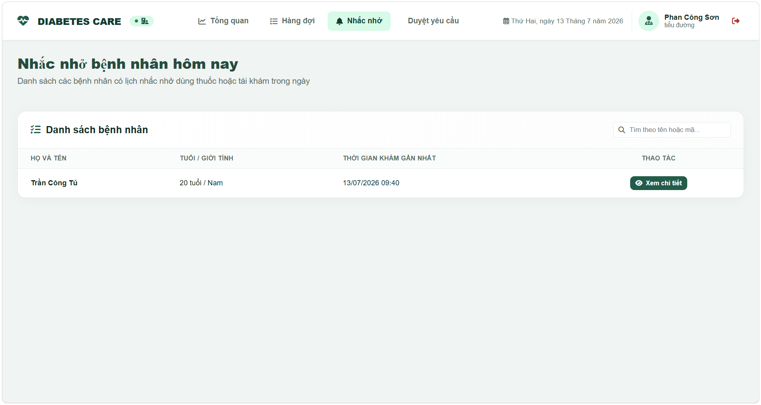
UI Elements Table
Field Name | Field Type | Description
Header Utilities
Thanh điều hướng Doctor | Navigation bar | Contains top navigation links: "Tổng quan", "Hàng đợi", "Nhắc nhở" (active), "Duyệt yêu cầu".
Search Actions
Tìm theo tên hoặc mã... | Text Input | Performs search query matching Patient full name or User ID. Triggered on enter.
Grid Table Columns
Họ và tên | Text (cell) | Displays patient's full name.
Tuổi / Giới tính | Text (cell) | Displays calculated age and gender label (e.g. 20 tuổi / Nam).
Thời gian khám gần nhất | Text (cell) | Displays the date and time of the latest checkup. Renders "Chưa có lịch sử khám" if null.
Thao tác | Button (Link) | Clicking redirects the Doctor to the detailed reminders timeline log for that patient (/doctor/reminders/{patientId}).

Database Access
Table | CRUD | Description
Reminder | R | Reads scheduled reminders today to fetch list of active patients.
Patient | R | Reads demographic data (Full name, DOB, gender).
ClinicalExamination | R | Reads latest exam timestamps.

SQL Commands
1/ Retrieve patients having reminders scheduled today
sql
SELECT DISTINCT p.UserID, p.FullName, p.DOB, p.Gender
FROM Patient p
INNER JOIN Reminder r ON p.UserID = r.PatientID
WHERE CAST(r.ScheduledTime AS DATE) = CAST(GETDATE() AS DATE);
2/ Query latest clinical examination date for a patient
sql
SELECT MAX(ExamDate)
FROM ClinicalExamination
WHERE PatientID = ?;

b. Patient Medication Schedule Detail Screen
This screen displays the complete detailed list of today's reminders generated for a selected patient. It highlights patient metadata (full name, age, gender, phone number) in a green banner block and lists each reminder card in chronological order, indicating the scheduled time, title, message content, delivery status ("Đã gửi" / "Chờ gửi"), and read status ("Đã đọc" / "Chưa đọc").
Related Use Cases:
- UC-32: View Patient Medication Schedule

UI Design
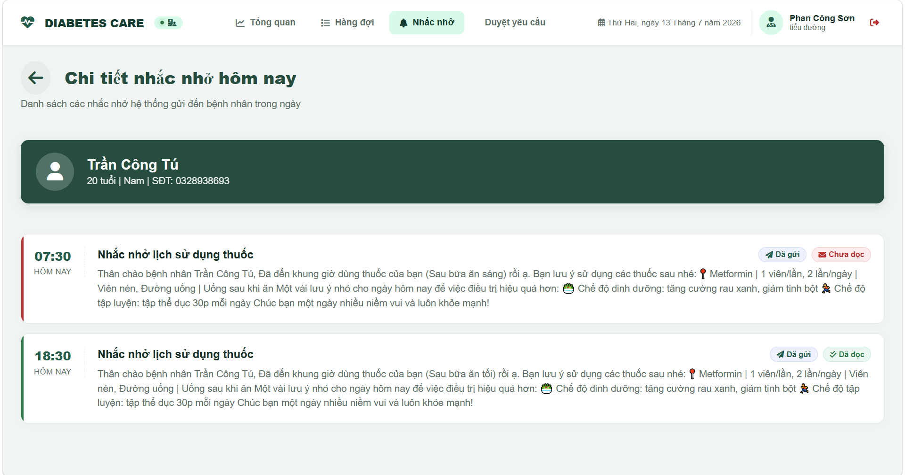
UI Elements Table
Field Name | Field Type | Description
Action Options
Quay lại | Button (Link) | Navigates back to the main patient reminders list screen.
Patient Info Banner
Thông tin bệnh nhân | Banner Block | Displays full name, age, gender, and phone number in a forest green container banner.
Reminder Card Timeline
Giờ nhắc | Time Text | Intake scheduled alert hour (e.g. 07:30) formatted.
Tiêu đề nhắc nhở | Text (h3) | Alert title header (e.g. Nhắc nhở lịch sử dụng thuốc).
Nội dung tin nhắn | Text | Complete template message details sent to the patient.
Trạng thái gửi | Badge | Dynamic badge: "Đã gửi" (Blue) or "Chờ gửi" (Gray).
Trạng thái đọc | Badge | Dynamic badge: "Đã đọc" (Green) or "Chưa đọc" (Red).

Database Access
Table | CRUD | Description
Reminder | R | Read all reminders matching target patients scheduled today.
Patient | R | Reads demographics for user profile checks.

SQL Commands
1/ Retrieve reminders of patient scheduled today
sql
SELECT r.ReminderID, r.Title, r.Message, r.ScheduledTime, r.IsSent, r.IsRead
FROM Reminder r
WHERE r.PatientID = ?
AND CAST(r.ScheduledTime AS DATE) = CAST(GETDATE() AS DATE)
ORDER BY r.ScheduledTime ASC;
2/ Query target patient demographics
sql
SELECT UserID, FullName, DOB, Gender, PhoneNumber
FROM Patient
WHERE UserID = ?;

4.8 Doctor Profile Screen

a. Doctor Profile Details Screen
This screen allows the logged-in doctor to view and update their personal information and professional details. The doctor can modify their full name, upload a new avatar image, select their specialty and clinic room assignment, email address, date of birth, gender, and office location address.

Related Use Cases
UC-07 Manage Doctor Profile

UI Design
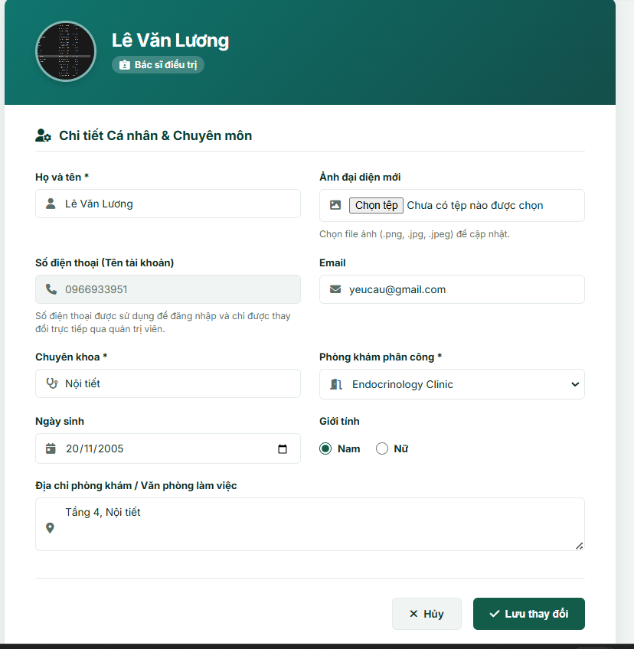
Field Name / UI Control | Field Type | Description
Patient Avatar | Image | Displays the doctor's current profile picture or a default icon.
Full Name | Text Input | Doctor's full name.
New Avatar File | File Input | Allows the doctor to upload a new profile picture.
Phone Number | Text Input | Displays the login phone number. Attribute: Read-only.
Email | Text Input | Doctor's email address.
Specialty | Text Input | Doctor's medical specialty.
Clinic Room | Dropdown Select | List of clinic rooms for assignment.
Date of Birth | Date Input | Doctor's birth date.
Gender | Radio Buttons | Options to select doctor's gender ("Nam" or "Nữ").
Office Address | Text Area | Clinic office location or workplace address.
"Lưu thay đổi" Button | Action Button | Submits and saves the updated personal and professional profile details.
"Hủy" Button | Navigation Link | Returns the doctor to the dashboard.

Database Access
Table | CRUD | Description
Profile | R, U | Read: Loads the doctor's name, email, specialty, room, dob, gender, address, and avatar image.  Update: Modifies the doctor's profile attributes.
Room | R | Queries the list of clinic rooms for the dropdown selection.

SQL Commands
1/ Fetch Doctor Profile Details

sql
SELECT UserID, FullName, Email, Specialty, RoomID, Dob, Gender, Address, ImageUrl
FROM [Profile]
WHERE UserID = ?;
2/ Fetch Clinic Rooms Catalog

sql
SELECT RoomID, RoomName
FROM [Room];
3/ Update Doctor Profile

sql
UPDATE [Profile]
SET FullName = ?, Email = ?, Specialty = ?, RoomID = ?, Dob = ?, Gender = ?, Address = ?, ImageUrl = ?
WHERE UserID = ?;

b. Doctor Password Update Screen
This screen allows the doctor to update their account login credentials. The doctor must enter their current password, input a new password adhering to standard complexity requirements, and confirm the new password to proceed.

Related Use Cases
UC-08 Reset Password in Doctor Profile

UI Design
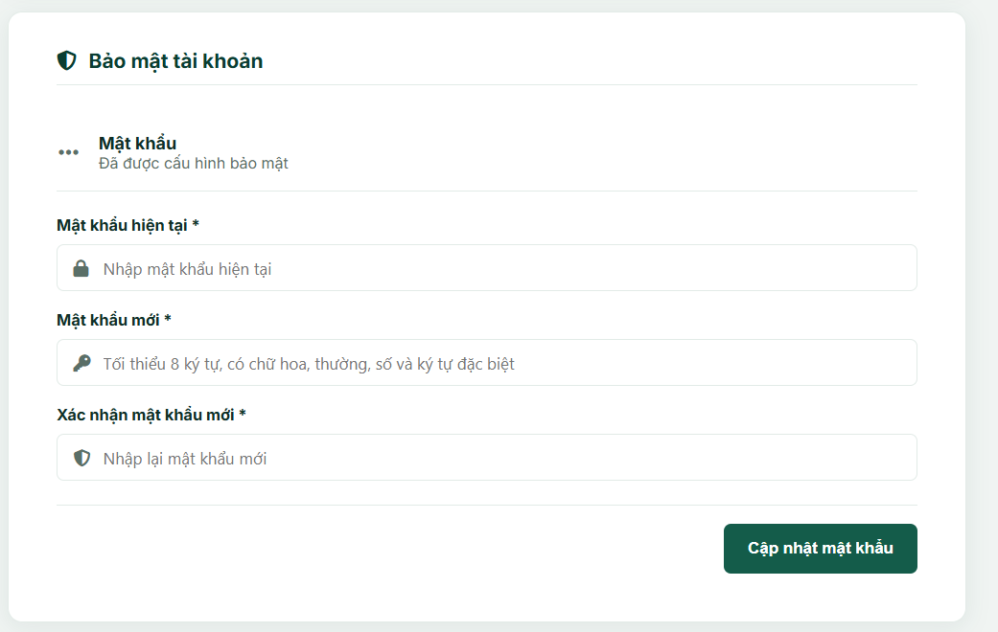
Field Name / UI Control | Field Type | Description
Current Password | Password Input | Text field to enter the doctor's current account password.
New Password | Password Input | Text field to enter a new password (min 8 characters).
Confirm Password | Password Input | Text field to confirm the new password.
"Cập nhật mật khẩu" | Action Button | Validates inputs and updates the account password.

Database Access
Table | CRUD | Description
User | R, U | Read: Loads the current hashed password to verify.  Update: Saves the new hashed password.

SQL Commands
1/ Fetch Current Hashed Password

sql
SELECT Password
FROM [User]
WHERE UserID = ?;
2/ Update Hashed Password

sql
UPDATE [User]
SET Password = ?
WHERE UserID = ?;

5. Patient Portal

5.1 Patient Dashboard
The patient landing page displaying health indices (BMI, Diabetes risk level), upcoming follow-up appointments, current visit progress, and scheduled medication reminders for today.

UI Design
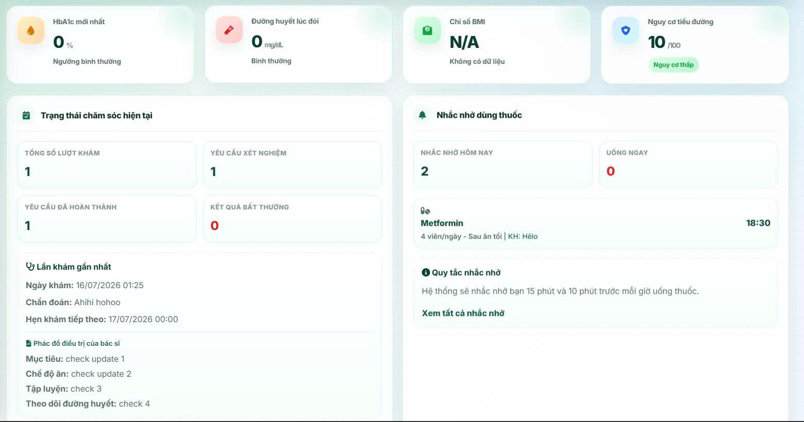

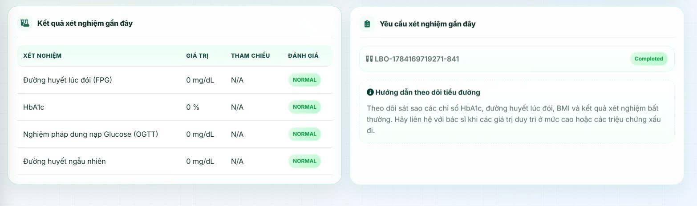
Field Name | Field Type | Description
Latest HbA1c | Statistic Card | Displays the percentage of HbA1c and assessment.
Latest Glucose | Statistic Card | Displays fasting glucose value and assessment.
BMI | Statistic Card | Displays BMI calculated from Height and Weight.
Risk Level | Statistic Card | Displays diabetes risk level (Low, Prediabetes, High).
Appointment Alert | Alert Panel | Displays the next scheduled follow-up appointment (date, clinic room, doctor).
Medication Reminders | List Widget | List of scheduled medication reminders for today.
Recent Lab Results | Table | Table showing recent laboratory test values.
Lab Test Status | List Widget | Displays statuses of today's laboratory orders.

Database Access
Table | CRUD | Description
Patient | R | Read height and weight to calculate BMI.
ClinicalExamination | R | Read details of the upcoming follow-up appointment.
LabResult | R | Read Glucose/HbA1c test results.
AI_Reminder | R | Read scheduled medication reminders for today.
SQL Commands
1/ Get latest next appointment
SELECT TOP 1 NextAppointment, DoctorID, ClinicalExamID
FROM ClinicalExamination
WHERE PatientID = ?
AND Status = 'Completed'
AND NextAppointment >= GETDATE()
ORDER BY NextAppointment ASC;

2/ Get recent lab results
SELECT lr.ResultValue, lr.Flag, lt.TestName, lr.ReferenceRange
FROM LabResult lr
JOIN LabOrder lo ON lr.LabOrderID = lo.LabOrderID
JOIN ClinicalExamination ce ON lo.ClinicalExamID = ce.ClinicalExamID
JOIN Lab_Test_Catalog lt ON lr.LabTestID = lt.LabTestID
WHERE ce.PatientID = ?
ORDER BY ce.ExamDate DESC;

5.2 Patient Profile Screen
Displays the patient's personal details, medical history, allergies, emergency contact, and allows editing of editable details or initiating a password change.

UI Design

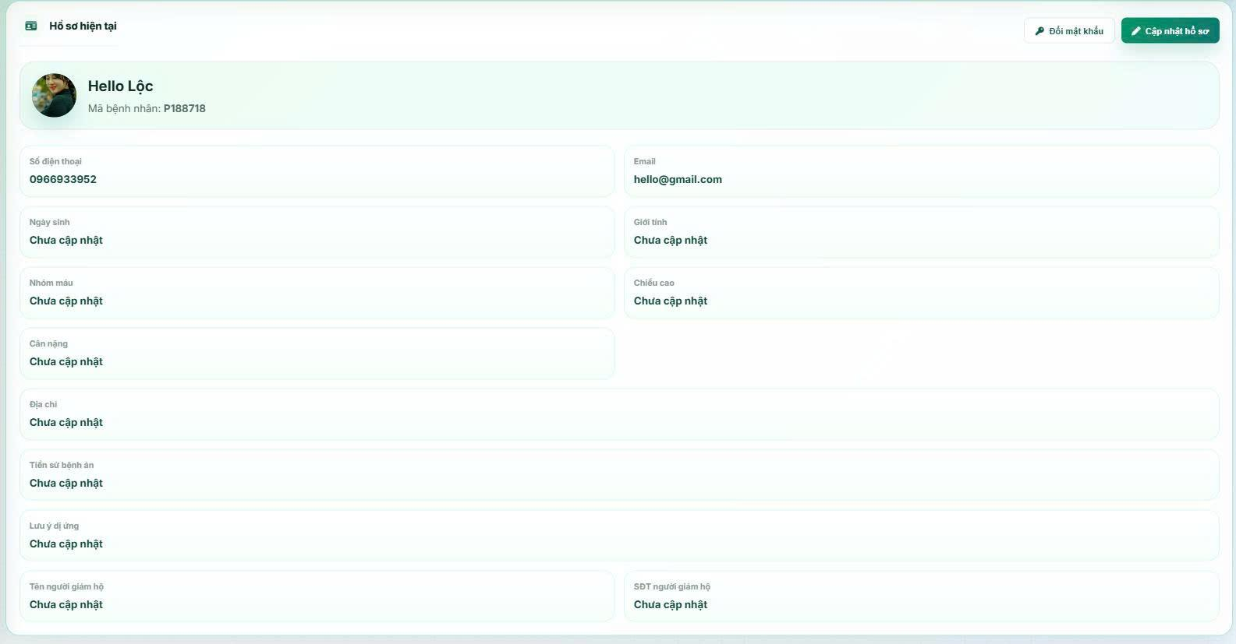

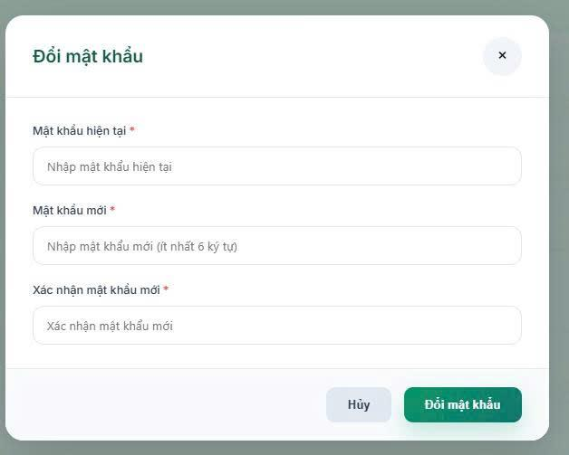

Field Name | Field Type | Description
Full Name | Text Input | View and edit the patient's full name.
Phone Number | Text Input | View registered phone number (Read-only).
Date of Birth | Date Picker | View and edit date of birth.
Gender | Radio Button | View and edit gender.
Blood Group | Combo Box | View and edit blood type.
Height | Number Input | View and edit height (cm).
Weight | Number Input | View and edit weight (kg).
Address | Text Input | View and edit residential address.
Email | Text Input | View and edit email address.
Medical History | Text Area | View and edit chronic disease notes.
Allergies | Text Area | View and edit drug or food allergies.
Supervisor Name | Text Input | View and edit emergency contact name.
Supervisor Phone | Text Input | View and edit emergency contact phone number.
Save Changes | Button | Saves the updated profile to the database.
Change Password | Button | Opens the password modification modal.

Database Access
Table | CRUD | Description
Patient | R, U | Read and update patient details in the database.
SQL Commands
1/ Load Patient Profile
SELECT * FROM Patient
WHERE UserID = ?;
2/ Update Patient Profile
UPDATE Patient SET FullName = ?, Dob = ?, Gender = ?, Bloodgroup = ?, Height = ?, Weight = ?, Address = ?, PermanentMedicalHistory = ?, AllergyNotes = ?, SupervisorName = ?, SupervisorPhone = ?, Email = ?
WHERE UserID = ?;

5.3 Medical Records History Screen
The Medical Records History Screen allows patients to review all previous medical examination records stored in the system. Patients can search records by date range and select a specific record to view detailed examination information, including diagnosis, laboratory results, prescriptions, and treatment plans.

UI Design

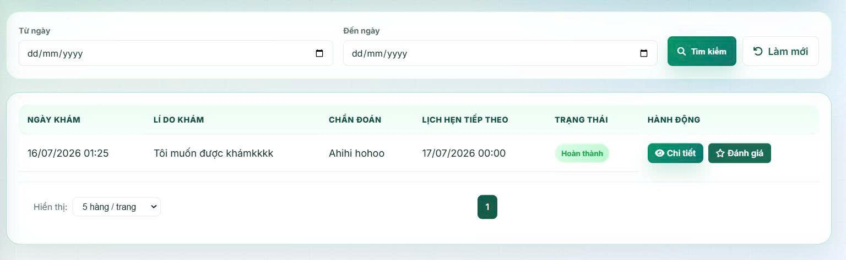

Field Name | UI Control | Field Type | Description
Page Title | Label | Text | Displays "Medical Records History".
From Date | Date Picker | Date | Selects the beginning date for filtering records.
To Date | Date Picker | Date | Selects the ending date for filtering records.
Search | Button | Action | Searches medical records within the selected date range.
Reset | Button | Action | Clears all search conditions.
Medical Records Table | Data Grid | Table | Displays the patient's examination history.
Examination Date | Column | Date | Date of examination.
Doctor Name | Column | Text | Name of the attending doctor.
Diagnosis | Column | Text | Primary diagnosis.
Status | Column | Text | Completed / In Progress.
View Detail | Button | Action | Opens Medical Record Detail Screen.
Pagination | Navigation | Control | Navigates through record pages.

Database Access

Table | CRUD | Description
MedicalRecord | R | Retrieve patient's medical records.
Examination | R | Retrieve examination information.
Diagnosis | R | Retrieve diagnosis summary.
Appointment | R | Retrieve examination date.
Doctor | R | Retrieve doctor's full name.

SQL Commands:
1/ Load Medical History
SELECT mr.RecordID, a.AppointmentDate, d.FullName AS DoctorName, dg.DiagnosisName, mr.Status FROM MedicalRecord mr
INNER JOIN Appointment a ON mr.AppointmentID = a.AppointmentID
INNER JOIN Doctor d ON mr.DoctorID = d.DoctorID
LEFT JOIN Diagnosis dg ON mr.DiagnosisID = dg.DiagnosisID
WHERE mr.PatientID = @PatientID
ORDER BY a.AppointmentDate DESC;

2/ Search by Date Range
SELECT mr.RecordID, a.AppointmentDate, d.FullName, dg.DiagnosisName, mr.Status
FROM MedicalRecord mr
INNER JOIN Appointment a ON mr.AppointmentID = a.AppointmentID
INNER JOIN Doctor d ON mr.DoctorID = d.DoctorID
LEFT JOIN Diagnosis dg ON mr.DiagnosisID = dg.DiagnosisID
WHERE mr.PatientID = @PatientID
AND a.AppointmentDate BETWEEN @FromDate
AND @ToDate
ORDER BY a.AppointmentDate DESC;

5.4 Medical Record Detail Screen
A comprehensive detail screen showing a patient's historical check-up session including attending physician, symptoms, laboratory findings, final diagnosis, treatment plans, and prescriptions.

UI Design

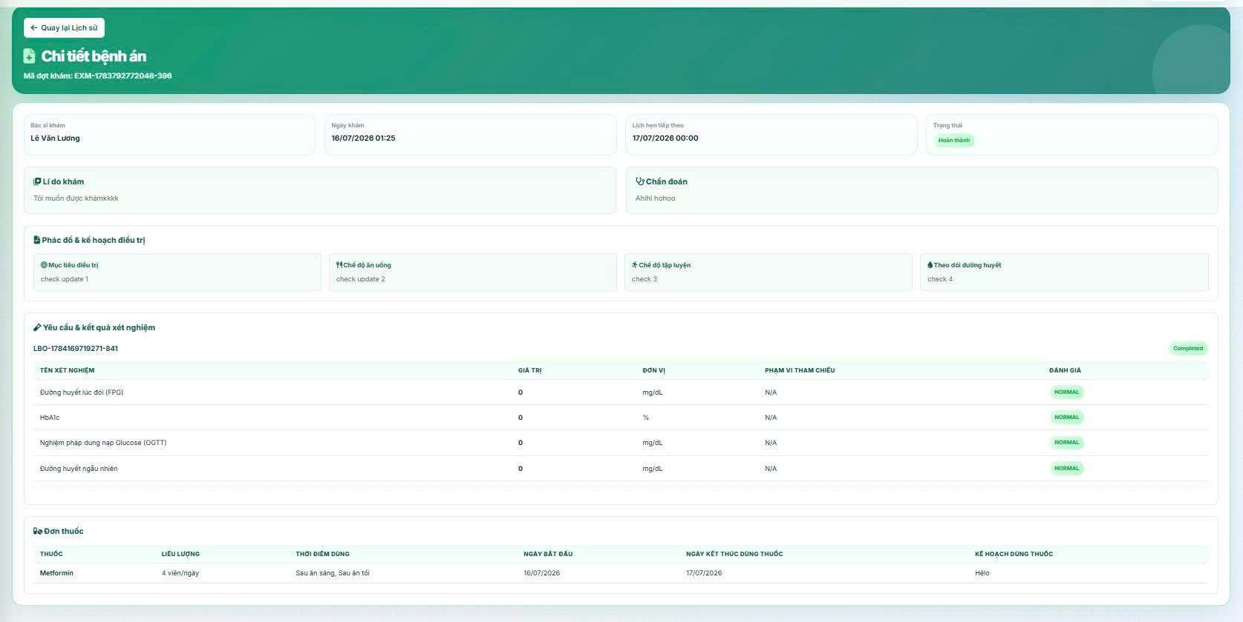

Field Name | Field Type | Description
Examination Info | Label | Displays Exam ID, Exam Date, Attending Doctor, and Final Diagnosis.
Reason for Visit | Text View | Displays patient's symptoms or check-up reasons.
Recorded Symptoms | Table | List of recorded symptoms with doctor's clinical notes.
Laboratory Results | Table | Table of test name, unit, value, reference range, and abnormal flags.
Prescription Details | Table | Table of prescribed medications (Name, form, dosage, quantity, schedule, instructions).
Treatment Plan | Panel | Displays treatment goals, dietary advice, exercise plan, and glucose monitoring plan.

Database Access
Table | CRUD | Description
ClinicalExamination | R | Read clinical examination overview.
ExamSymptom | R | Read symptoms associated with the exam.
LabResult | R | Read lab results of the exam.
PrescriptionDetail | R | Read prescription details.
TreatmentPlan | R | Read treatment plan of the exam.
SQL Commands
1/ Get Clinical Examination Details
SELECT * FROM ClinicalExamination
WHERE ClinicalExamID = ?;

2/ Get Associated Symptoms
SELECT es.Note, sc.SymptomName
FROM ExamSymptom es
JOIN Symptoms_Catalog sc ON es.SymptomID = sc.SymptomID
WHERE es.ClinicalExamID = ?;

3/ Get Prescription Details
SELECT pd.*, m.MedicationName, m.Form, m.Concentration
FROM PrescriptionDetail pd
JOIN Medication m ON pd.MedicationID = m.MedicationID
JOIN Prescription p ON pd.PrescriptionID = p.PrescriptionID
WHERE p.ClinicalExamID = ?;

4/ Get Treatment Plan details
SELECT * FROM TreatmentPlan
WHERE ClinicalExamID = ?;

5.5 Treatment Progress Screen
Allows patients to track their current visit status in real-time (Requested, Pending, InProgress, Completed, Cancelled) along with clinical orders today.

UI Design

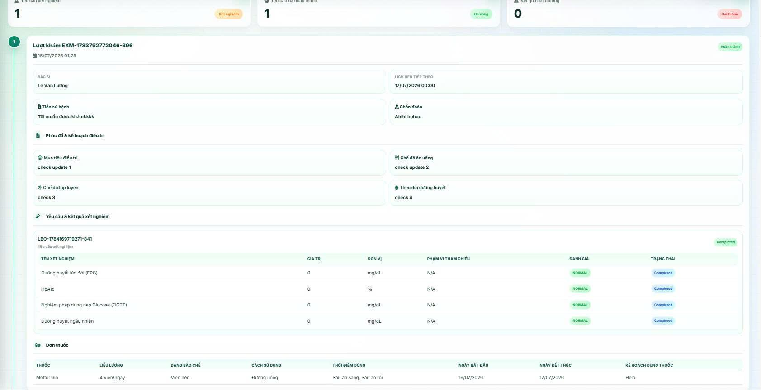

Field Name | Field Type | Description
Examination ID | Label | Displays current examination session identifier.
Examination Status | Badge | Displays status: Requested / Pending / InProgress / Completed / Cancelled.
Assigned Clinic/Room | Label | Displays assigned room or lab section location.
Laboratory Tests List | Table | Displays lab tests ordered today and their status (Pending / Completed).

Database Access
Table | CRUD | Description
ClinicalExamination | R | Read current examination status today.
LabOrder | R | Read list of lab orders today.
SQL Commands
1/ Get active examination today
SELECT * FROM ClinicalExamination
WHERE PatientID = ?
AND CAST(ExamDate AS DATE) = CAST(GETDATE() AS DATE)
ORDER BY ExamDate DESC;

2/ Get active lab orders
SELECT lo.LabOrderID, lo.Status, lt.TestName, lt.RoomID
FROM LabOrder lo
JOIN ClinicalExamination ce ON lo.ClinicalExamID = ce.ClinicalExamID
JOIN LabResult lr ON lo.LabOrderID = lr.LabOrderID
JOIN Lab_Test_Catalog lt ON lr.LabTestID = lt.LabTestID
WHERE ce.PatientID = ?
AND CAST(ce.ExamDate AS DATE) = CAST(GETDATE() AS DATE);

5.6 Medication & Next Appointment Reminder Screen

a. Medication Reminders Screen
This is the primary gateway for Patients (Role PAT) to monitor their daily medication intake schedule and AI notifications. It displays dynamic statistics counters (today's reminders, active due doses, upcoming, and health notifications) and a timeline list of today's medication logs categorized as "Uống ngay" (due now), "Sắp diễn ra" (upcoming), and "Đã qua" (past). The time is automatically generated and synchronized based on the doctor's active prescription.
Related Use Cases:
- UC-30: Receive and View Reminders and Notifications
UI Design
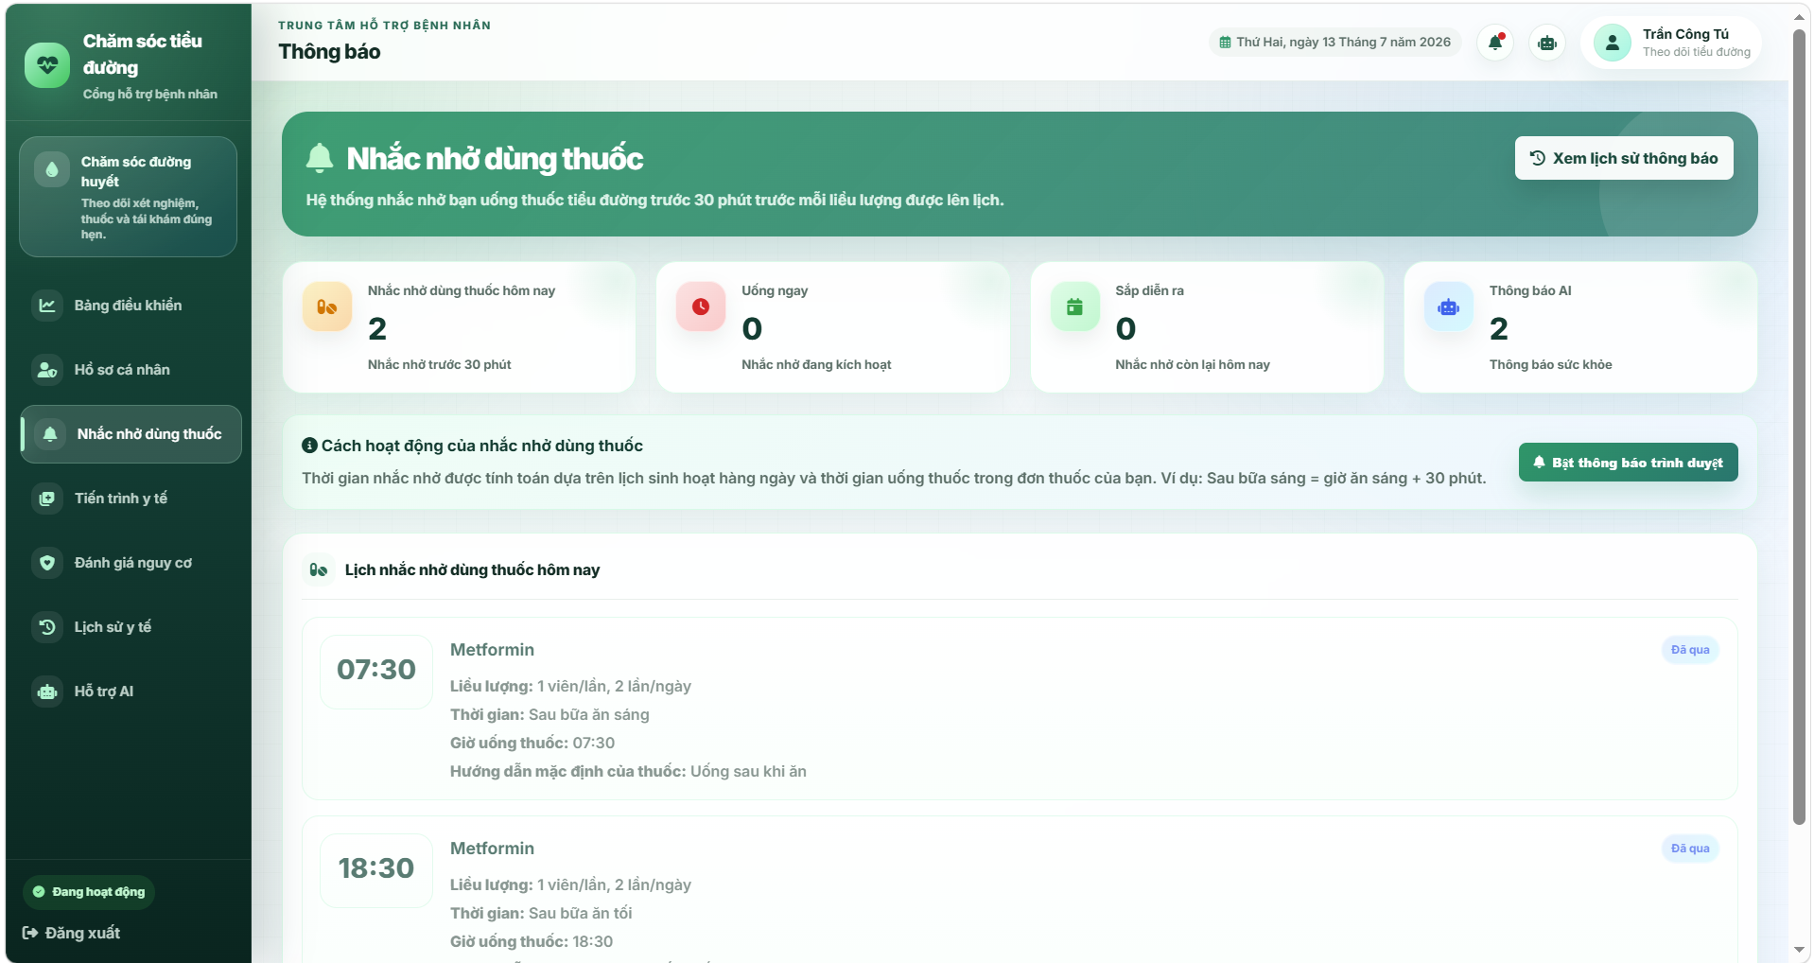
UI Elements Table
Field Name | Field Type | Description
Navigation Options
Xem lịch sử thông báo | Link / Button | Redirects to the complete grouped history page (/patient/notifications/history).
Bật thông báo trình duyệt | Button | Requests HTML5 browser permission to send desktop notifications.
Statistics Summary Cards
Nhắc nhở dùng thuốc hôm nay | Statistic Card | Displays count of all medications scheduled for today (dynamic model size).
Uống ngay | Statistic Card | Displays active count of reminders currently due for intake (dynamic model dueMedicationReminderCount).
Sắp diễn ra | Statistic Card | Displays remaining upcoming reminders for the day (dynamic model upcomingMedicationReminderCount).
Thông báo AI | Statistic Card | Displays count of AI assistant text notifications (dynamic model size of aiReminders).
Today Medication Timeline List
Giờ nhắc nhở | Time Text | Intake alarm hour (e.g. 08:00) rendered in the timeline timebox.
Tên thuốc | Text | Displays the prescribed drug name.
Trạng thái thời gian | Badge | Dynamic badge: "Uống ngay" (Red) / "Sắp diễn ra" (Green) / "Đã qua" (Info/Blue).
Liều lượng | Text | Displays dosage amount (e.g. 01 Viên).
Thời điểm | Text | General timing definition (e.g. Mỗi buổi sáng).
Kế hoạch dùng thuốc | Text | Plan details. Optional.
Hướng dẫn mặc định | Text | Clinical guidelines associated with the drug. Optional.

Database Access
Table | CRUD | Description
Reminder | R | Reads the list of reminders/notifications issued for the Patient.
Patient | R | Reads user data to associate notifications.
ClinicalExamination | R | Reads the patient's latest clinical examination to parse prescription details.
PrescriptionDetail | R | Reads medication name, dosage, frequency, and timing.
PrescriptionTiming | R | Reads timing IDs to map scheduled intake alarms.
Timing | R | Reads the timing labels.

SQL Commands
1/ Find notifications linked to the Patient
sql
SELECT * FROM Reminder
WHERE PatientID = ?
ORDER BY ScheduledTime DESC;
2/ Join tables to retrieve today's medication times based on the active prescription
sql
SELECT md.MedicationName, pd.Dosage, t.TimingName, t.TimingID, pr.PrescriptionID
FROM Prescription pr
INNER JOIN ClinicalExamination ce ON pr.ClinicalExamID = ce.ClinicalExamID
INNER JOIN PrescriptionDetail pd ON pr.PrescriptionID = pd.PrescriptionID
INNER JOIN PrescriptionTiming pt ON pd.PrescriptionDetailID = pd.PrescriptionDetailID
INNER JOIN Timing t ON pt.TimingID = t.TimingID
INNER JOIN Medication md ON pd.MedicationID = md.MedicationID
WHERE ce.PatientID = ? AND ce.ExamDate = (
SELECT MAX(ExamDate) FROM ClinicalExamination WHERE PatientID = ce.PatientID
);

b. Notification History Screen
This screen acts as a repository storing all historical reminders and notifications sent to the Patient. The logs are bucketed into chronological lists: "Hôm nay" (Today), "Hôm qua" (Yesterday), and "Cũ hơn" (Older). The admin/patient can toggle list view filters between "Tất cả" (All) and "Chưa đọc" (Unread), and mark all records read via a batch option.
Related Use Cases:
- UC-30: Receive and View Reminders and Notifications

UI Design
(A chronologically structured log stream displaying grouped time titles, notification cards categorized with pills, checkup calendar, or file text icons, unread indicators, filter tabs, and a check-double mark all read control)
[NOTE: INSERT PATIENT NOTIFICATION HISTORY SCREEN UI DESIGN IMAGE HERE]

UI Elements Table
Field Name | Field Type | Description
Tab Controls
Tất cả | Button (Tab) | Shows all notifications. Displays the total count of notifications.
Chưa đọc | Button (Tab) | Filters to show unread notifications only. Displays the count of unread notifications.
Đánh dấu tất cả là đã đọc | Button | Batch marks all notifications as read via AJAX POST to /patient/notifications/mark-all-read. Hidden if unread count is 0.
Notification Card Elements
Icon phân loại | Icon Wrapper | Displays pill icon (Medication), calendar icon (Appointment), or file text icon (Health Info) based on title classification.
Tiêu đề thông báo | Text | Notification header text. Appends an unread green dot if unread. Clicking redirect to the detailed page.
Nội dung tóm tắt | Text | Short message content describing the alert context.
Thời gian ghi nhận | Text | Scheduled time of notification (e.g. 10:30 or calendar date 25/09).

Database Access
Table | CRUD | Description
Reminder | U, R | Reads all user alerts. Updates status column values (IsRead = 1) for mark-all-read actions.

SQL Commands
1/ Retrieve notifications for list bucketing
sql
SELECT * FROM Reminder
WHERE PatientID = ?
ORDER BY ScheduledTime DESC;
2/ Mark all notifications as read
sql
UPDATE Reminder
SET IsRead = 1
WHERE PatientID = ? AND (IsRead IS NULL OR IsRead = 0);

c. Reminder Detail Screen (Medication Layout)
This detailed screen is triggered when clicking a medication notification from the list. It updates the notification status to read (IsRead = true), maps the target prescription detail (drug name, dosage, timing), and extracts the clinical instructions and personalized doctor notes associated with the latest clinical checkup.
Related Use Cases:
- UC-30: Receive and View Reminders and Notifications

UI Design
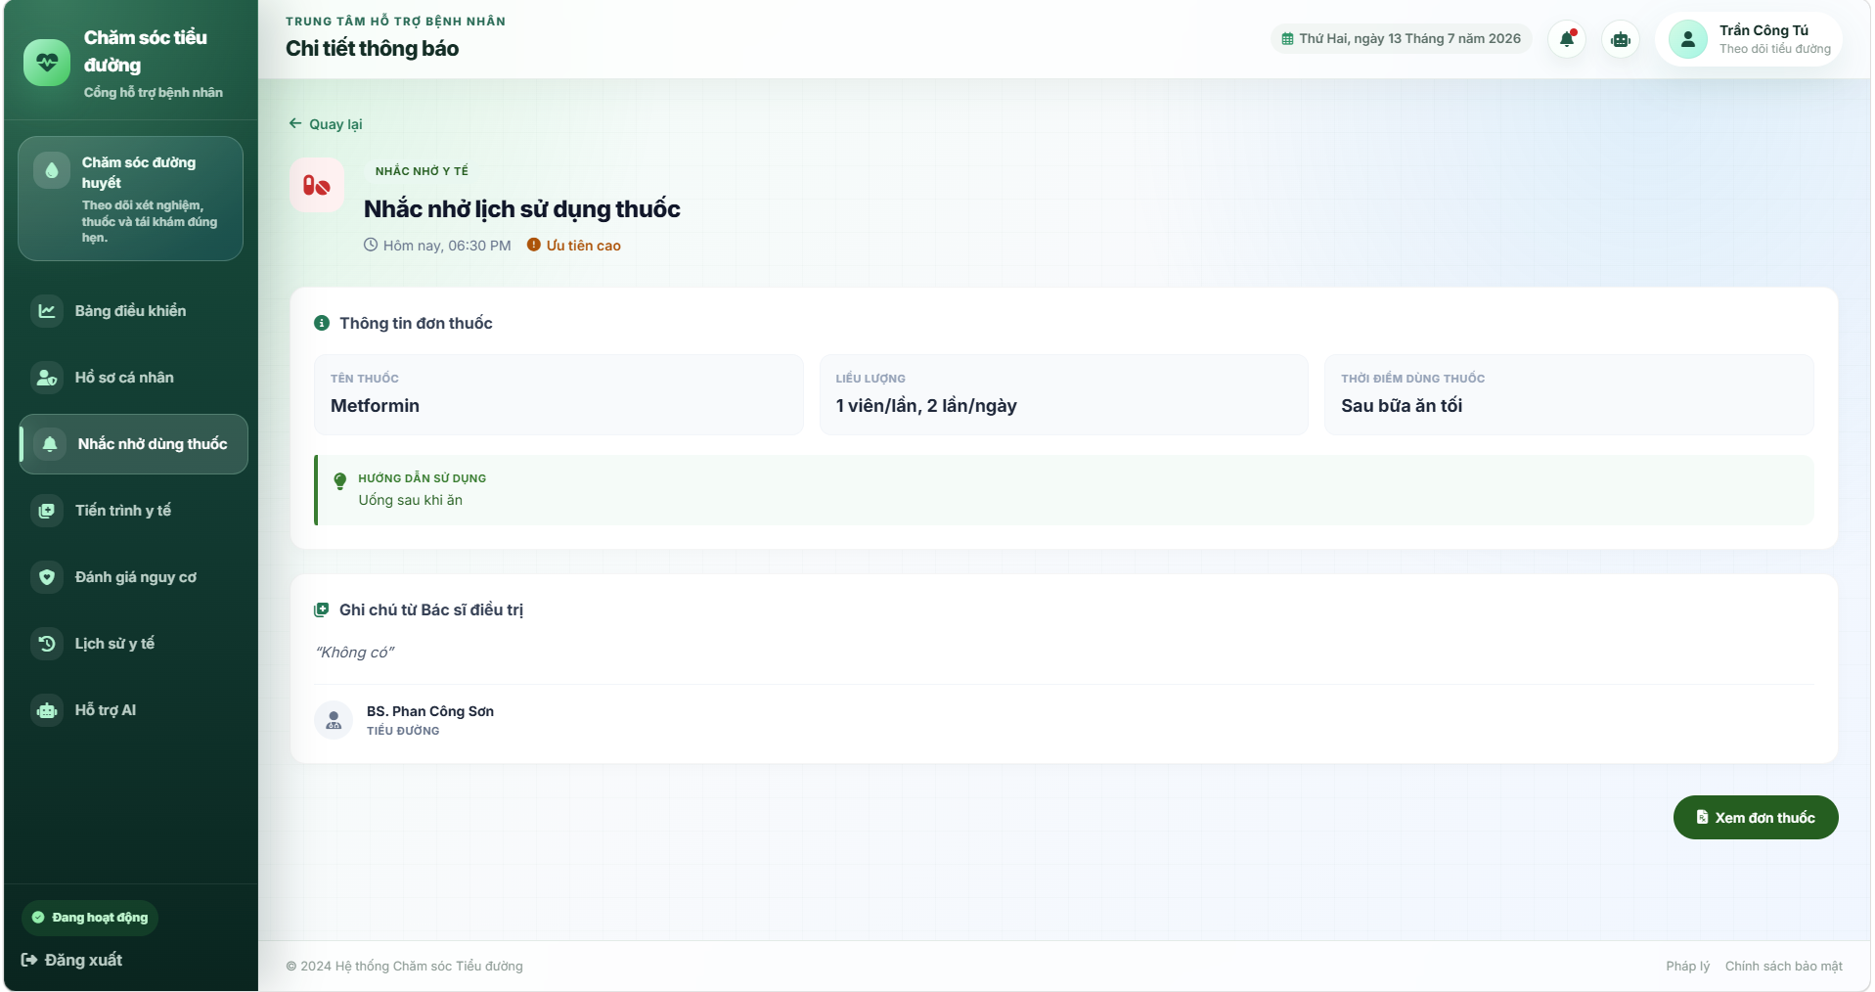
UI Elements Table
Field Name | Field Type | Description
Header Information
Category Badge | Badge | Displays "NHẮC NHỞ Y TẾ" for medication reminders.
Tiêu đề thông báo | Text (h2) | Detailed title of the alert (e.g. Nhắc nhở dùng thuốc Metformin).
Thời gian gửi | Text | Formatted schedule timestamp (e.g. Hôm nay, 10:30 AM).
Prescription Info Block
Tên thuốc | Text Card | Name of the target drug.
Liều lượng | Text Card | Target dosage.
Thời điểm dùng thuốc | Text Card | Target timing label (e.g. Mỗi buổi sáng).
Hướng dẫn sử dụng | Text block | Specific intake clinical rules (e.g. Uống 1 viên ngay sau bữa ăn sáng...).
Clinical & Doctor Advice
Ghi chú từ Bác sĩ | Text Block (Quote) | Quotes diagnosis advice notes entered by the prescribing doctor.
Thông tin bác sĩ | Profile block | Displays full doctor name and medical specialty category.
Actions
Xem đơn thuốc | Button (Link) | Redirects to the complete detailed prescription layout grid (/patient/prescription/detail?examId=...). Hidden if no exam context is associated.

Database Access
Table | CRUD | Description
Reminder | U, R | Reads specific reminder data. Updates status to read (IsRead = 1).
ClinicalExamination | R | Reads diagnosis notes and doctor information linked to the patient's record.
Profile | R | Reads doctor profile name and specialty.
PrescriptionDetail | R | Reads medication information matching the target timing.
Medication | R | Reads default usage instructions.

SQL Commands
1/ Load detailed alert record
sql
SELECT * FROM Reminder WHERE ReminderID = ?;
2/ Mark alert as read
sql
UPDATE Reminder SET IsRead = 1 WHERE ReminderID = ?;
3/ Query doctor profile & diagnosis note from latest clinical examination
sql
SELECT ce.ClinicalExamID, ce.DiagnosisNote, p.FullName AS DoctorName, p.Specialty
FROM ClinicalExamination ce
INNER JOIN Profile p ON ce.DoctorID = p.UserID
WHERE ce.PatientID = ?
ORDER BY ce.ExamDate DESC;
4/ Query matching prescription detail item
sql
SELECT md.MedicationName, pd.Dosage, md.UsageInstruction
FROM PrescriptionDetail pd
INNER JOIN Medication md ON pd.MedicationID = md.MedicationID
INNER JOIN PrescriptionTiming pt ON pd.PrescriptionDetailID = pt.PrescriptionDetailID
WHERE pd.PrescriptionID = (SELECT PrescriptionID FROM Prescription WHERE ClinicalExamID = ?)
AND pt.TimingID = ?;
=============================================================================

d. Reminder Detail Screen (Appointment Layout)
This detailed screen is triggered when selecting an appointment or clinical checkup alert. It informs the patient about their next scheduled clinical review, displaying the clinic location, the timing, and a checklist of preparatory instructions.
Related Use Cases:
- UC-30: Receive and View Reminders and Notifications

UI Design
(The screen features a green gradient header banner displaying appointment titles, two columns showing Doctor profile details and Scheduled time information, a clinic location card, and a gray checklist block listing preparatory rules)
[NOTE: INSERT PATIENT APPOINTMENT DETAIL SCREEN UI DESIGN IMAGE HERE]

UI Elements Table
Field Name | Field Type | Description
Banner Block
Thông báo lịch tái khám định kỳ | Text (Banner Title) | Prominent header rendered inside a green gradient block.
Grid Column Cards
Bác sĩ phụ trách | Text / Profile Card | Displays full doctor profile details (name and specialty).
Thời gian | Text / Card | Displays the scheduled appointment day of the week and date (e.g. Thứ Tư, 25 tháng 10, 2023).
Location & Preparation Notes
Vị trí thăm khám | Text / Card | Displays targeted clinical department room location (e.g. Phòng khám 204, Bệnh viện Đa khoa Tâm Anh).
Lưu ý chuẩn bị | Text List | Renders clinical prepare instructions list (e.g. fasting, check-in rules, carrying prescription books).

Database Access
Table | CRUD | Description
ClinicalExamination | R | Reads next appointment dates, times, and doctor associations.
Profile | R | Reads the clinic doctor name and department description.
SQL Commands
1/ Retrieve appointment details from latest clinical examination
sql
SELECT NextAppointment, DoctorID
FROM ClinicalExamination
WHERE PatientID = ?
ORDER BY ExamDate DESC;

e. Detailed Prescription Screen
This grid layout screen is triggered from the medication reminder detail page. It compiles a list of all active medication details prescribed during the clinical consultation, mapping subclass tags, dosage units, frequency rules, timings, and custom instruction notes.
Related Use Cases:
- UC-30: Receive and View Reminders and Notifications

UI Design
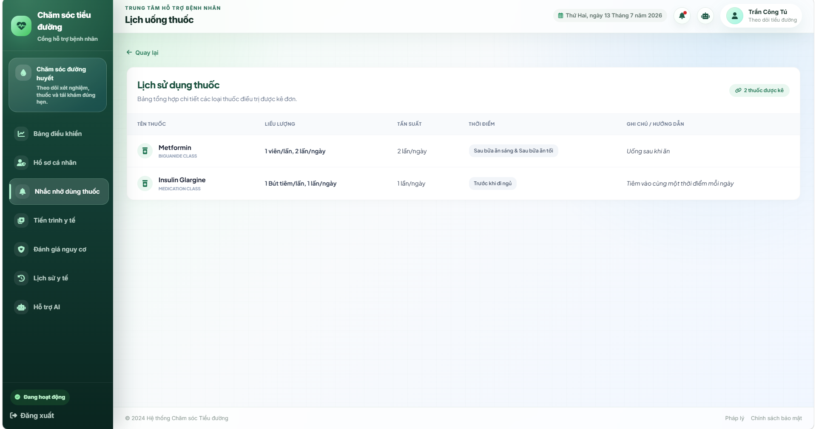
UI Elements Table
Field Name | Field Type | Description
Header Elements
Lịch sử dụng thuốc | Text (Header title) | Detailed header title.
Số lượng thuốc được kê | Badge | Displays active count of prescribed drugs (e.g. 4 thuốc được kê).
Grid Table Columns
Tên thuốc | Text (cell) | Displays the drug name and drug subclass (e.g. Metformin (BIGUANIDE CLASS)). Includes a pill icon.
Liều lượng | Text (cell) | Displays dosage unit size (e.g. 500mg).
Tần suất | Text (cell) | Daily frequency (e.g. 2 lần/ngày).
Thời điểm | Badge (cell) | Shows target timing badge (e.g. Sau ăn sáng & tối).
Ghi chú / Hướng dẫn | Text (cell) | Clinical remarks, warnings, or diet rules.

Database Access
Table | CRUD | Description
PrescriptionDetail | R | Reads the list of drug configurations registered in the prescription.
Medication | R | Reads chemical name and subclasses.
PrescriptionTiming | R | Reads assigned timing relations.
Timing | R | Reads daily timing descriptions.

SQL Commands
1/ Retrieve all prescription items for the clinic examination
sql
SELECT md.MedicationName, pd.Dosage, pd.PrescriptionDetailID, md.UsageInstruction
FROM PrescriptionDetail pd
INNER JOIN Medication md ON pd.MedicationID = md.MedicationID
WHERE pd.PrescriptionID = (SELECT PrescriptionID FROM Prescription WHERE ClinicalExamID = ?);
2/ Retrieve timings for each prescription detail item
sql
SELECT t.TimingName
FROM PrescriptionTiming pt
INNER JOIN Timing t ON pt.TimingID = t.TimingID
WHERE pt.PrescriptionDetailID = ?;

5.7 Next Appointment Screen
Displays detailed information of the next check-up schedule set by the doctor, including date, doctor name, and clinic room location.

UI Design
Field Name | Field Type | Description
Appointment Schedule | Card | Displays next consultation date and time.
Doctor Name | Label | Displays name of the attending physician.
Location | Label | Displays room name and location directions.
Doctor Note | Text View | Displays doctor's preparation instructions (e.g., fast for 8 hours).

Database Access
Table | CRUD | Description
ClinicalExamination | R | Read next appointment info.
Profile | R | Read doctor's profile to get full name.
Room | R | Read room details.
SQL Commands
1/ Get next follow-up appointment details
SELECT ce.NextAppointment, p.FullName AS DoctorName, r.RoomName
FROM ClinicalExamination ce
JOIN Profile p ON ce.DoctorID = p.UserID
JOIN Room r ON p.RoomID = r.RoomID
WHERE ce.PatientID = ?
AND ce.NextAppointment >= GETDATE()
AND ce.Status = 'Completed'
ORDER BY ce.NextAppointment ASC;

5.8 Daily Routine Configuration Screen
Allows patients to modify baseline life schedules (breakfast, lunch, dinner, wake up, bed time) to ensure AI medication alerts fire at accurate hours.

UI Design

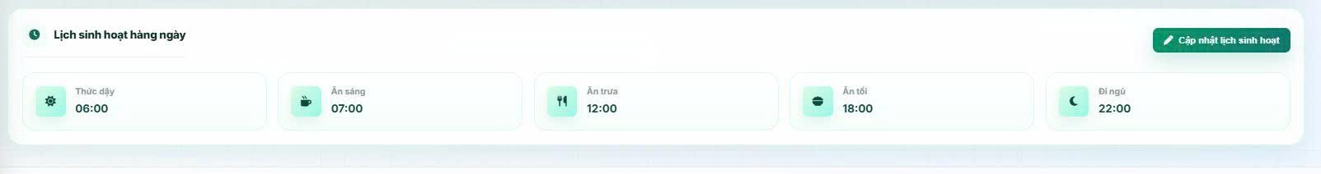

Field Name | Field Type | Description
Breakfast Time | Time Picker | Set breakfast time.
Lunch Time | Time Picker | Set lunch time.
Dinner Time | Time Picker | Set dinner time.
Wake Up Time | Time Picker | Set standard wake-up time.
Bed Time | Time Picker | Set standard bed time.
Save Settings | Button | Updates the daily routine configuration in the database.

Database Access
Table | CRUD | Description
PatientRoutine | R, U | Read and update patient routine configs.
SQL Commands
1/ Load Patient Routine
SELECT * FROM PatientRoutine
WHERE UserID = ?;

2/ Update Patient Routine
UPDATE PatientRoutine SET BreakfastTime = ?, LunchTime = ?, DinnerTime = ?, WakeUpTime = ?, SleepTime = ?
WHERE UserID = ?;

5.9 Risk Assessment Screen
Displays diabetes risk trends, vital comparisons, and AI doctor assessment summaries generated from laboratory findings.

UI Design

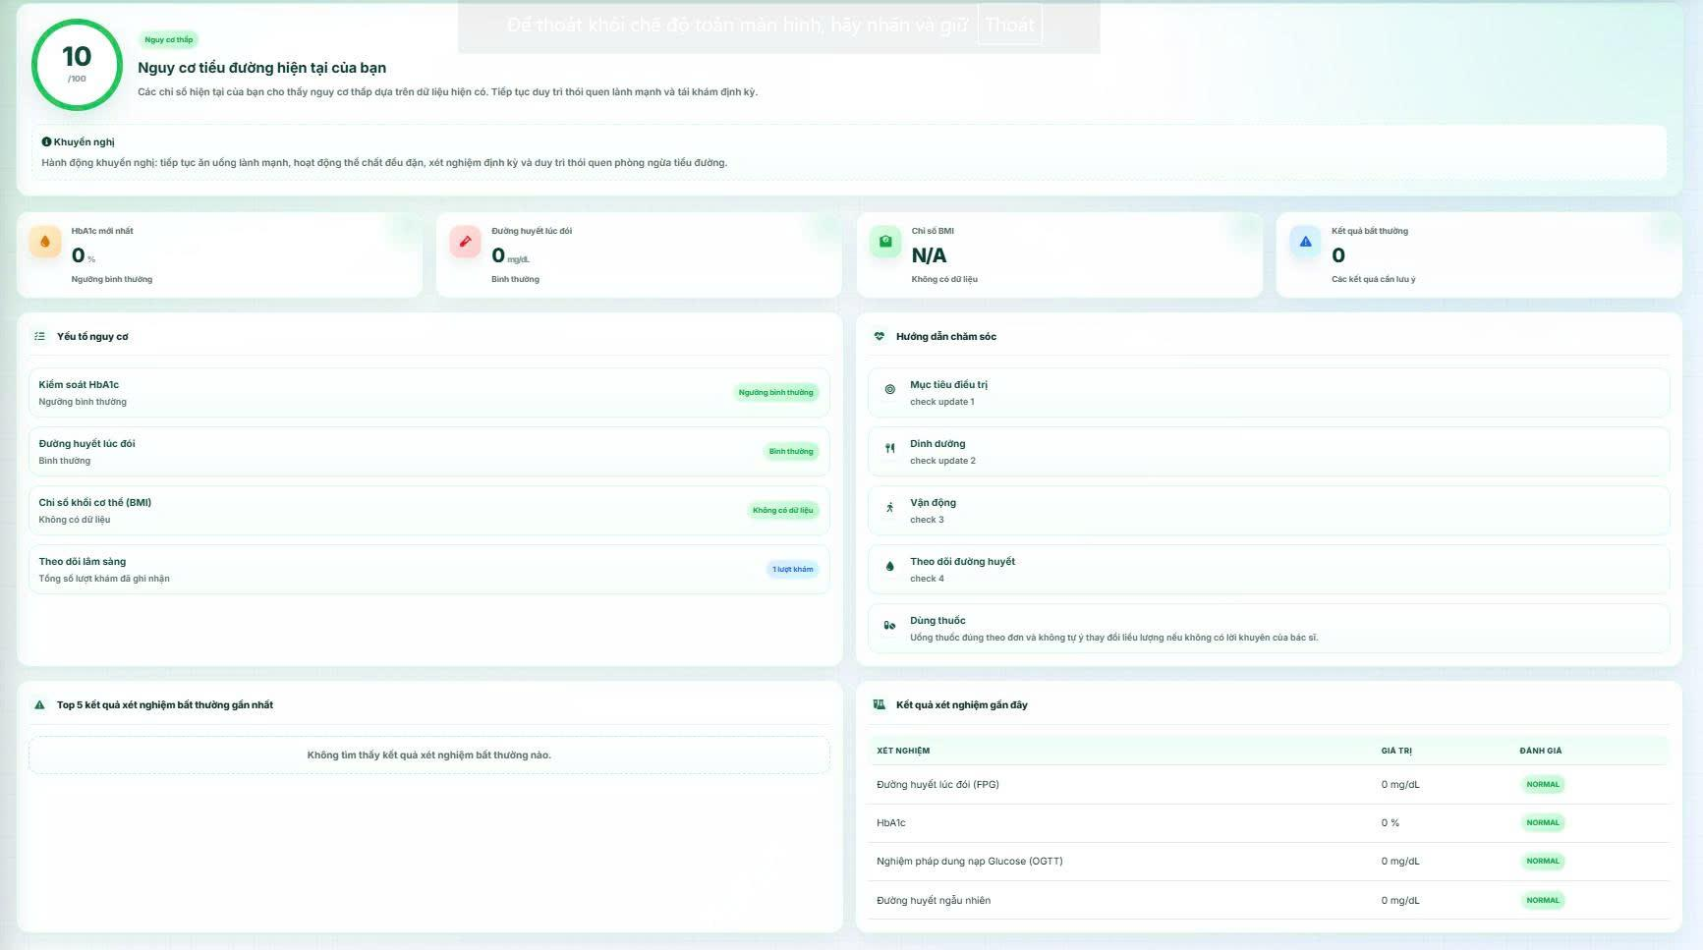

Field Name | Field Type | Description
Risk Category | Badge | Displays color-coded threat levels: Low Risk (green), Prediabetes (yellow), High Risk (red).
Risk Score | Stat Card | Displays calculated risk score percentage.
AI Evaluation Notes | Text Panel | Displays automated clinical assessment notes and suggestions from AI.
Telemetry Telemetry | Table | Compares actual patient vital and lab parameters (FPG, HbA1c, BMI) with reference thresholds.

Database Access
Table | CRUD | Description
LabResult | R | Read latest Fasting Blood Glucose and HbA1c values.
Patient | R | Read physical attributes (height, weight, age) for assessment.
SQL Commands
1/ Load latest lab results for risk evaluation
SELECT lr.ResultValue, lt.TestName
FROM LabResult lr JOIN LabOrder lo ON lr.LabOrderID = lo.LabOrderID
JOIN ClinicalExamination ce ON lo.ClinicalExamID = ce.ClinicalExamID
JOIN Lab_Test_Catalog lt ON lr.LabTestID = lt.LabTestID
WHERE ce.PatientID = ?
AND ce.Status = 'Completed'
ORDER BY ce.ExamDate DESC;

5.10 Medical Examination Request Screen
Allows patients to request clinical consultations by explaining their current symptoms, medical history, or concerns.

UI Design

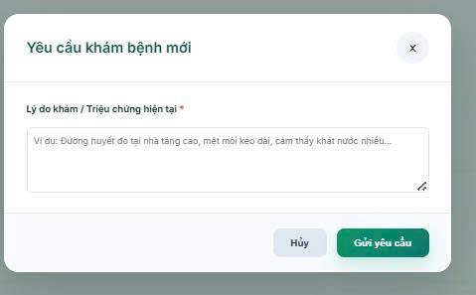

Field Name | Field Type | Description
Medical Concerns / Reason for Visit | Text Area | Required. Describe reasons for booking an appointment.
Submit Request | Button | Submits the new examination request (POST /patient/request-exam).

Database Access
Table | CRUD | Description
ClinicalExamination | C, R | Verify if there are duplicate active sessions, insert new examination request in 'Requested' status.
SQL Commands
1/ Check for active requested/pending exams
SELECT TOP 1 ClinicalExamID
FROM ClinicalExamination
WHERE PatientID = ?
AND Status IN ('Requested', 'Pending', 'InProgress');

2/ Save examination request
INSERT INTO ClinicalExamination (ClinicalExamID, ExamDate, MedicalHistory, Status, PatientID, DoctorID) VALUES (?, ?, ?, 'Requested', ?, ?);

5.11 Rating for doctor Screen
This screen allows the patient to rate their experience after completing a clinical examination. The patient can select a rating from 1 to 5 stars and optionally write a feedback comment about the doctor.

UI Design

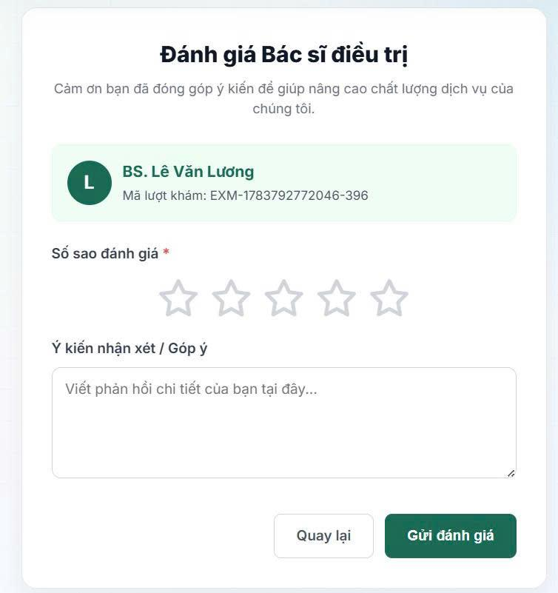

Field Name / UI Control | Field Type | Description
Clinical Exam ID | Text Label | Displays the clinical examination code currently being rated (immutable).
Rating Stars | Star Selector | Interactive star elements enabling patient to select 1 to 5 stars. Mandatory.
Feedback / Comment | Text Area | Text input box for writing detailed comments about the clinical session. Optional.
Submit Rating | Button | Submits the rating data (POST to /patient/history/rate).
Back | Button (Link) | Closes the rating screen and returns to the patient's medical history list.

Database Access

Table | CRUD | Description
DoctorRating | C, R | Checks for duplicate ratings before inserting, and saves the new rating record.
ClinicalExamination | R | Verifies that the clinical examination exists, is completed, and belongs to the patient.
SQL Commands
1/ Check for existing rating for the exam
sql
SELECT RatingID
FROM DoctorRating
WHERE ClinicalExamID = ?;
2/ Save Doctor Rating
sql
INSERT INTO DoctorRating (ClinicalExamID, PatientID, DoctorID, RatingValue, Comment, CreatedAt)
VALUES (?, ?, ?, ?, ?, GETDATE());

6. AI Services

6.1 AI Health Assistant Chat Screen

a. Chat with AI Assistant
This screen lets a Patient converse with the AI health assistant, review past conversations, and manage conversation history. Related use case:
· UC-PAT-07: Chat with AI Assistant
· UC-AI-01: AI Hybrid RAG Intent Processing

UI Design

Field Name | Field Type | Description
Conversation Panel
Suggestion Chips | Button group | Quick-start questions shown when the conversation is empty, e.g. "🍎 Chế độ ăn", "💊 Thuốc điều trị", "🏃 Tập thể dục".
Message List | Scrollable panel | Chronological list of patient and AI messages rendered as chat bubbles; AI messages are rendered from Markdown.
Message Input* | Text Box, maxlength 2000 | Free-text box for typing the question.
Send | Button | Submits the question via POST /patient/chat/api/send (or .../send/assistant/{id}).
History Sidebar
Bắt đầu cuộc trò chuyện mới | Button | Starts a brand-new conversation for the patient.
Conversation Item | List item | One entry per past conversation, showing its auto-generated topic; clicking loads its messages.
Delete | Icon | Opens a confirmation modal, then deletes the selected conversation and all of its messages.

Database Access
Table | CRUD | Description
AI_Conversation | C, R, U | Create a conversation on first visit / "new chat"; read the patient's conversation list; update Topic after the first exchange.
AI_Message | C, R | Persist each patient/AI message pair; read the message history of a conversation (limited to the last 20 for prompt context).
AI_Assistant | R | Resolve which AI assistant/model to use for the conversation.
Patient, ClinicalExamination, TreatmentPlan, LabResult, PrescriptionDetail | R (conditional) | Queried only when Stage-1 classification determines the question needs the patient's personal medical data, via the AiTool component.
ai_patient_access_log | C | One row inserted per personal-data access, recorded automatically by an AOP aspect around AiTool.
SQL Commands:
1/ Get or create the active conversation
SELECT * FROM AI_Conversation WHERE AIConversationID = ?
INSERT INTO AI_Conversation (AIConversationID, PatientID, AIAssistantID, Topic, CreatedAt)
VALUES (?, ?, ?, ?, ?)

2/ Save a chat message
INSERT INTO AI_Message (Content, Sender, Time, AIConversationID) VALUES (?, ?, ?, ?)

3/ Load recent conversation history (for prompt context)
SELECT TOP 20 Content, Sender, Time FROM AI_Message WHERE AIConversationID = ? ORDER BY Time DESC

4/ Retrieve personal data on demand (example: lab results)
SELECT lr.ResultValue, lr.ReferenceRange, lt.TestName, lt.Unit, lr.Flag
FROM LabResult lr
JOIN LabTestCatalog lt ON lr.TestID = lt.TestID
JOIN LabOrder lo ON lr.LabOrderID = lo.LabOrderID
JOIN ClinicalExamination ce ON lo.ClinicalExamID = ce.ClinicalExamID
WHERE ce.PatientID = ? ORDER BY ce.ExamDate DESC

5/ Log a personal-data access (written automatically by AiToolAspect)
INSERT INTO ai_patient_access_log (patientId, dataType, accessedAt) VALUES (?, ?, ?)

6.2 Medication Reminder Screen
Detailed view displaying how the AI assistant scheduled the daily medication timing segments based on patient's routines and active prescriptions.

UI Design
Field Name | Field Type | Description
Medication Name | Label | Name of the active medication.
Dosage & Routine Segment | Label | Prescribed dosage mapped to routine slot (Breakfast, Lunch, Dinner, Bedtime).
Notification Status | Badge | Displays: Sent / Scheduled.

Database Access
Table | CRUD | Description
AI_Reminder | R | Read future reminders scheduled for the patient.
SQL Commands
1/ Load active AI medication reminders
SELECT r.AIReminderID, r.Title, r.Message, r.ScheduledTime, r.IsRead, mt.TimingName
FROM AI_Reminder r
LEFT JOIN MedicationTiming mt ON r.TimingID = mt.TimingID
WHERE r.PatientID = ?
AND r.ScheduledTime >= GETDATE()
ORDER BY r.ScheduledTime ASC;

IV. Appendix

1. Assumptions & Dependencies

a. Assumptions
The following assumptions consolidate the per-use-case "Assumptions" fields already recorded throughout Section II, grouped by theme for readability.
- Every account is uniquely identified by a registered phone number, each user holds exactly one role (Admin, Doctor, Patient), and only accounts with Active status may authenticate (UC-01).
- Self-service registration is available to Patients only; Doctor and Admin accounts are created and managed exclusively by an Administrator (UC-02, UC-04).
- OTP codes (registration and password reset) are valid for 5 minutes and the user has timely access to the phone number or channel receiving them (UC-02, UC-03).
- Master/reference data — clinic rooms, medication catalog, symptom catalog, laboratory test catalog, medication timings, and indicator thresholds — is configured by an Administrator before doctors and patients rely on it (UC-04, UC-11–UC-15, UC-20, UC-23).
- The medication catalog is shared clinic-wide; the system does not support per-doctor or per-department medication lists (UC-11).
- A Clinical Examination record is created automatically once a doctor confirms an appointment, and its status field is expected to update instantly as the doctor progresses through the 4-step examination workflow (UC-17, UC-18).
- A Treatment Plan belongs to exactly one Clinical Examination, and the doctor derives it from the diagnosis, symptoms, and laboratory results already recorded for that exam (UC-22).
- If a laboratory result has no configured reference threshold, the system stores it as "N/A" with a Normal flag rather than leaving it unevaluated (UC-21).
- The 24-hour edit window for a completed Clinical Examination is calculated strictly from its completion timestamp, and only the doctor who owns the examination may edit it (UC-24).
- Each prescribed rating is tied to exactly one completed Clinical Examination, enforcing a one-rating-per-exam relationship (UC-37, UC-38).
- The Ollama server is reachable on the same network as the Spring Boot application and serves the fine-tuned "diabetes" model (Llama 3.2 3B, QLoRA fine-tuned) referenced by the AI Assistant (UC-32, UC-33).
- Every access to a patient’s personal medical data performed by the AI Assistant goes through the shared AiTool component, so the AOP-based audit logging is assumed to capture every such access without exception (UC-35).
- Patients are assumed to have internet access and a modern browser capable of receiving desktop/web push notifications for reminders; the registered email address is assumed correct for email-based notifications (UC-29).

b. Dependencies
The system depends on the following external technologies and services, confirmed from the project’s build configuration (pom.xml) and application.properties:
- Microsoft SQL Server — primary relational data store for all clinical, administrative, and AI-related data (spring.datasource.url points to a local SQL Server instance, database "Diabetes").
- Ollama (local LLM inference server) — serves the fine-tuned "diabetes" model that powers the AI Assistant chat feature; the application calls its /api/generate endpoint (default ollama.url=http://localhost:11434).
- LangChain4j — Java library used to integrate the Spring Boot backend with the local LLM.
- Cloudinary — third-party cloud image storage used for profile/avatar picture uploads.
- Gmail SMTP — outbound email channel used for OTPs, password-recovery emails, and reminder notifications (spring.mail.host=smtp.gmail.com).
- SpeedSMS API — third-party SMS gateway used to deliver OTP codes during registration and password reset; if the gateway call fails, the OTP is logged locally to the console as a fallback.
- Spring Boot 4 / Spring Security / Spring Data JPA (Hibernate) — application framework, authentication/authorization, and ORM layer.
- Thymeleaf — server-side template engine rendering all Admin, Doctor, and Patient web pages.

2. Limitations & Exclusions

a. Known Limitations (Current Implementation)
- The AI Assistant on/off switch is held in memory only (AtomicBoolean) and always resets to "enabled" whenever the application restarts; it is not persisted to the database (UC-35, Other Information).
- The "average response latency" metric shown on the AI System Monitoring dashboard is a placeholder reserved for a future release; it is not yet computed from real request timings (UC-35, Other Information).
- The Diabetes Risk Assessment score (UC-34) is produced by deterministic, rule-based calculation against Admin-configured thresholds (BasePatientController.calculateRiskScore); it is not generated by the AI model, even though it is presented to the patient alongside AI-assisted features.
- The AI Assistant is only available to the Patient role; there is no doctor-facing AI feature (e.g., diagnosis support, chart summarization) in the current implementation.
- The PromptTemplate database table, repository, and service exist in the codebase but are not wired to any controller — Admins currently cannot edit the AI system prompt from the UI; the prompt is hard-coded in AIChatServiceImpl.
- Section 8.5 (UC-36: System Log Monitoring) has no documented Functional Description or Business Rules in this RDS, even though a corresponding admin screen (SystemLogController) exists in the codebase; the specification for this use case should be completed in a future revision.
- The system is designed for a single clinic/tenant; there is no multi-branch or multi-tenant data isolation.

b. Exclusions (Out of Scope for the Current Release)
- Continuous/real-time vital sign monitoring, automated abnormal-data flagging, and automated health-alert dispatch — listed as AI Assistant capabilities in Section I.1.2.b, but not implemented; the current AI Assistant only responds to patient-initiated chat questions.
- AI-generated diagnosis support reports for doctors — not implemented; doctors record diagnoses manually during the clinical examination workflow.
- Syncing an upcoming follow-up appointment to an external mobile calendar app, as noted under UC-30 ("Other Information") — no calendar export/integration exists in the current codebase.
- A dedicated Doctor-facing screen to view their own rating statistics and patient feedback ("Đánh giá & Phản hồi", the primary flow of UC-38) — only the Admin-side alternative flow (viewing any doctor’s ratings) is implemented.
- Telemedicine features such as video/voice consultation between doctor and patient.
- Billing, insurance claims, and payment processing.
- Multi-language support beyond Vietnamese (all patient-facing AI responses and UI labels are Vietnamese-only).
- Support for AI model providers other than a locally hosted Ollama instance (e.g., cloud-hosted LLM APIs), despite the Overview describing the AI actor as able to "connect to multiple underlying AI model providers."

3. Business Rules
The table below consolidates every business rule already defined per use case in Section II ("b. Business Rules" of each UC) into a single reference list. The Rule ID column keeps each rule’s original local ID as written in Section II, prefixed with its use case for uniqueness, since local IDs (e.g., BR-01, BR1) repeat across different use cases.

a. Authentication
ID | Business Rule | Business Rule Description
UC-01-BR1 | Password Encoding | User passwords must be encoded using the BCrypt hashing algorithm before being stored and authenticated.
UC-01-BR2 | Invalid Login | A user cannot be authenticated if the entered phone number or password is incorrect. The system shall display the message "Tên tài khoản hoặc mật khẩu không chính xác."
UC-01-BR3 | Account Status Validation | A user cannot log in if the account status is Locked. The system shall display the message "Tài khoản của bạn đã bị khóa. Vui lòng liên hệ với quản trị viên."
UC-01-BR4 | Role-based Access Control | After successful authentication, the system shall redirect the user to the dashboard corresponding to the user's role.
UC-02-BR1 | Registration Form Validation | The following fields are mandatory and must be validated: - Họ và tên: Not empty. - Số điện thoại: Numeric only. - Mật khẩu: Minimum 8 characters, must contain at least one uppercase letter (A-Z), one lowercase letter (a-z), one digit (0-9), and one special character (!@#$%^& etc.). - Xác nhận mật khẩu: Must match the Mật khẩu field exactly. - Ngày sinh: Cannot be future date; max 120 years ago. - Chiều cao: 1 < value < 300 cm. - Cân nặng: 1 < value < 1000 kg. - Tôi đồng ý...: Must be checked. - Email: Optional – if provided, must follow valid email format (e.g., user@domain.com).
UC-02-BR2 | Phone Number Uniqueness | The phone number must be unique in the system. If a phone number already exists, the registration is rejected.
UC-02-BR3 | Email Uniqueness | The email (if provided) must be unique in the system. If an email already exists, the registration is rejected.
UC-02-BR4 | OTP Generation and Expiry | An OTP is generated for each registration attempt. It is valid for 5 minutes.
UC-02-BR5 | OTP Resend Cooldown | A patient must wait 60 seconds before requesting a new OTP.
UC-02-BR6 | Registration Data Persistence During OTP Verification | Registration data is stored in the session during OTP verification to maintain state.
UC-02-BR7 | Role Assignment | All registrations through this flow are assigned the Patient role only.
UC-02-BR8 | Doctor Account Creation | Doctor accounts are created exclusively by an Administrator and are not part of this use case
UC-03-BR1 | Registered Phone Number Required | The phone number must exist in the system. If not found, the password reset is rejected.
UC-03-BR2 | OTP Generation and Expiry | A 6‑digit OTP is generated for each reset attempt. It is valid for 5 minutes.
UC-03-BR3 | OTP Verification Required | The user must successfully verify the OTP before being allowed to set a new password.
UC-03-BR4 | Password Confirmation Match | The new password and confirm password must match exactly.
UC-03-BR5 | Password Security Encoding | The new password must be encoded (BCrypt) before being stored.
UC-03-BR6 | Session Invalidation After Reset | The session is invalidated after a successful password reset for security.
UC-03-BR7 | Password Complexity Requirements | The new password must have: - At least 8 characters - At least one uppercase letter (A-Z) - At least one lowercase letter (a-z) - At least one digit (0-9) - At least one special character (!@#$%^& etc.)
UC-03-BR8 | OTP Resend Cooldown | The user must wait 60 seconds before requesting a new OTP.

b. User Management
ID | Business Rule | Business Rule Description
UC-04-BR-01 | Doctor Account Creation | Only Administrators can create doctor accounts.
UC-04-BR-02 | Phone Number Uniqueness | Every doctor account must use a unique phone number as the login credential.
UC-04-BR-03 | Room Assignment | Every doctor must be assigned to one active clinic room before the account can be created.
UC-04-BR-04 | Password Encryption | Doctor passwords must be encrypted before being stored in the database.
UC-05-BR-01 | Search Users | Administrators may search users by full name, phone number or role.
UC-05-BR-02 | User Information Access | Administrators can view account and profile information of all users.
UC-05-BR-03 | Medical Privacy | Administrators cannot view or modify clinical examination records, prescriptions or laboratory results.
UC-06-BR-01 | Account Lock | Only Administrators may lock or unlock user accounts.
UC-06-BR-02 | Login Restriction | Locked accounts are denied access to the system until unlocked.
UC-06-BR-03 | Confirmation | The system must request confirmation before changing an account status.
UC-07-BR-01 | Personal Information Update | Doctors may update only their own profile information.
UC-07-BR-02 | Immutable Account Information | Login phone number, account role, and account status cannot be modified by doctors.
UC-07-BR-03 | Mandatory Information | Full names are mandatory profile fields and cannot be empty.
UC-07-BR-04 | Room Assignment Restriction | The assigned consultation room should be changed by an Administrator.
UC-08-BR-01 | Current Password Verification | Doctors must provide the correct current password before changing it.
UC-08-BR-02 | Password Confirmation | The new password and confirmation password must be identical.
UC-08-BR-03 | Password Encryption | All passwords must be encrypted before being stored in the database.
UC-08-BR-04 | Password History | The system should prevent doctors from reusing their most recently used password if password history is enabled.
UC-09-BR-01 | Personal Information Update | Patients may view and update only their own profile information.
UC-09-BR-02 | Immutable Account Information | Login phone number, account role, and account status cannot be modified by patients.
UC-09-BR-03 | Mandatory Information & Range Limits | Full names and phone numbers are mandatory profile fields and cannot be empty. Height must be between 1 and 300 cm, and Weight must be between 1 and 1000 kg. Date of birth cannot be a future date.
UC-09-BR-04 | Data Synchronicity | Core health metrics (height, weight) saved in the profile will serve as the baseline context for the AI Assistant to monitor and analyze diabetes risks.
UC-10-BR-01 | Current Password Verification | Patients must provide the correct current password before changing it.
UC-10-BR-02 | Password Confirmation | The new password and confirmation password must be identical.
UC-10-BR-03 | Password Encryption | All passwords must be encrypted before being stored in the database.
UC-10-BR-04 | Password History | The system should prevent patients from reusing their most recently used password if password history is enabled.
UC-10-BR-05 | Password Complexity Policy | The new password must contain at least 8 characters, including at least one uppercase letter (A-Z), one lowercase letter (a-z), one digit (0-9), and one special character (!@#$%^&).

c. System Configuration & Master Data Management
ID | Business Rule | Business Rule Description
UC-11-BR-MED-1 | Unique Medication Name | The system must reject creating or updating a medication whose name matches (case-insensitive) an existing medication name in the catalog.
UC-11-BR-MED-2 | Auto-generated Medication ID | Each new medication is assigned a system-generated ID in the format "MED-NN", where NN is the next sequential number after the highest existing numeric suffix.
UC-11-BR-MED-3 | Soft Delete Only | Removing a medication from active use ("Clock") only changes its Status to "Clocked"; the record is never physically deleted, so historical prescriptions that reference it remain valid.
UC-11-BR-MED-4 | Default Status on Creation | Every newly created medication is initialized with Status = "Active".
UC-11-BR-MED-5 | Restricted Value Sets | Dosage Form must be one of {tablet, capsule, injection}; Administration Route must be one of {Oral, Subcutaneous, Intravenous, Intramuscular}.
UC-12-BR1 | Symptom name uniqueness | The symptom name (symptomName) is mandatory, cannot be empty, and must be unique across the system (case-insensitive). For example, if "Mệt mỏi" already exists, one cannot add "mệt mỏi" or "MỆT MỎI".Additionally, it must not contain special characters (only Unicode letters, numbers, spaces, and the characters (, ), ,, ., - are allowed).
UC-12-BR2 | Symptom ID generation rule | The symptom ID (symptomId) must be automatically generated in the format SYM followed by 4 digits (e.g., SYM1234). During generation, the system must verify the uniqueness of the ID in the Database before saving.
UC-12-BR3 | State transitions | A newly created symptom defaults to Hoạt động (status = true). When locked, the status changes to false (Tạm khóa). When restored, it reverts to true (Hoạt động).
UC-12-BR4 | Symptom list pagination | The symptom list displays a maximum of 7 rows per page. When exceeding 7 rows, the system automatically paginates at the bottom of the data table.
UC-13-BR-UC13-01 | Unique Test Code and Name | Each laboratory test within the system must possess a unique Name and unique Identification Code. Duplicate entries within the same category are strictly prohibited.
UC-13-BR-UC13-02 | Status Restrictions | - Active: Fully operational; available for selection in doctor orders. - Blocked: Temporarily or permanently disabled. It cannot be chosen for new medical orders but must remain preserved in historical medical records.
UC-13-BR-UC13-03 | Price Modification Integrity | Any modifications or adjustments made to the base cost of a laboratory test will only apply to future medical orders and will not retroactively affect already paid or ongoing orders.
UC-13-BR-UC13-04 | Form Validation Bounds | All numerical thresholds for reference ranges (Minimum/Maximum limits) and costs must be positive values greater than zero. Data validation will fail if formatting constraints are breached.
UC-14-BR-UC14-01 | Unique room name | The clinic room name must be unique (case-insensitive). The system will not allow creating or updating to an existing room name.
UC-14-BR-UC14-02 | Required fields | The room name field is mandatory and cannot be empty or contain only whitespace. The maximum character length is 100 characters.
UC-14-BR-UC14-03 | Description length | The description field is optional and has a maximum character limit of 255 characters.
UC-14-BR-UC14-04 | Room deletion constraint | A clinic room cannot be deleted if it is currently assigned to a doctor or referenced by any laboratory test catalog in the system.
UC-15-BR-UC15-01 | Unique timing name | The medication timing name (e.g., "After breakfast", "Before bedtime") must be unique (case-insensitive).
UC-15-BR-UC15-02 | Required fields | The timing name is mandatory and cannot be left blank or contain only whitespace. The maximum character length is 100 characters.
UC-15-BR-UC15-03 | Timing deletion constraint | A medication timing cannot be deleted if it is currently being used in any patient's active prescription or active medication reminder schedule.

d. Patient Registration & Examination Workflow
ID | Business Rule | Business Rule Description
UC-16-BR-06 | Doctor Selection | Patients can only request examinations from doctors who have Active status and are assigned to a clinic room.
UC-16-BR-07 | Pending Request Limit | A patient cannot submit a new examination request if they already have an active request in 'Requested' status for the same doctor.
UC-17-BR-01 | Doctor Queue Restriction | Doctors may view only patients assigned to themselves.
UC-17-BR-02 | Queue Ordering | Patients are displayed in ascending order based on appointment time.
UC-17-BR-03 | Examination Access | A doctor can open only the clinical examination assigned to that doctor.
UC-17-BR-04 | Queue Status | Each consultation must display one of the following statuses: “Đang chờ”, “Đang khám”, “Hoàn thành”, “Đã hủy”.
UC-18-BR-01 | Privacy Boundaries | A patient can strictly only view the workflow progress of their own assigned clinical identity.
UC-18-BR-02 | Standard Status Workflow | The workflow progress status must precisely align with one of the predefined master codes: "Đang chờ" (Waiting), "Đang khám" (Undergoing Exam), "Chờ xét nghiệm" (Waiting for Lab), or "Hoàn thành" (Completed).
UC-19-BR-01 | Mandatory Rejection Reason | The doctor must specify a cancellation reason when rejecting an examination request.
UC-19-BR-02 | Queue Enrollment upon Approval | Once approved, the request is added to the clinic queue with status 'Pending' and becomes available in the doctor's today queue if the scheduled date matches the current date.

e. Clinical Examination & Treatment Management
ID | Business Rule | Business Rule Description
UC-20-BR-01 | Multiple Symptoms | Multiple symptoms may be selected for one examination.
UC-20-BR-02 | Active Symptoms Only | Only active symptoms are available for selection.
UC-20-BR-03 | Symptom Notes | Notes are optional for each symptom.
UC-21-BR-01 | Active Laboratory Tests | Doctors may order only laboratory tests whose status is Active.
UC-21-BR-02 | Reference Threshold Evaluation | Every laboratory result must be compared with the configured reference threshold corresponding to the patient's type.
UC-21-BR-03 | Diagnosis Requirement | The doctor must review laboratory results before recording the final diagnosis, and a diagnosis is required before proceeding to the treatment plan.
UC-22-BR-01 | One Treatment Plan per Examination | Each Clinical Examination may have only one Treatment Plan; saving again updates the same record instead of creating a new one.
UC-23-BR-01 | Active Medication Only | Doctors may prescribe only medications whose status is Active.
UC-23-BR-02 | Multiple Medications | A prescription may contain one or more medications.
UC-23-BR-03 | Medication Timing Requirement | Every prescribed medication must have at least one medication timing.
UC-23-BR-04 | Automatic End Date Calculation | The system automatically calculates the expected End Date based on the Start Date and Duration Days.
UC-23-BR-05 | Clinical Examination Association | Every prescription must belong to exactly one Clinical Examination.
UC-24-BR-01 | 24-Hour Editing Limit | A completed clinical examination may only be edited within 24 hours after its completion time.
UC-24-BR-02 | Owner Permission | Only the doctor who performed the clinical examination is allowed to edit it.
UC-24-BR-03 | Automatic Quantity Recalculation | If prescription information is modified, the system automatically recalculates the medication quantity.
UC-24-BR-04 | Automatic End Date Calculation | The system automatically calculates the expected End Date based on the Start Date and Duration Days.
UC-24-BR-05 | Examination Integrity | The Clinical Examination remains associated with the same patient and cannot be reassigned to another patient or doctor during editing.

f. Medical Records & Treatment History
ID | Business Rule | Business Rule Description
UC-25-BR-01 | Authorized Access | Only authenticated doctors are allowed to access patient medical histories.
UC-25-BR-02 | Patient Ownership | Doctors may only view examination records belonging to the selected patient.
UC-25-BR-03 | Read-only Records | Medical history records cannot be modified from the Medical History screen.
UC-25-BR-04 | Date Range Filtering | The system shall allow filtering examination history using Date From and Date To.
UC-25-BR-05 | Chronological Ordering | Examination history shall be sorted by examination date in descending order by default.
UC-25-BR-06 | Complete Examination Details | Each examination detail shall include medical history, symptoms, laboratory tests, laboratory results, diagnosis, treatment plan, and prescriptions.
UC-25-BR-07 | Multiple Entry Points | The Medical History page shall be accessible both from the patient profile and from the clinical examination screen.
UC-26-BR-01 | Strict Data Ownership | Patients are blocked from injecting alternative query parameters to request histories that do not belong to their specific authenticated UserID.
UC-26-BR-02 | Historical Presentation | The medical record overview panel must display the clinical field elements clearly: Examination Date, Final Diagnosis, and Doctor Name.
UC-26-BR-03 | Read-Only Masking | No input controls or editing mechanisms can be active inside the historical UI view layer for patients.
UC-27-BR-01 | Prescriber Integrity | The patient view screen must explicitly lock and reflect the original details finalized by the doctor; details are unalterable by the patient.
UC-27-BR-02 | Unified Metadata Mapping | All medication schedules must automatically match the exact timing specifications configured during the clinical appointment (e.g., Morning, Noon, Afternoon, Night).

g. Patient Routine & Medical Reminder Management
ID | Business Rule | Business Rule Description
UC-28-BR-01 | Temporal Integrity | All routine setup values must capture active 24-hour timestamp patterns and maintain sequential logic (Breakfast < Lunch < Dinner < Sleep).
UC-28-BR-02 | Notification Adaptation Engine | If a patient modifies their routine, the background notification orchestrator must instantly adapt and re-map all future un-triggered daily notification alarms.
UC-29-BR-01 | Reminder schedule offset | Medication reminders are scheduled to be sent and displayed 30 minutes prior to the designated medication intake segment.
UC-29-BR-02 | Daily routine calculation | The exact timing of the reminder is calculated based on the patient's routine settings (e.g. breakfast time, lunch time) stored in PatientRoutine combined with the prescription timing configuration.
UC-29-BR-03 | Daily routine calculation | Upon generation of new reminders for a new diagnosis/exam, all future unsent medication reminders under the old prescription are locked (lockStatus = true) and hidden.
UC-29-BR-04 | Unique email dispatch | Each reminder records isSent as true once dispatched to prevent duplicated emails for the same reminder instance.
UC-29-BR-05 | Real-time routine sync | Any modification in PatientRoutine must immediately trigger a recalculation and update the scheduledTime of all unsent reminders whose scheduledTime is in the future.
UC-30-BR-01 | Date Domain Check | Only upcoming appointment entries that are strictly chronologically ahead of or equal to the current system calendar day can be highlighted on the primary dashboard interface.
UC-30-BR-02 | Automatic Cancellation Sync | If an internal administrative system action flags the status of the master checkup event as "Đã hủy" (Cancelled), the corresponding follow-up dashboard container must be immediately un-rendered.
UC-31-BR-01 | Doctor visibility scope | The Doctor can only view patients who have at least one reminder record scheduled for the current date.
UC-31-BR-02 | Latest exam sorting | The column Thời gian khám gần nhất displays the maximum exam date found among all clinical examinations associated with the patient.
UC-31-BR-03 | Pagination limit | The patient list table shows a maximum of 10 rows per page. Pagination is hidden if there is only 1 page.

h. AI Assistant & System Monitoring
ID | Business Rule | Business Rule Description
UC-32-BR-CHAT-1 | AI Availability Gate | While the AI system is disabled by Admin, every chat request must receive a fixed maintenance notice instead of contacting the AI model.
UC-32-BR-CHAT-2 | Two-Stage Processing | Every question passes through a Stage-1 intent classification (keyword fallback, then LLM router) before a Stage-2 model call generates the final answer.
UC-32-BR-CHAT-3 | Personal Data Isolation | RAG tool calls only ever query data belonging to the currently authenticated patient's own patientId; no cross-patient access is possible from the chat feature.
UC-32-BR-CHAT-4 | Conversation Ownership | A conversationId supplied in a request must belong to the requesting patient, otherwise the request is rejected.
UC-32-BR-CHAT-5 | History Window | Only the most recent 20 messages of a conversation are sent as context to the AI model.
UC-32-BR-CHAT-6 | Auto Topic Naming | The conversation topic is automatically derived from the first five words of the patient's first question and is not manually editable.
UC-33-BR-01 | Keyword fallback classification | The system must first match the query against predefined keywords (e.g., "đơn thuốc", "xét nghiệm", "tiền sử") to bypass LLM classification. If a keyword matches, it returns the pre-mapped JSON tool immediately to save server resources and latency.
UC-33-BR-02 | Conversation history window | The final generation prompt must append a maximum of 3 messages from the recent conversation history to maintain context without overloading the token limit.
UC-33-BR-03 | Audit log isolation | The AOP aspect logging of RAG access must execute in a new propagation transaction (REQUIRES_NEW) to ensure that access logs are recorded successfully even if the main chat transaction rollback occurs due to generation errors.
UC-33-BR-04 | Medical diagnosis boundary | The AI Assistant is prohibited from diagnosing new illnesses or prescribing medicines, and must always conclude with the disclaimer: "Thông tin này mang tính tham khảo, không thay thế tư vấn của bác sĩ.".
UC-34-BR-01 | Precision Threshold Matching | All high-risk alert flags and color codes must strictly evaluate metrics against the active reference thresholds configured by the Admin role.
UC-34-BR-02 | Automated Legal Disclaimer | The risk insight screen must explicitly append the text: "Thông tin này mang tính tham khảo, không thay thế tư vấn của bác sĩ." on all patient-facing panels.
UC-34-BR-03 | Data Seclusion Protection | Patient profiles can only query risk indices computed from their specific account profile token context to guarantee clinical privacy.
UC-35-BR-MON-1 | Access Log Immutability | Entries in the Patient Access Log are created automatically by the system (via AOP) and cannot be created, edited, or deleted from the Admin UI.
UC-35-BR-MON-2 | Kill-Switch Scope | While Admin has disabled the AI system, every chat request from every patient must immediately receive a fixed maintenance message instead of an AI-generated answer.
UC-35-BR-MON-3 | Distinct Daily Users Metric | "Người dùng hôm nay" counts only distinct, known patient IDs (excluding "UNKNOWN") with at least one access-log entry since 00:00 of the current day.
UC-35-BR-MON-4 | Default Log Pagination | The Patient Access Log defaults to 7 rows per page, sorted by Accessed At in descending order (most recent first).

i. Rating
ID | Business Rule | Business Rule Description
UC-37-BR-RATE-1 | One Rating Per Exam | A patient cannot rate the same clinical examination more than once.
UC-37-BR-RATE-2 | Valid Rating Range | The rating value must be an integer between 1 (lowest) and 5 (highest) stars.
UC-37-BR-RATE-3 | Optional Comments | Feedback comments are optional; patients can submit a rating with only the star value.
UC-38-BR-RATE-4 | Doctor-Specific Ratings | Logged-in doctors can only view ratings and feedback submitted for their own clinical examinations. They cannot view ratings for other doctors.
UC-38-BR-RATE-5 | Admin-Wide Ratings | System Administrators can view ratings and average scores for all doctors in the system.

